ISO 20022

Investment Funds

Message Definition Report - Part 1

Approved by the Securities SEG on 20 January 2022

This document provides information about the use of the messages for Investment Funds and includes, for example, business transactions and examples.

24 January 2022

Table of Contents

Table of Contents 2

1 Introduction 5

1.1 Terms and Definitions 5

1.2 Abbreviations and Acronyms 5

1.3 Document Scope and Objectives 6

1.4 References 6

2 Scope and Functionality 7

2.1 Background 7

2.2 Scope 7

2.3 Groups of MessageDefinitions and Functionality 8

2.4 Securities Market Practice (SMPG) Investment Funds 13

3 BusinessRoles and Participants 14

3.1 Participants and BusinessRoles Definitions 14

3.2 BusinessRoles and Participants Table 16

4 BusinessProcess Description 17

5 Description of BusinessActivities 24

5.1 Account Administration 24

5.2 Reporting 26

5.3 Order Processing 27

5.4 Reconciliation (Statements) 28

5.5 Stock Transfers (Single Leg Transfer) 30

5.6 Portfolio and Stock Transfers (Single Leg) 32

5.7 Portfolio and Stock Transfers (Double/Matched Leg) 34

6 BusinessTransactions 37

6.1 Account Management 37

6.2 Fund Cash Forecast Reporting 46

6.3 Fund Reference Data Reporting 49

6.4 Order and Confirmation 50

6.5 Order Instruction Status Reporting 56

6.6 Scenarios For Confirmations When 'Multiple’ Orders Specified in a Single Message 62

6.7 Order Cancellation and Status 64

6.8 Order Confirmation Status Reporting 72

6.9 Order Confirmation Amendment 73

6.10 Order Confirmation Cancellation 79

6.11 Order Confirmation Status Request 84

6.12 Message Rejection 87

6.13 Portfolio Transfer Management 87

6.14 Individual Asset Transfer 91

6.15 Price Reporting 100

6.16 Statements 101

7 Business Examples 106

7.1 Account Management 106

7.2 Fund Cash Forecast 128

7.3 Fund Reference Data 148

7.4 Order and Confirmation 161

7.5 Order Status 190

7.6 Order Confirmation Amendment and Cancellation 195

7.7 Order Confirmation Status 198

7.8 Message Rejection 199

7.9 Portfolio Transfer 199

7.10 Portfolio Transfer- Additional Examples 216

7.11 Transfer - Single Leg Transfer (SLT) 244

7.12 Transfer - Matched Leg Transfer (MLT) 248

7.13 Transfer Status 253

7.14 Transfer Cancellation 255

7.15 Transfer Reversal 258

7.16 Price Report 260

7.17 Statements 266

7.18 Transparency Of Holdings 276

Revision Record 317

Preliminary Note

The Message Definition Report (MDR) is made of three parts:

MDR Part 1

This describes the contextual background required to understand the functionality of the proposed message set. Part 1 is produced by the submitting organisation that developed or maintained the message set in line with an MDR Part 1 template provided by the ISO 20022 Registration Authority (RA) on [www.iso20022.org](http://www.iso20022.org).

MDR Part 2

This is the detailed description of each message definition of the message set. Part 2 is produced by the RA using the model developed by the submitting organisation.

MDR Part 3

This is an extract if the ISO 20022 Business Model describing the business concepts used in the message set. Part 3 is an Excel document produced by the RA.

# Introduction

## Terms and Definitions

The following terms are reserved words defined in ISO 20022 Edition 2013 – Part1. When used in this document, the UpperCamelCase notation is followed.

|  |  |
| --- | --- |
| Term | Definition |
| BusinessRole | Functional role played by a business actor in a particular BusinessProcess or BusinessTransaction. |
| Participant | Involvement of a BusinessRole in a BusinessTransaction. |
| BusinessProcess | Definition of the business activities undertaken by BusinessRoles within a BusinessArea whereby each BusinessProcess fulfils one type of business activity and whereby a BusinessProcess may include and extend other BusinessProcesses. |
| BusinessTransaction | Particular solution that meets the communication requirements and the interaction requirements of a particular BusinessProcess and BusinessArea. |
| MessageDefinition | Formal description of the structure of a message instance. |

1. When a MessageDefinition or message identifier is specified, it should include the variant and version number. However, in this document (except in the business examples section, if present), variant and version numbers are not included. In order to know the correct variant and version number for a MessageDefinition, the related Message Definition Report Part 2 document should be consulted.

## Abbreviations and Acronyms

The following is a list of abbreviations and acronyms used in the document.

|  |  |
| --- | --- |
| Abbreviation/Acronyms | Definition |
| ACK | Acknowledgement |
| AML | Anti-Money Laundering |
| BIC | Business Identifier Code |
| CSD | Central Securities Depository |
| CUG | Closed User Group |
| IBAN | International Bank Account Number |
| ICSD | International Central Securities Depository |
| KYC | Know Your Customer |
| MCR | Maintenance Change Request |
| MDR | Message Definition Report |
| NAK | Negative acknowledge (reject) |
| OAGi | Open Application Group |
| SEG | Standards Evaluation Group |
| SLA | Service Level Agreement |
| SLT | Single Leg Transfer |
| SMPG | Securities Market Practice Group (www.smpg.info) |
| XML | eXtensible Mark-up Language |

## Document Scope and Objectives

This document is the first part of the Funds Message Definition Report (MDR) that describes the BusinessTransactions and underlying message set. For the sake of completeness, the document may also describe BusinessActivities that are not in the scope of the business processes covered in this document.

This document describes the following:

* the BusinessProcess scope
* the BusinessRoles involved in these BusinessProcesses

The main objectives of this document are as follows:

* to provide information about the messages that support the business processes
* to explain the BusinessProcesses and BusinessActivities these messages have addressed
* to give a high level description of BusinessProcesses and the associated BusinessRoles
* to document the BusinessTransactions
* to provide business examples

The messages definitions are specified in Funds Message Definition Report Part 2.

## References

|  |  |  |  |
| --- | --- | --- | --- |
| Document | Version | Date | Author |
| ISO 20022 Business Justification – Investment Funds Distribution |  | 2005-12-28 | SWIFT |
| ISO 20022 Investment Funds Maintenance 2020/2021 |  | 2021-01-31 | SWIFT |
| ISO 20022 Investment Funds Maintenance 2021/2022 |  | 2022-01-31 | SWIFT |

# Scope and Functionality

## Background

This Message Definition Report covers a set of sixty-three MessageDefinitions developed by SWIFT in close collaboration with the investment funds community. Many of these messages are ISO 20022 MessageDefinitions approved by the Securities Standards Evaluation Group (SEG). These funds messages are specifically designed to support the investment fund community for account management, orders (including alternative/hedge funds), price report, fund cash forecast, fund reference data, portfolio transfer, transfer and statements.

The detailed description of each message standard is provided in Funds Message Definition Report Part 2.

## Scope

As described in the ISO 20022 Business Justification, the scope covers the following communication flows:

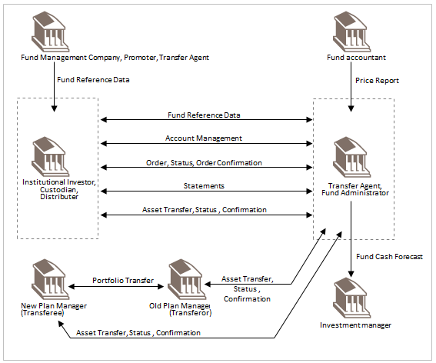

## Groups of MessageDefinitions and Functionality

### Groups

#### Account Management

Account management messages are used to manage the opening of an investment or securities account and modifications to registered account information.

|  |  |
| --- | --- |
| MessageDefinition | Message Identifier |
| AccountOpeningInstruction | acmt.001 |
| AccountDetailsConfirmation | acmt.002 |
| AccountModificationInstruction | acmt.003 |
| RequestForAccountManagementStatusReport | acmt.005 |
| AccountManagementStatusReport | acmt.006 |

#### Fund Cash Forecast Reporting

The fund cash forecast reporting messages are used to provide a report of the cash incomings and outgoings per investment fund. The cash incomings and outgoings result from redemption, subscription and switch transactions.

These messages are grouped into two categories.

* Estimated report: contains estimated cash forecasts, that is, cash flows calculated with an estimated price, usually the price of the previous trade date.
* Confirmed report: contains confirmed cash forecasts, that is, cash flows calculated with the definitive price on a specific trade date.

Each category is divided into two sub-categories:

* Short report: contains incoming and outgoing cash flows.
* Detailed report: contains incoming and outgoing cash flows. These may be sorted according to predefined or user-defined criteria and breakdown information may be given.

Estimated cash forecast messages do not need to be cancelled and replaced, as an estimated message overwrites the previous estimated message. Confirmed cash forecast reports may be cancelled and for this reason, two cancellation messages exist.

|  |  |
| --- | --- |
| MessageDefinition | Message Identifier |
| FundEstimatedCashForecastReport | camt.040 |
| FundConfirmedCashForecastReport | camt.041 |
| FundDetailedEstimatedCashForecastReport | camt.042 |
| FundDetailedConfirmedCashForecastReport | camt.043 |
| FundDetailedConfirmedCashForecastReportCancellation | camt.045 |
| FundConfirmedCashForecastReportCancellation | camt.044 |

#### Fund Reference Data

The FundReferenceDataReport message is used to convey the key reference data for financial instruments needed to facilitate trading. The message may also include reporting data concerning product governance, such as target market data, and a breakdown of the costs and fees as required by MiFID II and as specified in the European MiFID Template (EMT) document. The report may be requested with the InvestmentFundReportRequest.

|  |  |
| --- | --- |
| MessageDefinition | Message Identifier |
| FundReferenceDataReport [1] | reda.004 |
| InvestmentFundReportRequest | reda.005 |

#### Order and Confirmation

Order messages are used to instruct the executing party to subscribe, to redeem or to switch a given amount/quantity of a specified financial instrument.

There are three types of order message, subscription, redemption and switch.

In the funds industry, orders may be instructed in a variety of different ways, for example, some institutions group orders before sending them to the next party in the chain.

In order to cater for this, two sub-categories have been created for the subscription and the redemption types of messages.

Bulk order

A bulk message is typically a message containing a series of individual order transactions from different accounts, but for the same financial instrument with the same intermediary. The order will result in a single cash settlement, rather than settlement per individual order, executed using one single method. This order is sent by a concentrator or a party collecting orders and bulking them to relay the transactions to the transfer agent or another intermediary.

Order

An order message is typically a message containing a single order or multiple orders (list of orders related to several financial instruments) for the same account. It is a 'shopping list' for one account. This type of order is typically sent by financial advisers or banks that are managing a portfolio for a particular account.

In short, a bulk order is "one financial instrument-n accounts"; and an order is "one account- one financial instrument" if it is a single order and "one account-n financial instruments" if it is a multiple order.

No specific message/s have been created for cross or 'bed and breakfast' orders. In some countries, for legal reasons, these must appear as separate orders, while in others, the two orders may be given together. Therefore, no specific order has been created for a bed and breakfast order, as this transaction is the combination of a redemption and a subscription linked together. Limit and forward orders are not covered, as these are not common in the funds industry.

|  |  |
| --- | --- |
| MessageDefinition | Message Identifier |
| RedemptionBulkOrder | setr.001 |
| RedemptionBulkOrderCancellationRequest | setr.002 |
| RedemptionBulkOrderConfirmation | setr.003 |
| RedemptionOrder | setr.004 |
| RedemptionOrderCancellationRequest | setr.005 |
| RedemptionOrderConfirmation | setr.006 |
| SubscriptionBulkOrder | setr.007 |
| SubscriptionBulkOrderCancellationRequest | setr.008 |
| SubscriptionBulkOrderConfirmation | setr.009 |
| SubscriptionOrder | setr.010 |
| SubscriptionOrderCancellationRequest | setr.011 |
| SubscriptionOrderConfirmation | setr.012 |
| SwitchOrder | setr.013 |
| SwitchOrderCancellation | setr.014 |
| SwitchOrderConfirmation | setr.015 |
| SubscriptionOrderConfirmationCancellationInstruction | setr.047 |
| SubscriptionBulkOrderConfirmationCancellationInstruction | setr.049 |
| RedemptionOrderConfirmationCancellationInstruction | setr.051 |
| RedemptionBulkOrderConfirmationCancellationInstruction | setr.053 |
| SwitchOrderConfirmationCancellationInstruction | setr.055 |

The following messages were removed from the SWIFTNet funds service 18 November 2017:

|  |  |
| --- | --- |
| MessageDefinition | Message Identifier |
| SubscriptionOrderConfirmationAmendment | setr.048 |
| SubscriptionBulkOrderConfirmationAmendment | setr.050 |
| RedemptionOrderConfirmationAmendment | setr.052 |
| RedemptionBulkOrderConfirmationAmendment | setr.054 |
| SwitchOrderConfirmationAmendment | setr.056 |

The order confirmation messages are to be used for confirmation amendment

In the 2017 maintenance, the 'classic' funds messages, for example, SubscriptionOrder (setr.010), RedemptionOrder (setr.004), were updated to include hedge/alternative funds functionality.

Users that are planning to implement the SWIFTNet funds messages for hedge/alternative funds orders should use the 'classic' messages (setr.010, 001, 012, 004, 005, 005, 016 and 017) in preference to the 'alternative funds' messages (setr.059, 060, 061, 062, 064) which are also documented in this message definition report and will remain in the SWIFTNet Funds solution until there is no demand.

#### Order and Confirmation Status Reporting

The OrderInstructionStatusReport message informs the instructing party of the status of its order message, for example, SubscriptionOrder, SubscriptionBulkOrder, RedemptionOrder, RedemptionBulkOrder or SwitchOrder.

The OrderCancellationStatusReport message informs the instructing party of the status of its order cancellation request message, for example, SubscriptionOrderCancellationRequest, SubscriptionBulkOrderCancellationRequest, RedemptionOrderCancellationRequest, RedemptionBulkOrderCancellationRequest or SwitchOrderCancellationRequest.

The RequestForOrderConfirmationStatusReport is used to request the status of a previously sent confirmation. The OrderConfirmationStatusReport is sent to the executing party to provide the status of an order confirmation. The RequestForOrderStatusReport message requests the status of an order message or an order cancellation request message.

|  |  |
| --- | --- |
| MessageDefinition | Message Identifier |
| OrderInstructionStatusReport | setr.016 |
| OrderCancellationStatusReport | setr.017 |
| RequestForOrderStatusReport | setr.018 |
| OrderConfirmationStatusReport | setr.057 |
| RequestForOrderConfirmationStatusReport | setr.058 |

#### Portfolio Transfer Management

Portfolio discovery messages are used to request and provide information about financial instruments held on behalf of the client.

|  |  |
| --- | --- |
| MessageDefinition | Message Identifier |
| AccountHoldingInformation | sese.018 |
| AccountHoldingInformationRequest | sese.019 |

Portfolio transfer messages are used to instruct the transfer of one or more assets from an investor's account at an old plan manager (transferor) to an account with the new plan manager (transferee).

|  |  |
| --- | --- |
| MessageDefinition | Message Identifier |
| PortfolioTransferInstruction | sese.012 |
| PortfolioTransferConfirmation | sese.013 |
| PortfolioTransferCancellationRequest | sese.014 |

Transfer messages are used to instruct the transfer of a given amount/quantity of a specified financial instrument from one account to another own account or to a third party account. Specific messages have been created for transfer out and transfer in.

|  |  |
| --- | --- |
| MessageDefinition | Message Identifier |
| TransferOutInstruction | sese.001 |
| TransferOutCancellationRequest | sese.002 |
| TransferOutConfirmation | sese.003 |
| ReversalOfTransferOutConfirmation | sese.004 |
| TransferInInstruction | sese.005 |
| TransferInCancellationRequest | sese.006 |
| TransferInConfirmation | sese.007 |
| ReversalOfTransferInConfirmation | sese.008 |

The transfer status reporting messages allow a party to report on the status of transfer instructions and transfer cancellation instructions, and to request a status report.

|  |  |
| --- | --- |
| MessageDefinition | Message Identifier |
| RequestForTransferStatusReport | sese.009 |
| TransferCancellationStatusReport | sese.010 |
| TransferInstructionStatusReport | sese.011 |

For the portfolio transfer, transfer and transfer status messages, concurrent versions are supported. See the section 2.7 'Concurrent Versions of Transfer Messages'.

#### Price Report

The price messages are used to:

* communicate the price of an investment fund,
* correct a price that was previously sent,

cancel a previously sent PriceReport.

|  |  |
| --- | --- |
| MessageDefinition | Message Identifier |
| PriceReport | reda.001 |
| PriceReportCancellation | reda.002 |

#### Rejection Message

|  |  |
| --- | --- |
| MessageDefinition | Message Identifier |
| SecuritiesRejectionMessage | semt.001 |

#### Statement

Statement messages are used to report the holdings of or transactions on a specific account or sub-account on a specified date or period.

There are four types of statement:

* Accounting holdings statement,
* Custody holdings statement,
* Transactions statement,
* Securities Balance Transparency Report.

Additional messages, for example, the statement of pending transactions, will be available in a subsequent phase of the funds standards initiative.

|  |  |
| --- | --- |
| MessageDefinition | Message Identifier |
| CustodyStatementOfHoldings | semt.002 |
| AccountingStatementOfHoldings | semt.003 |
| CustodyStatementOfHoldingsCancellation | semt.004 |
| AccountingStatementOfHoldingsCancellation | semt.005 |
| StatementOfInvestmentFundTransaction | semt.006 |
| StatementOfInvestmentFundTransactionsCancellation | semt.007 |
| SecuritiesBalanceTransparencyReport | semt.041 |
| SecuritiesBalanceTransparencyReportStatusAdvice | semt.042 |

### Functionality

See Message Definition Report Part 2 for the message scopes and formats.

### Related Messages

Other ISO 20022 messages are also used in the context of investment funds and may be referred to in this document.

|  |  |
| --- | --- |
| MessageDefinition | Message Identifier |
| SecuritiesStatementQuery | semt.021 |

Securities Market Practice (SMPG) Investment Funds

The Securities Market Practice Group (SMPG) investment funds working group has published market practice for a number of investment fund business processes on the MyStandards platform, including collections for the order process and the single leg transfer process.

To view the market practice collections, search on 'SMPG IF'. Then select 'Groups'. Then select 'SMPG IF'. This provides a view of some of the investment fund market practice Usage Guidelines. Click on 'more guidelines' to see the complete set of investment fund market practice collections.

# BusinessRoles and Participants

A BusinessRole represents an entity (or a class of entities) of the real world, physical or legal, a person, a group of persons, a corporation. Examples of BusinessRoles: “Financial Institution”, “Automated Clearing House”, “Central Securities Depository”.

A Participant is a functional role performed by a BusinessRole in a particular BusinessProcess or BusinessTransaction. Examples of Participants: the “user” of a system, “debtor”, “creditor”, “investor”.

The relationship between BusinessRoles and Participants is many-to-many. One BusinessRole can be involved as different Participants at different moments in time or at the same time. Examples of BusinessRoles: "user", "debtor”, "creditor", "investor". Different BusinessRoles can be involved as the same Participant.

In the context of funds the high-level BusinessRoles and typical Participants can be represented as follows:

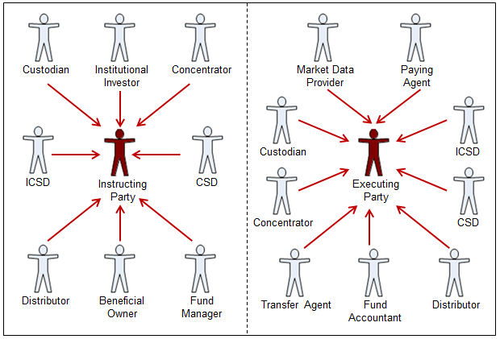

## Participants and BusinessRoles Definitions

Participants

|  |  |
| --- | --- |
| Description | Definition |
| Instructing Party | Party that requests an action, for example, instructs an investment fund order or a transfer. This is usually the account owner but may be an institution acting on behalf of the account owner. In the context of reporting this is the report user or requesting party. |
| Executing Party | Party that receives an instruction or request and acts accordingly, for example, registers the instruction (for example, transfer agent, fund manager order desk). In the context of reporting this is the reporting party or report provider. |
| Intermediary | Party that receives an instruction from the instructing party and transmits it to the executing party. |

Business Roles

|  |  |
| --- | --- |
| Description | Definition |
| Custodian | Party that safekeeps and administers assets on behalf of the owner and that has a network of sub-custodians. |
| CSD / ICSD | Infrastructure that, holds or controls, the holding of physical or dematerialised financial instruments belonging to all, or a large portion of, the investors in a securities market. It effects the centralised transfer of ownership of such securities by entries on its books and records. The depository may delegate custody to another entity (custodian). |
| Market Data Provider | Source of financial information. It provides financial news and data (for example, facts, statistics and analysis), for professional and individual investors through various media (for example, the Internet, magazine). |
| Institutional Investor | Organisation whose primary purpose is to invest its own assets or those held in trust by it for others. Includes [investment companies](http://www.investorwords.com/2609/investment_company.html), [mutual funds](http://www.investorwords.com/3173/mutual_fund.html), [brokerages](http://www.investorwords.com/585/brokerage.html), [insurance companies](http://www.investorwords.com/6843/insurance_company.html), [pension funds](http://www.investorwords.com/3652/pension_fund.html), [investment banks](http://www.investorwords.com/2602/investment_bank.html). |
| Fund Manager | Entity that implements the fund's investment strategy, that is, selects portfolio investments in accordance with the objectives and strategy in the fund's prospectus, and places orders to effect or liquidate selected investments in accordance with net flow of capital into or out of the fund. |
| Beneficial Owner | Person(s) or entity entitled to the benefits of ownership even through another party such as a broker or bank (the nominal owner) and actually has possession and title to the security. (Source: <http://www.rbeck.com>). |
| Distributor | Party that act as a wholesaler of funds. |
| Concentrator | Party that acts as an aggregator of funds, also called funds hub. |
| Transfer Agent | Party appointed by the fund management company. This party updates records of investor accounts to reflect the daily investor purchases, redemptions, switches, transfers, and re-registrations. It ensures the timely settlement of transactions, and may provide tax information to the investor and/or to its intermediaries. It may calculate, collect, and rebate commissions. It prepares and distributes confirmations reflecting transactions, resulting in unit or cash account movements to the investor or the investor's intermediary. It responds to inquiries concerning account status, and processes the income distribution. |
| Fund Accountant | Party that keeps accounting records of the available assets and liabilities of the fund. This party calculates deal prices, the Net Asset Value (NAV) of the fund, and may provide fund performance and tax data. |
| Paying Agent | Agent that executes the payment. In the context of the investment fund industry, the paying agent is the local legal representative of the fund. It may pay out dividends, and collects money for the purchase of funds when a client deals directly with the fund and/or when a client deals with bearer shares. It pays out the redemption of the fund, may distribute information about the fund, and provides legal information about the fund. |

## BusinessRoles and Participants Table

|  |  |  |  |
| --- | --- | --- | --- |
| BusinessRole | Participant  Instructing Party | Participant Intermediary | Participant  Executing Party |
| Custodian | X | X | X |
| ICSD | X | X | X |
| CSD | X | X | X |
| Market Data Provider |  |  | X |
| Institutional Investor | X |  |  |
| Fund Manager | X |  |  |
| Beneficial Owner | X |  |  |
| Distributor | X | X | X |
| Concentrator | X | X | X |
| Transfer Agent |  |  | X |
| Fund Accountant |  |  | X |
| Paying Agent |  |  | X |

# BusinessProcess Description

This diagram represents the high level BusinessProcesses.



Account Administration

|  |  |
| --- | --- |
| Item | Description |
| Definition | The account servicer creates and maintains an accounting record for the account owner/intermediary with the fund and records static information relating to the account owner/intermediary, for example, name, address, credit limit, anti-money laundering checks, tax and residency status, income distribution instructions, settlement instructions and terms and intermediary. |
| Trigger | * investor wants to make an investment in a fund * account owner wants to open, maintain or close its account |
| Pre-conditions | * formal demand from the account owner to open, maintain or close an account * if the account is to be closed, then a zero balance in the account |
| Post-conditions | * anti-money laundering, legal documentation or other documentation is available * credit limit is set * account identification is attributed * direct debit mandates are set up * power of attorney is added * reporting is defined * commission schedule is defined * confirmation of account details is provided to the account owner or its intermediary * relevant tax authorities are informed * account is open, updated or closed |
| Role | Account servicer |

Order Processing

|  |  |
| --- | --- |
| Item | Description |
| Definition | An investor places an instruction to subscribe to, redeem from, transfer or switch between units in one or more funds. |
| Trigger | * investor/intermediary decision * corporate action event * standing instruction, for example, saving plans or saving schemes |
| Pre-conditions | * valid account exists * fund exists * credit limit exists (for subscription), if required * for switch or redemption, the units in the account are settled/created * order respects the terms set out in the prospectus * instructing party is validated and verified |
| Post-conditions | Valid instruction is generated |
| Role | Instructing party |

Order Execution

|  |  |
| --- | --- |
| Item | Description |
| Definition | The transfer agent books and executes an instruction to buy, sell, transfer or switch between units in one or more funds. |
| Trigger | * trade date and cut-off time of the fund is reached * instruction has been accepted by the fund company * instruction has been processed by the transfer agent |
| Pre-conditions | * valid instruction is received. * quantities and amounts associated with the instruction have been calculated |
| Post-conditions | * quantities and amounts resulting from the execution of the instruction have been calculated * units are issued or redeemed * execution details are confirmed |
| Role | Executing party |

Payment Execution

|  |  |
| --- | --- |
| Item | Description |
| Definition | The investor or the intermediary pays for the fund units or the appointed agent collects a cash subscription into the investor's account (possibly prior to execution) and then deducts the consideration from the investor's account on settlement day, returning any excess cash to the investor or collecting any additional cash required. |
| Trigger | Deal confirmation |
| Pre-conditions | * confirmation that the deal was executed * value date of the payment is defined |
| Post-conditions | Depends on the type of payment method |
| Role | Paying agent |

Payment Execution - Advance Pay In

|  |  |
| --- | --- |
| Item | Description |
| Definition | The investor or intermediary pays or the paying agent/transfer agent collects a cash amount prior to execution. The transfer agent invests the consideration in the investor's account, returning any excess cash to the investor or collecting any additional cash required. |
| Trigger | * investor decides to invest * payment and instruction are posted |
| Pre-conditions | Identification of the account. For a savings plan or direct debit pay-ins:   * completed application form * agreed bank mandate * signed authorisation |
| Post-conditions | * payment is received * cash is cleared * cash is rejected if not identified * money laundering checks are negative |
| Role | Paying agent |

Payment Execution - Pay In Arrears

|  |  |
| --- | --- |
| Item | Description |
| Definition | After execution of the subscription the investor or intermediary pays the payable amount applied or the fund collects the cash money into the investor's account with fund and then deducts the consideration from investor's account on settlement day, returning any excess cash to the investor or collects any additional cash required. |
| Trigger | * confirmation of the deal execution * payment instruction |
| Pre-conditions | Execution is completed. |
| Post-conditions | * cash is applied to the deal * deal is fully settled * settlement and registration of the units is completed, if not already done |
| Role | Paying agent |

Payment Execution - Pay Out Arrears

|  |  |
| --- | --- |
| Item | Description |
| Definition | The transfer agent, custodian or paying agent pays out cash to the investor or its intermediary. |
| Trigger | * maturity of the fund * dividend payment * redemption * excess of an advanced payment * periodical withdrawals * commission has to be paid |
| Pre-conditions | * fund owes money to the investor * credit balance needs to be paid |
| Post-conditions | Balance to be paid is closed |
| Role | Paying agent |

Tax Accounting

|  |  |
| --- | --- |
| Item | Description |
| Definition | Calculation and identification of taxable income, taxable profits and losses pursuant to liquidation of an investment, determination of the allocation of net proceeds into categories such as taxable, tax-exempt, tax-deferred; determination of the holding period of an investment and calculation of whether it qualifies for preferential treatment due to long-term holdings. |
| Trigger | * annual, on request, per service level agreement (SLA) * upon completion of a transaction * regulatory deadline to declare taxes is reached |
| Pre-conditions | * historical information is available * taxation authority has been identified * tax position is known * holding or transaction exists |
| Post-conditions | Tax liability is known |
| Role | Fund accountant/transfer agent |

Fund Valuation

|  |  |
| --- | --- |
| Item | Description |
| Definition | The fund accountant calculates the value of assets, liabilities, expenses, income, buy/sell orders etc. of the fund and calculates the total net asset value, the NAV per fund unit, the dealing and unit price(s). |
| Trigger | * date and time of calculation is reached * fund dependent |
| Pre-conditions | * calculation method and accounting principles are known from the prospectus * number of units is known * portfolio evaluation is done * quantities and Prices (mid or buy/sell) for all fund assets are know * number of existing units of each class in the fund is known * income and expenses are known * reconciliation completed as required |
| Post-conditions | Net Asset Value (NAV) per unit and dealing price are determined |
| Role | Fund accountant |

Commission Accounting

|  |  |
| --- | --- |
| Item | Description |
| Definition | Identification and calculation of commission earned over a certain period of time. |
| Trigger | SLA execution |
| Pre-conditions | * relationship established between the fund company and the intermediary * commission details and calculation method is known |
| Post-conditions | Commission payment is initiated |
| Role | Fund accountant/transfer agent |

Commission Accounting / Transaction Based Commission Accounting

|  |  |
| --- | --- |
| Item | Description |
| Definition | Identification and calculation of commissions/taxes generated from sales charges. |
| Trigger | * calendar date is reached * transaction based |
| Pre-conditions | * trade is executed * fee structure is defined * level of intermediaries is known |
| Post-conditions | * commission payment is to be initiated on a deal level and/or on an intermediary level * commission details are created at the level of the intermediary |
| Role | Fund accountant/transfer agent |

Commission Accounting / Trailer Commission Accounting

|  |  |
| --- | --- |
| Item | Description |
| Definition | Identification and calculation of rebate of management fee based on the holdings position level of the investor accounts with the intermediary and/or based on a lot of transactions linked to a specific intermediary. |
| Trigger | * upon request * calendar date is reached * SLA dependent |
| Pre-conditions | * assets/accounts linked to an intermediary * fee structure is known |
| Post-conditions | * commission payment or accruals are to be initiated on a holding level * commission details are created at the level of the intermediary |
| Role | Fund accountant/transfer agent |

Reconciliation

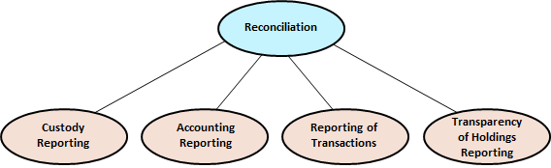

|  |  |
| --- | --- |
| Item | Description |
| Definition | Records (shares and cash) and account details on the books of a party are compared/matched and brought into conformity with the records and account details on the books of another party, through the identification of discrepancies, determination of the correct value for any item where a discrepancy exists, and modification of the books of one or both parties to result in the correct value enabling full reconciliation of both parties.   * Custody reporting * Accounting reporting * Transactions reporting * Transparency of holdings reporting: provides transparency and the breakdown structure of the underlying holdings through a chain of custodians of one or several financial instruments. |
| Trigger | * time period as defined in SLA * time period as defined by regulator * on request * completion of any transaction that affects account balances * corporate event |
| Pre-conditions | * both parties involved maintain records for an account that is recognisably the same account * both parties agree on the reconciliation process |
| Post-conditions | * parties agree (verbally, in writing) as to account details and balances, otherwise repeat process * reconciliation is completed |
| Role | Account servicer, account servicer |

Distribution

|  |  |
| --- | --- |
| Item | Description |
| Definition | The fund accountant calculates the benefits payable to the unit holders in the fund and announces it accordingly. The transfer agent/registrar/intermediary calculates at shareholder level the amount of distribution. The shareholder has instructed or will instruct to have the distribution paid in cash or reinvested. |
| Trigger | Entitlement date reached |
| Pre-conditions | * fund exists * prospectus dependent * decision by the fund company during the AGM to have a distribution |
| Post-conditions | * distribution is processed * payment of cash dividend and/or execution of the dividend reinvestment are initiated * tax reporting is initiated |
| Role | Account servicer |

Registration

|  |  |
| --- | --- |
| Item | Description |
| Definition | Process by which units are allocated/removed to/from the registrar. Process by which the legal status of the ownership is defined. |
| Trigger | Confirmation of a deal that is executed |
| Pre-conditions | * deal is executed * payment is received * an account is opened and all required legal documents are received |
| Post-conditions | * units are fully registered on the shareholder register * units are added or removed to or from the existing shareholder register |
| Role | Transfer agent |

# Description of BusinessActivities

This section presents the different BusinessActivities within each BusinessProcess. The BusinessActivities of a process are described with activity diagrams.

Legend

|  |  |  |
| --- | --- | --- |
| Symbol | Name | Definition |
|  | Start Point | Shows where the lifecycle of the business process commences. |
|  | End Point | Shows where the lifecycle of the business process may ends. |
|  | Lozenge (or diamond) | Indicates that a choice between several actions can be made. |
|  | Bar | Indicates that several actions are initiated in parallel. |

## Account Administration

### Account Opening

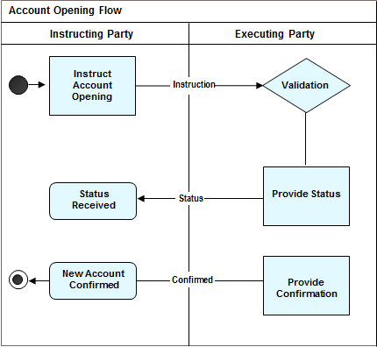

|  |  |  |
| --- | --- | --- |
| Step | Description | Initiator |
| Instruct Account Opening | An account opening instruction is sent by the instructing party to the executing party. The executing party may also be known as the registering party. | Instructing Party |
| Validate/Provide Status | The account opening instruction is validated, but if the account cannot be created immediately the executing party can send one or more status messages to the instructing party to keep it updated on progress so far. | Executing Party / Registering Party |
| Status Received | The instructing party receives an intermediate status to confirm receipt or updates of the account opening instruction. | Instructing Party |
| Provide Confirmation | If the instruction is accepted by the executing party, the details of the successfully opened account are sent by the executing party to the instructing party. | Executing Party / Registering Party |
| New Account Confirmed | The instructing party receives a confirmation that an account has been registered in the executing party/registering party’s records. | Instructing Party |

### Account Modification

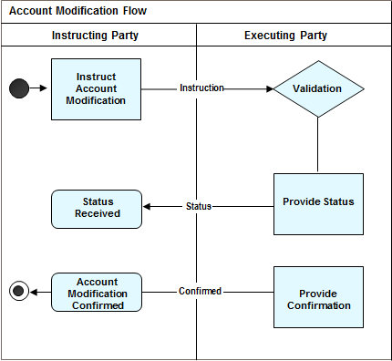

|  |  |  |
| --- | --- | --- |
| Step | Description | Initiator |
| Instruct Account Modification | The account modification instruction is sent to the executing party. The executing party may also be known as the registering party. | Instructing Party |
| Validate/Provide Status | The account modification instruction is validated and processed. The executing party can send one or more status messages to the instructing party to keep it updated on progress so far. | Executing Party / Registering Party |
| Status Received | The instructing party receives an intermediate status to confirm receipt or updates of the account opening instruction. | Instructing Party |
| Provide Confirmation | If the instruction is accepted by the executing party, the details of the successfully modified account are sent by the executing party to the instructing party. | Executing Party / Registering Party |

## Reporting

This example shows the reporting of prices.

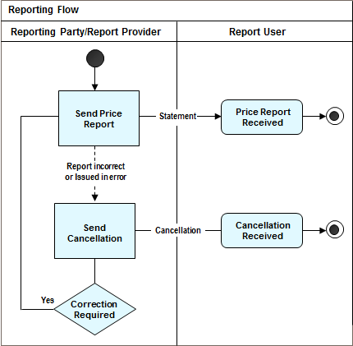

|  |  |  |
| --- | --- | --- |
| Step | Description | Initiator |
| Send Price Report | The reporting party sends a price report to the receiving party at the agreed frequency or in response to a request. | Reporting Party |
| Send Cancellation | If a price report is found to have been issued in error or contains incorrect information, a price report cancellation message is sent by the reporting party to the requesting party specifying the reason for cancellation. | Reporting Party |
| Send New Price Report | If the cancellation is because the price report contained incorrect information, the reporting party sends a new price report to the receiving party. | Reporting Party |

## Order Processing

The ordering party is also known as the instructing party.

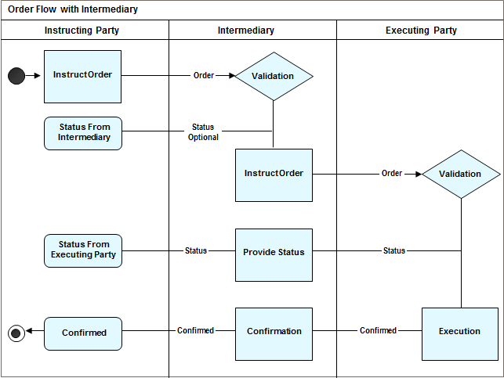

|  |  |  |
| --- | --- | --- |
| Step | Description | Initiator |
| Instruct Order | The instruction (subscription/redemption) order is sent by the instructing party to the Intermediary. | Instructing Party |
| Validation | The instruction (subscription/redemption) order is validated; the Intermediary can optionally send one or more status messages to the instructing party to keep them updated on progress so far. | Intermediary |
| Status From Intermediary | The instructing party receives an intermediate status to confirm receipt or updates of the instruction (subscription/redemption) order. | Instructing Party |
| Instruct Order | The instruction (subscription/redemption) order is sent by the intermediary to the executing party. | Intermediary |
| Validation | The instruction (subscription/redemption) order is validated; the executing party can optionally send one or more status messages to the intermediary to keep the intermediary updated on progress so far. | Executing Party |
| Provide Status | The intermediary can optionally send one or more status messages to the instructing party to keep the instructing updated on progress so far. | Intermediary |
| Status From Executing Party | The intermediary receives an intermediate status to confirm receipt or updates of the instruction (subscription/redemption) order. | Intermediary |
| Confirmation | If the instruction (subscription/redemption) order is accepted by the executing party, the details of the unit shares/price are notified by the executing party to the intermediary. | Executing Party |
| Confirmed | If the instruction (subscription/redemption) order is accepted by the executing party, the details of the unit shares/price are notified by the intermediary to the instructing party. | Intermediary |

## Reconciliation (Statements)

### Custody and Accounting

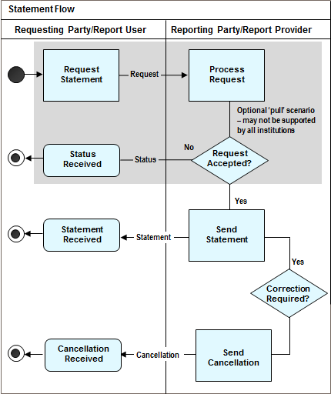

|  |  |  |
| --- | --- | --- |
| Step | Description | Initiator |
| Request Statement | The requesting party (where the "pull" scenario is supported), sends a request for a statement. | Requesting Party |
| Status Received | If the request is not accepted by the reporting party, it sends a status message to the requesting party rejecting the request and specifying the reason for the rejection. | Reporting Party |
| Send Statement | If the request is accepted by the reporting party, it sends a statement report to the requesting party in response to the request. In the "push" scenario, the reporting party sends a statement to the receiving party at the agreed frequency. | Reporting Party |
| Send Cancellation | If the statement is found to have been issued in error or contains incorrect information, a statement cancellation message is sent by the reporting party to the requesting/receiving party specifying the reason for cancellation. | Reporting Party |
| Send Statement | If the cancellation is because the statement contained incorrect information, the reporting party sends a new statement to the requesting/receiving party. | Reporting Party |

### Transparency of Holdings

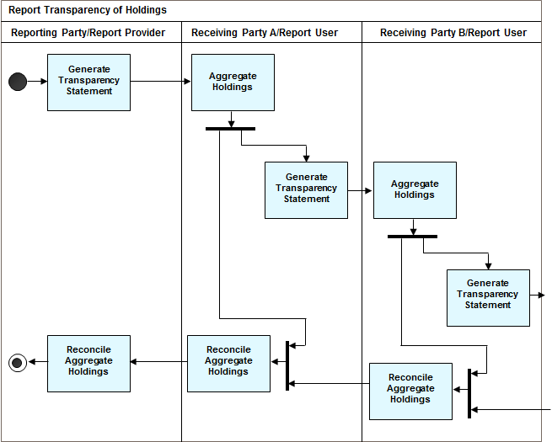

|  |  |  |
| --- | --- | --- |
| Step | Description | Initiator |
| Generate Transparency Statement | The reporting party generates a statement of the holdings containing all holdings reported  from customers to their custodian, “downstream” in the custody chain, providing transparency of holdings of customers of the customers and compiled with the customers’ inbound statements “upstream” in the custody chain, like a regular custody statement of holdings, from a custodian to their customers, aggregated with the inbound statements received from the respective customers and enriched with the same customer data as is reported to the fund company/transfer agent.  The purposes that the transparency of holdings statement has been designed for include:   * Disclosure of information about customers of customers * Verify/validate claims for retrocessions, rebates and commissions * Check compliance with laws, regulations and general terms and conditions. * Perform data analysis throughout custody chains, to identify geographic distribution patterns, measure the effects of targeted advertisement initiatives, and so on. | Reporting Party |
| Aggregate Holdings | Upon receipt of the Transparency of Holdings statement, the receiver combines data from its own books with the information received in the statement, and identifies any discrepancies to be reported as “account differences”. | Receiving Party (all levels) |
| Reconcile Aggregated Holdings | The receiver books all required updates in its own accounts for alignment. | Receiving Party (all levels) |

## Stock Transfers (Single Leg Transfer)

This scenario is based on the Securities Market Practice Group (SMPG) Investment Funds working group market practice.

The instructing party may be a transferor's bank or transferee's bank. The executing party may be the transfer agent.

There may be one an intermediary/transferee's custodian between the transferee's bank and the transfer agent. There may be one an intermediary/transferor's custodian between the transferor's bank and the transfer agent.

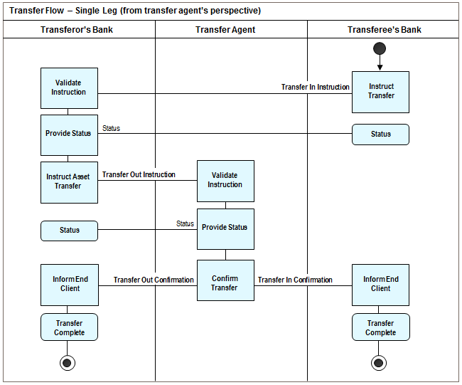

|  |  |  |
| --- | --- | --- |
| Step | Description | Initiator |
| Instruct Transfer | A transfer in instruction is sent by the transferee’s bank to the transferor's bank. The transferee's bank must have enough information to instruct the transfer | Transferee's Bank (Instructing Party) |
| Validate Instruction + provide Status | The transfer in instruction is validated, a transfer instruction status report is sent. | Transferor's Bank (Executing Party) |
| Instruct Transfer | A transfer out instruction is sent by the transferor’s bank to the transfer agent. | Transferor's Bank (Instructing Party) |
| Validate Instruction + provide Status | The transfer out instruction is validated, a transfer instruction status report is sent. |  |
| Confirm Transfer | The transfer out and transfer in confirmations are simultaneously sent by the transfer agent to the transferor’s bank and the transferee’s bank. | Transfer Agent |
| Inform End Client | The transferee's bank informs the end-client of the transfer. | Transferee's Bank (Executing Party) |
| Inform End Client | The transferor's bank informs the end-client of the transfer. | Transferor's Bank (Executing Party) |

## Portfolio and Stock Transfers (Single Leg)

The instructing party may be a transferor's bank, transferor's intermediary/custodian, transferee's bank or transferee's intermediary/custodian.

The executing party may be the transferor's intermediary/custodian, transferee's intermediary/custodian or transfer agent.

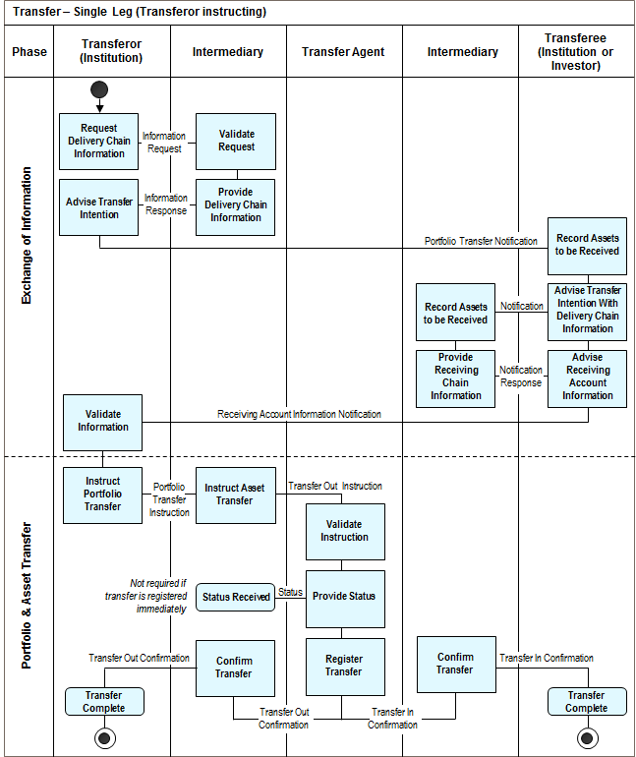

|  |  |  |
| --- | --- | --- |
| Step | Description | Initiator |
| Request Delivery Chain Information | The account holding information request is sent by the transferor. | Transferor |
| Provide Delivery Chain Information | The request is validated by the transferor’s Intermediary, who subsequently sends the delivery chain account holding information to the transferor. | Intermediary |
| Advise Transfer Intention | The transferor advises the transferee of its intention to transfer an investor’s portfolio, the delivery chain account information is provided. | Transferor |
| Record Asserts to be Received | The assets to be received are recorded by the transferee. The transferee requests its intermediary for the receiving chain account holding information. | Transferee |
| Record Asserts to be Received | The assets to be received are recorded by the transferee’s intermediary, who subsequently notifies the transferee of the receiving chain account holding information. | Intermediary |
| Advice Receiving Account Information | The transferee notifies the transferor of the receiving chain account holding information. | Transferee |
| Instruct Portfolio Transfer | The portfolio transfer instruction is sent by the transferor to its intermediary. | Transferor |
| Instruct Asset transfer | A transfer out instruction is sent by the transferor’s Intermediary to the transfer agent. | Intermediary |
| Provide Status | The transfer out instruction is validated by the transfer agent, who optionally sends a transfer instruction status report; if the transfer could not be registered immediately. | Transfer Agent |
| Confirm Transfer | The transfer out and transfer in confirmations are simultaneously sent by the transfer agent to the transferor’s intermediary and the transferee’s intermediary. | Transfer Agent |
| Confirm transfer | The transfer out confirmation is sent by the transferor’s intermediary to the transferor, while the transfer in confirmation is sent to the transferee’s intermediary to complete the stock transfer. | Intermediary |

## Portfolio and Stock Transfers (Double/Matched Leg)

The instructing party may be a transferor's bank, transferor's intermediary/custodian, transferee's bank or transferee's intermediary/custodian.

The executing party may be the transferor's intermediary/custodian, transferee's intermediary/custodian or transfer agent.

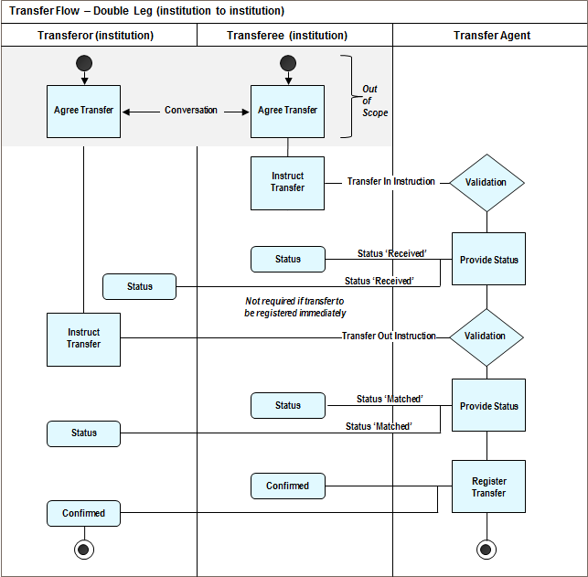

|  |  |  |
| --- | --- | --- |
| Step | Description | Initiator |
| Instruct Transfer | The transfer out instruction is sent by the transferor to the transferee’s transfer agent. | Transferor |
| Instruct Transfer | The transfer in instruction is sent by the transferee to its transfer agent. | Transferee |
| Provide Status | The transfer out and transfer in instructions are validated by the transfer agent, who sends first a transfer instruction status report with the status received to the transferor and transferee as soon as their instructions have been received and optionally a second transfer instruction status report with the status matched is sent to the transferor and transferee, if the transfer could not be registered immediately. | Transfer Agent |
| Confirmed | The transfer out and transfer in confirmations are simultaneously sent by the transfer agent to the transferor and the transferee to complete the transfer. | Transfer Agent |

# BusinessTransactions

This section describes the message flows based on the activity diagrams documented above. It shows the typical exchanges of information in the context of a BusinessTransaction.

## Account Management

This message flow section illustrates the use of the account management messages in typical message sequencing scenarios. The account management messages are exchanged between an account owner and an account servicer. There may be one or more intermediaries between the account owner and the account servicer.

The account owner is, for example, an investor or its designated agent. The account servicer is, for example, a registrar, transfer agent or custodian.

### Account Opening

#### Direct

The account owner sends an AccountOpeningInstruction message to the account servicer to request the opening of a new or supplementary account.

The account servicer may send an AccountManagementStatusReport message, with the status Received (RECE) or Accepted (ACCP), in response to the AccountOpeningInstruction message.

The account servicer sends an AccountDetailsConfirmation message to the account owner with the confirmation type code AccountOpening (ACCO) to confirm the opening of the account.

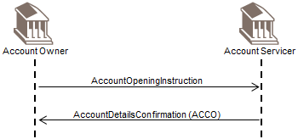

#### Intermediary

In a scenario involving an intermediary, the account owner sends an AccountOpeningInstruction message to an intermediary. The intermediary either forwards the message to another intermediary, or to the account servicer.

The intermediary may send an AccountManagementStatusReport message, with the status Received (RECE), Accepted (ACCP) or SentToNextParty (STNP), to the account owner, in response to the AccountOpeningInstruction message.

The account servicer may send an AccountManagementStatusReport message, with the status Received (RECE) or Accepted (ACCP), to the intermediary, in response to the AccountOpeningInstruction message.

The account servicer sends an AccountDetailsConfirmation message to the intermediary with the confirmation type code AccountOpening (ACCO) to confirm the opening of the account.. This intermediary, in turn, either forwards the AccountDetailsConfirmation message to the previous intermediary in the chain, or to the account owner.

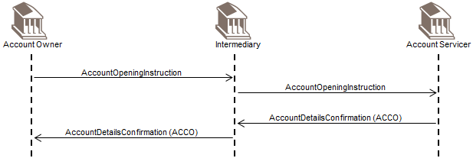

#### Rejection - Direct

If an AccountOpeningInstruction message is not compliant with an agreed SLA, then an AccountManagementStatusReport message is sent by the account servicer to the account owner with a rejected status and reason code.

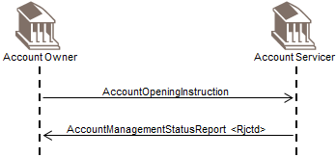

If there is no SLA between the account owner and servicer, or the linked reference is not recognised, a SecuritiesMessageRejection message is sent by the account servicer to the account owner.

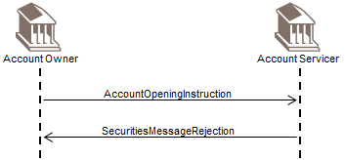

#### Rejection - Intermediary

If an AccountOpeningInstruction message is not compliant with an agreed SLA, and the scenario involves an intermediary, then the AccountManagementStatusReport message (with a rejected status and reason code) is forwarded by the intermediary to the account owner.

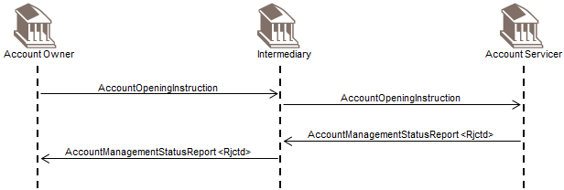

If there is no SLA between the account owner and servicer, or the linked reference is not recognised, a SecuritiesMessageRejection message is forwarded by the intermediary to the account owner.

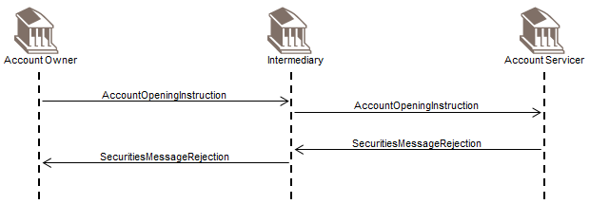

### Account Modification

#### Direct

The account owner sends an AccountModificationInstruction message to the account servicer to request the modification, that is, insertion, deletion, update, of account details.

The account servicer sends an AccountDetailsConfirmation message to the account owner with the confirmation type code AccountModification (ACCM) to confirm the modification of the account.

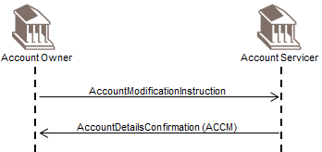

#### Intermediary

In the scenario involving an intermediary, the account owner sends an AccountModificationInstruction message to an intermediary. The intermediary either forwards the message to another intermediary, or to the account servicer. The account servicer sends an AccountDetailsConfirmation message to the intermediary from which the AccountModificationInstruction message was received. This intermediary then forwards the AccountDetailsConfirmation message to the previous intermediary in the chain, or to the account owner.

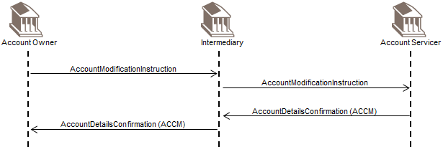

#### Rejection - Direct

If an AccountModificationInstruction message is not compliant with an agreed SLA, then an AccountManagementStatusReport message is sent by the account servicer to the account owner with a rejected status and reason code.

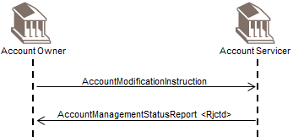

If there is no SLA between the account owner and servicer, or the linked reference is not recognised, a SecuritiesMessageRejection message is sent by the account servicer to the account owner.

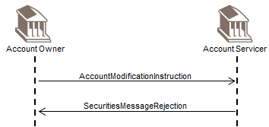

#### Rejection - Intermediary

If an AccountModificationInstruction message is not compliant with an agreed SLA, and the scenario involves an intermediary, then the AccountManagementStatusReport message (with a rejected status and reason code) is forwarded by the intermediary to the account owner.

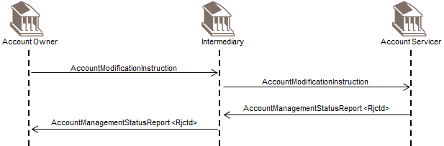

If there is no SLA between the account owner and servicer, or the linked reference is not recognised, a SecuritiesMessageRejection message is forwarded by the intermediary to the account owner.

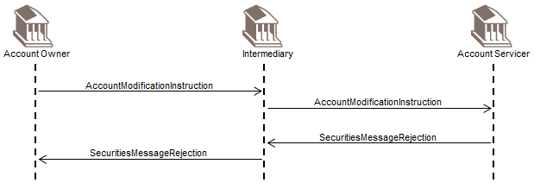

### Status of Account Opening - Direct

The account owner sends a RequestForAccountManagementStatusReport message to the account servicer to request the processing status of a previously sent AccountOpeningInstruction message for which an AccountDetailsConfirmation message has not yet been received.

The account servicer sends an AccountManagementStatusReport message to the account owner with the appropriate status code. More than one AccountManagementStatusReport message may sent to reflect the status as the status changes.

Once the AccountOpeningInstruction message has been successfully processed, the account servicer sends the AccountDetailsConfirmation message to the account owner.

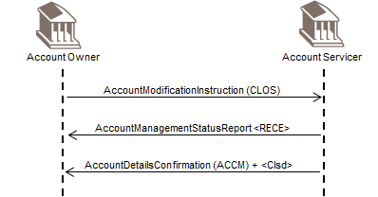

### Status of Account Modification – Direct

The account owner sends a RequestForAccountManagementStatusReport message to the account servicer to request the processing status of a previously sent AccountModificationInstruction message for which an AccountDetailsConfirmation message has not yet been received.

The account servicer sends an AccountManagementStatusReport message to the account owner with the appropriate status code. More than one AccountManagementStatusReport message may sent to reflect the status as the status changes.

Once the AccountModificationInstruction message has been successfully processed, the account servicer sends the AccountDetailsConfirmation message to the account owner.

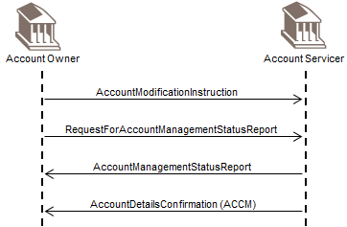

### Status of Account Opening - Intermediary

In a scenario involving an intermediary, the account owner sends a RequestForAccountManagementStatusReport message to an intermediary to request the processing status of a previously sent AccountOpeningInstruction message for which an AccountDetailsConfirmation message has not yet been received. The intermediary either forwards the message to another intermediary, or to the account servicer.

The intermediary may also send an AccountManagementStatusReport message with the status SentToNextParty (STNP) to the account owner.

After the receipt of the RequestForAccountManagementStatusReport message, the account servicer sends an AccountManagementStatusReport message, with the appropriate status, to the intermediary. This intermediary in turn forwards the AccountManagementStatusReport message to the previous intermediary in the chain, or to the account owner.

Once the AccountOpeningInstruction message has been successfully processed, the account servicer sends the AccountDetailsConfirmation message to the intermediary. The intermediary either forwards the message to another intermediary in the chain, or to the account owner.

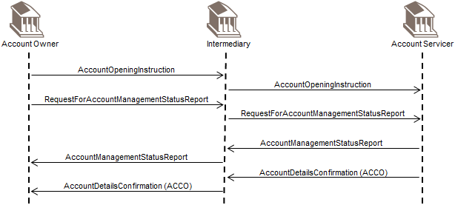

### Status of Account Modification - Intermediary

In a scenario involving an intermediary, the account owner sends a RequestForAccountManagementStatusReport message to an intermediary to request the processing status of a previously sent AccountModificationInstruction message for which an AccountDetailsConfirmation message has not yet been received. The intermediary either forwards the message to another intermediary, or to the account servicer.

The intermediary may also send an AccountManagementStatusReport message with the status SentToNextParty (STNP) to the account owner.

After the receipt of the RequestForAccountManagementStatusReport message, the account servicer sends an AccountManagementStatusReport message, with the appropriate status, to the intermediary. This intermediary in turn forwards the AccountManagementStatusReport message to the previous intermediary in the chain, or to the account owner.

Once the AccountModificationInstruction message has been successfully processed, the account servicer sends the AccountDetailsConfirmation message to the intermediary. The intermediary either forwards the message to another intermediary in the chain, or to the account owner.

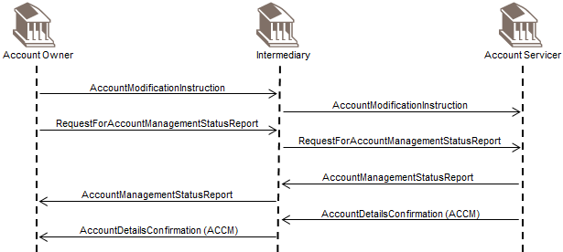

### Request for Account Management Status Rejection - Direct

If a RequestForAccountManagementStatusReport message is not compliant with an agreed SLA or if the account cannot be uniquely identified by the account servicer, then an AccountManagementStatusReport message with a rejected status and reason code is sent by the account servicer to the account owner.

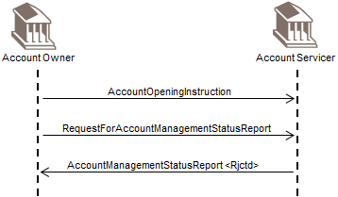

If there is no SLA between the account owner and servicer or the linked reference is not recognised, a SecuritiesMessageRejection message is sent by the account servicer to the account owner.

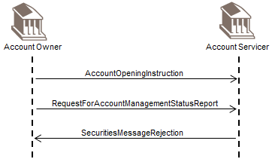

For scenarios involving an intermediary, the AccountManagementStatusReport message or the SecuritiesMessageRejection message is forwarded by the intermediary to the account owner.

### Account Closure - Direct

The account owner sends an AccountModificationInstruction message to the account servicer to instruct the closure of its account (AccountStatusUpdateInstruction/UpdateInstruction/Code is CLOS). The account servicer may respond with an AccountManagementStatusReport message with the status Received (RECE). When the account servicer has actioned the instruction, it sends an AccountDetailsConfirmation message with the confirmation type code AccountModification (ACCM) and confirms the account status is closed (InvestmentAccount/AccountStatus/Closed).

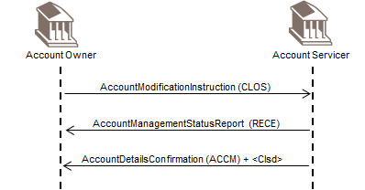

### Account Closure and Reactivation - Direct

The account owner sends an AccountModificationInstruction message to the account servicer to instruct the closure of its account (AccountStatusUpdateInstruction/UpdateInstruction/Code is CLOS). The account servicer may respond with an AccountManagementStatusReport message with the status Received (RECE). The account owner subsequently sends an AccountModificationInstruction message to instruct the reactivation of the account (AccountStatusUpdateInstruction/UpdateInstruction/Code is REAC).

When the account servicer has actioned the instruction, it sends an AccountDetailsConfirmation message with the confirmation type code AccountModification (ACCM) and confirms the account status is enabled (InvestmentAccount/AccountStatus/Enabled).

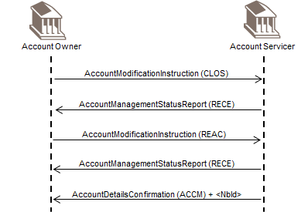

## Fund Cash Forecast Reporting

This message flow section illustrates the use of the fund cash forecast messages in typical message sequencing scenarios. The fund cash forecast messages are sent by a report provider to the report user.

The report provider is, for example, a fund accountant, transfer agent, market data provider, or any other interested party.

The report user is, for example, a fund management company, a transfer agent, market data provider, regulator or any other interested party.

The difference between estimated and confirmed cash forecast reports is that estimated reports are sent before the cut-off time and/or the price valuation, whereas confirmed cash forecast reports contain definitive prices.

The difference between detailed and non-detailed cash forecast reports is in the level of information that can be provided. In the detailed reports, the cash flow amounts can be sorted according to pre-defined or user-defined criteria and it is possible to breakdown cash forecast amounts by, for example, investment fund transaction types.

### Estimated and Confirmed Reporting

#### Estimated

The report provider sends a FundEstimatedCashForecastReport message to the report user.

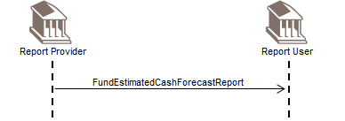

#### Estimated and Confirmed

The report provider sends a FundEstimatedCashForecastReport message to the report user.

As additional estimated information has become available, the report provider sends another FundEstimatedCashForecastReport message to the report user. This FundEstimatedCashForecastReport message overrides the previously sent report.

Later, when the cut-off time has been passed and/or the price valuation of the fund has been carried out, the report provider sends a FundConfirmedCashForecastReport message to the report user to inform the report user of the definitive cash flow movements for a specific financial instrument on a specific trade date.

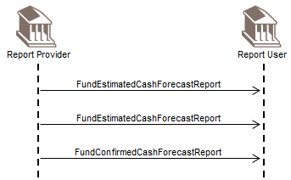

### Detailed Estimated and Confirmed

#### Detailed Estimated

The report provider sends a FundDetailedEstimatedCashForecastReport message to the report user.

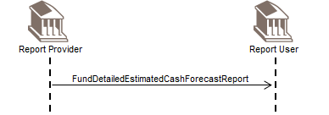

#### Detailed Estimated and Confirmed

The report provider sends a FundDetailedEstimatedCashForecastReport message to the report user.

As additional estimated information has become available, another FundDetailedEstimatedCashForecastReport message is sent to the report user. This FundDetailedEstimatedCashForecastReport message overrides the previously sent report.

As the cut-off time has been passed and/or the price valuation of the fund has been carried out, the report provider sends a FundDetailedConfirmedCashForecastReport message to the report user to inform the report user of the definitive cash flow movements for a specific financial instrument on a specific trade date.

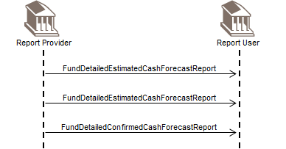

### Cancellation and New

#### Confirmed, Cancellation and New Confirmed

After the cut-off time and/or the price valuation of the fund, the report provider sends a FundConfirmedCashForecastReport message to the report user to inform the report user of the definitive cash flow movements for a specific financial instrument on a specific trade date.

As the FundConfirmedCashForecastReport message needs to be cancelled or amended, the report provider sends a FundConfirmedCashForecastReportCancellation message to the report user. Subsequently, the report provider sends a new FundConfirmedCashForecastReport message to the report user.

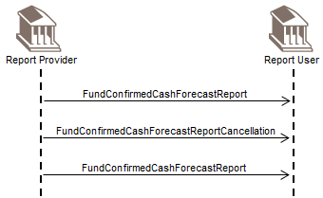

#### Detailed Confirmed, Cancellation and New Confirmed

After the cut-off time and/or the price valuation of the fund, the report provider sends a FundDetailedConfirmedCashForecastReport message to the report user to inform the report user of the definitive cash flow movements for a specific financial instrument on a specific trade date.

As the FundDetailedConfirmedCashForecastReport message needs to be cancelled or amended, the report provider sends a FundDetailedConfirmedCashForecastReportCancellation message to the report user. Subsequently, the report provider sends a new FundDetailedConfirmedCashForecastReport message to the report user.

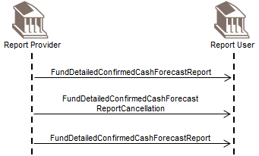

## Fund Reference Data Reporting

This message flow section illustrates the use of the fund reference data messages in typical message sequencing scenarios. The fund reference data reports are exchanged between a report provider and the report user.

The report provider is, for example, a fund promoter, fund management company, transfer agent or market data provider. The report user is, for example, a professional investor, investment fund distributor, market data provider, regulator or other interested party.

### Fund Reference Data Report – Solicited (requested)

The report user sends an InvestmentFundReportRequest message to the report provider.

In this scenario, the InvestmentFundReportRequest message is used to request a FundReferenceDataReport for a specific financial instrument.

Subsequently, the report provider responds by sending a FundReferenceDataReport message.

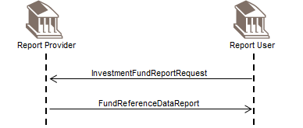

### Fund Reference Data Report – Unsolicited

The report provider sends a FundReferenceDataReport message to the report user.

The message is sent according to the Service Level Agreement (SLA) in place between the report provider and the report user.

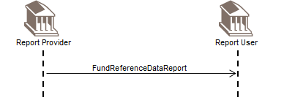

## Order and Confirmation

This message flow section illustrates the use of the order and confirmation messages in typical message sequencing scenarios. The different order instructions are sent by the instructing party to the executing party to instruct either a subscription, a redemption or a switch.

The order confirmation messages are sent by the executing party to the instructing party to the confirm the execution of a subscription or a redemption or a switch.

The order status messages are sent by the executing party to the instructing party to the provide the status of the order instructions. Use of this optional message is shown in the next section.

There may be one or more intermediaries in the transaction chain.

The instructing party is, for example, an investment manager. The executing party is, for example, a transfer agent.

The intermediary party is, for example, a distributor.

### Subscription

#### Direct

An instructing party sends a SubscriptionOrder message to the executing party.

To confirm execution of the order, the executing party sends a SubscriptionOrderConfirmation message to the instructing party.

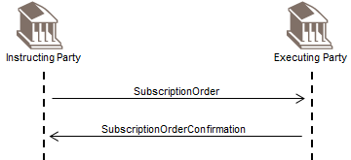

When more than one order is sent within the same order message, the response to the SubscriptionOrder message may be more than one SubscriptionOrderConfirmation message, as the valuation cycle of the financial instruments of each individual order may be different.

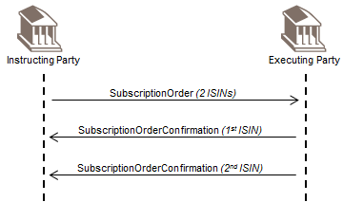

#### Intermediary

An instructing party sends a SubscriptionOrder message to the intermediary party. The intermediary party sends a SubscriptionOrder message to the executing party.

To confirm execution of the order, the executing party sends a SubscriptionOrderConfirmation message to the intermediary party. In turn, the intermediary party sends a SubscriptionOrderConfirmation message to the instructing party.

When more than one order is sent within the same order message, the response to the SubscriptionOrder message may be more than one SubscriptionOrderConfirmation message, as the valuation cycle of the financial instruments of each individual order may be different.

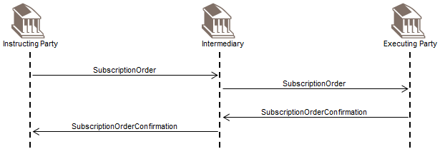

When more than one order is sent within the same order message, the response to the SubscriptionOrder message may be more than one SubscriptionOrderConfirmation message, as the valuation cycle of the financial instruments of each individual order may be different.

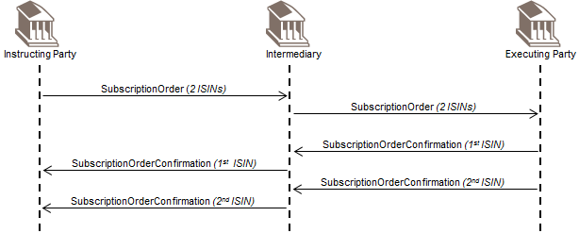

#### Bulk

Instructing party 1 sends a SubscriptionOrder to the intermediary party. Instructing party 2 sends a SubscriptionOrder to the intermediary party.

The intermediary party collects the individual orders. As the orders sent by instructing parties 1 and 2 are for the same financial instrument, the orders are grouped together and the intermediary sends a SubscriptionBulkOrder to the transfer agent.

The executing party sends a SubscriptionBulkOrderConfirmation to the intermediary party.

The intermediary party splits up the confirmation according to the originating chain of instructions and sends a SubscriptionOrderConfirmation to instructing party 1 and a SubscriptionOrderConfirmation to instructing party 2.

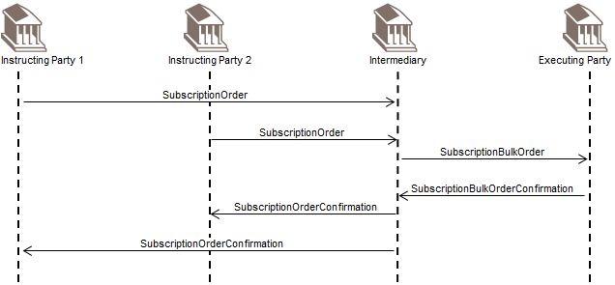

### Redemption

#### Direct

An instructing party sends a RedemptionOrder message to the executing party.

To confirm execution of the order, the executing party sends a RedemptionOrderConfirmation message to the instructing party.

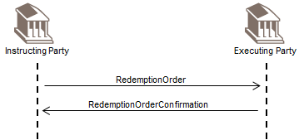

When more than one order is sent within the same order message, the response to the RedemptionOrder message may be more than one RedemptionOrderConfirmation message, as the valuation cycle of the financial instruments of each individual order may be different.

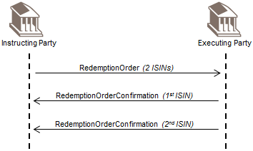

#### Intermediary

An instructing party sends a RedemptionOrder message to the intermediary party. The intermediary party sends a RedemptionOrder message to the executing party.

To confirm execution of the order, the executing party sends a RedemptionOrderConfirmation message to the intermediary party. In turn, the intermediary party sends a RedemptionOrderConfirmation message to the instructing party.

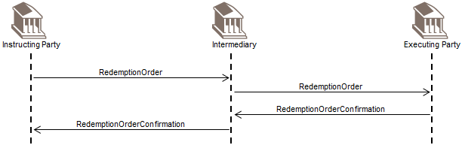

When more than one order is sent within the same order message, the response to the RedemptionOrder message may be more than one RedemptionOrderConfirmation message, as the valuation cycle of the financial instruments of each individual order may be different.

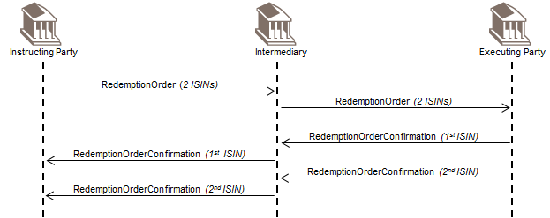

#### Bulk

Instructing party 1 sends a RedemptionOrder message to the intermediary party. Instructing party 2 sends a RedemptionOrder message to the intermediary party.

The intermediary party collects the individual orders. As the orders sent by instructing parties 1 and 2 are for the same financial instrument, the orders are grouped together and the intermediary party sends a RedemptionBulkOrder message to the executing party.

The executing party sends a RedemptionBulkOrderConfirmation message to the intermediary party.

The intermediary party splits up the confirmation according to the originating chain of instructions and sends a RedemptionOrderConfirmation message to instructing party 1 and a RedemptionOrderConfirmation message to instructing party 2.

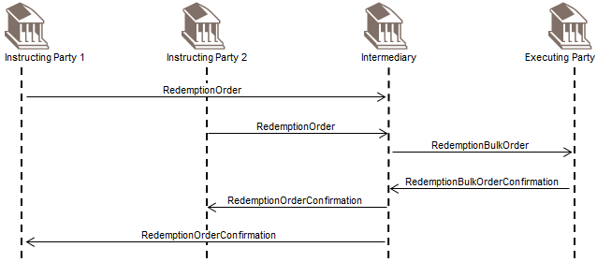

### Switch

#### Direct

The instructing party sends a SwitchOrder message to the executing party.

To confirm execution of the order, the executing party sends the SwitchOrderConfirmation message to the instructing party.

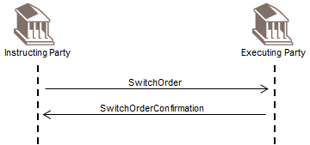

#### Intermediary

The instructing party sends a SwitchOrder message to the intermediary party. The intermediary party sends the SwitchOrder message to the executing party.

The executing party sends the SwitchOrderConfirmation message to the intermediary party. In turn, the intermediary party sends the SwitchOrderConfirmation message to the instructing party.

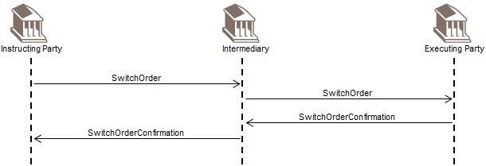

## Order Instruction Status Reporting

This message flow section illustrates the use of the OrderInstructionStatusReport message in typical message sequencing scenarios. The OrderInstructionStatusReport message is sent by the executing party to the instructing party. It is used to inform the instructing party of the status of its order/s or order message.

There may be one or more intermediaries in the transaction chain.

Different message flows may exist depending on the service level agreement (SLA). These include:

* how frequently an order instruction status message must be sent,
* when, and if, an order instruction status message must be sent at a pre-defined time (at cut-off time or once a day) or upon request,
* which statuses will be sent, for example, 'rejected only', 'received and rejected only’, ‘sent to next party’ and accepted only’.

The instructing party is, for example, an investment manager. The executing party is, for example, a transfer agent.

The intermediary party is, for example, a distributor.

### Subscription

#### Direct

The instructing party sends a SubscriptionOrder message to the executing party.

As the execution of the order in the SubscriptionOrder message is pending until there is enough cash in the account to pay for the subscription, the executing party responds with an OrderInstructionStatusReport message, with the status ConditionallyAccepted, and awaiting money.

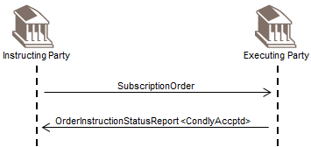

#### Intermediary

The instructing party sends a SubscriptionOrder message to the intermediary party. There may be more than one intermediary party in the transaction chain.

The intermediary party sends a SubscriptionOrder message to the executing party.

The intermediary sends an OrderInstructionStatusReport message, with the status SentToNextParty (STNP) or Received (RECE), to the instructing party.

As the intermediary party and the executing party have a service level agreement (SLA) that states the executing party will always send a status, the executing party responds to the SubscriptionOrder message by sending an OrderInstructionStatusReport message, with the status Accepted (PACK), to the intermediary.

Likewise, the intermediary party sends a OrderInstructionStatusReport message, with the status Accepted (PACK), to the instructing party.

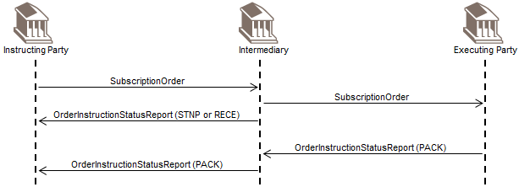

#### Bulk

Instructing party 1 sends a SubscriptionOrder message to the intermediary party. Instructing party 2 sends a SubscriptionOrder to the intermediary party.

There may be more than two instructing parties sending SubscriptionOrder messages to the intermediary party.

The intermediary party collects the individual orders. As the orders sent by instructing parties 1 and 2 are for the same financial instrument, the orders are grouped together and the intermediary sends a SubscriptionBulkOrder message to the executing party.

The intermediary sends OrderInstructionStatusReport messages, with the status Received (RECE) or SentToNextParty (STNP), to instructing party 1 and instructing party 2.

When the orders in the bulk have been accepted, the executing party responds with an OrderInstructionStatusReport message, with the status Accepted (PACK), to the intermediary party.

Likewise, the intermediary sends OrderInstructionStatusReport messages, with the status Accepted (PACK), to instructing party 1 and instructing party 2.

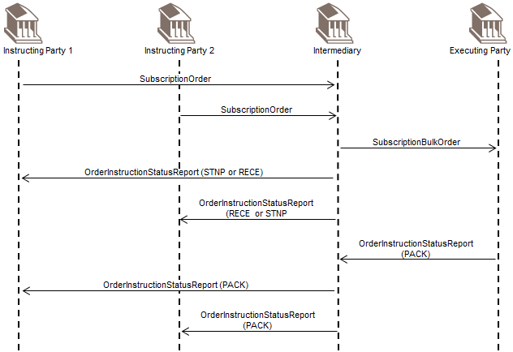

### Redemption

#### Direct

An instructing party sends a RedemptionOrder message to the executing party.

When the order in the RedemptionOrder message has been accepted, the executing party sends an OrderInstructionStatusReport message, with the status Accepted (PACK).

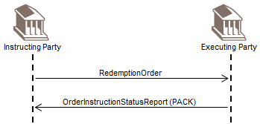

#### Intermediary

The instructing party sends a RedemptionOrder message to the intermediary party. There may be more than one intermediary party in the transaction chain.

The intermediary party sends a RedemptionOrder message to the executing party.

The intermediary sends an OrderInstructionStatusReport message, with the status SentToNextParty (STNP) or Received (RECE), to the instructing party

As the intermediary party and the executing party have a service level agreement (SLA) that states the executing party will always send a status, the executing party responds to the RedemptionOrder message by sending an OrderInstructionStatusReport message, with the status Accepted (PACK), to the intermediary.

Likewise, the intermediary party sends a OrderInstructionStatusReport message, with the status Accepted (PACK), to the instructing party.

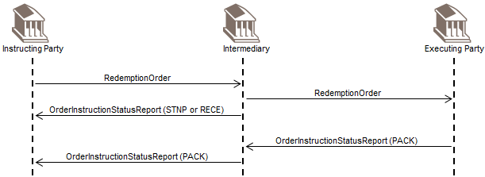

#### Bulk

Instructing party 1 sends a RedemptionOrder message to the intermediary party. Instructing party 2 sends a RedemptionOrder message to the intermediary party.

There may be more than two instructing parties sending RedemptionOrder messages to the intermediary party.

The intermediary party collects the individual orders. As the orders sent by instructing parties 1 and 2 are for the same financial instrument, the orders are grouped together and the intermediary sends a RedemptionBulkOrder message to the executing party.

The intermediary sends an OrderInstructionStatusReport messages, with the status Received (RECE) or SentToNextParty (STNP), to instructing party 1 and instructing party 2.

When the orders in the bulk have been accepted, the executing party responds with an OrderInstructionStatusReport message, with the status Accepted (PACK) to the intermediary party.

Likewise, the intermediary sends an OrderInstructionStatusReport messages, with the status Accepted (PACK), to instructing party 1 and instructing party 2.

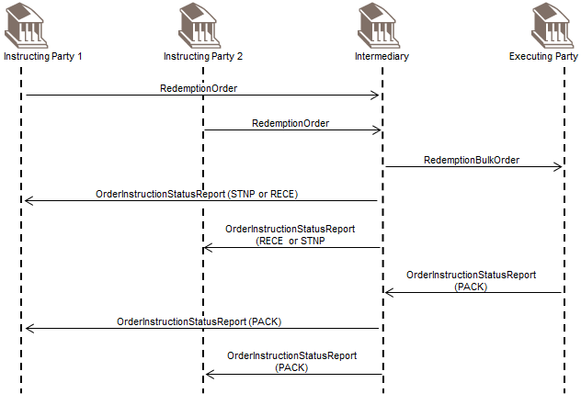

### Switch

#### Direct

The instructing party sends a SwitchOrder message to the executing party.

When the SwitchOrder message has been accepted, the executing party responds with an OrderInstructionStatusReport message, with the status Accepted (PACK).

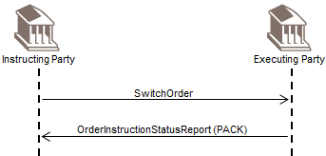

#### Intermediary

The instructing party sends a SwitchOrder message to the intermediary party. There may be more than one intermediary party in the transaction chain.

The intermediary party sends a SwitchOrder message to the executing party.

The intermediary sends an OrderInstructionStatusReport message, with the status SentToNextParty (STNP) or Received (RECE), to the instructing party.

As the switch order has been accepted, but not yet executed, the executing party responds to the SwitchOrder by sending a an OrderInstructionStatusReport message, with the status Accepted (PACK), to the intermediary party. In turn, the intermediary party sends an OrderInstructionStatusReport message, with the status Accepted (PACK), to the instructing party.

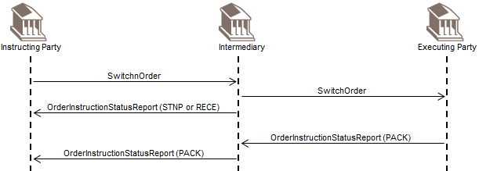

### Order Instruction Status Request

#### Request Status of Subscription

The instructing party sends a SubscriptionOrder message to the executing party.

Subsequently, the instructing party wants to know the status of its subscription order and sends a RequestForOrderStatusReport message.

The executing party responds by sending an OrderInstructionStatusReport message, with, for example, the status Accepted (PACK).

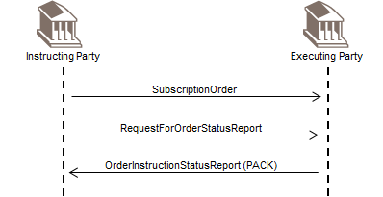

#### Request Status of Redemption

The instructing party sends a RedemptionOrder message to the executing party.

Subsequently, the instructing party wants to know the status of its redemption order and sends a RequestForOrderStatusReport message.

The executing party responds by sending an OrderInstructionStatusReport message , with, for example, the status Accepted (PACK).

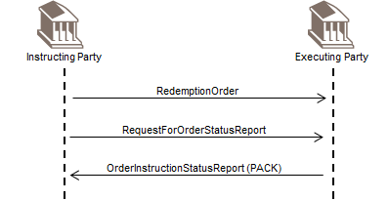

#### Request Status of Switch

The instructing party sends a SwitchOrder message to the executing party.

Subsequently, the instructing party wants to know the status of its switch order and sends a RequestForOrderStatusReport message.

The executing party responds by sending an OrderInstructionStatusReport message , with, for example, the status Accepted (PACK).

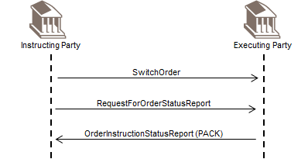

## Scenarios For Confirmations When 'Multiple’ Orders Specified in a Single Message

The SubscriptionOrder (setr.010), RedemptionOrder (setr.004), SubscriptionOrderConfirmation (setr.012) and RedemptionOrderConfirmation (setr.006) messages all allow the specification of one or more individual orders or order executions for the same investment account.

The following section shows the various possibilities.

[1] Some institutions send more than one individual order per message. Most institutions, on receipt of a ‘multiple’ order will respond with individual status and confirmation messages:

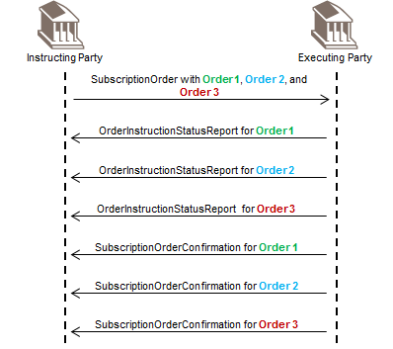

[2] Some institutions send more than one individual order per message. Some institutions will send back a single confirmation message with all the executions for the order:

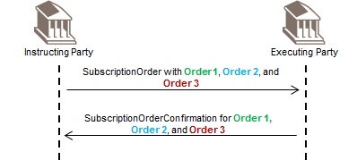

The OrderInstructionStatusReport (setr.016) message is not shown on the diagram.

This means the ‘order executing party' will wait until all orders are executed and then send a single SubscriptionOrderConfirmation (setr.012) message with the three individual executions. Because the trade dates may be different this could mean a delay for those orders that are executed on an earlier trade date.

[3] Some institutions offer full flexibility and will, for example, send a ‘combination’ depending on the trade date cycles of the investment funds in the order message.

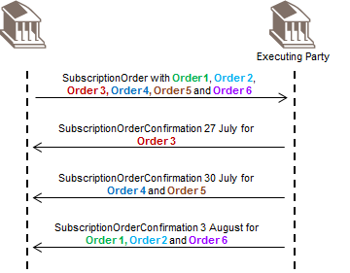

The OrderInstructionStatusReport (setr.016) message is not shown on the diagram.

An institution could decide ‘it’s always single a confirmation message per order’ or the institution could offer flexibility.

## Order Cancellation and Status

This message flow section illustrates the use of the order cancellation messages in typical message sequencing scenarios. The different order cancellation request messages are sent by the instructing party to the executing party. There may be one or more intermediaries in the transaction chain.

The OrderCancellationStatusReport message is sent by the executing party to the instructing party to inform the instructing party of the acceptance or rejection of an order cancellation request message that was previously sent by the instructing party.

The deadline and acceptance of an order cancellation request message is subject to a service level agreement (SLA).

Depending on the scenario, the executing party will verify whether:

* it is legally possible to cancel the order,
* the party that initiated the cancellation request has the right to do so,
* the cancellation request is allowed by the service level agreement (SLA).

The instructing party is, for example, an investment manager. The executing party is, for example, a transfer agent.

The intermediary party is, for example, an distributor.

### Subscription

#### Request and Status - Direct

The instructing party sends a SubscriptionOrder message to the executing party.

Subsequently, the instructing party sends a SubscriptionOrderCancellationRequest message to the executing party. As it is possible to cancel the order, the executing party responds by sending an OrderCancellationStatusReport message, with the status CancellationCompleted (CAND), to the instructing party.

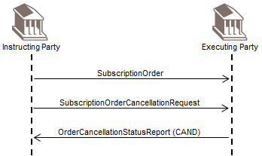

#### Request and Status - Intermediary

The instructing party sends a SubscriptionOrder message to the intermediary party. The intermediary party sends a SubscriptionOrder message to the executing party.

Subsequently, the instructing party sends a SubscriptionOrderCancellationRequest message to the intermediary party. The intermediary party sends a SubscriptionOrderCancellationRequest message to the executing party.

The executing party responds by sending an OrderCancellationStatusReport message, with the status CancellationCompleted (CAND), to the intermediary party. In turn, the intermediary party sends an OrderCancellationStatusReport message, with the status CancellationCompleted (CAND), to the instructing party.

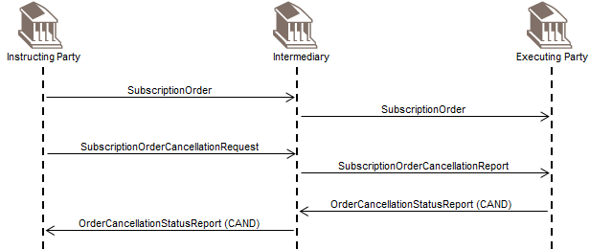

#### Request and Status - Bulk

Instructing party 1 sends a SubscriptionOrder message to the intermediary party. Instructing party 2 sends a SubscriptionOrder message to the intermediary party. There may be many instructing parties sending subscription orders to the intermediary party.

The intermediary party collects the individual orders. As the orders sent by instructing parties 1 and 2 are for the same financial instrument, the orders are grouped together and the intermediary sends a SubscriptionBulkOrder message to the executing party.

Subsequently, instructing party 1 sends a SubscriptionOrderCancellationRequest message to the intermediary party. In turn, the intermediary party sends a SubscriptionBulkOrderCancellationRequest message to the executing party.

As the bulk order has not yet been executed, the executing party effects the cancellation and sends an OrderCancellationStatusReport message, with the status CancellationCompleted (CAND), to the intermediary party.

The SubscriptionBulkOrderCancellationRequest message cancels the entire previously sent bulk order message, therefore, the intermediary party sends a SubscriptionBulkOrder message to re-instruct the order from instructing party 2 (and orders from other instructing parties for the same financial instrument).

After the intermediary party cancels the order of instructing party 1, the intermediary party sends an OrderCancellationStatusReport message, with the status CancellationCompleted (CAND), to instructing party 1.

Later, when the new bulk order has been executed, the executing party sends a SubscriptionBulkOrderConfirmation message to the intermediary party. In turn, the intermediary party sends a SubscriptionOrderConfirmation message to instructing party 2.

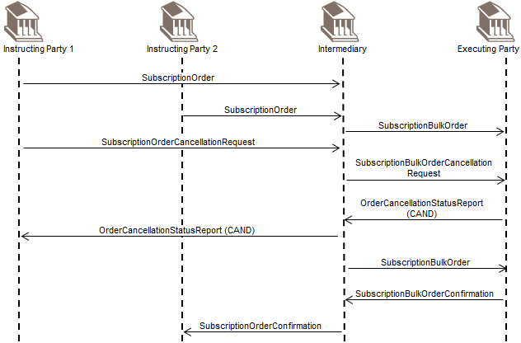

### Redemption

#### Request and Status - Direct

The instructing party sends a RedemptionOrder message to the executing party.

Subsequently, the instructing party sends a RedemptionOrderCancellationRequest message to the executing party.

As it is possible to cancel the order, the executing party responds by sending an OrderCancellationStatusReport message, with the status CancellationCompleted (CAND), to the instructing party.

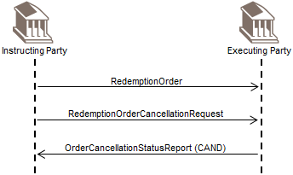

#### Request and Status - Intermediary

The instructing party sends a RedemptionOrder message to the intermediary party. The intermediary party sends a RedemptionOrder message to the executing party.

Subsequently, the instructing party sends a RedemptionOrderCancellationRequest message to the intermediary party. The intermediary party sends a RedemptionOrderCancellationRequest message to the executing party.

The executing party responds by sending an OrderCancellationStatusReport message, with the status CancellationCompleted (CAND), to the intermediary party. In turn, the intermediary party sends an OrderCancellationStatusReport message, with the status CancellationCompleted (CAND), to the instructing party.

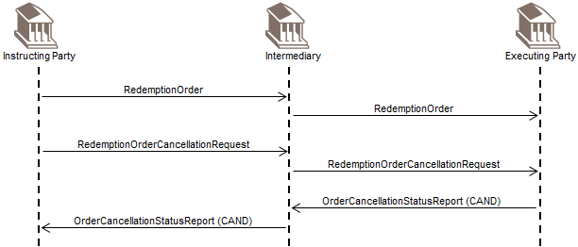

#### Request and Status - Bulk

Instructing party 1 sends a RedemptionOrder message to the intermediary party. Instructing party 2 sends a RedemptionOrder message to the intermediary party. There may be many instructing parties sending redemption orders to the intermediary party.

The intermediary party collects the individual orders. As the orders sent by instructing parties 1 and 2 are for the same financial instrument, the orders are grouped together and the intermediary sends a RedemptionBulkOrder message to the executing party.

Subsequently, instructing party 1 sends a RedemptionOrderCancellationRequest message to the intermediary party. In turn, the intermediary party sends a RedemptionBulkOrderCancellationRequest message to the executing party.

As the bulk order has not yet been executed, the executing party effects the cancellation and sends an OrderCancellationStatusReport message, with the status CancellationCompleted (CAND), to the intermediary party.

The RedemptionBulkOrderCancellationRequest message cancels the entire previously sent bulk order message, therefore, the intermediary party sends a RedemptionBulkOrder to re-instruct the order from instructing party 2 (and orders from other instructing parties for the same financial instrument).

After the intermediary party cancels the order of instructing party 1, the intermediary party sends an OrderCancellationStatusReport message, with the status CancellationCompleted (CAND), to instructing party 1.

Later, when the new bulk order has been executed, the executing party sends a RedemptionBulkOrderConfirmation message to the intermediary party. In turn, the intermediary party sends a RedemptionOrderConfirmation message to instructing party 2.

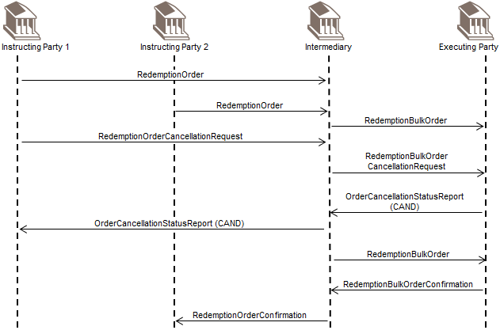

### Switch

#### Request and Status - Direct

The instructing party sends a SwitchOrder message to the executing party.

Subsequently, the instructing party sends a SwitchOrderCancellationRequest message to the executing party. The executing party responds by sending an OrderCancellationStatusReport message, with the status CancellationCompleted (CAND), to the instructing party.

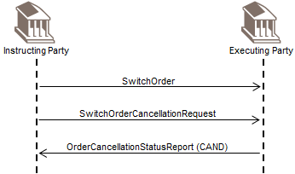

#### Request and Status - Intermediary

The instructing party sends a SwitchOrder message to the intermediary party. The intermediary party sends the SwitchOrder message to the executing party.

Subsequently, the instructing party sends a SwitchOrderCancellationRequest message to the intermediary party. The intermediary party sends the SwitchOrderCancellationRequest message to the executing party.

The executing party responds by sending an OrderCancellationStatusReport message, with the status CancellationCompleted (CAND), to the intermediary party. In turn, the intermediary party sends an OrderCancellationStatusReport message, with the status CancellationCompleted (CAND), to the instructing party.

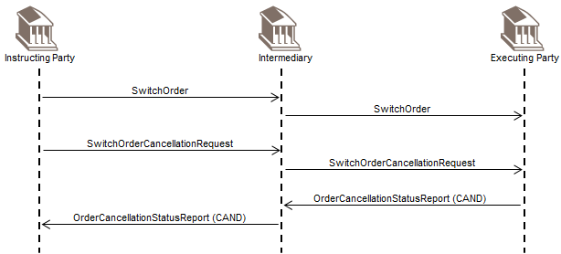

### Order Cancellation Status Request

The RequestForOrderStatusReport message is sent by the instructing party to the executing party. It is used to request the status of one or several order messages and/or order cancellation instruction messages.

The reply to the RequestForOrderStatusReport message is one of the following:

* an OrderInstructionStatusReport, or,
* an OrderCancellationStatusReport.

The scenarios below focus on cases where a OrderCancellationStatusReport message is used.

#### Request Status of Subscription

An instructing party sends a SubscriptionOrder message to the executing party.

Subsequently, the instructing party sends a SubscriptionOrderCancellationRequest message to the executing party.

Later, the instructing party sends a RequestForOrderStatusReport message to find out the status of its cancellation request.

As the executing party has now effected the cancellation, it sends an OrderCancellationStatusReport message, with the status CancellationCompleted (CAND), to the instructing party.

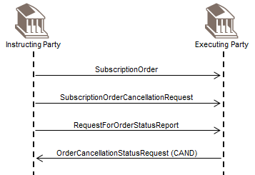

#### Request Status of Redemption

An instructing party sends a RedemptionOrder message to the executing party.

Subsequently, the instructing party sends a RedemptionOrderCancellationRequest message to the executing party.

Later, the instructing party sends a RequestForOrderStatusReport message to find out the status of its cancellation request.

As the executing party has now effected the cancellation, it sends an OrderCancellationStatusReport message, with the status CancellationCompleted (CAND), to the instructing party.

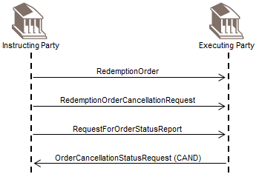

#### Status Request Rejected

The instructing party sends a RedemptionOrder message to the executing party.

Subsequently the instructing party sends a RedemptionOrderCancellationRequest message to the executing party.

As the executing party does not recognise the reference in the RedemptionOrderCancellationRequest message, it responds with a SecuritiesMessageRejection message, with the reason InvalidOrUnrecognisedReference.

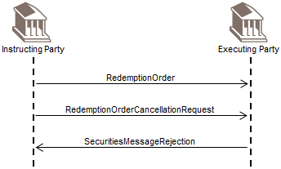

#### Request Status of Switch

An instructing party sends a SwitchOrder message to the executing party.

Subsequently, the instructing party sends a SwitchOrderCancellationRequest message to the executing party.

Later, the instructing party sends a RequestForOrderStatusReport message to find out the status of its cancellation request.

As the executing party has now effected the cancellation, it sends an OrderCancellationStatusReport message, with the status CancellationCompleted (CAND), to the instructing party.

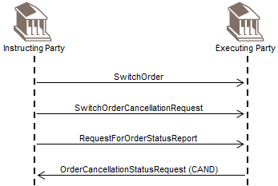

## Order Confirmation Status Reporting

This message flow section illustrates the use of the OrderConfirmationStatusReport message in typical message sequencing scenarios. The OrderConfirmationStatusReport message is sent by the instructing party to the executing party to provide the status of a subscription, redemption or switch confirmation or confirmation amendment.

There may be one or more intermediaries in the transaction chain.

The instructing party is, for example, an investment manager. The executing party is, for example, a transfer agent.

The intermediary party is, for example, a distributor.

### Subscription

The instructing party sends a SubscriptionOrder message to the executing party.

After execution of the order, the executing party sends a SubscriptionOrderConfirmation message to the instructing party.

As the executing party has quoted an order reference that is not recognised, the instructing party sends an OrderConfirmationStatusReport message to inform that the confirmation message is rejected.

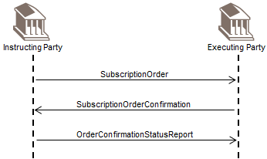

### Redemption

An instructing party sends a RedemptionOrder message to the executing party.

After execution of the order, the executing party sends a RedemptionOrderConfirmation message to the instructing party.

As the executing party has quoted an order reference that is not recognised, the instructing party sends an OrderConfirmationStatusReport message to inform that the confirmation message is rejected.

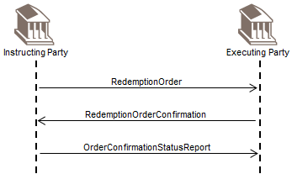

### Switch

The instructing party sends a SwitchOrder message to the executing party.

After execution of the order, the executing party sends a SwitchOrderConfirmation message to the instructing party.

As the executing party has quoted an order reference that is not recognised, the instructing party sends an OrderConfirmationStatusReport message to inform that the confirmation message is rejected.

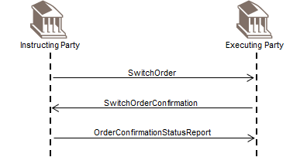

## Order Confirmation Amendment

This message flow section illustrates the use of the messages for the amendment of an order confirmation in typical message sequencing scenarios.

More than one message detail can be amended. The order confirmation, when sent as an amendment (AmendmentIndicator set to 'true' or '1'), might follow an order confirmation cancellation instruction message, if, in the order confirmation cancellation instruction message, the AmendmentIndicator is set to 'true' or '1' (see sequence diagrams related to order confirmation cancellation instruction messages).

The instructing party is, for example, an investment manager. The executing party is, for example, a transfer agent.

The intermediary party is, for example, a distributor.

There may be one or more intermediaries in the transaction chain

### Subscription

#### Direct

An instructing party sends a SubscriptionOrder message to the executing party.

To confirm execution of the order, the executing party sends a SubscriptionOrderConfirmation message to the instructing party.

As an amendment has to be made to the SubscriptionOrderConfirmation message details, another SubscriptionOrderConfirmation is sent with the AmendmentIndicator set to 'true' or '1'.

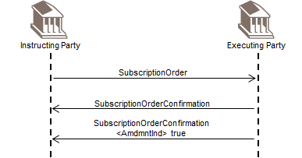

#### Intermediary

An instructing party sends a SubscriptionOrder message to the intermediary party. In turn, the intermediary party sends a SubscriptionOrder message to the executing party.

To confirm execution of the order, the executing party sends a SubscriptionOrderConfirmation message to the intermediary party. In turn, the intermediary party sends a SubscriptionOrderConfirmation message to the instructing party.

As an amendment has to be made to the SubscriptionOrderConfirmation message details, another SubscriptionOrderConfirmation is sent by the executing party to inform the intermediary about the amended details, with the AmendmentIndicator set to 'true' or '1'.

In turn, the intermediary party sends a SubscriptionOrderConfirmation message to the instructing party, with the AmendmentIndicator set to 'true' or '1'.

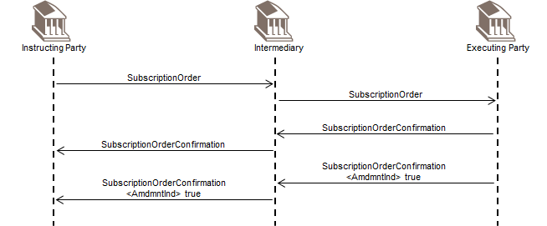

#### Bulk

Instructing party 1 sends a SubscriptionOrder message to the intermediary party. Instructing party 2 sends a SubscriptionOrder message to the intermediary party.

The intermediary party collects the individual orders. As the orders sent by instructing parties 1 and 2 are for the same financial instrument, the orders are grouped together and the intermediary sends a SubscriptionBulkOrder message to the transfer agent.

The executing party sends a SubscriptionBulkOrderConfirmation message to the intermediary party.

The intermediary party splits up the confirmation according to the originating chain of instructions and sends a SubscriptionOrderConfirmation message to instructing party 1 and a SubscriptionOrderConfirmation message to instructing party 2.

As an amendment has to be made to the SubscriptionBulkOrderConfirmation message details, another SubscriptionBulkOrderConfirmation message is sent by the executing party to inform the intermediary about the amended details, with the AmendmentIndicator set to 'true' or '1'.

In turn, the intermediary party splits up the confirmation message according to the originating chain of instructions and sends a SubscriptionOrderConfirmation message to instructing party 1 with the AmendmentIndicator set to 'true' or '1' and a SubscriptionOrderConfirmation message to instructing party 2 with the AmendmentIndicator set to 'true' or '1'.

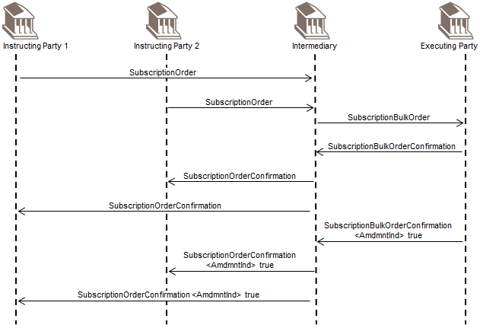

### Redemption

#### Direct

An instructing party sends a RedemptionOrder message to the executing party.

To confirm execution of the order, the executing party sends a RedemptionOrderConfirmation message to the instructing party.

As an amendment has to be made to the RedemptionOrderConfirmation message details, another RedemptionOrderConfirmation message is sent with the AmendmentIndicator set to 'true' or '1'

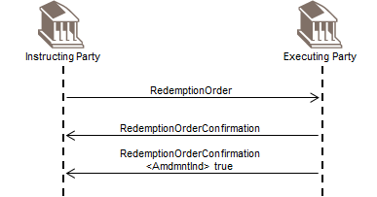

#### Intermediary

An instructing party sends a RedemptionOrder message to the intermediary party. In turn, the intermediary party sends a RedemptionOrder message to the executing party.

To confirm execution of the order, the executing party sends a RedemptionOrderConfirmation message to the intermediary party. In turn, the intermediary party sends a RedemptionOrderConfirmation message to the instructing party.

As an amendment has to be made to the RedemptionOrderConfirmation message details, another RedemptionOrderConfirmation message is sent by the executing party to inform the intermediary about the amended details, with the AmendmentIndicator set to 'true' or '1'.

In turn, the intermediary party sends a RedemptionOrderConfirmation message to the instructing party, with the AmendmentIndicator set to 'true' or '1'.

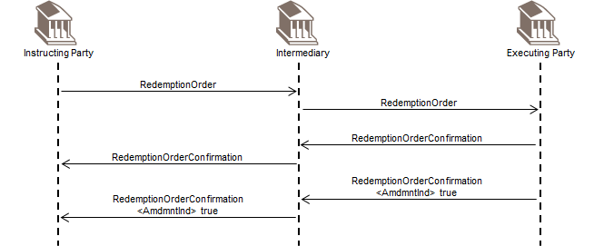

#### Bulk

Instructing party 1 sends a RedemptionOrder message to the intermediary party. Instructing party 2 sends a RedemptionOrder message to the intermediary party.

The intermediary party collects the individual orders. As the orders sent by instructing parties 1 and 2 are for the same financial instrument, the orders are grouped together and the intermediary sends a RedemptionBulkOrder message to the transfer agent.

The executing party sends a RedemptionBulkOrderConfirmation message to the intermediary party.

The intermediary party splits up the confirmation according to the originating chain of instructions and sends a RedemptionOrderConfirmation message to instructing party 1 and a RedemptionOrderConfirmation message to instructing party 2.

As an amendment has to be made to the RedemptionBulkOrderConfirmation message details, another RedemptionBulkOrderConfirmation message is sent by the executing party to inform the intermediary about the amended details, with the AmendmentIndicator set to 'true' or '1'..

In turn, the intermediary party splits up the confirmation message according to the originating chain of instructions and sends a RedemptionOrderConfirmation message to instructing party 1 with the AmendmentIndicator set to 'true' or '1' and a RedemptionOrderConfirmation message to instructing party 2 with the AmendmentIndicator set to 'true' or '1'.

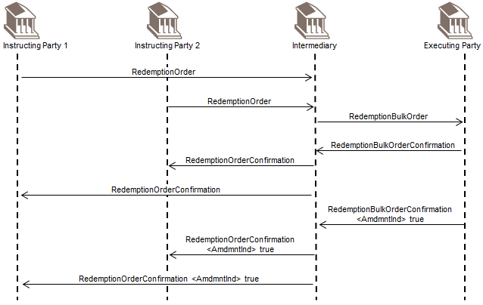

### Switch

#### Direct

The instructing party sends a SwitchOrder message to the executing party. The executing party sends the SwitchOrderConfirmation message to the instructing party.

As an amendment has to be made to the SwitchOrderConfirmation message details, another SwitchOrderConfirmation message is sent, with the AmendmentIndicator set to 'true' or '1'.

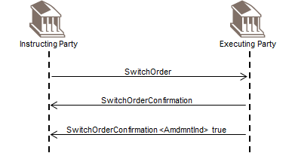

#### Intermediary

The instructing party sends a SwitchOrder message to the intermediary party. In turn, the intermediary party sends the SwitchOrder message to the executing party.

The executing party sends the SwitchOrderConfirmation message to the intermediary party. The intermediary party sends the SwitchOrderConfirmation message to the instructing party.

As an amendment has to be made to the SwitchOrderConfirmation message details, another SwitchOrderConfirmation message is sent by the executing party to inform the intermediary about the amended details, with the AmendmentIndicator set to 'true' or '1'.

In turn, the intermediary party sends a SwitchOrderConfirmation message to the instructing party, with the AmendmentIndicator set to 'true' or '1'.

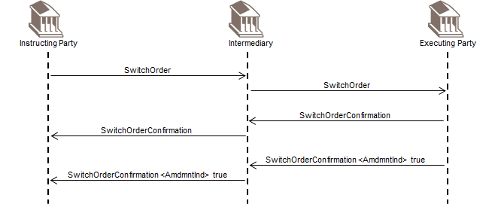

## Order Confirmation Cancellation

This message flow section illustrates the use of the order confirmation cancellation messages in typical message sequencing scenarios. The different order confirmation cancellation instruction messages are sent by the executing party to the instructing party to cancel a previously sent subscription, redemption or order confirmation message.

There may be one or more intermediaries in the transaction chain.

The order confirmation cancellation instruction message might be followed by an order confirmation message sent as an amendment (AmendmentIndicator set to 'true' or '1'), (see sequence diagrams related to order confirmation amendment).

The instructing party is, for example, an investment manager. The executing party is, for example, a transfer agent.

The intermediary party is, for example, a distributor.

### Subscription

#### Direct

An instructing party sends a SubscriptionOrder message to the executing party.

To confirm execution of the order, the executing party sends a SubscriptionOrderConfirmation message to the instructing party.

As the confirmation needs to be cancelled, a SubscriptionOrderConfirmationCancellationInstruction message is sent by the executing party to inform the instructing party.

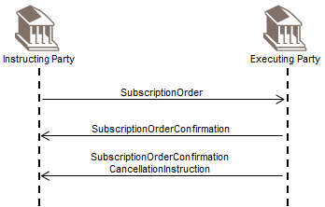

#### Intermediary

An instructing party sends a SubscriptionOrder message to the intermediary party. The intermediary party sends a SubscriptionOrder message to the executing party.

To confirm execution of the order, the executing party sends a SubscriptionOrderConfirmation message to the intermediary party. In turn, the intermediary party sends a SubscriptionOrderConfirmation message to the instructing party.

As the confirmation needs to be cancelled, SubscriptionOrderConfirmationCancellationInstruction message is sent by the executing party to inform the intermediary. In turn, the intermediary party sends a SubscriptionOrderConfirmationCancellationInstruction message to the instructing party.

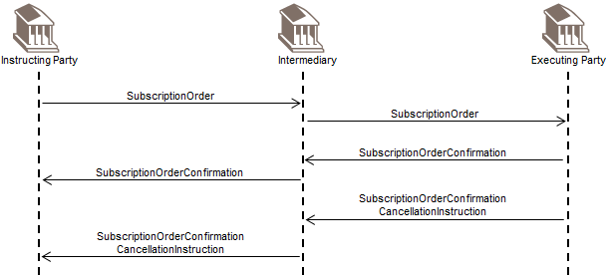

#### Bulk

Instructing party 1 sends a SubscriptionOrder message to the intermediary party. Instructing party 2 sends a SubscriptionOrder message to the intermediary party.

The intermediary party collects the individual orders. As the orders sent by instructing parties 1 and 2 are for the same financial instrument, the orders are grouped together and the intermediary sends a SubscriptionBulkOrder message to the transfer agent.

The executing party sends a SubscriptionBulkOrderConfirmation message to the intermediary party.

The intermediary party splits up the confirmation according to the originating chain of instructions and sends a SubscriptionOrderConfirmation message to instructing party 1 and a SubscriptionOrderConfirmation message to instructing party 2.

As the confirmation needs to be cancelled, a SubscriptionBulkOrderConfirmationCancellationInstruction message is sent by the executing party to inform the intermediary.

In turn, the intermediary party splits up the confirmation amendment message according to the originating chain of instructions and sends a SubscriptionOrderConfirmationCancellationInstruction message to instructing party 1 and a SubscriptionOrderConfirmationCancellationInstruction message to instructing party 2.

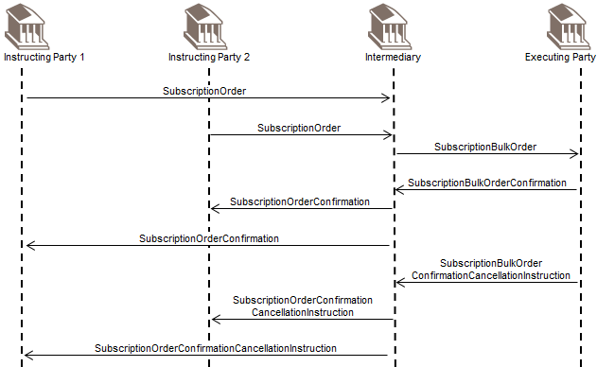

### Redemption

#### Direct

An instructing party sends a RedemptionOrder message to the executing party.

To confirm execution of the order, the executing party sends a RedemptionOrderConfirmation message to the instructing party.

As the confirmation needs to be cancelled, a RedemptionOrderConfirmationCancellationInstruction message is sent by the executing party to inform the instructing party.

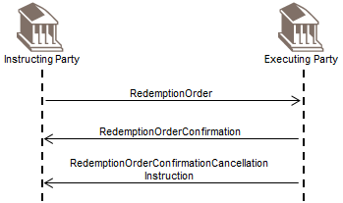

#### Intermediary

An instructing party sends a RedemptionOrder message to the intermediary party.

The intermediary party sends a RedemptionOrder to the executing party.

To confirm execution of the order, the executing party sends a RedemptionOrderConfirmation message to the intermediary party. In turn, the intermediary party sends a RedemptionOrderConfirmation message to the instructing party.

As the confirmation needs to be cancelled, a RedemptionOrderConfirmationCancellationInstruction message is sent by the executing party to inform the intermediary. In turn, the intermediary party sends a RedemptionOrderConfirmationCancellationInstruction message to the instructing party.

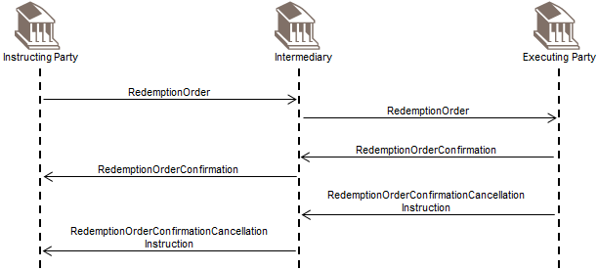

#### Bulk

Instructing party 1 sends a RedemptionOrder message to the intermediary party. Instructing party 2 sends a RedemptionOrder message to the intermediary party.

The intermediary party collects the individual orders. As the orders sent by instructing parties 1 and 2 are for the same financial instrument, the orders are grouped together and the intermediary sends a RedemptionBulkOrder message to the transfer agent.

The executing party sends a RedemptionBulkOrderConfirmation message to the intermediary party.

The intermediary party splits up the confirmation according to the originating chain of instructions and sends a RedemptionOrderConfirmation message to instructing party 1 and a RedemptionOrderConfirmation message to instructing party 2.

As the confirmation needs to be cancelled, a RedemptionBulkOrderConfirmationCancellationInstruction message is sent by the executing party to inform the intermediary.

In turn, the intermediary party splits up the confirmation amendment message according to the originating chain of instructions and sends a RedemptionOrderConfirmationCancellationInstruction message to instructing party 1 and a RedemptionOrderConfirmationCancellationInstruction message to instructing party 2

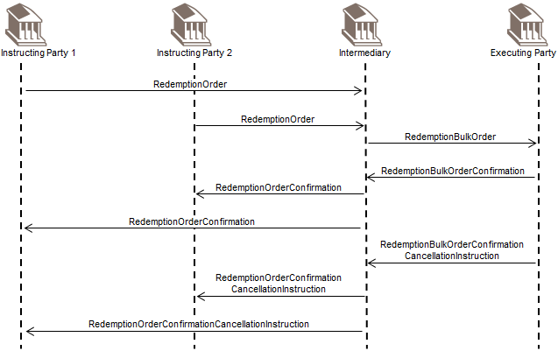

### Switch

#### Direct

The instructing party sends a SwitchOrder message to the executing party. The executing party sends the SwitchOrderConfirmation message to the instructing party.

As the confirmation needs to be cancelled, a SwitchOrderConfirmationCancellationInstruction message is sent by the executing party to inform the instructing party.

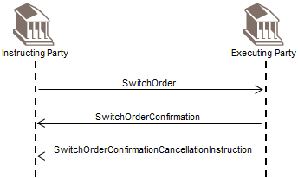

#### Intermediary

The instructing party sends a SwitchOrder message to the intermediary party.

The intermediary party sends the SwitchOrder message to the executing party.

The executing party sends the SwitchOrderConfirmation message to the intermediary party. The intermediary party sends the SwitchOrderConfirmation message to the instructing party.

As the confirmation needs to be cancelled, a SwitchOrderConfirmationCancellationInstruction message is sent by the executing party to inform the intermediary. In turn, the intermediary party sends a SwitchOrderConfirmationCancellationInstruction message to the instructing party.

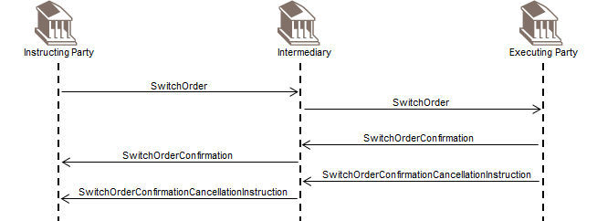

## Order Confirmation Status Request

This message flow section illustrates the use of the RequestForOrderConfirmationStatusReport message in typical message sequencing scenarios. The RequestForOrderConfirmationStatusReport message is sent by the executing party to the instructing party. It is used to request the status of one or several order confirmation messages. There may be one or more intermediaries in the transaction chain.

The reply to the RequestForOrderConfirmationStatusReport message is an OrderConfirmationStatusReport message.

The instructing party is, for example, an investment manager. The executing party is, for example, a transfer agent.

The intermediary party is, for example, a distributor.

### Subscription

An instructing party sends a SubscriptionOrder message to the executing party.

The executing party replies with a SubscriptionOrderConfirmation message.

As execution details need to be amended, the executing party sends another SubscriptionOrderConfirmation message, with the AmendmentIndicator set to 'true' or '1'.

Later, the executing party sends a RequestForOrderConfirmationStatusReport message to find out the status of its SubscriptionOrderConfirmation (amendment) message.

The instructing party sends an OrderConfirmationStatusReport message to the executing party, indicating the status of the SubscriptionOrderConfirmation (amendment) message is accepted.

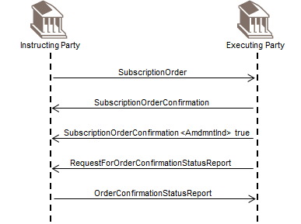

### Redemption

An instructing party sends a RedemptionOrder message to the executing party.

The executing party replies with a RedemptionOrderConfirmation message.

As execution details need to be amended, the executing party sends another RedemptionOrderConfirmation message, with the AmendmentIndicator set to 'true' or '1'.

Later, the executing party sends a RequestForOrderConfirmationStatusReport message to find out the status of its RedemptionOrderConfirmation message (amendment) message.

The instructing party sends an OrderConfirmationStatusReport message to the executing party, indicating the status of the RedemptionOrderConfirmation (amendment) message is accepted.

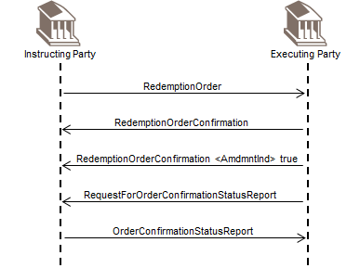

### Switch

An instructing party sends a SwitchOrder message to the executing party.

The executing party replies with a SwitchOrderConfirmation message.

As execution details need to be amended, the executing party sends another SwitchOrderConfirmation message with the AmendmentIndicator set to 'true' or '1'..

Later, the executing party sends a RequestForOrderConfirmationStatusReport message to find out the status of its SwitchOrderConfirmation (amendment) message.

The instructing party sends an OrderConfirmationStatusReport message to the executing party, indicating the status of the SwitchOrderConfirmation (amendment) is accepted.

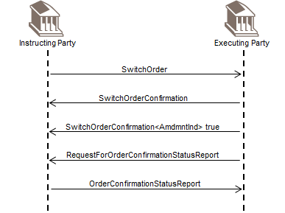

## Message Rejection

The SecuritiesMessageRejection message can be used to reject any securities message. One example of the use of the SecuritiesMessageRejection is illustrated below.

An instructing party sends a TransferOutInstruction message to the executing party.

Subsequently, the instructing party sends a RequestForTransferStatusReport message to the executing party but, for example, it misquotes the message reference of the TransferOutInstruction message.

The executing party cannot process the RequestForTransferStatusReport message because it does not know to which transfer instruction the instructing party is referring. Therefore, the executing party replies with a SecuritiesMessageRejection message with the reason 'UnknownOrInvalidReference'.

The message flow works in a similar way when a TransferInInstruction is sent and a transfer instruction status report is subsequently requested with, for example, a misquoted reference.

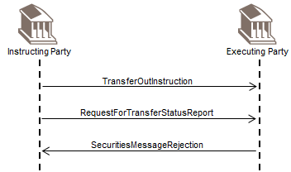

## Portfolio Transfer Management

This message flow section illustrates the use of the portfolio transfer messages in typical message sequencing scenarios. The portfolio transfer instruction and confirmation messages are exchanged between a transferee (new plan manager) and the transferor (old plan manager).

The PortfolioTransferInstruction message is sent by the transferee and may be accepted or rejected by the transferor. The transferor may report on the status of a PortfolioTransferInstruction message with the TransferInstructionStatusReport message.

The PortfolioTransferInstruction message may be cancelled by the transferee with the PortfolioTransferCancellationRequest message. The transferor may report on the status of a PortfolioTransferCancellationRequest message with the TransferInstructionStatusReport message.

The transferee may query the status of a previously sent PortfolioTransferInstruction message with a RequestForTransferStatusReport message.

### Discovery

A transferee (new plan manager or instructing party) sends the AccountHoldingInformationRequest message to the transferor (old plan manager or executing party) to request information about financial instruments held on behalf of the client.

The transferor responds by sending an AccountHoldingInformation message, containing the information requested.

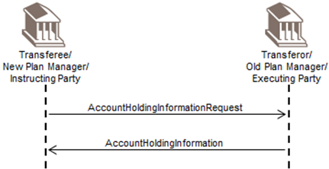

### Portfolio Transfer Instruction

A transferee (new plan manager or instructing party) sends the AccountHoldingInformationRequest message to the transferor (old plan manager or executing party) to request information about financial instruments held on behalf of the client.

The transferor responds by sending an AccountHoldingInformation message, specifying the individual products in the portfolio.

The transferee now instructs the transfer of the portfolio by sending a PortfolioTransferInstruction message to the transferor. This instructs the transfer of the individual products in the portfolio, such as fund units, cash, equities and other assets such as property. For each individual asset, the transferee will instruct one of the following:

* transfer 'as is' (in specie)
* liquidate and transfer as cash
* convert to another instrument and then transfer 'as is' (in specie).

The transferor sends a PortfolioTransferConfirmation message to confirm its intent to transfer the assets. The actual transfer and confirmation of the individual assets, if fund units, is carried out using the transfer out instruction and confirmation. If the portfolio contains cash, then there will be a payment flow. If an asset is to be liquidated and transferred as cash, there will be a redemption flow and a payment flow.

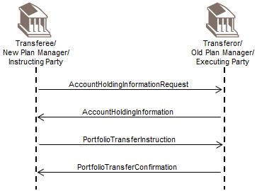

### Status

#### Rejected

A transferee (new plan manager or instructing party) sends a PortfolioTransferInstruction message to the transferor (old plan manager or executing party) to instruct the transfer the products held by an investor on an account serviced by the transferor.

The transferor sends a TransferInstructionStatusReport message with the status Rejected and a reason to advise that the request is rejected.

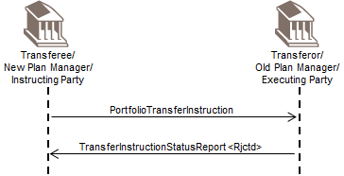

#### Request Status

A transferee (new plan manager or instructing party) sends a PortfolioTransferInstruction message to the transferor (old plan manager or executing party) to transfer the products held by an investor on an account serviced by the transferor.

Subsequently, the transferee sends a RequestForTransferStatusReport message to the transferor to request the status of its instruction.

The transferor replies with a TransferInstructionStatusReport message with the appropriate status, for example, Accepted (PACK).

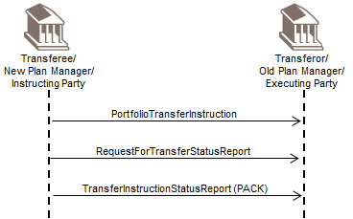

### Cancellation

#### Cancellation

A transferee (new plan manager or instructing party) sends a PortfolioTransferInstruction message to the transferor (old plan manager or executing party) to transfer the products held by an investor on an account serviced by the transferor.

Subsequently, the transferee sends a PortfolioTransferCancellationRequest message to the transferor to request the cancellation of the previously sent PortfolioTransferInstruction message.

The transferor replies with a TransferCancellationStatusReport message with the appropriate status, for example, Accepted (PACK).

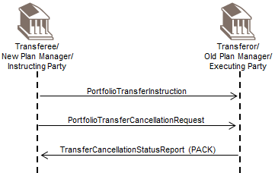

#### Rejected Cancellation - Invalid Reference

A transferee (new plan manager or instructing party) sends a PortfolioTransferInstruction message to the transferor (old plan manager or executing party) to transfer the products held by an investor on an account serviced by the transferor.

Subsequently, the transferee sends a PortfolioTransferCancellationRequest message to the transferor to request the cancellation of the previously sent PortfolioTransferInstruction message, but, for example, misquotes the message reference of the PortfolioTransferInstruction.

The transferor replies with a SecuritiesMessageRejection message containing the reason InvalidOrUnrecognisedReference.

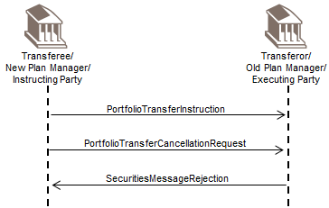

#### Rejected Cancellation – Already Executed

A transferee (new plan manager or instructing party) sends a PortfolioTransferInstruction message to the transferor (old plan manager or executing party) to transfer the products held by an investor on an account serviced by the transferor.

The transferor sends a PortfolioTransferConfirmation message to confirm that the products have been transferred to the nominee account.

Later, the transferee sends a PortfolioTransferCancellationRequest message to the transferor.

The transferor replies with a TransferCancellationStatusReport message containing the status Rejected with reason Already Executed (COSE).

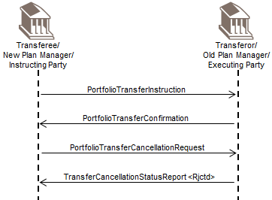

## Individual Asset Transfer

This message flow section illustrates the use of the transfer messages in typical message sequencing scenarios. The transfer instruction messages are sent by the instructing party to the executing party to instruct either a transfer out or a transfer in.

The transfer confirmation messages are sent by the executing party to the instructing party to confirm a transfer out or transfer in.

The transfer status messages are sent by the executing party to the instructing party to provide the status of the transfer instructions.

There may be one or more intermediaries in the transaction chain.

The instructing party is, for example, an investment manager. The executing party is, for example, a transfer agent.

### Own Account - Direct

An instructing party sends a TransferOutInstruction message to the executing party. The message requests the executing party to withdraw a quantity of financial instrument from one account the instructing party owns and deliver it to another account it also owns at the executing party.

As the transfer is an own account transfer, both parties have agreed that it is not necessary for the instructing party to send the executing party the corresponding TransferInInstruction message.

The executing party sends a TransferOutConfirmation message to the instructing party to confirm the delivery.

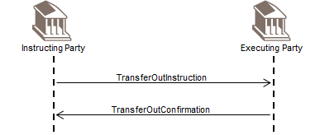

### Two Account Owners – Direct – Double Leg

Instructing party 1 sends a TransferOutInstruction message to the executing party.

The message requests the executing party to withdraw a quantity of financial instrument from the instructing party's account and deliver the financial instrument to instructing party 2, which also has its account at the executing party.

At the same time, instructing party 2 sends a TransferInInstruction message to the executing party, requesting the executing party to receive the financial instrument from instructing party 1.

The executing party sends a TransferOutConfirmation message to instructing party 1 to confirm the delivery and a TransferInConfirmation message to instructing party 2, to confirm the receipt of the financial instrument.

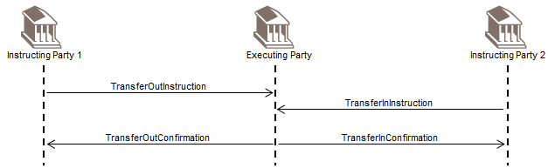

### Two Account Owners – Direct – Single Leg

Instructing party 1 sends a TransferOutInstruction message to the executing party.

The message requests the executing party to withdraw a quantity of financial instrument from the instructing party's account and deliver the financial instrument to instructing party 2, which also has its account at the executing party.

The Service Level Agreement (SLA) in place between the executing party and instructing party 2, specifies that the executing party does not need to receive a corresponding TransferInInstruction message from instructing party 2 in order to act upon the TransferOutInstruction message.

The executing party sends a TransferOutConfirmation message to instructing party 1 to confirm the delivery and a TransferInConfirmation message to instructing party 2, to confirm the receipt of the financial instrument.

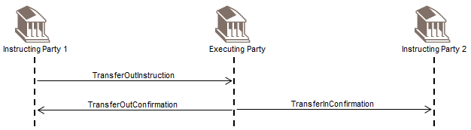

### Two Account Owners – Direct – SLT Market Practice

The transferee's bank sends a TransferInInstruction message to the transferor's bank. The message instructs the transferor's bank party to withdraw a quantity of financial instrument from the end client's account and deliver the financial instrument to the account of the transferee's bank at the transfer agent.

The transferor replies with a TransferInstructionStatusReport message with the status Accepted (PACK).

The transferor's bank then actions the transfer by sending a Transfer Out Instruction message to the transfer agent.

The transfer agent replies with a TransferInstructionStatusReport message with the status Accepted (PACK).

The transfer agent carries out the transfer and sends:

* a TransferOutConfirmation message to the transferor's bank
* a TransferInConfirmation message to the transferee's bank

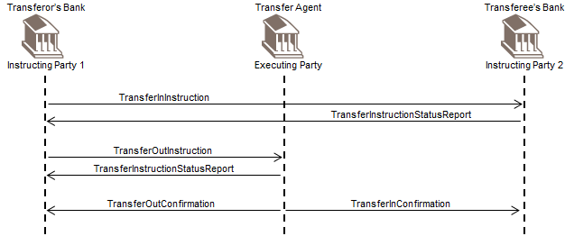

### Two Account Owners – Intermediary - Double Leg

Instructing party 1 sends a TransferOutInstruction message to intermediary 1.

The message requests intermediary 1 to withdraw a quantity of financial instrument from the account of instructing party 1 and deliver the financial instrument to instructing party 2, which has its account at intermediary 2. Intermediary 1, in turn, has an account at the executing party and sends a TransferOutInstruction message to the executing party.

At the same time, instructing party 2 sends a TransferInInstruction message to intermediary 2. The message requests intermediary 2 to receive the financial instrument from instructing party 1, via intermediary 1, via the executing party. Intermediary 2, in turn, sends a TransferInInstruction message to the executing party.

The executing party sends a TransferOutConfirmation message to intermediary 1 to confirm the delivery. Intermediary 1, in turn, sends a TransferOutConfirmation message to instructing party 1 to confirm the delivery. The executing party sends a TransferInConfirmation message to intermediary 2 to confirm the receipt. Intermediary 2, in turn, sends a TransferInConfirmation message to instructing party 2 to confirm the receipt.

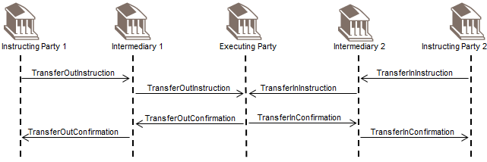

### Transfer Out Reversal

An instructing party sends a TransferOutInstruction message to the executing party. The message requests the executing party to withdraw a quantity of financial instrument from an account the instructing party owns and deliver it to another account.

The executing party sends a TransferOutConfirmation message to the instructing party to confirm the delivery.

Subsequently, the executing party sends a ReversalOfTransferOutConfirmation message to reverse the TransferOutConfirmation message.

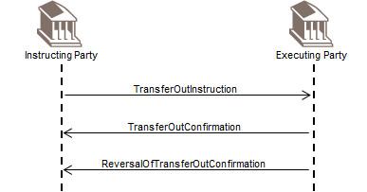

### Transfer In Reversal

An instructing party sends a TransferInInstruction message to the executing party. The message requests the executing party to receive a quantity of financial instrument from another account.

The executing party sends a TransferInConfirmation message to the instructing party, to confirm a receipt into the account of the instructing party.

Subsequently, the executing party sends a ReversalOfTransferInConfirmation message to reverse the TransferInConfirmation message.

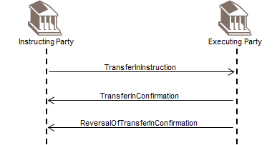

### Transfer Out Cancellation

An instructing party sends a TransferOutInstruction message to the executing party.

There is an SLA in place between the instructing party and the executing party that allows the instructing party to cancel the transfer instructions, if necessary and if in accordance with the SLA. Subsequently, the instructing party needs to cancel the transfer and sends a TransferOutCancellationRequest message to cancel the previously sent TransferOutInstruction message.

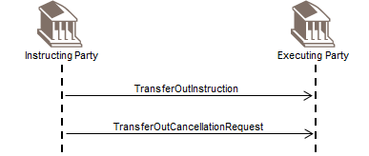

### Transfer In Cancellation

An instructing party sends a TransferInInstruction message to the executing party.

There is an SLA in place between the instructing party and the executing party that allows the instructing party to cancel the transfer instructions, if necessary and if in accordance with the SLA. Subsequently, the instructing party needs to cancel the transfer and sends a TransferInCancellationRequest message to cancel the previously sent TransferInInstruction message.

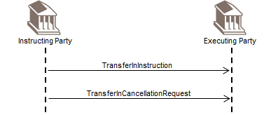

### Request for Transfer Status and Transfer Status

This message flow section illustrates the use of the transfer status messages in typical message sequencing scenarios.

The RequestForTransferStatusReport message is sent by an instructing party to the executing party to request the status of a transfer instruction. The response to a RequestForTransferStatusReport is a TransferInstructionStatusReport or a TransferCancellationStatusReport message.

The TransferInstructionStatusReport is sent by the executing party to the instructing party. There may be one or more intermediaries in the transaction chain.

The instructing party is, for example, an investment manager. The executing party is, for example, a transfer agent.

If the Service Level Agreement (SLA) allows it, a TransferInstructionStatusReport or a TransferCancellationStatusReport message may be sent by the executing party to the instructing party even though no RequestForTransferStatusReport message has been received by the executing party.

#### Request for Status

An instructing party sends a transfer instruction, for example, a TransferOutInstruction message, to the executing party.

Subsequently, the instructing party sends a RequestForTransferStatusReport message to request the status of the TransferOutInstruction message. In response, the executing party sends a TransferInstructionStatusReport message to the instructing party giving the status of the TransferOutInstruction message, for example, Accepted (PACK).

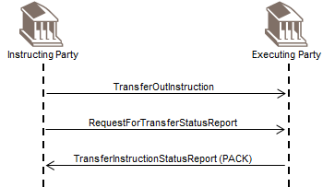

#### Request for Status Rejection

An instructing party sends a transfer instruction, for example, a TransferOutInstruction message, to the executing party.

Subsequently, the investor sends a RequestForTransferStatusReport message but, for example, it misquotes the message reference of the TransferOutInstruction message. The transfer agent cannot process the RequestForTransferStatusReport message because it does not know to which transfer instruction the investor is referring. Therefore, the transfer agent replies with a Rejection message with the reason 'UnknownOrInvalidReference'.

The message flow works in a similar way when a TransferInInstruction message is sent.

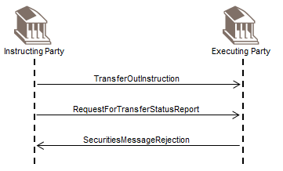

#### Status - Direct

The instructing party sends a TransferOutInstruction message to the executing party.

Subsequently, as specified in the SLA in place between the two parties, the executing party sends a TransferInstructionStatusReport message to the instructing party. The status report gives the status of the transfer instruction, for example, Accepted (PACK).

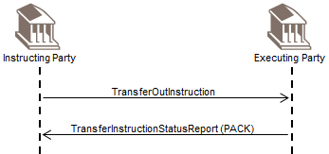

The message flow works in a similar way when a TransferInInstruction message is sent.

#### Status - Intermediary

An instructing party sends a TransferOutInstruction message to the executing party via one or several intermediaries.

Subsequently, as specified in the Service Level Agreement (SLA) in place between the two parties, the executing party sends a TransferInstructionStatusReport message to the instructing party, via one or several intermediaries. The status report gives the status of the transfer instruction, for example, Accepted (PACK).

The message flow works in a similar way when a TransferInInstruction message is sent.

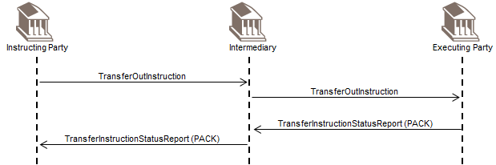

#### Cancellation Status – Direct

The instructing party sends a TransferInInstruction message to the executing party.

There is an SLA in place between the instructing party and the executing party that allows the instructing party to cancel the transfer instructions, if necessary and if in accordance with the SLA. Subsequently, the instructing party sends a TransferInCancellationRequest message to cancel the TransferInInstruction message.

Subsequently, the instructing party sends a RequestForTransferStatusReport message to the executing party, to request the status of the TransferInCancellationRequest message.

In response, the executing party sends a TransferCancellationStatusReport message to the instructing party, giving the status of the TransferInCancellationRequest message, for example, Cancelled.

The message flow works in a similar way when a TransferOutInstruction message is sent and subsequently, a TransferOutCancellationRequest message is sent.

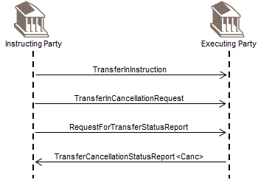

#### Transfer Cancellation Status – Intermediary

An instructing party sends a TransferInInstruction message to the executing party via one or several intermediaries.

There is an SLA in place between the instructing party and the executing party that allows the instructing party to cancel the transfer instructions, if necessary and if in accordance with the SLA. Subsequently, the instructing party sends a TransferInCancellationRequest message to cancel the TransferInInstruction message.

Subsequently, the instructing party sends a RequestForTransferStatusReport message to the executing party. The message requests the status of the TransferInCancellationRequest message.

In response, the executing party sends a TransferCancellationStatusReport message to the instructing party, via one or several intermediaries. The report gives the status of the TransferInCancellationRequest message, for example, Cancelled.

The message flow works in a similar way when a TransferOutInstruction message is sent and subsequently, a TransferOutCancellationRequest message is sent, with the status Cancelled.

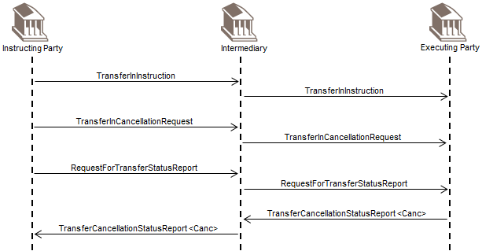

## Price Reporting

This message flow section illustrates the use of the price report messages in typical message sequencing scenarios. The price report messages are sent by a report provider to the report user.

The report provider is, for example, a fund accountant, transfer agent, market data provider, or any other interested party.

The report user is, for example, a fund management company, a transfer agent, market data provider, regulator or any other interested party.

### Price Report

A report provider sends a PriceReport message to the report user. The report user may, in turn, forward the PriceReport message. (Function is NewPriceReport, code NEWP.)

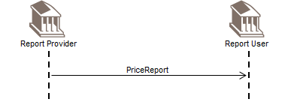

### Price Report Cancellation - complete

A report provider sends a PriceReport message to the report user. The report user may, in turn, forward the PriceReport message. (Function is NewPriceReport, code NEWP.)

Subsequently the report provider cancels all the prices in the previously sent PriceReport message by sending a PriceReportCancellation message (CompletePriceCancellation is ‘true’ or ‘1’).

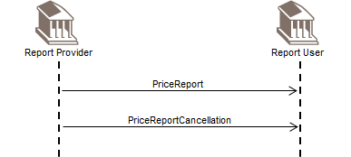

### Price Report Cancellation – partial and correction

A report provider sends a PriceReport message to the report user. The report user may, in turn, forward the PriceReport message. (Function is NewPriceReport, code NEWP.)

Subsequently, the report provider cancels one the prices in the previously sent PriceReport by sending a Price Report Cancellation message (CompletePriceCancellation is ‘false’ or ‘0’). Later, the report provider supplies the corrected price by sending a PriceReport message (Function is PartialCorrectionPriceReport, code PART.)

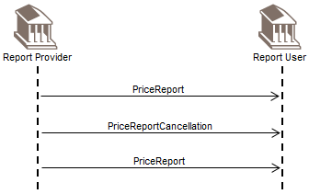

## Statements

This message flow section illustrates the use of the statement messages in typical message sequencing scenarios. The statement messages are sent by an account servicer to the account owner.

Typically, a statement is sent according to the Service Level Agreement (SLA) held between the account servicer and the account owner. This SLA sets the parameters around the frequency at which the statement message is sent, for example, daily, weekly, intra-day.

The account owner is, for example, an investment manager or its authorised representative. The account servicer is, for example, a transfer agent.

### Holdings Statements

#### Accounting Statement of Holdings

An account servicer sends an AccountingStatementOfHoldings message to the account owner.

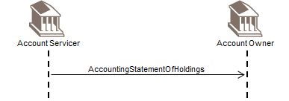

#### Accounting Statement of Holdings – Request

An account owner sends a SecuritiesStatementQuery message to the account servicer to request a statement of holdings (accounting). The account servicer responds by sending an AccountingStatementOfHoldings message.

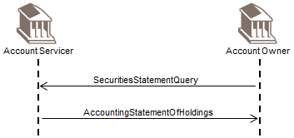

#### Accounting Statement of Holdings - Cancellation

An account servicer sends an AccountingStatementOfHoldings message to the account owner.

Subsequently, the account servicer needs to cancel the previously send statement and sends an AccountingStatementOfHoldingsCancellation message.

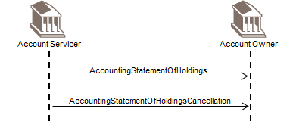

#### Custody Statement of Holdings

An account servicer sends an CustodyStatementOfHoldings message to the account owner.

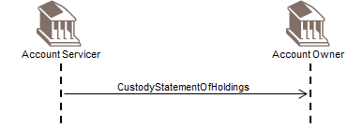

#### Custody Statement of Holdings – Request

An account owner sends a SecuritiesStatementQuery message to the account servicer to request a statement of holdings (custody). The account servicer responds by sending a CustodyStatementOfHoldings message.

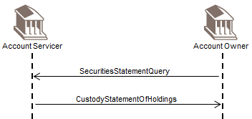

#### Custody Statement of Holdings - Cancellation

An account servicer sends an CustodyStatementOfHoldingsCancellation message to the account owner.

Subsequently, the account servicer needs to cancel the previously send statement and sends an CustodyStatementOfHoldingsCancellation message

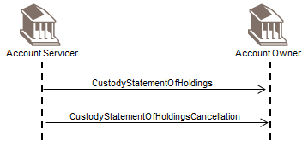

### Transparency of Holdings Statement

An account servicer, such as a custodian, sends the SecuritiesBalanceTransparencyReport statement message to a receiver, who in turn, may enrich it with data of its own and send the aggregated statement onward in the custody chain.

The receiver of the message responds with the SecuritiesBalanceTransparencyReportStatusAdvice message to accept or reject the statement of holdings as presented in the aggregated statement.

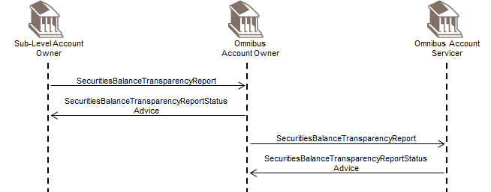

### Transaction Statement

#### Statement of Investment Fund Transactions

An account servicer sends an StatementOfInvestmentFundTransactions message to the account owner.

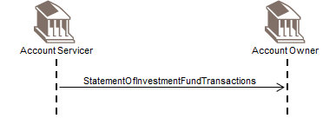

#### Statement of Investment Fund Transactions – Request

An account owner sends a SecuritiesStatementQuery message to the account servicer to request a statement of transactions. The account servicer responds by sending a StatementOfInvestmentFundTransactions message.

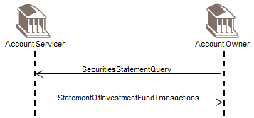

#### Statement of Investment Fund Transactions - Cancellation

An account servicer sends an StatementOfInvestmentFundTransactions message to the account owner.

Subsequently, the account servicer needs to cancel the previously send statement and sends an StatementOfInvestmentFundTransactions Cancellation message.

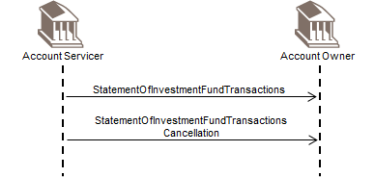

# Business Examples

This section describes business examples of the use of the MessageDefinitions.

## Account Management

### AccountOpeningInstruction acmt.001.001.08 – 1

Description

An AccountOpeningInstruction message is sent to an account servicer, by an institution requesting the opening of an account.

This AccountOpeningInstruction message instructs the account servicer to open a joint Euro Supplementary Retirement Scheme Account (SRSA). The account is to be opened in the name of Richard Lee, the primary owner, of French nationality, to whom the related correspondence is to be sent; Suzanne Plessey is a secondary owner, also of French nationality. The account is opened for investments in the Pension Equity Growth Fund family.

The account opening is requested with the following characteristics:

* the statements are to be issued on a monthly basis,
* any dividends from the investments are to be re-invested,
* the tax is to be withheld at the source,
* a single owner only (the primary owner in this case) may authorise transactions on the account,
* money laundering identification procedures have been carried out.

This message also instructs the opening of an investment plan in the Pension Equity Growth Europe B fund in bearer form, ISIN FR1234567890. The plan is defined as a yearly investment of EUR 523,20 starting on 2 February 2020. Any income is to be accumulated to the capital.

The Euro amount to be invested on a yearly basis is to be paid through a direct debit transaction on IBAN account FR12345678987654321 at ASRVFRXX.

**Message Instance**

<AcctOpngInstr>

<MsgId>

<Id>123456-1</Id>

<CreDtTm>2020-01-06T09:30:30</CreDtTm>

</MsgId>

<InstrDtls>

<OpngTp>

<Cd>NEWA</Cd>

</OpngTp>

</InstrDtls>

<InvstmtAcct>

<Tp>

<Cd>SRSA</Cd>

</Tp>

<OwnrshTp>

<Cd>JOIN</Cd>

</OwnrshTp>

<StmtFrqcy>

<Cd>MNTH</Cd>

</StmtFrqcy>

<RefCcy>EUR</RefCcy>

<IncmPref>SECU</IncmPref>

<TaxWhldgMtd>WTHD</TaxWhldgMtd>

<ReqrdSgntriesNb>1</ReqrdSgntriesNb>

<FndFmlyNm>Pension Equity Growth</FndFmlyNm>

</InvstmtAcct>

<AcctPties>

<PrncplAcctPty>

<PmryOwnr>

<Pty>

<IndvPrsn>

<GvnNm>Richard</GvnNm>

<Nm>Lee</Nm>

<BirthDt>1961-05-09</BirthDt>

<PstlAdr>

<AdrTp>

<Cd>HOME</Cd>

</AdrTp>

<MlngInd>true</MlngInd>

<RegnAdrInd>true</RegnAdrInd>

<AdrLine>Avenue Ariane 152</AdrLine>

<PstCd>75005</PstCd>

<TwnNm>Paris</TwnNm>

<Ctry>FR</Ctry>

</PstlAdr>

<Ctznsh>

<Ntlty>FR</Ntlty>

<MnrInd>false</MnrInd>

</Ctznsh>

</IndvPrsn>

</Pty>

<MnyLndrgChck>

<Cd>PASS</Cd>

</MnyLndrgChck>

<SgntryRghtInd>true</SgntryRghtInd>

</PmryOwnr>

</PrncplAcctPty>

<ScndryOwnr>

<Pty>

<IndvPrsn>

<GvnNm>Suzanne</GvnNm>

<Nm>Plessey</Nm>

<BirthDt>1962-05-16</BirthDt>

<PstlAdr>

<AdrTp>

<Cd>HOME</Cd>

</AdrTp>

<MlngInd>true</MlngInd>

<RegnAdrInd>true</RegnAdrInd>

<AdrLine>Avenue Ariane 152</AdrLine>

<PstCd>75005</PstCd>

<TwnNm>Paris</TwnNm>

<Ctry>FR</Ctry>

</PstlAdr>

<Ctznsh>

<Ntlty>FR</Ntlty>

<MnrInd>false</MnrInd>

</Ctznsh>

</IndvPrsn>

</Pty>

<MnyLndrgChck>

<Cd>PASS</Cd>

</MnyLndrgChck>

<SgntryRghtInd>false</SgntryRghtInd>

</ScndryOwnr>

</AcctPties>

<SvgsInvstmtPlan>

<Frqcy>

<Cd>YEAR</Cd>

</Frqcy>

<StartDt>2020-02-02</StartDt>

<Qty>

<Amt Ccy="EUR">523.20</Amt>

</Qty>

<SctyDtls>

<Qty>

<Pctg>100</Pctg>

</Qty>

<FinInstrm>

<Id>

<ISIN>FR1234567890</ISIN>

</Id>

<Nm>Pension Equity Growth Europe B</Nm>

<SctiesForm>BEAR</SctiesForm>

<DstrbtnPlcy>ACCU</DstrbtnPlcy>

</FinInstrm>

</SctyDtls>

</SvgsInvstmtPlan>

<CshSttlm>

<OthrCshSttlmDtls>

<SttlmCcy>EUR</SttlmCcy>

<SvgsPlanPmtInstrm>

<DrctDbtDtls>

<DbtrAcct>

<Id>

<IBAN>FR12345678987654321</IBAN>

</Id>

</DbtrAcct>

<DbtrAgt>

<BICFI>ASRVFRXX</BICFI>

</DbtrAgt>

</DrctDbtDtls>

</SvgsPlanPmtInstrm>

</OthrCshSttlmDtls>

</CshSttlm>

</AcctOpngInstr>

### AccountOpeningInstruction acmt.001.001.08 – 2

**Description**

An AccountOpeningInstruction message is sent to an account servicer, by an institution requesting the opening of an account.

This AccountOpeningInstruction message instructs the account servicer to open a single owner account (SIGL). The account is to be opened in the name of John Doe Private Account.

The account opening is requested with the following characteristics:

* the tax is to be withheld at source (WRTE) and the tax information is to be reported,
* the country of taxation is Denmark,
* the account servicer identification is 79999, VPDK,
* the account to be opened is an investor account (INVE),
* the power of attorney may only view the account (VIEW),
* the opening date of the account is 4 February 2020.

Primary Owner

* the account owner name is John Doe,
* the address to which mail is to be sent is Haraldstedvej, 2, Copenhagen 0001, DK,
* the social security number (SOCS) 123456-7890,
* the tax exemption/reporting is ‘ordinary’ (ORDR),
* the language in which the account owner communicates is Danish,
* for reporting purposes the account is regard as domestic (YDOM).

Power of Attorney

* the power of attorney is PEFI Bank, identification 70000, VPDK,
* the start date of the power of attorney 4 February 2020, 10am,
* post is to be sent via air mail.

Rights Holder

* the holder of the rights is Jane Doe,
* the address is Haraldstedvej, 2, Copenhagen 0001, DK,
* the social security number (SOCS) 987654-3210,
* the tax exemption status is ‘rights holder’ (RIHO).
* the language for correspondence is Danish,
* post is to be sent via airmail,
* the account status is domestic (YDOM).

Registered Shareholder

The register shareholder name is John Doe, Haraldstedvej, 2, Copenhagen 0001, DK.

Cash Settlement

There are three sets of cash settlement information:

* for the payment of dividends, the account is DK6000010090908080,
* for the payment of interest, the account is DK6000010090908080,
* for the payment of redemption proceeds, the account is DK6000010090908080,
* in all cases the currency is DKK.

The rights holder information is specified in AccountParties/OtherParty.

**Message Instance**

<AcctOpngInstr>

<MsgId>

<Id>123456-1</Id>

<CreDtTm>2020-01-06T09:30:30</CreDtTm>

</MsgId>

<InstrDtls>

<OpngTp>

<Cd>NEWA</Cd>

</OpngTp>

</InstrDtls>

<InvstmtAcct>

<Id>000187745687</Id>

<Nm>John Doe Private Account</Nm>

<OwnrshTp>

<Cd>SIGL</Cd>

</OwnrshTp>

<TaxWhldgMtd>WTRE</TaxWhldgMtd>

<TaxRptg>

<TaxtnCtry>DK</TaxtnCtry>

</TaxRptg>

<AcctSvcr>

<PrtryId>

<Id>79999</Id>

<Issr>VPDK</Issr>

</PrtryId>

</AcctSvcr>

<AcctUsgTp>

<Cd>INVE</Cd>

</AcctUsgTp>

<PwrOfAttnyLvlOfCtrl>

<Cd>VIEW</Cd>

</PwrOfAttnyLvlOfCtrl>

<OpngDt>

<Dt>2020-02-04</Dt>

</OpngDt>

</InvstmtAcct>

<AcctPties>

<PrncplAcctPty>

<PmryOwnr>

<Pty>

<IndvPrsn>

<Nm>John Doe</Nm>

<PstlAdr>

<RegnAdrInd>true</RegnAdrInd>

<AdrLine>Haraldstedvej 2</AdrLine>

<PstCd>0001</PstCd>

<TwnNm>Copenhagen</TwnNm>

<Ctry>DK</Ctry>

</PstlAdr>

</IndvPrsn>

</Pty>

<OthrId>

<Id>123456-7890</Id>

<Tp>

<Cd>SOCS</Cd>

</Tp>

</OthrId>

<TaxXmptn>

<Cd>ORDR</Cd>

</TaxXmptn>

<Lang>DK</Lang>

<AcctgSts>

<Cd>YDOM</Cd>

</AcctgSts>

</PmryOwnr>

</PrncplAcctPty>

<PwrOfAttny>

<Pty>

<Org>

<Nm>Account Bank</Nm>

<Id>

<PrtryId>

<Id>70000</Id>

<Issr>VPDK</Issr>

</PrtryId>

</Id>

<PstlAdr>

<Ctry>DK</Ctry>

</PstlAdr>

</Org>

</Pty>

<MailTp>

<Cd>AIRM</Cd>

</MailTp>

</PwrOfAttny>

<OthrPty>

<XtndedPtyRole>Account Rights Holder</XtndedPtyRole>

<OthrPtyDtls>

<Pty>

<IndvPrsn>

<Nm>Jane Doe</Nm>

<PstlAdr>

<AdrLine>Haraldstedvej 2</AdrLine>

<PstCd>0001</PstCd>

<TwnNm>Copenhagen</TwnNm>

<Ctry>DK</Ctry>

</PstlAdr>

</IndvPrsn>

</Pty>

<OthrId>

<Id>987654-3210</Id>

<Tp>

<Cd>SOCS</Cd>

</Tp>

</OthrId>

<TaxXmptn>

<Cd>RIHO</Cd>

</TaxXmptn>

<Lang>DK</Lang>

<MailTp>

<Cd>AIRM</Cd>

</MailTp>

<AcctgSts>

<Cd>YDOM</Cd>

</AcctgSts>

<AddtlInf>

<Prd>

<FrDtTm>2020-02-04T10:00:00</FrDtTm>

</Prd>

</AddtlInf>

</OthrPtyDtls>

</OthrPty>

<RegdShrhldrNm>

<IndvPrsn>

<Nm>John Doe </Nm>

<PstlAdr>

<AdrLine>Haraldstedvej 2</AdrLine>

<PstCd>0001</PstCd>

<TwnNm>Copenhagen</TwnNm>

<Ctry>DK</Ctry>

</PstlAdr>

</IndvPrsn>

</RegdShrhldrNm>

</AcctPties>

<CshSttlm>

<CshAcctDtls>

<SttlmCcy>DKK</SttlmCcy>

<Id>

<Id>

<IBAN>DK6000010090908080</IBAN>

</Id>

</Id>

<SttlmInstrRsn>

<Cd>DIVI</Cd>

</SttlmInstrRsn>

</CshAcctDtls>

<CshAcctDtls>

<SttlmCcy>DKK</SttlmCcy>

<Id>

<Id>

<IBAN>DK6000010090908080</IBAN>

</Id>

</Id>

<SttlmInstrRsn>

<Cd>INTE</Cd>

</SttlmInstrRsn>

</CshAcctDtls>

<CshAcctDtls>

<SttlmCcy>DKK</SttlmCcy>

<Id>

<Id>

<IBAN>DK6000010090908080</IBAN>

</Id>

</Id>

<SttlmInstrRsn>

<Cd>REDM</Cd>

</SttlmInstrRsn>

</CshAcctDtls>

</CshSttlm>

</AcctOpngInstr>

### AccountDetailsConfirmation acmt.002.001.08

**Description**

An AccountDetailsConfirmation message is sent from an account servicer to an account owner to confirm the opening of an account.

This AccountDetailsConfirmation message confirms the opening of account number XYZ123456789, which was instructed via the 'AccountOpeningInstruction acmt.001.001.08 - 1' message above, with reference 123456-1. This message confirms that the account is active.

The complete set of account information, account parties information, investment plan and cash settlement information that was specified in the AccountOpeningInstruction message is returned in the AccountDetailsConfirmation message.

**Message Instance**

<AcctDtlsConf>

<MsgId>

<Id>123456-2</Id>

<CreDtTm>2020-01-06T14:30:30</CreDtTm>

</MsgId>

<ConfDtls>

<ConfTp>

<Cd>ACCO</Cd>

</ConfTp>

</ConfDtls>

<InvstmtAcct>

<Id>XYZ123456789</Id>

<AcctSts>

<Nbld>

<NoSpcfdRsn>NORE</NoSpcfdRsn>

</Nbld>

</AcctSts>

<OwnrshTp>

<Cd>JOIN</Cd>

</OwnrshTp>

<StmtFrqcy>

<Cd>MNTH</Cd>

</StmtFrqcy>

<RefCcy>EUR</RefCcy>

<TaxWhldgMtd>WTHD</TaxWhldgMtd>

<ReqrdSgntriesNb>1</ReqrdSgntriesNb>

<FndFmlyNm>Pension Equity Growth</FndFmlyNm>

</InvstmtAcct>

<AcctPties>

<PrncplAcctPty>

<PmryOwnr>

<Pty>

<IndvPrsn>

<GvnNm>Richard</GvnNm>

<Nm>Lee</Nm>

<BirthDt>1961-05-09</BirthDt>

<PstlAdr>

<AdrTp>

<Cd>HOME</Cd>

</AdrTp>

<MlngInd>true</MlngInd>

<RegnAdrInd>true</RegnAdrInd>

<AdrLine>Avenue Ariane 152</AdrLine>

<PstCd>75005</PstCd>

<TwnNm>Paris</TwnNm>

<Ctry>FR</Ctry>

</PstlAdr>

<Ctznsh>

<Ntlty>FR</Ntlty>

<MnrInd>false</MnrInd>

</Ctznsh>

</IndvPrsn>

</Pty>

<MnyLndrgChck>

<Cd>PASS</Cd>

</MnyLndrgChck>

<SgntryRghtInd>true</SgntryRghtInd>

</PmryOwnr>

</PrncplAcctPty>

<ScndryOwnr>

<Pty>

<IndvPrsn>

<GvnNm>Suzanne</GvnNm>

<Nm>Plessey</Nm>

<BirthDt>1962-05-16</BirthDt>

<PstlAdr>

<AdrTp>

<Cd>HOME</Cd>

</AdrTp>

<MlngInd>true</MlngInd>

<RegnAdrInd>true</RegnAdrInd>

<AdrLine>Avenue Ariane 152</AdrLine>

<PstCd>75005</PstCd>

<TwnNm>Paris</TwnNm>

<Ctry>FR</Ctry>

</PstlAdr>

<Ctznsh>

<Ntlty>FR</Ntlty>

<MnrInd>false</MnrInd>

</Ctznsh>

</IndvPrsn>

</Pty>

<MnyLndrgChck>

<Cd>PASS</Cd>

</MnyLndrgChck>

<SgntryRghtInd>false</SgntryRghtInd>

</ScndryOwnr>

</AcctPties>

<SvgsInvstmtPlan>

<Frqcy>

<Cd>YEAR</Cd>

</Frqcy>

<StartDt>2020-02-02</StartDt>

<Qty>

<Amt Ccy="EUR">523.20</Amt>

</Qty>

<SctyDtls>

<Qty>

<Pctg>100</Pctg>

</Qty>

<FinInstrm>

<Id>

<ISIN>FR1234567890</ISIN>

</Id>

<Nm>Pension Equity Growth Europe B</Nm>

<SctiesForm>BEAR</SctiesForm>

<DstrbtnPlcy>ACCU</DstrbtnPlcy>

</FinInstrm>

</SctyDtls>

</SvgsInvstmtPlan>

<CshSttlm>

<OthrCshSttlmDtls>

<SttlmCcy>EUR</SttlmCcy>

<SvgsPlanPmtInstrm>

<DrctDbtDtls>

<DbtrAcct>

<Id>

<IBAN>FR12345678987654321</IBAN>

</Id>

</DbtrAcct>

<DbtrAgt>

<BICFI>ASRVFRXX</BICFI>

</DbtrAgt>

</DrctDbtDtls>

</SvgsPlanPmtInstrm>

</OthrCshSttlmDtls>

</CshSttlm>

</AcctDtlsConf>

### AccountModificationInstruction acmt.003.001.08 – 1

**Description**

An AccountModificationInstruction message is sent by an account owner to an account servicer in order to instruct modifications to the existing account information.

This AccountModificationInstruction message instructs updates to account number XYZ123456789. It instructs the following updates:

* Addition of an end date to the investment plan
* Replacement of the direct debit payment information by payment via a credit card owned by Richard Lee. This is done by requesting the deletion (DELT) of the direct debit information and the insertion (INSE) of the new credit card payment information.

**Message Instance**

<AcctModInstr>

<MsgId>

<Id>123456-3</Id>

<CreDtTm>2020-01-14T09:00:00</CreDtTm>

</MsgId>

<InstrDtls>

<ModRsn>Update savings plan end date, replace direct debit by credit card</ModRsn>

</InstrDtls>

<InvstmtAcctSelctn>

<AcctId>XYZ123456789</AcctId>

</InvstmtAcctSelctn>

<ModfdSvgsInvstmtPlan>

<ModScpIndctn>UPDT</ModScpIndctn>

<InvstmtPlan>

<Frqcy>

<Cd>MNTH</Cd>

</Frqcy>

<StartDt>2020-02-02</StartDt>

<EndDt>2027-02-03</EndDt>

<Qty>

<Amt Ccy="EUR">523.20</Amt>

</Qty>

<SctyDtls>

<Qty>

<Pctg>100</Pctg>

</Qty>

<FinInstrm>

<Id>

<ISIN>FR1234567890</ISIN>

</Id>

</FinInstrm>

</SctyDtls>

</InvstmtPlan>

</ModfdSvgsInvstmtPlan>

<ModfdCshSttlm>

<ModScpIndctn>DELT</ModScpIndctn>

<OthrCshSttlmDtls>

<SttlmCcy>EUR</SttlmCcy>

<SvgsPlanPmtInstrm>

<DrctDbtDtls>

<DbtrAcct>

<Id>

<IBAN>FR12345678987654321</IBAN>

</Id>

</DbtrAcct>

<DbtrAgt>

<BICFI>ASRVFRXX</BICFI>

</DbtrAgt>

</DrctDbtDtls>

</SvgsPlanPmtInstrm>

</OthrCshSttlmDtls>

</ModfdCshSttlm>

<ModfdCshSttlm>

<ModScpIndctn>INSE</ModScpIndctn>

<OthrCshSttlmDtls>

<SttlmCcy>EUR</SttlmCcy>

<SvgsPlanPmtInstrm>

<PmtCardDtls>

<Tp>CRDT</Tp>

<Nb>1234567890123456</Nb>

<HldrNm>Richard Lee</HldrNm>

<XpryDt>2023-09</XpryDt>

</PmtCardDtls>

</SvgsPlanPmtInstrm>

</OthrCshSttlmDtls>

</ModfdCshSttlm>

</AcctModInstr>

### AccountModificationInstruction acmt.003.001.08 – 2

**Description**

An AccountModificationInstruction message is sent by an account owner to an account servicer in order to instruct modifications to the existing account information.

This AccountModificationInstruction message instructs updates to account number 66666666. It instructs updates (UPDT) to the primary owner (Martin Johnson) data set because the following information is now available

* Customer conduct classification is standard (STAN)
* Risk level is low (LOWW)
* Know Your Customer Check is ordinary (ORDN)
* MiFID classification is eligible (ELIG)

**Message Instance**

<AcctModInstr>

<MsgId>

<Id>123456-12</Id>

<CreDtTm>2020-01-06T16:30:00</CreDtTm>

</MsgId>

<InvstmtAcctSelctn>

<AcctId>66666666</AcctId>

</InvstmtAcctSelctn>

<ModfdAcctPties>

<ModScpIndctn>UPDT</ModScpIndctn>

<PrncplAcctPty>

<PmryOwnr>

<Pty>

<IndvPrsn>

<GvnNm>Martin</GvnNm>

<Nm>Johnson</Nm>

<BirthDt>1957-05-11</BirthDt>

</IndvPrsn>

</Pty>

<ModfdInvstrPrflVldtn>

<ModScpIndctn>INSE</ModScpIndctn>

<InvstrPrflVldtn>

<CstmrCndctClssfctn>

<Cd>STAN</Cd>

</CstmrCndctClssfctn>

<RskLvl>

<Cd>LOWW</Cd>

</RskLvl>

<KnowYourCstmrChckTp>

<Cd>ORDN</Cd>

</KnowYourCstmrChckTp>

</InvstrPrflVldtn>

</ModfdInvstrPrflVldtn>

<MiFIDClssfctn>

<Clssfctn>ELIG</Clssfctn>

</MiFIDClssfctn>

</PmryOwnr>

</PrncplAcctPty>

</ModfdAcctPties>

</AcctModInstr>

### GetAccountDetails acmt.004.001.06

**Description**

A GetAccountDetails message, is sent by an account owner to an account servicer in order to instruct the return of registered information about an existing account.

This GetAccountDetails message is instructing the return of the following selected account information: investment account characteristics, account parties and investment plan for the account bearing the number XYZ123456789.

**Message Instance**

<GetAcctDtls>

<MsgId>

<Id>123456-4</Id>

<CreDtTm>2020-01-15T09:30:30</CreDtTm>

</MsgId>

<InvstmtAcctSelctn>

<AcctId>XYZ123456789</AcctId>

</InvstmtAcctSelctn>

<SelctdInfTp>

<InvstmtAcct>true</InvstmtAcct>

<AcctPties>true</AcctPties>

<Intrmies>false</Intrmies>

<InvstmtPlan>true</InvstmtPlan>

<CshSttlm>false</CshSttlm>

<SvcLvlAgrmt>false</SvcLvlAgrmt>

</SelctdInfTp>

</GetAcctDtls>

### RequestForAccountManagementStatusReport acmt.005.001.06

**Description**

A RequestForAccountManagementStatusReport message is sent by an account owner to an account servicer in order to request the status of previously sent AccountModificationInstruction message for which an AccountDetailsConfirmation message has not yet been received.

This RequestForAccountManagementStatusReport message requests the status of an AccountModificationInstruction message with message identification 123456-12, for account number 66666666.

**Message Instance**

<ReqForAcctMgmtStsRpt>

<MsgId>

<Id>123456-25</Id>

<CreDtTm>2020-01-14T13:00:00</CreDtTm>

</MsgId>

<ReqDtls>

<LkdRef>

<PrvsRef>

<Ref>123456-12</Ref>

<MsgNm>acmt.003</MsgNm>

</PrvsRef>

</LkdRef>

<StsReqTp>ACCM</StsReqTp>

<InvstmtAcct>

<AcctId>66666666</AcctId>

</InvstmtAcct>

</ReqDtls>

</ReqForAcctMgmtStsRpt>

### AccountManagementStatusReport acmt.006.001.07 – Received

**Description**

An AccountManagementStatusReport message is sent by an account servicer to the account owner in order to indicate the status of an account modification instruction.

This AccountManagementStatusReport message indicates that the status of the account modification instruction referenced as 123456-3 has been received (RECE) and is acknowledged.

**Message Instance**

<AcctMgmtStsRpt>

<MsgId>

<Id>123456-6</Id>

<CreDtTm>2020-01-14T13:10:00</CreDtTm>

</MsgId>

<RltdRef>

<Ref>123456-3</Ref>

</RltdRef>

<StsRpt>

<Sts>

<Sts>RECE</Sts>

</Sts>

</StsRpt>

</AcctMgmtStsRpt>

### AccountManagementStatusReport acmt.006.001.07 – Rejected

**Description**

In this example, an AccountManagementStatusReport message is sent by an account servicer to the account owner in order to indicate the status of an account modification instruction (reference Mod-123456) is rejected.

The modification instruction is rejected because it is not compliant with service level agreement (NSLA) because it contains a modification to the withdrawal investment plan and this is not allowed.

**Message Instance**

<AcctMgmtStsRpt>

<MsgId>

<Id>123456-7</Id>

<CreDtTm>2020-01-16T11:20:00</CreDtTm>

</MsgId>

<RltdRef>

<Ref>Mod-123456</Ref>

</RltdRef>

<StsRpt>

<Sts>

<Rjctd>

<Rsn>

<Cd>NSLA</Cd>

</Rsn>

<AddtlRsnInf>Withdrawal investment modifications not allowed </AddtlRsnInf>

</Rjctd>

</Sts>

</StsRpt>

</AcctMgmtStsRpt>

### Account Closing

This scenario illustrates the use of the account management messages for account closure using the AccountModificationInstruction message, the AccountManagementStatusReport message and the AccountDetailsConfirmation message.

#### Message 1 - AccountModificationInstruction acmt.003.001.08

**Description**

An Account Modification Instruction is sent by the account owner to instruct the account servicer to close account 111111.

**Message Instance**

<AcctModInstr>

<MsgId>

<Id>FD43001</Id>

<CreDtTm>2020-01-05T09:00:00</CreDtTm>

</MsgId>

<InvstmtAcctSelctn>

<AcctId>111111</AcctId>

</InvstmtAcctSelctn>

<ModfdInvstmtAcct>

<AcctStsUpdInstr>

<UpdInstr>

<Cd>CLOS</Cd>

</UpdInstr>

</AcctStsUpdInstr>

</ModfdInvstmtAcct>

</AcctModInstr>

#### Message 2 - AccountManagementStatusReport acmt.006.001.07

**Description**

The account service responds with an AccountManagementStatusReport to report the AccountModificationInstruction has been received (RECE). Subsequently, the account servicer may send an AccountManagementStatusReport to report the AccountModificationInstruction has been validated and accepted (ACCP) but this is not shown.

**Message Instance**

<AcctMgmtStsRpt>

<MsgId>

<Id>CA572001</Id>

<CreDtTm>2020-01-05T09:03:00</CreDtTm>

</MsgId>

<RltdRef>

<Ref>FD43001</Ref>

</RltdRef>

<StsRpt>

<Sts>

<Sts>RECE</Sts>

</Sts>

<AcctId>111111</AcctId>

</StsRpt>

</AcctMgmtStsRpt>

#### Message 3 - AccountDetailsConfirmation acmt.002.001.08

**Description**

When the account closure has been carried out, the account servicer sends an AccountDetailsConfirmation to confirm the account is closed.

**Message Instance**

<AcctDtlsConf>

<MsgId>

<Id>CA572027</Id>

<CreDtTm>2020-01-05T11:00:00</CreDtTm>

</MsgId>

<ConfDtls>

<ConfTp>

<Cd>ACCM</Cd>

</ConfTp>

</ConfDtls>

<InvstmtAcct>

<Id>111111</Id>

<AcctSts>

<Clsd>

<NoSpcfdRsn>NORE</NoSpcfdRsn>

</Clsd>

</AcctSts>

</InvstmtAcct>

</AcctDtlsConf>

### Account Reactivation

This scenario illustrates the use of the account management messages for the reactivation of the account using the AccountModificationInstruction message, the AccountManagementStatusReport message and the AccountDetailsConfirmation message. An AccountModificationInstruction message was sent to instruct the closure of an account but a short time later, the account owner realises this was a mistake and sends an AccountModificationInstruction message to instruct the reactivation of the account. Only the messages for the reactivation of the account are shown.

#### Message 1 - AccountModificationInstruction acmt.003.001.08

**Description**

An Account Modification Instruction is sent by the account owner to instruct the account servicer to reactivate account 111111.

**Message Instance**

<AcctModInstr>

<MsgId>

<Id>FD43062</Id>

<CreDtTm>2020-01-05T09:30:00</CreDtTm>

</MsgId>

<InvstmtAcctSelctn>

<AcctId>111111</AcctId>

</InvstmtAcctSelctn>

<ModfdInvstmtAcct>

<AcctStsUpdInstr>

<UpdInstr>

<Cd>REAC</Cd>

</UpdInstr>

</AcctStsUpdInstr>

</ModfdInvstmtAcct>

</AcctModInstr>

#### Message 2 - AccountManagementStatusReport acmt.006.001.07

**Description**

The account service responds with an AccountManagementStatusReport to report the AccountModificationInstruction has been received (RECE). Subsequently, the account servicer may send an AccountManagementStatusReport to report the AccountModificationInstruction has been validated and accepted (ACCP) but this is not shown.

**Message Instance**

<AcctMgmtStsRpt>

<MsgId>

<Id>CA5720034</Id>

<CreDtTm>2020-01-05T09:32:00</CreDtTm>

</MsgId>

<RltdRef>

<Ref>FD43062</Ref>

</RltdRef>

<StsRpt>

<Sts>

<Sts>RECE</Sts>

</Sts>

<AcctId>111111</AcctId>

</StsRpt>

</AcctMgmtStsRpt>

#### Message 3 - AccountDetailsConfirmation acmt.002.001.08

**Description**

When the account has been reactivated, the account servicer sends an AccountDetailsConfirmation to confirm the account is enabled.

**Message Instance**

<AcctDtlsConf>

<MsgId>

<Id>CA5720038</Id>

<CreDtTm>2020-01-05T09:35:00</CreDtTm>

</MsgId>

<ConfDtls>

<ConfTp>

<Cd>ACCM</Cd>

</ConfTp>

</ConfDtls>

<InvstmtAcct>

<Id>111111</Id>

<AcctSts>

<Nbld>

<NoSpcfdRsn>NORE</NoSpcfdRsn>

</Nbld>

</AcctSts>

</InvstmtAcct>

</AcctDtlsConf>

## Fund Cash Forecast

### FundEstimatedCashForecastReport camt.040.001.04 – 1

**Description**

A FundEstimatedCashForecastReport message is sent to report the cash-flow movements of financial instrument ISIN SG1234567890, fund name ABC, for trade date 9 January 2015.

As it is an estimated cash forecast report, the estimated amounts are based on the price of the previous trade date, 08 January 2015. This report does not contain an exceptional net cash flow.

The cash-in flows for settlement date 12 January 2015 are the result of the subscription to 2,000 units for an estimated total cash-in amount of SGD 40,000.

The cash-out flows for settlement date 12 January 2015 are the result of the redemption of 500 units for an estimated total cash-out amount of SGD 10,000.

The estimated net cash amount coming into the fund is SGD 30,000.

**Message Instance**

<FndEstmtdCshFcstRpt>

<MsgId>

<Id>123DA5409</Id>

<CreDtTm>2015-01-08T16:45:00</CreDtTm>

</MsgId>

<MsgPgntn>

<PgNb>1</PgNb>

<LastPgInd>true</LastPgInd>

</MsgPgntn>

<EstmtdFndCshFcstDtls>

<Id>FCF0002</Id>

<TradDtTm>

<Dt>2015-01-09</Dt>

</TradDtTm>

<PrvsTradDtTm>

<Dt>2015-01-08</Dt>

</PrvsTradDtTm>

<FinInstrmDtls>

<Id>

<ISIN>SG1234567890</ISIN>

</Id>

<Nm>Fund ABC</Nm>

<DualFndInd>false</DualFndInd>

</FinInstrmDtls>

<XcptnlNetCshFlowInd>false</XcptnlNetCshFlowInd>

<EstmtdCshInFcstDtls>

<CshSttlmDt>2015-01-12</CshSttlmDt>

<SubTtlAmt Ccy="SGD">40000</SubTtlAmt>

<SubTtlUnitsNb>

<Unit>2000</Unit>

</SubTtlUnitsNb>

</EstmtdCshInFcstDtls>

<EstmtdCshOutFcstDtls>

<CshSttlmDt>2015-01-12</CshSttlmDt>

<SubTtlAmt Ccy="SGD">10000</SubTtlAmt>

<SubTtlUnitsNb>

<Unit>500</Unit>

</SubTtlUnitsNb>

</EstmtdCshOutFcstDtls>

<EstmtdNetCshFcstDtls>

<CshSttlmDt>2015-01-12</CshSttlmDt>

<NetAmt Ccy="SGD">30000</NetAmt>

<NetUnitsNb>

<Unit>1500</Unit>

</NetUnitsNb>

<FlowDrctn>INCG</FlowDrctn>

</EstmtdNetCshFcstDtls>

</EstmtdFndCshFcstDtls>

</FndEstmtdCshFcstRpt>

### FundEstimatedCashForecastReport camt.040.001.04 – 2

**Description**

A FundDetailedEstimatedCashForecastReport message is sent to report the cash-flow movements of share class ISIN LU1234567890 of the fund ‘AB Ethical Fund’. The currency of the share class is EUR. The currency of the fund is USD. The estimated total NAV of the fund is USD 3,000,000. The cash flow as an estimated percentage of the total NAV of the main fund is 0.03%.

As the report is an estimated report, the cash amounts are based on the price of the previous trade date, 16 January 2015. The next trade date is 23 January 2015.

The estimated total NAV of the share class is EUR 2,000,000.

The price (of the previous trade date) is EUR 10.

The cash flow as an estimated percentage of the total NAV of the share class is 0.35%.

Cash–In Details

The cash-in for settlement date 20 January 2015 is EUR 7,000 and the number of units is 700. The estimated amount of cash expected from orders placed in units is EUR 2000 and the estimated amount of cash from orders placed in cash is EUR 5000.

Cash-Out Details

The cash-out for settlement date 20 January 2015 is EUR 2,500 and the number of units is 250.

Net Details

The estimated net cash amount coming into the fund, for settlement date 20 January 2015, is EUR 3,500 and the net number of units is 350.

**Message Instance**

<FndEstmtdCshFcstRpt>

<MsgId>

<Id>412AC7676</Id>

<CreDtTm>2015-01-19T11:30:00</CreDtTm>

</MsgId>

<MsgPgntn>

<PgNb>1</PgNb>

<LastPgInd>true</LastPgInd>

</MsgPgntn>

<FndOrSubFndDtls>

<Nm>AB Ethical Fund</Nm>

<Ccy>USD</Ccy>

<EstmtdTtlNAV Ccy="USD">3000000</EstmtdTtlNAV>

<EstmtdPctgOfFndTtlNAV>0.03</EstmtdPctgOfFndTtlNAV>

</FndOrSubFndDtls>

<EstmtdFndCshFcstDtls>

<Id>FCF0004</Id>

<TradDtTm>

<Dt>2015-01-23</Dt>

</TradDtTm>

<PrvsTradDtTm>

<Dt>2015-01-16</Dt>

</PrvsTradDtTm>

<FinInstrmDtls>

<Id>

<ISIN>LU1234567890</ISIN>

</Id>

<DualFndInd>true</DualFndInd>

</FinInstrmDtls>

<EstmtdTtlNAV Ccy="EUR">2000000</EstmtdTtlNAV>

<InvstmtCcy>EUR</InvstmtCcy>

<XcptnlNetCshFlowInd>true</XcptnlNetCshFlowInd>

<Pric>

<PricTp>

<Cd>NAVL</Cd>

</PricTp>

<Val>

<Amt Ccy="EUR">10</Amt>

</Val>

</Pric>

<EstmtdPctgOfShrClssTtlNAV>0.35</EstmtdPctgOfShrClssTtlNAV>

<EstmtdCshInFcstDtls>

<CshSttlmDt>2015-01-20</CshSttlmDt>

<SubTtlAmt Ccy="EUR">7000</SubTtlAmt>

<SubTtlUnitsNb>

<Unit>700</Unit>

</SubTtlUnitsNb>

<AddtlBal>

<TtlCshFrUnitOrdrs Ccy="EUR">2000</TtlCshFrUnitOrdrs>

<TtlCshFrCshOrdrs Ccy="EUR">5000</TtlCshFrCshOrdrs>

</AddtlBal>

</EstmtdCshInFcstDtls>

<EstmtdCshOutFcstDtls>

<CshSttlmDt>2015-01-20</CshSttlmDt>

<SubTtlAmt Ccy="EUR">2500</SubTtlAmt>

<SubTtlUnitsNb>

<Unit>250</Unit>

</SubTtlUnitsNb>

</EstmtdCshOutFcstDtls>

<EstmtdNetCshFcstDtls>

<CshSttlmDt>2015-01-20</CshSttlmDt>

<NetAmt Ccy="EUR">3500</NetAmt>

<NetUnitsNb>

<Unit>350</Unit>

</NetUnitsNb>

<FlowDrctn>INCG</FlowDrctn>

</EstmtdNetCshFcstDtls>

</EstmtdFndCshFcstDtls>

</FndEstmtdCshFcstRpt>

### FundConfirmedCashForecastReport camt.041.001.04 – 1

**Description**

A FundConfirmedCashForecastReport message is sent to report the cash-flow movements of financial instrument ISIN US1234567890, for trade date 16 January 2015. This report does not contain an exceptional net cash flow.

The cash-in flows for settlement date 19 January 2015 are the result of the subscription to 1,000 units for a total cash-in amount of USD 10,000.

The cash-out flows for settlement date 19 January 2015 are the result of the redemption of 1,100 units for a total cash-out amount of USD 11,000.

The estimated net cash amount going out of the fund is USD 1,000.

**Message Instance**

<FndConfdCshFcstRpt>

<MsgId>

<Id>22FB5436</Id>

<CreDtTm>2015-01-16T16:45:00</CreDtTm>

</MsgId>

<MsgPgntn>

<PgNb>1</PgNb>

<LastPgInd>true</LastPgInd>

</MsgPgntn>

<FndCshFcstDtls>

<Id>FCF0006</Id>

<TradDtTm>

<Dt>2015-01-16</Dt>

</TradDtTm>

<FinInstrmDtls>

<Id>

<ISIN>US1234567890</ISIN>

</Id>

<DualFndInd>false</DualFndInd>

</FinInstrmDtls>

<XcptnlNetCshFlowInd>false</XcptnlNetCshFlowInd>

<CshInFcstDtls>

<CshSttlmDt>2015-01-19</CshSttlmDt>

<SubTtlAmt Ccy="USD">10000</SubTtlAmt>

<SubTtlUnitsNb>

<Unit>1000</Unit>

</SubTtlUnitsNb>

</CshInFcstDtls>

<CshOutFcstDtls>

<CshSttlmDt>2015-01-19</CshSttlmDt>

<SubTtlAmt Ccy="USD">11000</SubTtlAmt>

<SubTtlUnitsNb>

<Unit>1100</Unit>

</SubTtlUnitsNb>

</CshOutFcstDtls>

<NetCshFcstDtls>

<CshSttlmDt>2015-01-19</CshSttlmDt>

<NetAmt Ccy="USD">1000</NetAmt>

<FlowDrctn>OUTG</FlowDrctn>

</NetCshFcstDtls>

</FndCshFcstDtls>

</FndConfdCshFcstRpt>

### FundConfirmedCashForecastReport camt.041.001.04 – 2

**Description**

A FundConfirmedCashForecastReport message is sent to report the cash-flow movements of two funds.

Fund 1

‘AB Ethical Fund’, for trade date 3 March 2015. The currency of the fund is USD. The total NAV is USD 3,000,000. The previous total NAV is USD 2,080,000.

Fund 2

‘Green Fund’, for trade date 4 March 2015. The currency of the fund is EUR. The total NAV is EUR 2,500,000. The previous total NAV is EUR 1,900,000

**Message Instance**

<FndConfdCshFcstRpt>

<MsgId>

<Id>32DC34C</Id>

<CreDtTm>2015-03-05T09:30:10</CreDtTm>

</MsgId>

<MsgPgntn>

<PgNb>1</PgNb>

<LastPgInd>true</LastPgInd>

</MsgPgntn>

<FndOrSubFndDtls>

<Nm>AB Ethical Fund</Nm>

<Ccy>USD</Ccy>

<TradDtTm>

<Dt>2015-03-03</Dt>

</TradDtTm>

<TtlNAV Ccy="USD">3000000</TtlNAV>

<PrvsTtlNAV Ccy="USD">2080000</PrvsTtlNAV>

</FndOrSubFndDtls>

<FndOrSubFndDtls>

<Nm>Green Fund</Nm>

<Ccy>EUR</Ccy>

<TradDtTm>

<Dt>2015-03-04</Dt>

</TradDtTm>

<TtlNAV Ccy="EUR">2500000</TtlNAV>

<PrvsTtlNAV Ccy="EUR">1900000</PrvsTtlNAV>

</FndOrSubFndDtls>

</FndConfdCshFcstRpt>

### FundDetailedEstimatedCashForecastReport camt.042.001.04 – By Country

**Description**

A FundDetailedEstimatedCashForecastReport message is sent to report the cash-flow movements of financial instrument ISIN BE1234567890 for trade date 16 January 2015. As it is an estimated cash flow report, the estimated amounts are based on the price of the previous trade date, 15 January 2015. This report does not contain an exceptional net cash flow. In this report, the cash forecasts are sorted by country.

CASH MOVEMENTS FOR BELGIUM

The cash-in flows from Belgium for settlement date 19 January 2015 are the result of switch and subscription orders for 1,000 units for an estimated total cash-in amount of EUR 1,000,000. The 1000 units are broken down as follows: 600 units were the result of a switch-in and the original switch order was placed as units. The remaining 400 units were the result of a subscription and the original subscription order was placed as an amount of money.

The cash-out flows from Belgium for settlement date 19 January 2015 are the result of switch and redemption orders for 1,450 units for an estimated total cash-out amount of EUR 1,450,000. The 1,450 units are broken down as follows: 1000 units were the result of a switch-out. The remaining 450 units were the result of a redemption.

CASH MOVEMENTS FOR LUXEMBOURG

The cash-in flows from Luxembourg for settlement date 19 January 2015 are the result of switch and subscription orders for 80,000 units for an estimated total cash-in amount of EUR 80,000,000. The amount of EUR 80,000,000 are broken down as follows: EUR 70,000,000 comes from subscriptions, the original order was placed as cash. The remaining EUR 10,000,000 comes from switch-in orders, the original order was placed as cash.

The cash-out flows from Luxembourg for settlement date 19 January 2015 are the result of the redemption of 25,000 units for an estimated total cash-out amount of EUR 25,000,000.

**Message Instance**

<FndDtldEstmtdCshFcstRpt>

<MsgId>

<Id>87AC543</Id>

<CreDtTm>2015-01-16T16:50:00</CreDtTm>

</MsgId>

<MsgPgntn>

<PgNb>1</PgNb>

<LastPgInd>true</LastPgInd>

</MsgPgntn>

<EstmtdFndCshFcstDtls>

<Id>FCF0008</Id>

<TradDtTm>

<Dt>2015-01-16</Dt>

</TradDtTm>

<FinInstrmDtls>

<Id>

<ISIN>BE1234567890</ISIN>

</Id>

<DualFndInd>false</DualFndInd>

</FinInstrmDtls>

<XcptnlNetCshFlowInd>false</XcptnlNetCshFlowInd>

<BrkdwnByCtry>

<Ctry>BE</Ctry>

<CshInFcst>

<CshSttlmDt>2015-01-19</CshSttlmDt>

<SubTtlAmt Ccy="EUR">1000000</SubTtlAmt>

<SubTtlUnitsNb>

<Unit>1000</Unit>

</SubTtlUnitsNb>

<CshInBrkdwnDtls>

<UnitsNb>

<Unit>600</Unit>

</UnitsNb>

<InvstmtFndTxInTp>

<Cd>SWII</Cd>

</InvstmtFndTxInTp>

<OrgnlOrdrQtyTp>

<Cd>UNIT</Cd>

</OrgnlOrdrQtyTp>

</CshInBrkdwnDtls>

<CshInBrkdwnDtls>

<UnitsNb>

<Unit>400</Unit>

</UnitsNb>

<InvstmtFndTxInTp>

<Cd>SUBS</Cd>

</InvstmtFndTxInTp>

<OrgnlOrdrQtyTp>

<Cd>CASH</Cd>

</OrgnlOrdrQtyTp>

</CshInBrkdwnDtls>

</CshInFcst>

<CshOutFcst>

<CshSttlmDt>2015-01-19</CshSttlmDt>

<SubTtlAmt Ccy="EUR">1450000</SubTtlAmt>

<SubTtlUnitsNb>

<Unit>1450</Unit>

</SubTtlUnitsNb>

<CshOutBrkdwnDtls>

<UnitsNb>

<Unit>1000</Unit>

</UnitsNb>

<InvstmtFndTxOutTp>

<Cd>SWIO</Cd>

</InvstmtFndTxOutTp>

<OrgnlOrdrQtyTp>

<Cd>UNIT</Cd>

</OrgnlOrdrQtyTp>

</CshOutBrkdwnDtls>

<CshOutBrkdwnDtls>

<UnitsNb>

<Unit>450</Unit>

</UnitsNb>

<InvstmtFndTxOutTp>

<Cd>REDM</Cd>

</InvstmtFndTxOutTp>

<OrgnlOrdrQtyTp>

<Cd>UNIT</Cd>

</OrgnlOrdrQtyTp>

</CshOutBrkdwnDtls>

</CshOutFcst>

</BrkdwnByCtry>

<BrkdwnByCtry>

<Ctry>LU</Ctry>

<CshInFcst>

<CshSttlmDt>2015-01-19</CshSttlmDt>

<SubTtlAmt Ccy="EUR">80000000</SubTtlAmt>

<SubTtlUnitsNb>

<Unit>80000</Unit>

</SubTtlUnitsNb>

<CshInBrkdwnDtls>

<Amt Ccy="EUR">70000000</Amt>

<InvstmtFndTxInTp>

<Cd>SUBS</Cd>

</InvstmtFndTxInTp>

<OrgnlOrdrQtyTp>

<Cd>CASH</Cd>

</OrgnlOrdrQtyTp>

</CshInBrkdwnDtls>

<CshInBrkdwnDtls>

<Amt Ccy="EUR">10000000</Amt>

<InvstmtFndTxInTp>

<Cd>SWII</Cd>

</InvstmtFndTxInTp>

<OrgnlOrdrQtyTp>

<Cd>CASH</Cd>

</OrgnlOrdrQtyTp>

</CshInBrkdwnDtls>

</CshInFcst>

<CshOutFcst>

<CshSttlmDt>2015-01-19</CshSttlmDt>

<SubTtlAmt Ccy="EUR">25000000</SubTtlAmt>

<SubTtlUnitsNb>

<Unit>25000</Unit>

</SubTtlUnitsNb>

</CshOutFcst>

</BrkdwnByCtry>

</EstmtdFndCshFcstDtls>

</FndDtldEstmtdCshFcstRpt>

### FundDetailedConfirmedCashForecastReport camt.043.001.04 – By Currency

**Description**

A FundDetailedConfirmedCashForecastReport message is sent to report the cash flow movements of financial instrument ISIN DE1234567890 for trade date 15 January 2015. This report contains an exceptional net cash flow. In this report, the cash flows are sorted by currency.

MOVEMENTS IN USD

The cash-in flows in USD for settlement date 19 January 202015 are the result of orders for 150 units for a total cash-in amount of USD 15,000. The 150 units can be broken down as follows: 90 units are the result of a switch-in. The original order was placed as units. The remaining 60 units are the result of a subscription. The original order was placed as units.

The cash-out flows in USD for settlement date 19 January 2015 are the result of orders redeeming 80 units for a total cash-out amount of USD 8,000. The 80 units can be broken down as follows: 30 units are the result of a switch-out. The remaining 50 units are the result of a redemption.

MOVEMENTS IN EUR

The cash-in flows in EUR for settlement date 19 January 2015 are the result of orders for 2,000,000 units for a total cash-in amount of EUR 200,000,000. This is regarded as an exceptional cash-in movement. The 2,000,000 units can be broken down as follows: 500,000 units are the result of a subscription and the original order was placed as units. The remaining 1,500,000 units are the result of a subscription and the original order was placed as cash.

The cash-out flows in EUR for settlement date 19 January 2015 are the result of orders redeeming 10,000 units for a total cash-out amount of EUR 10,000,000. This is regarded as an exceptional cash-in movement. The 10,000 units can be broken down as follows: 2,000 are the result of a switch-out. The remaining 8,000 units are the result of a redemption.

**Message Instance**

<FndDtldConfdCshFcstRpt>

<MsgId>

<Id>44FA34195</Id>

<CreDtTm>2015-01-15T17:00:00</CreDtTm>

</MsgId>

<MsgPgntn>

<PgNb>1</PgNb>

<LastPgInd>true</LastPgInd>

</MsgPgntn>

<FndCshFcstDtls>

<Id>FCF010</Id>

<TradDtTm>

<Dt>2015-01-15</Dt>

</TradDtTm>

<FinInstrmDtls>

<Id>

<ISIN>DE1234567890</ISIN>

</Id>

<DualFndInd>false</DualFndInd>

</FinInstrmDtls>

<XcptnlNetCshFlowInd>false</XcptnlNetCshFlowInd>

<BrkdwnByCcy>

<Ccy>USD</Ccy>

<CshOutFcst>

<CshSttlmDt>2015-01-19</CshSttlmDt>

<SubTtlAmt Ccy="USD">8000</SubTtlAmt>

<SubTtlUnitsNb>

<Unit>80</Unit>

</SubTtlUnitsNb>

<XcptnlCshFlowInd>false</XcptnlCshFlowInd>

<CshOutBrkdwnDtls>

<UnitsNb>

<Unit>30</Unit>

</UnitsNb>

<InvstmtFndTxOutTp>

<Cd>SWIO</Cd>

</InvstmtFndTxOutTp>

<OrgnlOrdrQtyTp>

<Cd>UNIT</Cd>

</OrgnlOrdrQtyTp>

</CshOutBrkdwnDtls>

<CshOutBrkdwnDtls>

<UnitsNb>

<Unit>50</Unit>

</UnitsNb>

<InvstmtFndTxOutTp>

<Cd>REDM</Cd>

</InvstmtFndTxOutTp>

<OrgnlOrdrQtyTp>

<Cd>UNIT</Cd>

</OrgnlOrdrQtyTp>

</CshOutBrkdwnDtls>

</CshOutFcst>

<CshInFcst>

<CshSttlmDt>2015-01-19</CshSttlmDt>

<SubTtlAmt Ccy="USD">15000</SubTtlAmt>

<SubTtlUnitsNb>

<Unit>150</Unit>

</SubTtlUnitsNb>

<XcptnlCshFlowInd>false</XcptnlCshFlowInd>

<CshInBrkdwnDtls>

<UnitsNb>

<Unit>90</Unit>

</UnitsNb>

<InvstmtFndTxInTp>

<Cd>SWII</Cd>

</InvstmtFndTxInTp>

<OrgnlOrdrQtyTp>

<Cd>UNIT</Cd>

</OrgnlOrdrQtyTp>

</CshInBrkdwnDtls>

<CshInBrkdwnDtls>

<UnitsNb>

<Unit>60</Unit>

</UnitsNb>

<InvstmtFndTxInTp>

<Cd>SUBS</Cd>

</InvstmtFndTxInTp>

<OrgnlOrdrQtyTp>

<Cd>UNIT</Cd>

</OrgnlOrdrQtyTp>

</CshInBrkdwnDtls>

</CshInFcst>

</BrkdwnByCcy>

<BrkdwnByCcy>

<Ccy>EUR</Ccy>

<CshOutFcst>

<CshSttlmDt>2015-01-19</CshSttlmDt>

<SubTtlAmt Ccy="EUR">10000000</SubTtlAmt>

<SubTtlUnitsNb>

<Unit>10000</Unit>

</SubTtlUnitsNb>

<XcptnlCshFlowInd>true</XcptnlCshFlowInd>

<CshOutBrkdwnDtls>

<UnitsNb>

<Unit>2000</Unit>

</UnitsNb>

<InvstmtFndTxOutTp>

<Cd>SWIO</Cd>

</InvstmtFndTxOutTp>

<OrgnlOrdrQtyTp>

<Cd>UNIT</Cd>

</OrgnlOrdrQtyTp>

</CshOutBrkdwnDtls>

<CshOutBrkdwnDtls>

<UnitsNb>

<Unit>8000</Unit>

</UnitsNb>

<InvstmtFndTxOutTp>

<Cd>REDM</Cd>

</InvstmtFndTxOutTp>

<OrgnlOrdrQtyTp>

<Cd>UNIT</Cd>

</OrgnlOrdrQtyTp>

</CshOutBrkdwnDtls>

</CshOutFcst>

<CshInFcst>

<CshSttlmDt>2015-01-19</CshSttlmDt>

<SubTtlAmt Ccy="EUR">200000000</SubTtlAmt>

<SubTtlUnitsNb>

<Unit>2000000</Unit>

</SubTtlUnitsNb>

<XcptnlCshFlowInd>true</XcptnlCshFlowInd>

<CshInBrkdwnDtls>

<UnitsNb>

<Unit>500000</Unit>

</UnitsNb>

<InvstmtFndTxInTp>

<Cd>SUBS</Cd>

</InvstmtFndTxInTp>

<OrgnlOrdrQtyTp>

<Cd>UNIT</Cd>

</OrgnlOrdrQtyTp>

</CshInBrkdwnDtls>

<CshInBrkdwnDtls>

<UnitsNb>

<Unit>150000</Unit>

</UnitsNb>

<InvstmtFndTxInTp>

<Cd>SUBS</Cd>

</InvstmtFndTxInTp>

<OrgnlOrdrQtyTp>

<Cd>CASH</Cd>

</OrgnlOrdrQtyTp>

</CshInBrkdwnDtls>

</CshInFcst>

</BrkdwnByCcy>

</FndCshFcstDtls>

</FndDtldConfdCshFcstRpt>

### FundDetailedConfirmedCashForecastReport camt.043.001.04 – By Party

**Description**

A FundDetailedConfirmedCashForecastReport message is sent to report the cash-flow movements of financial instrument ISIN FR1234567890 for trade date 29 January 2015. As it is a confirmed cash flow report, the amounts are based on the price of the trade date. This report does not contain an exceptional net cash flow. In this report, the cash forecasts are sorted by party.

CASH MOVEMENTS FOR PEFILULL:

The cash-in flows from PEFILULL for settlement date 3 February 2015 are the result of switch and subscription orders for 1,000 units for a total cash-in amount of EUR 1,000,000. The 1000 units are broken down as follows: 600 units were the result of a switch-in and the original switch order was placed as units. The remaining 400 units were the result of a subscription and the original subscription order was placed as an amount of money.

The cash-out flows from PEFILULL for settlement date 3 February 2015 are the result of switch and redemption orders for 1,450 units for a total cash-out amount of EUR 1,450,000. The 1,450 units are broken down as follows: 1000 units were the result of a switch-out and the original switch order was placed as cash. The remaining 450 units were the result of a redemption and the original order was placed as cash.

CASH MOVEMENTS FOR BDAPLULL:

The cash-in flows from BDAPLULL for settlement date 3 February 2015 are the result of switch and subscription orders for 80,000 units for a total cash-in amount of EUR 80,000,000. The amount of EUR 80,000,000 are broken down as follows: EUR 70,000,000 comes from subscriptions, , the original order was placed as cash. The remaining EUR 10,000,000 comes from switch-in orders, the original order was placed as cash.

The cash-out flows from BDAPLULL for settlement date 3 February 2015 are the result of the redemption of 25,000 units for an estimated total cash-out amount of EUR 25,000,000.

**Message Instance**

<FndDtldConfdCshFcstRpt>

<MsgId>

<Id>56DA7623</Id>

<CreDtTm>2015-01-29T16:55:30</CreDtTm>

</MsgId>

<MsgPgntn>

<PgNb>1</PgNb>

<LastPgInd>true</LastPgInd>

</MsgPgntn>

<FndCshFcstDtls>

<Id>FCF012</Id>

<TradDtTm>

<Dt>2015-01-29</Dt>

</TradDtTm>

<FinInstrmDtls>

<Id>

<ISIN>FR1234567890</ISIN>

</Id>

<DualFndInd>false</DualFndInd>

</FinInstrmDtls>

<XcptnlNetCshFlowInd>false</XcptnlNetCshFlowInd>

<BrkdwnByPty>

<Pty>

<OwnrId>

<BICOrBEI>PEFILULL</BICOrBEI>

</OwnrId>

</Pty>

<CshInFcst>

<CshSttlmDt>2015-02-03</CshSttlmDt>

<SubTtlAmt Ccy="EUR">1000000</SubTtlAmt>

<SubTtlUnitsNb>

<Unit>1000</Unit>

</SubTtlUnitsNb>

<CshInBrkdwnDtls>

<UnitsNb>

<Unit>600</Unit>

</UnitsNb>

<InvstmtFndTxInTp>

<Cd>SWII</Cd>

</InvstmtFndTxInTp>

<OrgnlOrdrQtyTp>

<Cd>UNIT</Cd>

</OrgnlOrdrQtyTp>

</CshInBrkdwnDtls>

<CshInBrkdwnDtls>

<UnitsNb>

<Unit>400</Unit>

</UnitsNb>

<InvstmtFndTxInTp>

<Cd>SUBS</Cd>

</InvstmtFndTxInTp>

<OrgnlOrdrQtyTp>

<Cd>CASH</Cd>

</OrgnlOrdrQtyTp>

</CshInBrkdwnDtls>

</CshInFcst>

<CshOutFcst>

<CshSttlmDt>2015-02-03</CshSttlmDt>

<SubTtlAmt Ccy="EUR">1450000</SubTtlAmt>

<SubTtlUnitsNb>

<Unit>1450</Unit>

</SubTtlUnitsNb>

<CshOutBrkdwnDtls>

<UnitsNb>

<Unit>1000</Unit>

</UnitsNb>

<InvstmtFndTxOutTp>

<Cd>SWIO</Cd>

</InvstmtFndTxOutTp>

<OrgnlOrdrQtyTp>

<Cd>CASH</Cd>

</OrgnlOrdrQtyTp>

</CshOutBrkdwnDtls>

<CshOutBrkdwnDtls>

<UnitsNb>

<Unit>450</Unit>

</UnitsNb>

<InvstmtFndTxOutTp>

<Cd>REDM</Cd>

</InvstmtFndTxOutTp>

<OrgnlOrdrQtyTp>

<Cd>CASH</Cd>

</OrgnlOrdrQtyTp>

</CshOutBrkdwnDtls>

</CshOutFcst>

</BrkdwnByPty>

<BrkdwnByPty>

<Pty>

<OwnrId>

<BICOrBEI>BDAPLULL</BICOrBEI>

</OwnrId>

</Pty>

<CshInFcst>

<CshSttlmDt>2015-02-03</CshSttlmDt>

<SubTtlAmt Ccy="EUR">80000000</SubTtlAmt>

<SubTtlUnitsNb>

<Unit>80000</Unit>

</SubTtlUnitsNb>

<CshInBrkdwnDtls>

<Amt Ccy="EUR">70000000</Amt>

<InvstmtFndTxInTp>

<Cd>SUBS</Cd>

</InvstmtFndTxInTp>

<OrgnlOrdrQtyTp>

<Cd>CASH</Cd>

</OrgnlOrdrQtyTp>

</CshInBrkdwnDtls>

<CshInBrkdwnDtls>

<Amt Ccy="EUR">10000000</Amt>

<InvstmtFndTxInTp>

<Cd>SWII</Cd>

</InvstmtFndTxInTp>

<OrgnlOrdrQtyTp>

<Cd>CASH</Cd>

</OrgnlOrdrQtyTp>

</CshInBrkdwnDtls>

</CshInFcst>

<CshOutFcst>

<CshSttlmDt>2015-02-03</CshSttlmDt>

<SubTtlAmt Ccy="EUR">25000000</SubTtlAmt>

<SubTtlUnitsNb>

<Unit>25000</Unit>

</SubTtlUnitsNb>

</CshOutFcst>

</BrkdwnByPty>

</FndCshFcstDtls>

</FndDtldConfdCshFcstRpt>

### FundConfirmedCashForecastReportCancellation camt.044.001.03

**Description**

A FundConfirmedCashForecastReportCancellation message is sent to request the cancellation of a previously sent FundConfirmedCashForecastReport message with message identification 22FB5436.

**Message Instance**

<FndConfdCshFcstRptCxl>

<MsgId>

<Id>88EC432943</Id>

<CreDtTm>2015-01-16T16:55:00</CreDtTm>

</MsgId>

<PrvsRef>

<Ref>22FB5436</Ref>

</PrvsRef>

<MsgPgntn>

<PgNb>1</PgNb>

<LastPgInd>true</LastPgInd>

</MsgPgntn>

</FndConfdCshFcstRptCxl>

### FundDetailedConfirmedCashForecastReport Cancellation camt.045.001.03

**Description**

A FundDetailedConfirmedCashForecastReportCancellation message is sent to request the cancellation of a previously sent FundDetailedConfirmedCashForecastReport message with message identification 44FA34195.

**Message Instance**

<FndDtldConfdCshFcstRptCxl>

<MsgId>

<Id>44FA34354</Id>

<CreDtTm>2015-01-15T17:15:00</CreDtTm>

</MsgId>

<PrvsRef>

<Ref>44FA34195</Ref>

</PrvsRef>

<MsgPgntn>

<PgNb>1</PgNb>

<LastPgInd>true</LastPgInd>

</MsgPgntn>

</FndDtldConfdCshFcstRptCxl>

## Fund Reference Data

### FundReferenceDataReport reda.004.001.06 - European MiFID Template (EMT)

**Description**

The following represents the use of the FundReferenceDataReport reda.004 message for the specification of MiFID II data in compliance with the European MiFID Template (EMT) V3.1.

**Message Instance**

|  |  |
| --- | --- |
| XML | EMT V3.1 reference |
| <FndRefDataRpt> |  |
| <MsgId> |  |
| <Id>FM-001</Id> |  |
| <CreDtTm>2021-07-23T09:30:00</CreDtTm> |  |
| </MsgId> |  |
| <Rpt> |  |
| <Vrsn> |  |
| <Nm>V03</Nm> | EMT reference 00001 |
| </Vrsn> |  |
| <GnlRefDt>2021-07-23</GnlRefDt> | EMT reference 00050 |
| <TrgtMktInd>true</TrgtMktInd> | EMT reference 00006 |
| <ExAnteInd>true</ExAnteInd> | EMT reference 00007 |
| <ExPstInd>true</ExPstInd> | EMT reference 00008 |
| <SctyId> |  |
| <Id> | EMT reference 00010 |
| <ISIN>IT1234567890</ISIN> |  |
| </Id> |  |
| <Nm>Green Investment Fund</Nm> | EMT reference 00010 |
| <BaseCcy>EUR</BaseCcy> | EMT reference 00040 |
| <PdctTp> | EMT reference 00060 |
| <Cd>UCIT</Cd> |  |
| </PdctTp> |  |
| <Issr> | EMT reference 00070. |
| <Nm>Issuer A</Nm> |  |
| <EmailAdr>IssuerA@gmail.com</EmailAdr> |  |
| <LEI>ISSUERAALEIADDRESS44</LEI> |  |
| </Issr> |  |
| <IssrPdctGovncPrc> | EMT reference 00075 |
| <Cd>AMIF</Cd> |  |
| </IssrPdctGovncPrc> |  |
| <PdctCtgy>Equity fund</PdctCtgy> | EMT reference 00090 |
| <NtnlOrUnitBased> | EMT reference 00085 |
| <Cd>NOTI</Cd> |  |
| </NtnlOrUnitBased> |  |
| <LvrgdOrCntgntLblty>true</LvrgdOrCntgntLblty> | EMT reference 00100. |
| <NoRtrcssnInd>true</NoRtrcssnInd> | EMT reference 00110 |
| <ExPstCostClctnBsis> | EMT reference 00120 |
| <Cd>ROLL</Cd> |  |
| </ExPstCostClctnBsis> |  |
| </SctyId> |  |
| <FndPties> |  |
| <Guarntr> | EMT reference 00080 |
| <Nm>Guarantor A</Nm> |  |
| </Guarntr> |  |
| </FndPties> |  |
| <FndDtls> |  |
| <DstrbtnPlcy>DIST</DstrbtnPlcy> | EMT reference 00047 |
| <MtrtyDt>2024-06-30</MtrtyDt> | EMT reference 00065 |
| <MayBeTermntdEarly>YSCO</MayBeTermntdEarly> | EMT reference 00067 |
| <PrfrmncFee>true</PrfrmncFee> | EMT reference 00045 |
| </FndDtls> |  |
| <TrgtMkt> |  |
| <RefDt>2021-06-01</RefDt> | EMT reference 01000 |
| <InvstrTp> |  |
| <InvstrTpRtl>NSCO</InvstrTpRtl> | EMT reference 01010 |
| <InvstrTpPrfssnl> | EMT reference 01020 |
| <Tp>BOT3</Tp> |  |
| </InvstrTpPrfssnl> |  |
| <InvstrTpElgblCtrPty>YSCO</InvstrTpElgblCtrPty> | EMT reference 01030 |
| </InvstrTp> |  |
| <KnwldgAndOrExprnc> |  |
| <BsicInvstr>NSCO</BsicInvstr> | EMT reference 02010 |
| <InfrmdInvstr>YSCO</InfrmdInvstr> | EMT reference 02020 |
| <AdvncdInvstr>YSCO</AdvncdInvstr> | EMT reference 02030 |
| <ExprtInvstrDE>YSCO</ExprtInvstrDE> | EMT reference 02040 |
| </KnwldgAndOrExprnc> |  |
| <AbltyToBearLosses> |  |
| <NoCptlLoss>NEUT</NoCptlLoss> | EMT reference 03010 |
| <LtdCptlLoss>NSCO</LtdCptlLoss> | EMT reference 03020 |
| <LtdCptlLossLvl>15</LtdCptlLossLvl> | EMT reference 03030 |
| <NoCptlGrnt>YSCO</NoCptlGrnt> | EMT reference 03040 |
| <LossByndCptl>NSCO</LossByndCptl> | EMT reference 03050 |
| </AbltyToBearLosses> |  |
| <RskTlrnce> |  |
| <RskTlrncePRIIPSMthdlgy>1</RskTlrncePRIIPSMthdlgy> | EMT reference 04010 |
| <RskTlrnceUCITSMthdlgy>1</RskTlrnceUCITSMthdlgy> | EMT reference 04020 |
| <RskTlrnceIntl>MEDM</RskTlrnceIntl> | EMT reference 04030 |
| <RskTlrnceForNonPRIIPSAndNonUCITSES>1 </RskTlrnceForNonPRIIPSAndNonUCITSES> | EMT reference 04040 |
| <NotForInvstrsWthTheLwstRskTlrnceDE>NEUT </NotForInvstrsWthTheLwstRskTlrnceDE> | EMT reference 04050 |
| </RskTlrnce> |  |
| <ClntObjctvsAndNeeds> |  |
| <RtrPrflPrsrvtn>NEUT</RtrPrflPrsrvtn> | EMT) reference 05010 |
| <RtrPrflGrwth>NSCO</RtrPrflGrwth> | EMT reference 05020 |
| <RtrPrflIncm>YSCO</RtrPrflIncm> | EMT reference 05030. |
| <RtrPrflHdgg>NSCO</RtrPrflHdgg> | EMT reference 05040. |
| <OptnOrLvrgdRtrPrfl>NSCO</OptnOrLvrgdRtrPrfl> | EMT reference 05050. |
| <RtrPrflPnsnSchmeDE>NSCO</RtrPrflPnsnSchmeDE> | EMT reference 05070 |
| <MinHldgPrd> | EMT reference 05080 |
| <NbOfYrs>4</NbOfYrs> |  |
| </MinHldgPrd> |  |
| <ESGPrefs>YSCO</ESGPrefs> | EMT reference 05105 |
| <SstnbltyPrfrncs>CESG</SstnbltyPrfrncs> | EMT reference 05105 |
| <OthrSpcfcInvstmtNeed> | EMT reference 05115 |
| <Cd>NSPE</Cd> |  |
| </OthrSpcfcInvstmtNeed> |  |
| </ClntObjctvsAndNeeds> |  |
| </TrgtMkt> |  |
| <DstrbtnStrtgy> |  |
| <ExctnOnly> | EMT reference 06010 |
| <Cd>PRF2</Cd> |  |
| </ExctnOnly> |  |
| <ExctnWthApprprtnssTstOrNonAdvsdSvcs> | EMT reference 06020 |
| <Cd>PRF2</Cd> |  |
| </ExctnWthApprprtnssTstOrNonAdvsdSvcs> |  |
| <InvstmtAdvc> | EMT reference 06030 |
| <Cd>PRF2</Cd> |  |
| </InvstmtAdvc> |  |
| <PrtflMgmt> | EMT reference 06040 |
| <Cd>PRF2</Cd> |  |
| </PrtflMgmt> |  |
| </DstrbtnStrtgy> |  |
| <CostsAndChrgs> |  |
| <ExAnteRefDt>2021-07-23</ExAnteRefDt> | EMT reference 07160 |
| <IndvCostOrChrg> |  |
| <CostTp> |  |
| <Cd>FEND</Cd> | EMT reference 07020 |
| </CostTp> |  |
| <ExAnteOrExPst>ANTE</ExAnteOrExPst> |  |
| <Rate>2</Rate> |  |
| </IndvCostOrChrg> |  |
| <IndvCostOrChrg> |  |
| <CostTp> |  |
| <Cd>ENFX</Cd> | EMT reference 07030 |
| </CostTp> |  |
| <ExAnteOrExPst>ANTE</ExAnteOrExPst> |  |
| <Rate>2.1</Rate> |  |
| </IndvCostOrChrg> |  |
| <IndvCostOrChrg> |  |
| <CostTp> |  |
| <Cd>ENAC</Cd> | EMT reference 07040 |
| </CostTp> |  |
| <ExAnteOrExPst>ANTE</ExAnteOrExPst> |  |
| <Rate>2.2</Rate> |  |
| </IndvCostOrChrg> |  |
| <IndvCostOrChrg> |  |
| <CostTp> |  |
| <Cd>BEND</Cd> | EMT reference 07050 |
| </CostTp> |  |
| <ExAnteOrExPst>ANTE</ExAnteOrExPst> |  |
| <Rate>2.3</Rate> |  |
| </IndvCostOrChrg> |  |
| <IndvCostOrChrg> |  |
| <CostTp> |  |
| <Cd>ENBX</Cd> | EMT reference 07060 |
| </CostTp> |  |
| <ExAnteOrExPst>ANTE</ExAnteOrExPst> |  |
| <Rate>2.4</Rate> |  |
| </IndvCostOrChrg> |  |
| <IndvCostOrChrg> |  |
| <CostTp> |  |
| <Cd>EXAC</Cd> | EMT reference 07070 |
| </CostTp> |  |
| <ExAnteOrExPst>ANTE</ExAnteOrExPst> |  |
| <Rate>2.5</Rate> |  |
| </IndvCostOrChrg> |  |
| <IndvCostOrChrg> |  |
| <CostTp> |  |
| <Cd>PENO</Cd> | EMT reference 07080 |
| </CostTp> |  |
| <ExAnteOrExPst>ANTE</ExAnteOrExPst> |  |
| <Rate>2.6</Rate> |  |
| </IndvCostOrChrg> |  |
| <IndvCostOrChrg> |  |
| <CostTp> |  |
| <Cd>GOC1</Cd> | EMT reference 07100 |
| </CostTp> |  |
| <ExAnteOrExPst>ANTE</ExAnteOrExPst> |  |
| <Rate>2.7</Rate> |  |
| </IndvCostOrChrg> |  |
| <IndvCostOrChrg> |  |
| <CostTp> |  |
| <Cd>MNF1</Cd> | EMT reference 07110 |
| </CostTp> |  |
| <ExAnteOrExPst>ANTE</ExAnteOrExPst> |  |
| <Rate>2.8</Rate> |  |
| </IndvCostOrChrg> |  |
| <IndvCostOrChrg> |  |
| <CostTp> |  |
| <Cd>DIS2</Cd> |  |
| </CostTp> |  |
| <ExAnteOrExPst>ANTE</ExAnteOrExPst> |  |
| <Rate>2.9</Rate> |  |
| </IndvCostOrChrg> |  |
| <IndvCostOrChrg> |  |
| <CostTp> |  |
| <Cd>TRS1</Cd> | EMT reference 07130 |
| </CostTp> |  |
| <ExAnteOrExPst>ANTE</ExAnteOrExPst> |  |
| <Rate>3</Rate> |  |
| </IndvCostOrChrg> |  |
| <IndvCostOrChrg> |  |
| <CostTp> |  |
| <Cd>INCF</Cd> | EMT reference 08080 |
| </CostTp> |  |
| <ExAnteOrExPst>ANTE</ExAnteOrExPst> |  |
| <Rate>3.2</Rate> |  |
| </IndvCostOrChrg> |  |
| </CostsAndChrgs> |  |
| <CostsAndChrgs> |  |
| <IndvCostOrChrg> |  |
| <CostTp> |  |
| <Cd>GOC1</Cd> | EMT reference 08030 |
| </CostTp> |  |
| <ExAnteOrExPst>POST</ExAnteOrExPst> |  |
| <Rate>4.0</Rate> |  |
| <RefPrd> | EMT reference 08090 + 08100 |
| <StartDt>2021-06-01</StartDt> |  |
| <EndDt>2021-06-30</EndDt> |  |
| </RefPrd> |  |
| </IndvCostOrChrg> |  |
| <IndvCostOrChrg> |  |
| <CostTp> |  |
| <Cd>MNF1</Cd> | EMT reference 08050 |
| </CostTp> |  |
| <ExAnteOrExPst>POST</ExAnteOrExPst> |  |
| <Rate>4.1</Rate> |  |
| <RefPrd> | EMT reference 08090 + 08100 |
| <StartDt>2021-06-01</StartDt> |  |
| <EndDt>2021-06-30</EndDt> |  |
| </RefPrd> |  |
| </IndvCostOrChrg> |  |
| <IndvCostOrChrg> |  |
| <CostTp> |  |
| <Cd>DIS2</Cd> | EMT reference 08060 |
| </CostTp> |  |
| <ExAnteOrExPst>POST</ExAnteOrExPst> |  |
| <Rate>4.2</Rate> |  |
| <RefPrd> | EMT reference 08090 + 08100 |
| <StartDt>2021-06-01</StartDt> |  |
| <EndDt>2021-06-30</EndDt> |  |
| </RefPrd> |  |
| </IndvCostOrChrg> |  |
| <IndvCostOrChrg> |  |
| <CostTp> |  |
| <Cd>TRS1</Cd> | EMT reference 08070 |
| </CostTp> |  |
| <ExAnteOrExPst>POST</ExAnteOrExPst> |  |
| <Rate>4.3</Rate> |  |
| <RefPrd> | EMT reference 08090 + 08100 |
| <StartDt>2021-06-01</StartDt> |  |
| <EndDt>2021-06-30</EndDt> |  |
| </RefPrd> |  |
| </IndvCostOrChrg> |  |
| <IndvCostOrChrg> |  |
| <CostTp> |  |
| <Cd>INCF</Cd> | EMT reference 08080 |
| </CostTp> |  |
| <ExAnteOrExPst>POST</ExAnteOrExPst> |  |
| <Rate>4.5</Rate> |  |
| <RefPrd> | EMT reference 08090 + 08100 |
| <StartDt>2021-06-01</StartDt> |  |
| <EndDt>2021-06-30</EndDt> |  |
| </RefPrd> |  |
| </IndvCostOrChrg> |  |
| </CostsAndChrgs> |  |
| <AddtlPdctInfGrmnMkt> | EMT reference 09000 |
| <ESGCtgyGrmnFndMkt>BASF</ESGCtgyGrmnFndMkt> |  |
| <ESGCtgyGrmnStrdSctiesMkt>BASS  </ESGCtgyGrmnStrdSctiesMkt> |  |
| <ESGFcs>ENVR</ESGFcs> | EMT reference 09010 |
| <ESGLablOrStd>A001</ESGLablOrStd> | EMT reference 09020 |
| </AddtlPdctInfGrmnMkt> |  |
| <AddtlPdctInfFrnchMkt> | EMT reference 10020 |
| <AMFDctrn>1001</AMFDctrn> |  |
| </AddtlPdctInfFrnchMkt> |  |
| </Rpt> |  |
| </FndRefDataRpt> |  |

### FundReferenceDataReport reda.004.001.06 - General

**Description**

The following represents the use of the FundReferenceDataReport reda.004 message for general funds reference data.

**Message Instance**

<FndRefDataRpt>

<MsgId>

<Id>FM-002</Id>

<CreDtTm>2021-05-27T09:30:00</CreDtTm>

</MsgId>

<FndRefDataRptId>RefData_Italy-01</FndRefDataRptId>

<Rpt>

<GnlRefDt>2020-05-27</GnlRefDt>

<SctyId>

<Id>

<ISIN>IT1111111111</ISIN>

</Id>

<Nm>Etico Giallo Fondo</Nm>

<BaseCcy>EUR</BaseCcy>

<CtryOfDmcl>IT</CtryOfDmcl>

<RegdDstrbtnCtry>IT</RegdDstrbtnCtry>

</SctyId>

<MainFndOrdrDsk>

<OrdrDsk>

<Nm>Investimenti Globali</Nm>

<PstlAdr>

<PstCd>20019</PstCd>

<TwnNm>Milan</TwnNm>

<Ctry>IT</Ctry>

</PstlAdr>

<AnyBIC>PEFIITMM</AnyBIC>

</OrdrDsk>

<ClsrDts>2020-07-21</ClsrDts>

<ClsrDts>2020-08-15</ClsrDts>

<ClsrDts>2020-11-01</ClsrDts>

<ClsrDts>2020-12-25</ClsrDts>

<ClsrDts>2020-12-26</ClsrDts>

<ClsrDts>2020-01-01</ClsrDts>

</MainFndOrdrDsk>

<FndMgmtCpny>

<Nm>Investimenti Etico Verde</Nm>

<PstlAdr>

<Ctry>IT</Ctry>

</PstlAdr>

<PhneNb>+39-9433311166</PhneNb>

</FndMgmtCpny>

<FndDtls>

<PhysBrScties>false</PhysBrScties>

<DmtrlsdBrScties>true</DmtrlsdBrScties>

<PhysRegdScties>false</PhysRegdScties>

<DmtrlsdRegdScties>true</DmtrlsdRegdScties>

<DstrbtnPlcy>DIST</DstrbtnPlcy>

<FrntEndLd>true</FrntEndLd>

<BckEndLd>false</BckEndLd>

<SwtchFee>false</SwtchFee>

<EUSvgsDrctv>EUSI</EUSvgsDrctv>

</FndDtls>

<ValtnDealgChrtcs>

<ValtnFrqcy>DAIL</ValtnFrqcy>

<ValtnFrqcyDesc>Daily at 12.00 </ValtnFrqcyDesc>

<DcmlstnUnits>6</DcmlstnUnits>

<DcmlstnPric>2</DcmlstnPric>

<DualFndInd>false</DualFndInd>

<PricMtd>HIST</PricMtd>

<PricCcy>EUR</PricCcy>

</ValtnDealgChrtcs>

<InvstmtRstrctns>

<MinInitlSbcptAmt Ccy="EUR">1000</MinInitlSbcptAmt>

<MinSbsqntSbcptAmt Ccy="EUR">400</MinSbsqntSbcptAmt>

<HldgTrfbl>TRAL</HldgTrfbl>

</InvstmtRstrctns>

<SbcptPrcgChrtcs>

<DealgCcyAccptd>EUR</DealgCcyAccptd>

<InitlInvstmtAppl>

<ApplForm>false</ApplForm>

<SgntrTp>NONE</SgntrTp>

</InitlInvstmtAppl>

<SbsqntInvstmtAppl>

<ApplForm>false</ApplForm>

<SgntrTp>NONE</SgntrTp>

</SbsqntInvstmtAppl>

<AmtInd>true</AmtInd>

<UnitsInd>true</UnitsInd>

<MainFndOrdrDskLctn>

<Ctry>IT</Ctry>

<TmZoneOffSet>

<Sgn>true</Sgn>

<NbOfHrs>02:00:00.0</NbOfHrs>

</TmZoneOffSet>

</MainFndOrdrDskLctn>

<DealgFrqcy>DAIL</DealgFrqcy>

<DealgFrqcyDesc>Daily at 12.00</DealgFrqcyDesc>

<DealgCutOffTm>14:20:00.0</DealgCutOffTm>

<DealgCutOffTmFrame>

<TMns>1</TMns>

</DealgCutOffTmFrame>

<SttlmCycl>

<TPlus>2</TPlus>

</SttlmCycl>

</SbcptPrcgChrtcs>

<RedPrcgChrtcs>

<DealgCcyAccptd>EUR</DealgCcyAccptd>

<RedAuthstn>

<ApplForm>false</ApplForm>

<SgntrTp>NONE</SgntrTp>

</RedAuthstn>

<AmtInd>true</AmtInd>

<UnitsInd>true</UnitsInd>

<MainFndOrdrDskLctn>

<Ctry>IT</Ctry>

<TmZoneOffSet>

<Sgn>true</Sgn>

<NbOfHrs>02:00:00.0</NbOfHrs>

</TmZoneOffSet>

</MainFndOrdrDskLctn>

<DealgFrqcy>DAIL</DealgFrqcy>

<DealgFrqcyDesc>Daily at 12.00</DealgFrqcyDesc>

<DealgCutOffTm>14:20:00.0</DealgCutOffTm>

<DealgCutOffTmFrame>

<TMns>1</TMns>

</DealgCutOffTmFrame>

<SttlmCycl>

<TPlus>2</TPlus>

</SttlmCycl>

</RedPrcgChrtcs>

<SwtchPrcgChrtcs>

<SwtchAuthstn>

<ApplForm>false</ApplForm>

<SgntrTp>NONE</SgntrTp>

</SwtchAuthstn>

<AmtInd>true</AmtInd>

<UnitsInd>true</UnitsInd>

<MainFndOrdrDskLctn>

<Ctry>IT</Ctry>

<TmZoneOffSet>

<Sgn>true</Sgn>

<NbOfHrs>02:00:00.0</NbOfHrs>

</TmZoneOffSet>

</MainFndOrdrDskLctn>

<DealgFrqcy>DAIL</DealgFrqcy>

<DealgFrqcyDesc>Daily at 12.00</DealgFrqcyDesc>

<DealgCutOffTm>14:20:00.0</DealgCutOffTm>

<DealgCutOffTmFrame>

<TMns>1</TMns>

</DealgCutOffTmFrame>

<SttlmCycl>

<TPlus>2</TPlus>

</SttlmCycl>

</SwtchPrcgChrtcs>

<PlanChrtcs>

<PlanTp>

<Cd>INVP</Cd>

</PlanTp>

<Frqcy>

<Cd>MNTH</Cd>

</Frqcy>

<TtlNbOfInstlmts>24</TtlNbOfInstlmts>

<Qty>

<Amt Ccy="EUR">200</Amt>

</Qty>

<PlanConttn>false</PlanConttn>

<AddtlSbcpt>false</AddtlSbcpt>

<AddtlSbcptFctn>true</AddtlSbcptFctn>

</PlanChrtcs>

<PlanChrtcs>

<PlanTp>

<Cd>WTHP</Cd>

</PlanTp>

<Frqcy>

<Cd>SEMI</Cd>

</Frqcy>

<Qty>

<Amt Ccy="EUR">600</Amt>

</Qty>

</PlanChrtcs>

<PlanChrtcs>

<PlanTp>

<Cd>SWIP</Cd>

</PlanTp>

<Frqcy>

<Cd>QUTR</Cd>

</Frqcy>

</PlanChrtcs>

<PmtInstrm>

<OrdrTp>

<Cd>SUBS</Cd>

</OrdrTp>

<InstrmTp>

<Cd>CACC</Cd>

</InstrmTp>

</PmtInstrm>

<PmtInstrm>

<OrdrTp>

<Cd>REDM</Cd>

</OrdrTp>

<InstrmTp>

<Cd>CRDT</Cd>

</InstrmTp>

</PmtInstrm>

</Rpt>

</FndRefDataRpt>

### InvestmentFundReportRequest reda.005.001.03 – 1

**Description**

An InvestmentFundReportRequest message is sent to request a FundReferenceDataReport reda.004 for financial instrument ISIN IT00001234567.

**Message Instance**

<InvstmtFndRptReq>

<MsgId>

<Id>DS-001</Id>

<CreDtTm>2019-03-07T09:15:00</CreDtTm>

</MsgId>

<RptReq>

<Params>

<FinInstrmDtls>

<Id>

<ISIN>IT1111111111</ISIN>

</Id>

</FinInstrmDtls>

</Params>

</RptReq>

</InvstmtFndRptReq>

## Order and Confirmation

### Redemption

#### RedemptionBulkOrder setr.001.001.04

**Description**

A RedemptionBulkOrder message is sent for financial instrument ISIN FR1234567890. It contains two orders.

The first individual order has order reference 1111 and is for account 001-56576576. For this account, 100 units are to be redeemed. There will be no physical delivery.

The second individual order has order reference 2222 and is for account 007-23415354. For this account, 50 units are to be redeemed. There will be no physical delivery. The requested settlement currency for all the orders in the message is EUR.

**Message Instance**

<RedBlkOrdr>

<MsgId>

<Id>R0001</Id>

<CreDtTm>2017-01-04T09:30:30</CreDtTm>

</MsgId>

<BlkOrdrDtls>

<FinInstrmDtls>

<Id>

<ISIN>FR1234567890</ISIN>

</Id>

</FinInstrmDtls>

<IndvOrdrDtls>

<OrdrRef>1111</OrdrRef>

<InvstmtAcctDtls>

<AcctId>001-56576576</AcctId>

</InvstmtAcctDtls>

<AmtOrUnitsOrPctg>

<UnitsNb>100</UnitsNb>

</AmtOrUnitsOrPctg>

<PhysDlvryInd>false</PhysDlvryInd>

</IndvOrdrDtls>

<IndvOrdrDtls>

<OrdrRef>2222</OrdrRef>

<InvstmtAcctDtls>

<AcctId>007-23415354</AcctId>

</InvstmtAcctDtls>

<AmtOrUnitsOrPctg>

<UnitsNb>50</UnitsNb>

</AmtOrUnitsOrPctg>

<PhysDlvryInd>false</PhysDlvryInd>

</IndvOrdrDtls>

<ReqdSttlmCcy>EUR</ReqdSttlmCcy>

</BlkOrdrDtls>

</RedBlkOrdr>

#### RedemptionBulkOrderCancellationRequest setr.002.001.04

Description

A RedemptionBulkOrderCancellationRequest message is sent to request the cancellation of previously sent orders.

The first individual order has order reference 1111 and the second individual order has order reference 2222.

Message Instance

<RedBlkOrdrCxlReq>

<MsgId>

<Id>R0002</Id>

<CreDtTm>2007-01-04T10:30:30</CreDtTm>

</MsgId>

<OrdrRefs>

<OrdrRef>1111</OrdrRef>

</OrdrRefs>

<OrdrRefs>

<OrdrRef>2222</OrdrRef>

</OrdrRefs>

</RedBlkOrdrCxlReq>

#### RedemptionBulkOrderConfirmation setr.003.001.04

Description

A RedemptionBulkOrderConfirmation message is sent for financial instrument ISIN FR1234567890. The confirmation message contains two order executions.

Order 1

The first execution is for an order with order reference 1111 and deal reference 1111-0001. It is for account 001-56576576. For this account, 100 units have been redeemed at a NAV price of EUR 10 per unit for an amount of EUR 1000. The trade date for this execution is 03 January 2017. This execution is made ex dividend. It is not a partial execution of the original order. There will not be a physical delivery for this execution.

Order 2

The second execution is for an order with order reference 2222 and deal reference 2222-0001. It is for account 007-23415354. For this account, 50 units have been redeemed at a NAV price of EUR 10 per unit for an amount of EUR 500. The trade date for this execution is 03 January 2017. For this execution, a commission of EUR 30 applies. The beneficiary of this commission is the party DISTFRPP. The settlement amount is EUR 470.This execution is made ex dividend. It is not a partial execution of the original order. There will not be a physical delivery for this execution.

Message Instance

<RedBlkOrdrConf>

<MsgId>

<Id>R0003</Id>

<CreDtTm>2017-01-05T09:30:30</CreDtTm>

</MsgId>

<BlkExctnDtls>

<FinInstrmDtls>

<Id>

<ISIN>FR1234567890</ISIN>

</Id>

</FinInstrmDtls>

<IndvExctnDtls>

<OrdrRef>1111</OrdrRef>

<DealRef>1111-0001</DealRef>

<UnitsNb>100</UnitsNb>

<InvstmtAcctDtls>

<AcctId>001-56576576</AcctId>

</InvstmtAcctDtls>

<TradDtTm>

<Dt>2017-01-03</Dt>

</TradDtTm>

<SttlmAmt Ccy="EUR">1000</SttlmAmt>

<DealgPricDtls>

<Tp>

<Cd>NAVL</Cd>

</Tp>

<Val>

<Amt Ccy="EUR">58.90</Amt>

</Val>

</DealgPricDtls>

<PrtlyExctdInd>false</PrtlyExctdInd>

<CumDvddInd>false</CumDvddInd>

<PhysDlvryInd>false</PhysDlvryInd>

</IndvExctnDtls>

<IndvExctnDtls>

<OrdrRef>2222</OrdrRef>

<DealRef>2222-0001</DealRef>

<UnitsNb>50</UnitsNb>

<InvstmtAcctDtls>

<AcctId>007-23415354</AcctId>

</InvstmtAcctDtls>

<GrssAmt Ccy="EUR">500</GrssAmt>

<TradDtTm>

<Dt>2017-01-03</Dt>

</TradDtTm>

<SttlmAmt Ccy="EUR">570</SttlmAmt>

<DealgPricDtls>

<Tp>

<Cd>NAVL</Cd>

</Tp>

<Val>

<Amt Ccy="EUR">10</Amt>

</Val>

</DealgPricDtls>

<PrtlyExctdInd>false</PrtlyExctdInd>

<CumDvddInd>false</CumDvddInd>

<TxOvrhd>

<IndvFee>

<Tp>

<Cd>COMM</Cd>

</Tp>

<ApldAmt Ccy="EUR">30</ApldAmt>

<RcptId>

<Pty>

<AnyBIC>DISTFRPP</AnyBIC>

</Pty>

</RcptId>

<InftvInd>false</InftvInd>

</IndvFee>

</TxOvrhd>

<PhysDlvryInd>false</PhysDlvryInd>

</IndvExctnDtls>

</BlkExctnDtls>

</RedBlkOrdrConf>

#### RedemptionOrder setr.004.001.04 - 1

Description

A RedemptionOrder message is sent for investment account 78-89ABCD. It contains one order. The individual order has order reference KL67TRE54 and is for financial instrument ISIN IE9876543210. The amount (gross) of 5000 EUR is to be redeemed.

There will be no physical delivery.

Message Instance

<RedOrdr>

<MsgId>

<Id>R0004</Id>

<CreDtTm>2017-01-02T09:30:30</CreDtTm>

</MsgId>

<MltplOrdrDtls>

<InvstmtAcctDtls>

<AcctId>78-89ABCD</AcctId>

</InvstmtAcctDtls>

<IndvOrdrDtls>

<OrdrRef>KL67TRE54</OrdrRef>

<FinInstrmDtls>

<Id>

<ISIN>IE9876543210</ISIN>

</Id>

</FinInstrmDtls>

<AmtOrUnitsOrPctg>

<GrssAmt Ccy="EUR">5000</GrssAmt>

</AmtOrUnitsOrPctg>

<PhysDlvryInd>false</PhysDlvryInd>

</IndvOrdrDtls>

</MltplOrdrDtls>

</RedOrdr>

#### RedemptionOrder setr.004.001.04 - 2

Description

A RedemptionOrder message is sent for investment account 36-96XYZ. It contains 2 individual orders.

Order 1

The first individual order has order reference REF A and is for financial instrument ISIN IE0000012345. The net amount of 3000 EUR is to be redeemed.

Order 2

The second individual order has order reference REF B and is for financial instrument ISIN IE0000078910. The net amount of 2000 EUR is to be redeemed. The back-end charge rate is 10 percent, the commercial agreement COMAGR4582.

There will be no physical delivery. A copy of the message will be sent to a third party, BDAPIEXX.

Message Instance

<RedOrdr>

<MsgId>

<Id>R0005</Id>

<CreDtTm>2017-01-02T09:30:30</CreDtTm>

</MsgId>

<MltplOrdrDtls>

<InvstmtAcctDtls>

<AcctId>36-96XYZ</AcctId>

</InvstmtAcctDtls>

<IndvOrdrDtls>

<OrdrRef>REF A</OrdrRef>

<FinInstrmDtls>

<Id>

<ISIN>IE0000012345</ISIN>

</Id>

</FinInstrmDtls>

<AmtOrUnitsOrPctg>

<NetAmt Ccy="EUR">3000</NetAmt>

</AmtOrUnitsOrPctg>

<PhysDlvryInd>false</PhysDlvryInd>

</IndvOrdrDtls>

<IndvOrdrDtls>

<OrdrRef>REF B</OrdrRef>

<FinInstrmDtls>

<Id>

<ISIN>IE0000078910</ISIN>

</Id>

</FinInstrmDtls>

<AmtOrUnitsOrPctg>

<NetAmt Ccy="EUR">2000</NetAmt>

</AmtOrUnitsOrPctg>

<TxOvrhd>

<ComrclAgrmtRef>COMAGR4582</ComrclAgrmtRef>

<IndvFee>

<Tp>

<Cd>BEND</Cd>

</Tp>

<StdRate>10</StdRate>

</IndvFee>

</TxOvrhd>

<PhysDlvryInd>false</PhysDlvryInd>

</IndvOrdrDtls>

</MltplOrdrDtls>

<CpyDtls>

<CpyInd>true</CpyInd>

<OrgnlRcvr>BDAPIEXX</OrgnlRcvr>

</CpyDtls>

</RedOrdr>

#### RedemptionOrderCancellationRequest setr.005.001.04

Description

A RedemptionOrderCancellationRequest message is sent to request the cancellation of a redemption order, order reference KL67TRE54.

Message Instance

<RedOrdrCxlReq>

<MsgId>

<Id>R0006</Id>

<CreDtTm>2017-01-04T09:30:30</CreDtTm>

</MsgId>

<OrdrRefs>

<OrdrRef>KL67TRE54</OrdrRef>

</OrdrRefs>

</RedOrdrCxlReq>

#### RedemptionOrderConfirmation setr.006.001.04

Description

A RedemptionOrderConfirmation message is sent for investment account 78-89ABCD.

The confirmation message contains one execution. It is the execution of an order with order reference KL67TRE54 and deal reference ZERER6. This execution is for financial instrument ISIN IE9876543210.

A gross amount of EUR 5000 has been redeemed at an NAVL price of EUR 20 per unit, equating to 250 units.

The trade date for this execution is 03 January 17. This execution is made cum dividend. The order was fully executed, and there is no physical delivery of the units.

Message Instance

<RedOrdrConf>

<MsgId>

<Id>R0007</Id>

<CreDtTm>2017-01-05T09:30:30</CreDtTm>

</MsgId>

<MltplExctnDtls>

<InvstmtAcctDtls>

<AcctId>78-89ABCD</AcctId>

</InvstmtAcctDtls>

<IndvExctnDtls>

<OrdrRef>KL67TRE54</OrdrRef>

<DealRef>ZERER6</DealRef>

<FinInstrmDtls>

<Id>

<ISIN>IE9876543210</ISIN>

</Id>

</FinInstrmDtls>

<UnitsNb>250</UnitsNb>

<GrssAmt Ccy="EUR">5000</GrssAmt>

<TradDtTm>

<Dt>2017-01-03</Dt>

</TradDtTm>

<DealgPricDtls>

<Tp>

<Cd>NAVL</Cd>

</Tp>

<Val>

<Amt Ccy="EUR">20</Amt>

</Val>

</DealgPricDtls>

<SttlmAmt Ccy="GBP">5000</SttlmAmt>

<PrtlyExctdInd>false</PrtlyExctdInd>

<CumDvddInd>false</CumDvddInd>

<PhysDlvryInd>false</PhysDlvryInd>

</IndvExctnDtls>

</MltplExctnDtls>

</RedOrdrConf>

#### RedemptionOrderConfirmation setr.006.001.04 - Amendment

Description

The RedemptionOrderConfirmation message is sent as an amendment to the previously sent confirmation above. The AmendmentIndicator is present with the value 'true'. The price, which was previously NAVL EUR 20, is now NAVL EUR 25 and the number of units has been adjusted accordingly.

Message Instance

<RedOrdrConf>

<MsgId>

<Id>R0008</Id>

<CreDtTm>2017-01-05T09:40:30</CreDtTm>

</MsgId>

<MltplExctnDtls>

<AmdmntInd>true</AmdmntInd>

<InvstmtAcctDtls>

<AcctId>78-89ABCD</AcctId>

</InvstmtAcctDtls>

<IndvExctnDtls>

<OrdrRef>KL67TRE54</OrdrRef>

<DealRef>ZERER6</DealRef>

<FinInstrmDtls>

<Id>

<ISIN>IE9876543210</ISIN>

</Id>

</FinInstrmDtls>

<UnitsNb>200</UnitsNb>

<GrssAmt Ccy="EUR">5000</GrssAmt>

<TradDtTm>

<Dt>2017-01-03</Dt>

</TradDtTm>

<DealgPricDtls>

<Tp>

<Cd>NAVL</Cd>

</Tp>

<Val>

<Amt Ccy="EUR">20</Amt>

</Val>

</DealgPricDtls>

<SttlmAmt Ccy="GBP">5000</SttlmAmt>

<PrtlyExctdInd>false</PrtlyExctdInd>

<CumDvddInd>false</CumDvddInd>

<PhysDlvryInd>false</PhysDlvryInd>

</IndvExctnDtls>

</MltplExctnDtls>

</RedOrdrConf>

### Subscription

#### SubscriptionBulkOrder setr.007.001.04

Description

A SubscriptionBulkOrder message is sent for financial instrument ISIN LU8888888888. It contains two orders.

Order 1

The first individual order, order reference 123-1, is for account 11111111. For this account, EUR 500 net is to be invested. There will be no physical delivery.

Order 2

The second individual order, order reference 123-2, is for account22222222. For this account, GBP 200 net is to be invested. There will be no physical delivery. The requested settlement currency for all the orders in the message is EUR, even though for one of the orders, the ordered amount is in GBP.

Message Instance

<SbcptBlkOrdr>

<MsgId>

<Id>S0001</Id>

<CreDtTm>2017-01-05T09:30:30</CreDtTm>

</MsgId>

<BlkOrdrDtls>

<FinInstrmDtls>

<Id>

<ISIN>LU8888888888</ISIN>

</Id>

</FinInstrmDtls>

<IndvOrdrDtls>

<OrdrRef>123-1</OrdrRef>

<AmtOrUnits>

<NetAmt Ccy="EUR">500</NetAmt>

</AmtOrUnits>

<InvstmtAcctDtls>

<AcctId>11111111</AcctId>

</InvstmtAcctDtls>

<PhysDlvryInd>false</PhysDlvryInd>

</IndvOrdrDtls>

<IndvOrdrDtls>

<OrdrRef>123-2</OrdrRef>

<AmtOrUnits>

<NetAmt Ccy="GBP">200</NetAmt>

</AmtOrUnits>

<InvstmtAcctDtls>

<AcctId>22222222</AcctId>

</InvstmtAcctDtls>

<PhysDlvryInd>false</PhysDlvryInd>

</IndvOrdrDtls>

<ReqdSttlmCcy>EUR</ReqdSttlmCcy>

</BlkOrdrDtls>

</SbcptBlkOrdr>

#### SubscriptionBulkOrderCancellationRequest setr.008.001.04

Description

A SubscriptionBulkOrderCancellationRequest message is sent to request the cancellation of two subscription orders.

The first individual order to be cancelled has reference 123-1.

The second individual order to be cancelled has reference 123-2.

Message Instance

<SbcptBlkOrdrCxlReq>

<MsgId>

<Id>S0002</Id>

<CreDtTm>2017-01-04T09:30:30</CreDtTm>

</MsgId>

<OrdrRefs>

<OrdrRef>123-1</OrdrRef>

</OrdrRefs>

<OrdrRefs>

<OrdrRef>123-2</OrdrRef>

</OrdrRefs>

</SbcptBlkOrdrCxlReq>

#### SubscriptionBulkOrderConfirmation setr.009.001.04

Description

A SubscriptionBulkOrderConfirmation is sent for financial instrument ISIN LU8888888888. It contains two order executions.

Confirmation 1

The first execution is for an order with order reference 123-1 and deal reference 123-1/001. It is for account 11111111. For this account, EUR 500 have been invested, corresponding to 50 units subscribed at an NAV price of EUR 10.

The trade date for this execution is 03 January 2017. The execution is cum dividend. The original order was executed fully. A front-end charge of EUR 5 has been levied. There will not be a physical delivery for this execution. The settlement and custody details indicates that the place of settlement will be SICVFRPP and the delivery agent details will be Euroclear France participant scheme 068.

Confirmation 2

The second execution is for an order with order reference 123-2 and deal reference 123-2/002. It is for account 22222222. For this account, GBP 200 have been invested, corresponding to EUR 300 at an exchange rate of 1.5. It corresponds to 30 units subscribed at an NAV price of EUR 10.

The trade date for this execution is 03 January 2017. The execution is made cum dividend. The original order was executed fully. There will not be a physical delivery for this execution. The settlement and custody details indicates that the place of settlement will be SICVFRPP and the delivery agent details will be Euroclear France participant scheme 068.

Message Instance

<SbcptBlkOrdrConf>

<MsgId>

<Id>S003</Id>

<CreDtTm>2017-01-05T09:30:30</CreDtTm>

</MsgId>

<BlkExctnDtls>

<FinInstrmDtls>

<Id>

<ISIN>LU8888888888</ISIN>

</Id>

</FinInstrmDtls>

<IndvExctnDtls>

<OrdrRef>123-1</OrdrRef>

<DealRef>123-1/001</DealRef>

<InvstmtAcctDtls>

<AcctId>11111111</AcctId>

</InvstmtAcctDtls>

<UnitsNb>50</UnitsNb>

<TradDtTm>

<Dt>2017-01-03</Dt>

</TradDtTm>

<DealgPricDtls>

<Tp>

<Cd>NAVL</Cd>

</Tp>

<Val>

<Amt Ccy="EUR">10</Amt>

</Val>

</DealgPricDtls>

<SttlmAmt Ccy="EUR">500</SttlmAmt>

<PrtlyExctdInd>false</PrtlyExctdInd>

<CumDvddInd>true</CumDvddInd>

<TxOvrhd>

<IndvFee>

<Tp>

<Cd>FEND</Cd>

</Tp>

<StdAmt Ccy="EUR">5</StdAmt>

<InftvInd>false</InftvInd>

</IndvFee>

</TxOvrhd>

<SttlmAndCtdyDtls>

<SttlmPlc>

<Pty>

<AnyBIC>SICVFRPP</AnyBIC>

</Pty>

</SttlmPlc>

<DlvrgSdDtls>

<DlvrgAgtDtls>

<PtyId>

<Pty>

<PrtryId>

<Id>068</Id>

<SchmeNm>Participant</SchmeNm>

<Issr>Euroclear France</Issr>

</PrtryId>

</Pty>

</PtyId>

</DlvrgAgtDtls>

</DlvrgSdDtls>

</SttlmAndCtdyDtls>

<PhysDlvryInd>false</PhysDlvryInd>

</IndvExctnDtls>

<IndvExctnDtls>

<OrdrRef>123-2</OrdrRef>

<DealRef>123-2/002</DealRef>

<InvstmtAcctDtls>

<AcctId>22222222</AcctId>

</InvstmtAcctDtls>

<UnitsNb>30</UnitsNb>

<TradDtTm>

<Dt>2017-01-03</Dt>

</TradDtTm>

<DealgPricDtls>

<Tp>

<Cd>NAVL</Cd>

</Tp>

<Val>

<Amt Ccy="EUR">10</Amt>

</Val>

</DealgPricDtls>

<SttlmAmt Ccy="EUR">300</SttlmAmt>

<PrtlyExctdInd>false</PrtlyExctdInd>

<CumDvddInd>true</CumDvddInd>

<FXDtls>

<ToAmt Ccy="GBP">200</ToAmt>

<FrAmt Ccy="EUR">300</FrAmt>

<UnitCcy>GBP</UnitCcy>

<QtdCcy>EUR</QtdCcy>

<XchgRate>1.5</XchgRate>

</FXDtls>

<SttlmAndCtdyDtls>

<SttlmPlc>

<Pty>

<AnyBIC>SICVFRPP</AnyBIC>

</Pty>

</SttlmPlc>

<DlvrgSdDtls>

<DlvrgAgtDtls>

<PtyId>

<Pty>

<PrtryId>

<Id>068</Id>

<Issr>Euroclear France</Issr>

</PrtryId>

</Pty>

</PtyId>

</DlvrgAgtDtls>

</DlvrgSdDtls>

</SttlmAndCtdyDtls>

<PhysDlvryInd>false</PhysDlvryInd>

</IndvExctnDtls>

</BlkExctnDtls>

</SbcptBlkOrdrConf>

#### SubscriptionOrder setr.010.001.04 (1)

Description

A SubscriptionOrder message is sent for investment account 33333333. It contains one order.

The individual order has order reference Order 1 and is for financial instrument ISIN BE1234567890.

EUR 5,000 is to be invested in the referenced financial instrument, this amount includes any charges.

A discount of 3% to the standard front-end change of 5% has been agreed,.

Message Instance

<SbcptOrdr>

<MsgId>

<Id>S0004</Id>

<CreDtTm>2007-01-02T09:30:30</CreDtTm>

</MsgId>

<MltplOrdrDtls>

<InvstmtAcctDtls>

<AcctId>33333333</AcctId>

</InvstmtAcctDtls>

<IndvOrdrDtls>

<OrdrRef>Order 1</OrdrRef>

<FinInstrmDtls>

<Id>

<ISIN>BE1234567890</ISIN>

</Id>

</FinInstrmDtls>

<AmtOrUnits>

<GrssAmt Ccy="EUR">5000</GrssAmt>

</AmtOrUnits>

<TxOvrhd>

<IndvFee>

<Tp>

<Cd>FEND</Cd>

</Tp>

<StdRate>5</StdRate>

<DscntDtls>

<Rate>3</Rate>

</DscntDtls>

<ReqdRate>2</ReqdRate>

</IndvFee>

</TxOvrhd>

<PhysDlvryInd>false</PhysDlvryInd>

</IndvOrdrDtls>

</MltplOrdrDtls>

</SbcptOrdr>

#### SubscriptionOrder setr.010.001.04 (2)

Description

A SubscriptionOrder message is sent for investment account 44444444. It contains instructions for two individual orders.

Order 1

The individual order, order reference Order 1, is for financial instrument ISIN BE1111111111. EUR 500 is to be invested in the referenced financial instrument.

Order 2

The individual order, order reference Order 2, is for financial instrument ISIN BE1234567890. EUR 800 is to be invested in the referenced financial instrument.

There will be no physical delivery.

Message Instance

<SbcptOrdr>

<MsgId>

<Id>S0005</Id>

<CreDtTm>2017-01-02T09:30:30</CreDtTm>

</MsgId>

<MltplOrdrDtls>

<InvstmtAcctDtls>

<AcctId>44444444</AcctId>

</InvstmtAcctDtls>

<IndvOrdrDtls>

<OrdrRef>Order 1</OrdrRef>

<FinInstrmDtls>

<Id>

<ISIN>BE1111111111</ISIN>

</Id>

</FinInstrmDtls>

<AmtOrUnits>

<NetAmt Ccy="EUR">500</NetAmt>

</AmtOrUnits>

<PhysDlvryInd>false</PhysDlvryInd>

</IndvOrdrDtls>

<IndvOrdrDtls>

<OrdrRef>Order 2</OrdrRef>

<FinInstrmDtls>

<Id>

<ISIN>BE1234567890</ISIN>

</Id>

</FinInstrmDtls>

<AmtOrUnits>

<NetAmt Ccy="EUR">800</NetAmt>

</AmtOrUnits>

<PhysDlvryInd>false</PhysDlvryInd>

</IndvOrdrDtls>

</MltplOrdrDtls>

</SbcptOrdr>

#### SubscriptionOrderCancellationRequest setr.011.001.04

Description

A SubscriptionOrderCancellationRequest message is sent to request the cancellation of a previously sent subscription order, order reference Order 1.

Message Instance

<SbcptOrdrCxlReq>

<MsgId>

<Id>S0006</Id>

<CreDtTm>2017-01-04T09:30:30</CreDtTm>

</MsgId>

<OrdrRefs>

<OrdrRef>Order 1</OrdrRef>

</OrdrRefs>

</SbcptOrdrCxlReq>

#### SubscriptionOrderConfirmation setr.012.001.04

Description

A SubscriptionOrderConfirmation message is sent for investment account 33333333 to confirm the execution of a subscription order.

The confirmation message contains one order execution. It is the execution of an order with order reference Order 1 and with deal reference Deal 1. This execution is for financial instrument ISIN BE1234567890.

The gross amount is EUR 5000. The front-end charge applied is EUR 100 (a discount of 3% on the standard charge of 5%). The net amount (price x quantity) is EUR 4900. The price (NAVL) is EUR 40 per unit, equating to 122.5 units. The total fees for the transaction is EUR 100.

The trade date for this execution is 03 January 2017. This execution is cum dividend. The order was fully executed, and there is no physical delivery of the units.

Message Instance

<SbcptOrdrConf>

<MsgId>

<Id>S00</Id>

<CreDtTm>2017-01-05T09:30:00</CreDtTm>

</MsgId>

<MltplExctnDtls>

<InvstmtAcctDtls>

<AcctId>33333333</AcctId>

</InvstmtAcctDtls>

<IndvExctnDtls>

<OrdrRef> Order 1</OrdrRef>

<DealRef>Deal 1</DealRef>

<FinInstrmDtls>

<Id>

<ISIN>BE1234567890</ISIN>

</Id>

</FinInstrmDtls>

<UnitsNb>122.5</UnitsNb>

<NetAmt Ccy="EUR">4900</NetAmt>

<GrssAmt Ccy="EUR">5000</GrssAmt>

<TradDtTm>

<Dt>2017-01-03</Dt>

</TradDtTm>

<DealgPricDtls>

<Tp>

<Cd>NAVL</Cd>

</Tp>

<Val>

<Amt Ccy="EUR">40</Amt>

</Val>

</DealgPricDtls>

<SttlmAmt Ccy="EUR">4900</SttlmAmt>

<PrtlyExctdInd>false</PrtlyExctdInd>

<CumDvddInd>true</CumDvddInd>

<TxOvrhd>

<TtlFees Ccy="EUR">100</TtlFees>

<IndvFee>

<Tp>

<Cd>FEND</Cd>

</Tp>

<StdRate>5</StdRate>

<DscntDtls>

<Rate>3</Rate>

</DscntDtls>

<ApldAmt Ccy="EUR">100</ApldAmt>

<ApldRate>2</ApldRate>

<InftvInd>false</InftvInd>

</IndvFee>

</TxOvrhd>

<PhysDlvryInd>false</PhysDlvryInd>

</IndvExctnDtls>

</MltplExctnDtls>

</SbcptOrdrConf>

#### SubscriptionOrderConfirmation setr.012.001.04 - Amendment

Description

The SubscriptionOrderConfirmation message is sent as an amendment to the previously sent confirmation above. The AmendmentIndicator is present with the value 'true'. The price, which was previously NAVL EUR 40, is now NAVL EUR 35 and the number of units has been adjusted accordingly.

Message Instance

<SbcptOrdrConf>

<MsgId>

<Id>S008</Id>

<CreDtTm>2017-01-05T09:40:00</CreDtTm>

</MsgId>

<MltplExctnDtls>

<AmdmntInd>true</AmdmntInd>

<InvstmtAcctDtls>

<AcctId>33333333</AcctId>

</InvstmtAcctDtls>

<IndvExctnDtls>

<OrdrRef>Order 1</OrdrRef>

<DealRef>Deal 1</DealRef>

<FinInstrmDtls>

<Id>

<ISIN>BE1234567890</ISIN>

</Id>

</FinInstrmDtls>

<UnitsNb>140</UnitsNb>

<NetAmt Ccy="EUR">4900</NetAmt>

<GrssAmt Ccy="EUR">5000</GrssAmt>

<TradDtTm>

<Dt>2017-01-03</Dt>

</TradDtTm>

<DealgPricDtls>

<Tp>

<Cd>NAVL</Cd>

</Tp>

<Val>

<Amt Ccy="EUR">35</Amt>

</Val>

</DealgPricDtls>

<SttlmAmt Ccy="EUR">4900</SttlmAmt>

<PrtlyExctdInd>false</PrtlyExctdInd>

<CumDvddInd>true</CumDvddInd>

<TxOvrhd>

<TtlFees Ccy="EUR">100</TtlFees>

<IndvFee>

<Tp>

<Cd>FEND</Cd>

</Tp>

<StdRate>5</StdRate>

<DscntDtls>

<Rate>3</Rate>

</DscntDtls>

<ApldAmt Ccy="EUR">100</ApldAmt>

<ApldRate>2</ApldRate>

<InftvInd>false</InftvInd>

</IndvFee>

</TxOvrhd>

<PhysDlvryInd>false</PhysDlvryInd>

</IndvExctnDtls>

</MltplExctnDtls>

</SbcptOrdrConf>

#### SubscriptionOrder setr.010.001.04 (3) Hedge Fund

Description

A SubscriptionOrder message is sent for investment account 44444444, the beneficial owner reference is 444444. The order, reference Order HF-001, is an instruction to subscribe EUR 50,000 to 9-Theta Hedge Fund, class A (Identification 12345678, GA). A special agreement is in place that means the fee is waived and reference is made to the side letter. The total settlement amount is to be EUR 50,000.

The cash will be settled on 4 January 2017. There will be no physical delivery.

Message Instance

<SbcptOrdr>

<MsgId>

<Id>HF-0325-DA</Id>

<CreDtTm>2017-01-04T09:30:00</CreDtTm>

</MsgId>

<MltplOrdrDtls>

<InvstmtAcctDtls>

<AcctId>1111111111</AcctId>

<AcctDsgnt>444444</AcctDsgnt>

</InvstmtAcctDtls>

<IndvOrdrDtls>

<OrdrRef>Order HF-001</OrdrRef>

<FinInstrmDtls>

<Id>

<OthrPrtryId>

<Id>12345678</Id>

<IdSrc>

<Prtry>GA</Prtry>

</IdSrc>

</OthrPrtryId>

</Id>

<Nm>9-Theta Hedge Fund</Nm>

<ClssTp>Class A</ClssTp>

</FinInstrmDtls>

<AmtOrUnits>

<GrssAmt Ccy="EUR">50000</GrssAmt>

</AmtOrUnits>

<SttlmAmt Ccy="EUR">50000</SttlmAmt>

<CshSttlmDt>2017-01-04</CshSttlmDt>

<PhysDlvryInd>false</PhysDlvryInd>

<OrdrWvrDtls>

<OrdrWvrRsn>

<Cd>COMW</Cd>

</OrdrWvrRsn>

<InfVal>SIDELETTER</InfVal>

</OrdrWvrDtls>

</IndvOrdrDtls>

</MltplOrdrDtls>

</SbcptOrdr>

#### SubscriptionOrderConfirmation setr.012.001.04 (3) Hedge Fund

Description

A SubscriptionOrderConfirmation message is sent for investment account 44444444, beneficial owner reference 444444, to confirm the execution of a subscription order.

The confirmation message contains one order execution. It is the execution of an order with order reference Order HF-001 and with deal reference Deal HF-001-01. This execution is for 9-Theta Hedge Fund, class A (Identification 12345678, GA). The series is identified as Series 42.

The trade date is 8 February 2017.

EUR 50,000 was subscribed at a price of EUR 100, with the creation of 500 units. The settlement amount is EUR 50,000. It is confirmed that the fees are waived.

It is confirmed the cash was/is to be settled on 4 January 2017. There will be no physical delivery.

Message Instance

<SbcptOrdrConf>

<MsgId>

<Id>EX-0056</Id>

<CreDtTm>2017-01-08T09:00:00</CreDtTm>

</MsgId>

<MltplExctnDtls>

<InvstmtAcctDtls>

<AcctId>1111111111</AcctId>

<AcctDsgnt>444444</AcctDsgnt>

</InvstmtAcctDtls>

<IndvExctnDtls>

<OrdrRef>Order HF-001</OrdrRef>

<DealRef>Deal HF-001-01</DealRef>

<FinInstrmDtls>

<Id>

<OthrPrtryId>

<Id>12345678</Id>

<IdSrc>

<Prtry>GA</Prtry>

</IdSrc>

</OthrPrtryId>

</Id>

<Nm>9-Theta Hedge Fund</Nm>

<ClssTp>Class A</ClssTp>

<SrsId>

<SrsNm>Series 42</SrsNm>

</SrsId>

</FinInstrmDtls>

<UnitsNb>500</UnitsNb>

<GrssAmt Ccy="EUR">50000</GrssAmt>

<TradDtTm>

<Dt>2017-01-08</Dt>

</TradDtTm>

<DealgPricDtls>

<Tp>

<Cd>NAVL</Cd>

</Tp>

<Val>

<Amt Ccy="EUR">100</Amt>

</Val>

</DealgPricDtls>

<SttlmAmt Ccy="EUR">50000</SttlmAmt>

<CshSttlmDt>2017-02-08</CshSttlmDt>

<PrtlyExctdInd>true</PrtlyExctdInd>

<CumDvddInd>false</CumDvddInd>

<PhysDlvryInd>false</PhysDlvryInd>

<OrdrWvrDtls>

<OrdrWvrRsn>

<Cd>COMW</Cd>

</OrdrWvrRsn>

<InfVal>SIDELETTER</InfVal>

</OrdrWvrDtls>

</IndvExctnDtls>

</MltplExctnDtls>

</SbcptOrdrConf>

### Switch

#### SwitchOrder setr.013.001.04

Description

A SwitchOrder message is sent for investment account11111111.

This order has order reference Order 1.

The redemption leg indicates that EUR 500 worth of financial instrument ISIN IT1111111111 is to be redeemed. There is no physical delivery for this leg.

The subscription leg indicates that 100 percent of the redeemed total amount must be subscribed to financial instrument ISIN IT2222222222. There is no physical delivery for this leg.

In addition, the switch order specifies that an additional EUR 200 must be invested.

Message Instance

<SwtchOrdr>

<MsgId>

<Id>SW0001</Id>

<CreDtTm>2017-01-03T09:30:30</CreDtTm>

</MsgId>

<SwtchOrdrDtls>

<OrdrRef>Order 1</OrdrRef>

<InvstmtAcctDtls>

<AcctId>11111111</AcctId>

</InvstmtAcctDtls>

<AddtlAmt>

<AddtlCshIn Ccy="EUR">200</AddtlCshIn>

</AddtlAmt>

<RedLegDtls>

<LegId>1</LegId>

<FinInstrmDtls>

<Id>

<ISIN>IT1111111111</ISIN>

</Id>

</FinInstrmDtls>

<FinInstrmQtyChc>

<NetAmt Ccy="EUR">500</NetAmt>

</FinInstrmQtyChc>

<PhysDlvryInd>false</PhysDlvryInd>

</RedLegDtls>

<SbcptLegDtls>

<LegId>2</LegId>

<FinInstrmDtls>

<Id>

<ISIN>IT2222222222</ISIN>

</Id>

</FinInstrmDtls>

<FinInstrmQtyChc>

<PctgOfTtlRedAmt>100</PctgOfTtlRedAmt>

</FinInstrmQtyChc>

<PhysDlvryInd>false</PhysDlvryInd>

</SbcptLegDtls>

</SwtchOrdrDtls>

</SwtchOrdr>

#### SwitchOrderCancellationRequest setr.014.001.04

Description

A SwitchOrderCancellationRequest message is sent to request the cancellation of a previously sent switch order.

The order reference of the switch order to be cancelled is Order 1.

Message Instance

<SwtchOrdrCxlReq>

<MsgId>

<Id>SW0002</Id>

<CreDtTm>2017-01-04T10:30:30</CreDtTm>

</MsgId>

<OrdrRefs>

<OrdrRef>Order 1</OrdrRef>

</OrdrRefs>

</SwtchOrdrCxlReq>

#### SwitchOrderConfirmation setr.015.001.04

Description

A SwitchOrderConfirmation message is sent for investment account 11111111to confirm the execution of a switch order.

This order has order reference Order 1 and deal reference Deal 1.

The redemption leg indicates that 25 units of financial instrument ISIN IT1111111111, worth EUR 500 have been redeemed at a switch price of EUR 20 per unit. There is no physical delivery for this leg.

The subscription leg indicates that 100 units of financial instrument ISIN IT2222222222 have been subscribed to at EUR 7 per unit for an amount of EUR 700 (The amount derived from the redemption is EUR 500 and EUR 200 has been added as instructed in the order). There is no physical delivery for this leg.

Message Instance

<SwtchOrdrConf>

<MsgId>

<Id>SW0003</Id>

<CreDtTm>2017-01-03T09:30:30</CreDtTm>

</MsgId>

<SwtchExctnDtls>

<DealRef>Deal 1</DealRef>

<OrdrRef>Order 1</OrdrRef>

<InvstmtAcctDtls>

<AcctId>11111111 </AcctId>

</InvstmtAcctDtls>

<AddtlAmt>

<AddtlCshIn Ccy="EUR">200</AddtlCshIn>

</AddtlAmt>

<RedLegDtls>

<LegId>1</LegId>

<FinInstrmDtls>

<Id>

<ISIN>IT1111111111</ISIN>

</Id>

</FinInstrmDtls>

<UnitsNb>25</UnitsNb>

<TradDtTm>

<Dt>2017-01-03</Dt>

</TradDtTm>

<PricDtls>

<Tp>

<Cd>SWIC</Cd>

</Tp>

<Val>

<Amt Ccy="EUR">20</Amt>

</Val>

</PricDtls>

<CumDvddInd>true</CumDvddInd>

<PhysDlvryInd>false</PhysDlvryInd>

</RedLegDtls>

<SbcptLegDtls>

<LegId>2</LegId>

<FinInstrmDtls>

<Id>

<ISIN>IT2222222222</ISIN>

</Id>

</FinInstrmDtls>

<UnitsNb>100</UnitsNb>

<NetAmt Ccy="EUR">700</NetAmt>

<TradDtTm>

<Dt>2017-01-03</Dt>

</TradDtTm>

<PricDtls>

<Tp>

<Cd>SWIC</Cd>

</Tp>

<Val>

<Amt Ccy="EUR">7</Amt>

</Val>

</PricDtls>

<CumDvddInd>true</CumDvddInd>

<PhysDlvryInd>false</PhysDlvryInd>

</SbcptLegDtls>

</SwtchExctnDtls>

</SwtchOrdrConf>

#### SwitchOrderConfirmation setr.015.001.04 - Amendment

Description

The SwitchOrderConfirmation message is sent as an amendment to the previously sent confirmation above. The AmendmentIndicator is present with the value 'true'. On the redemption, the price, which was previously NAVL EUR 20, is now NAVL EUR 15 and the subscription leg has been adjusted accordingly, in that EUR 575 is now available for the subscription.

Message Instance

<SwtchOrdrConf>

<MsgId>

<Id>SW0004</Id>

<CreDtTm>2017-01-03T09:55:30</CreDtTm>

</MsgId>

<SwtchExctnDtls>

<AmdmntInd>true</AmdmntInd>

<DealRef>Deal 1</DealRef>

<OrdrRef>Order 1</OrdrRef>

<InvstmtAcctDtls>

<AcctId>11111111 </AcctId>

</InvstmtAcctDtls>

<AddtlAmt>

<AddtlCshIn Ccy="EUR">200</AddtlCshIn>

</AddtlAmt>

<RedLegDtls>

<LegId>1</LegId>

<FinInstrmDtls>

<Id>

<ISIN>IT1111111111</ISIN>

</Id>

</FinInstrmDtls>

<UnitsNb>25</UnitsNb>

<TradDtTm>

<Dt>2017-01-03</Dt>

</TradDtTm>

<PricDtls>

<Tp>

<Cd>SWIC</Cd>

</Tp>

<Val>

<Amt Ccy="EUR">15</Amt>

</Val>

</PricDtls>

<CumDvddInd>true</CumDvddInd>

<PhysDlvryInd>false</PhysDlvryInd>

</RedLegDtls>

<SbcptLegDtls>

<LegId>2</LegId>

<FinInstrmDtls>

<Id>

<ISIN>IT2222222222</ISIN>

</Id>

</FinInstrmDtls>

<UnitsNb>82</UnitsNb>

<NetAmt Ccy="EUR">575</NetAmt>

<TradDtTm>

<Dt>2017-01-03</Dt>

</TradDtTm>

<PricDtls>

<Tp>

<Cd>SWIC</Cd>

</Tp>

<Val>

<Amt Ccy="EUR">7</Amt>

</Val>

</PricDtls>

<CumDvddInd>true</CumDvddInd>

<PhysDlvryInd>false</PhysDlvryInd>

</SbcptLegDtls>

</SwtchExctnDtls>

</SwtchOrdrConf>

## Order Status

### OrderInstructionStatusReport setr.016.001.04 – 1 Rejected

Description

An OrderInstructionStatusReport message is sent to report on the status of two orders. It reports the rejection of two individual orders that were previously instructed for account 44444444. The reasons for the rejections are given with a textual descriptions (rather than with codes).

Order 1

The individual order with reference Order 1 is rejected because the identification of the security is not recognised or is invalid.

Order 2

The individual order with reference Order 2 is rejected because there is not enough cash in the account to process the instruction.

Message Instance

<OrdrInstrStsRpt>

<MsgId>

<Id>O0001</Id>

<CreDtTm>2017-01-08T09:30:30</CreDtTm>

</MsgId>

<StsRpt>

<IndvOrdrDtlsRpt>

<OrdrRef>Order 1</OrdrRef>

<OrdrSts>

<Rjctd>

<AddtlInf>Financial Instrument ID not known</AddtlInf>

</Rjctd>

</OrdrSts>

</IndvOrdrDtlsRpt>

<IndvOrdrDtlsRpt>

<OrdrRef>Order 2</OrdrRef>

<OrdrSts>

<Rjctd>

<AddtlInf>Not enough cash</AddtlInf>

</Rjctd>

</OrdrSts>

</IndvOrdrDtlsRpt>

</StsRpt>

</OrdrInstrStsRpt>

### OrderInstructionStatusReport setr.016.001.04 – 2 Accepted

Description

An OrderInstructionStatusReport message is sent to report on the status of an order. It reports that an order with order reference REF A has been accepted.

The message also pre-confirms that the expected cash settlement date of the order is 10 January 2017.

Message Instance

<OrdrInstrStsRpt>

<MsgId>

<Id>O0001</Id>

<CreDtTm>2017-01-08T09:30:30</CreDtTm>

</MsgId>

<StsRpt>

<IndvOrdrDtlsRpt>

<OrdrRef>REF A</OrdrRef>

<OrdrSts>

<Sts>PACK</Sts>

</OrdrSts>

<NewDtls>

<XpctdCshSttlmDt>2017-01-10</XpctdCshSttlmDt>

</NewDtls>

</IndvOrdrDtlsRpt>

</StsRpt>

</OrdrInstrStsRpt>

### OrderInstructionStatusReport setr.016.001.04 – 3 Suspended

Description

An OrderInstructionStatusReport message is sent to report on the status of an order. It reports that an order with order reference Order 14 is suspended because the fund management company, FUNALULL, has indicated that the pricing is suspended. The fund management company is reported as the status initiator.

Message Instance

<OrdrInstrStsRpt>

<MsgId>

<Id>O0001</Id>

<CreDtTm>2017-01-08T09:30:30</CreDtTm>

</MsgId>

<StsRpt>

<IndvOrdrDtlsRpt>

<OrdrRef>Order 14</OrdrRef>

<OrdrSts>

<Sspd>

<RsnDtls>

<Rsn>

<Cd>PRIC</Cd>

</Rsn>

</RsnDtls>

</Sspd>

</OrdrSts>

<StsInitr>

<Pty>

<AnyBIC>FUNALULL</AnyBIC>

</Pty>

</StsInitr>

</IndvOrdrDtlsRpt>

</StsRpt>

</OrdrInstrStsRpt>

### OrderInstructionStatusReport setr.016.001.04 – 4 Gated Redemption

Description

An OrderInstructionStatusReport message is sent to report on the status of a redemption order. It reports that an order, with order reference Order 22, is partially settled, the redemption has been gated and all settlement will be done at the same price (GAT1).

Message Instance

<OrdrInstrStsRpt>

<MsgId>

<Id>O0001</Id>

<CreDtTm>2017-01-08T09:30:30</CreDtTm>

</MsgId>

<StsRpt>

<IndvOrdrDtlsRpt>

<OrdrRef>Order 22</OrdrRef>

<OrdrSts>

<PrtlySttld>

<Rsn>

<Cd>GAT1</Cd>

</Rsn>

</PrtlySttld>

</OrdrSts>

</IndvOrdrDtlsRpt>

</StsRpt>

</OrdrInstrStsRpt>

### OrderCancellationStatusReport setr.017.001.04

Description

An OrderCancellationStatusReport message is sent to report on the status of a cancellation request. It reports that the order with order reference Order 15 is pending cancellation.

Message Instance

<OrdrCxlStsRpt>

<MsgId>

<Id>OC001</Id>

<CreDtTm>2017-01-10T09:30:30</CreDtTm>

</MsgId>

<StsRpt>

<IndvCxlStsRpt>

<OrdrRef>Order 15</OrdrRef>

<CxlSts>

<Sts>CANP</Sts>

</CxlSts>

</IndvCxlStsRpt>

</StsRpt>

</OrdrCxlStsRpt>

### RequestForOrderStatusReport setr.018.001.04 – 1

Description

A RequestForOrderStatusReport message is sent to request the statuses of two previously sent orders with the following references: order reference REF A and order reference REF B.

Message Instance

<ReqForOrdrStsRpt>

<MsgId>

<Id>RS0001</Id>

<CreDtTm>2017-01-10T09:30:30</CreDtTm>

</MsgId>

<ReqDtls>

<OrdrRef>

<OrdrRef>REF A</OrdrRef>

</OrdrRef>

<OrdrRef>

<OrdrRef>REF B</OrdrRef>

</OrdrRef>

</ReqDtls>

</ReqForOrdrStsRpt>

### RequestForOrderStatusReport setr.018.001.04 – 2

Description

A RequestForOrderStatusReport message is sent to request the statuses of two previously sent SubscriptionOrder messages with the following message identification references: SubsOrder001 and SubsOrder002.

Message Instance

<ReqForOrdrStsRpt>

<MsgId>

<Id>RS0001</Id>

<CreDtTm>2017-01-10T09:30:30</CreDtTm>

</MsgId>

<ReqDtls>

<Ref>

<PrvsRef>

<Ref>SubsOrder001</Ref>

</PrvsRef>

<PrvsRef>

<Ref>SubsOrder002</Ref>

</PrvsRef>

</Ref>

</ReqDtls>

</ReqForOrdrStsRpt>

## Order Confirmation Amendment and Cancellation

### Subscription

#### SubscriptionOrderConfirmationCancellationInstruction setr.047.001.02

Description

A SubscriptionOrderConfirmationCancellationInstruction message is sent to cancel a previously sent subscription order confirmation with order reference Order 1.

A SubscriptionOrderConfirmation message with AmendmentIndicator with the value 'true' or 1 will follow this cancellation instruction.

Message Instance

<SbcptOrdrConfCxlInstr>

<MsgId>

<Id>S0020</Id>

<CreDtTm>2017-01-05T14:30:30</CreDtTm>

</MsgId>

<AmdmntInd>true</AmdmntInd>

<OrdrRefs>

<OrdrRef>Order 1</OrdrRef>

</OrdrRefs>

</SbcptOrdrConfCxlInstr>

#### SubscriptionBulkOrderConfirmationCancellationInstruction setr.049.001.02

Description

A SubscriptionBulkOrderConfirmationCancellationInstruction message is sent to cancel two previously sent subscription order confirmations.

Confirmation 1

The first confirmed order, for which the cancellation instruction is sent, has order reference 123-1 and deal reference 123-1/001.

Confirmation 2

The second confirmed order, for which the cancellation instruction is sent, has order reference 123-2 and deal reference 123-2/002.

A SubscriptionBulkOrderConfirmation (amendment) message will follow this cancellation instruction

Message Instance

<SbcptBlkOrdrConfCxlInstr>

<MsgId>

<Id>S0022</Id>

<CreDtTm>2017-01-05T14:30:30</CreDtTm>

</MsgId>

<AmdmntInd>true</AmdmntInd>

<OrdrRefs>

<OrdrRef>123-1</OrdrRef>

<DealRef>123-1/001</DealRef>

</OrdrRefs>

<OrdrRefs>

<OrdrRef>123-2</OrdrRef>

<DealRef>123-2/002</DealRef>

</OrdrRefs>

</SbcptBlkOrdrConfCxlInstr>

### Redemption

#### RedemptionOrderConfirmationCancellationInstruction setr.051.001.02

Description

A RedemptionOrderConfirmationCancellationInstruction message is sent to cancel a previously sent redemption order confirmation with order reference KL67TRE54.

A RedemptionOrderConfirmation (amendment) message will follow this cancellation instruction.

Message Instance

<RedOrdrConfCxlInstr>

<MsgId>

<Id>R0020</Id>

<CreDtTm>2017-01-05T12:30:30</CreDtTm>

</MsgId>

<AmdmntInd>true</AmdmntInd>

<OrdrRefs>

<OrdrRef>KL67TRE54</OrdrRef>

</OrdrRefs>

</RedOrdrConfCxlInstr>

#### RedemptionBulkOrderConfirmationCancellationInstruction setr.053.001.02

Description

A RedemptionBulkOrderConfirmationCancellationInstruction is sent to cancel two previously sent redemption order confirmations.

The first confirmed order for which the cancellation instruction is sent has reference order reference 1111 and deal reference 1111-0001.

The second confirmed order for which the cancellation instruction is sent has reference order reference 2222 and deal reference 2222-0002.

A RedemptionBulkOrderConfirmation (amendment) message will follow this cancellation instruction.

Message Instance

<RedBlkOrdrConfCxlInstr>

<MsgId>

<Id>R0022</Id>

<CreDtTm>2007-01-05T14:30:30</CreDtTm>

</MsgId>

<AmdmntInd>true</AmdmntInd>

<OrdrRefs>

<OrdrRef>1111</OrdrRef>

<DealRef>1111-0001</DealRef>

</OrdrRefs>

<OrdrRefs>

<OrdrRef>2222</OrdrRef>

<DealRef>2222-0002</DealRef>

</OrdrRefs>

</RedBlkOrdrConfCxlInstr>

### Switch

#### SwitchOrderConfirmationCancellationInstruction setr.055.001.02

Description

A SwitchOrderConfirmationCancellationInstruction message is sent to cancel a previously sent switch order confirmation with order reference 20070103093512.

A SwitchOrderConfirmation (amendment) message will not follow this cancellation instruction.

Message Instance

<SwtchOrdrConfCxlInstr>

<MsgId>

<Id>SW0020</Id>

<CreDtTm>2017-01-03T16:30:30</CreDtTm>

</MsgId>

<AmdmntInd>true</AmdmntInd>

<OrdrRefs>

<OrdrRef>20070103093512</OrdrRef>

</OrdrRefs>

</SwtchOrdrConfCxlInstr>

## Order Confirmation Status

### OrderConfirmationStatusReport setr.057.001.02

Description

An OrderConfirmationStatusReport message is sent to report the status of an order confirmation previously sent by an executing party. It reports the status of a subscription order confirmation for order reference ID8965REF2767. This report is stating that the confirmation has been received and accepted (status code COAC) by the instructing party

Message Instance

<OrdrConfStsRpt>

<MsgId>

<Id>OC020</Id>

<CreDtTm>2017-01-05T11:22:30</CreDtTm>

</MsgId>

<IndvOrdrConfDtlsRpt>

<OrdrRef>ID8965REF2767</OrdrRef>

<Conf>

<Sts>COAC</Sts>

</Conf>

</IndvOrdrConfDtlsRpt>

</OrdrConfStsRpt>

### RequestForOrderConfirmationStatusReport setr.058.001.02

Description

A RequestForOrderConfirmationStatusReport message is sent to request the status of a previously sent SubscriptionOrderConfirmation with the message identification reference SubsConf001.

Message Instance

<ReqForOrdrConfStsRpt>

<MsgId>

<Id>OC0024</Id>

<CreDtTm>2017-01-05T09:55:00</CreDtTm>

</MsgId>

<ReqDtls>

<Ref>

<PrvsRef>

<Ref>SubsConf001</Ref>

<MsgNm>setr.012.001.03</MsgNm>

</PrvsRef>

</Ref>

</ReqDtls>

</ReqForOrdrConfStsRpt>

## Message Rejection

### SecuritiesMessageRejection semt.001.001.03

Description

A SecuritiesMessageRejection message is sent by an executing party to the instructing party to reject a message. The instructing party had sent a TransferInCancellationRequest message, message identification A-11 that the executing party could not process because the transfer reference quoted was not recognised.

Message Instance

<SctiesMsgRjctn>

<MsgId>

<Id>SM001</Id>

<CreDtTm>2015-01-06T11:30:30</CreDtTm>

</MsgId>

<RltdRef>

<Ref>A-111</Ref>

<MsgNm>sese.006</MsgNm>

</RltdRef>

<Rsn>

<Rsn>REFE</Rsn>

</Rsn>

</SctiesMsgRjctn>

## Portfolio Transfer

### AccountHoldingInformationRequest sese.019.001.08

Description

An AccountHoldingInformationRequest is sent by the new plan manager (transferee/acquiring party), PEFIGB22, to the old plan manager (transferor/ceding party), BDAPGB22, to request information about a stocks and shares ISA (EQUI) managed on behalf of the client, Gethin Brown. The client's account at the old plan manager is 2000000.The reference for the intended portfolio transfer is PORT-GB-001.

Message Instance

<AcctHldgInfReq>

<MsgRef>

<Id>IP-0001</Id>

<CreDtTm>2020-03-01T09:15:00</CreDtTm>

</MsgRef>

<PmryIndvInvstr>

<Nm>Brown</Nm>

<GvnNm>Gethin</GvnNm>

<IndvInvstrAdr>

<AdrTp>HOME</AdrTp>

<AdrLine>1 High Street</AdrLine>

<PstCd>TW11 1RJ</PstCd>

<TwnNm>Twickenham</TwnNm>

<Ctry>GB</Ctry>

</IndvInvstrAdr>

</PmryIndvInvstr>

<TrfrAcct>

<Id>2000000</Id>

<Svcr>

<AnyBIC>BDAPGB22</AnyBIC>

</Svcr>

</TrfrAcct>

<Trfee>

<AnyBIC>PEFIGB22</AnyBIC>

</Trfee>

<PdctTrf>

<TrfId>PORT-GB-001</TrfId>

<Prtfl>

<TaxEffcntPdct>

<TaxEffcntPdctTp>

<Cd>EQUI</Cd>

</TaxEffcntPdctTp>

<CurYr>true</CurYr>

<PrvsYrs>

<AllPrvsYrs>ALL</AllPrvsYrs>

</PrvsYrs>

</TaxEffcntPdct>

</Prtfl>

</PdctTrf>

</AcctHldgInfReq>

### AccountHoldingInformation sese.018.001.09

Description

There are five assets:

[1] 2,000 units of ISIN GB1111111111, Ethical Green Fund. The fund manager/transfer agent for this asset is TATAGB22.

[2] 400 units of ISIN GB2222222222, Ethical Yellow Fund. The fund manager/transfer agent for this asset is FUNAGB22.

[3] 300 units of ISIN GB3333333333, Ethical Red Fund. The fund manager/transfer agent for this asset is FUNBGB22.

[4] Cash assets not yet invested in the amount of GBP 3,000.

[5] Property (reference 'PropA01') with the value of GBP 725,000.

The portfolio transfer reference provided in the AccountHoldingInformationRequest (sese.019) message, PORT-GB-001, is echoed back.

Message Instance

<AcctHldgInf>

<MsgRef>

<Id>EP-0001</Id>

<CreDtTm>2020-03-04T09:15:00</CreDtTm>

</MsgRef>

<PmryIndvInvstr>

<Nm>Brown</Nm>

<GvnNm>Gethin</GvnNm>

<IndvInvstrAdr>

<AdrTp>HOME</AdrTp>

<AdrLine>1 High Street</AdrLine>

<PstCd>TW11 1RJ</PstCd>

<TwnNm>Twickenham</TwnNm>

<Ctry>GB</Ctry>

</IndvInvstrAdr>

</PmryIndvInvstr>

<TrfrAcct>

<Id>2000000</Id>

<Svcr>

<AnyBIC>BDAPGB22</AnyBIC>

</Svcr>

</TrfrAcct>

<Trfee>

<AnyBIC>PEFIGB22</AnyBIC>

</Trfee>

<PdctTrf>

<TrfId>PORT-GB-001</TrfId>

<FinInstrmAsstForTrf> Repetition 1

<Instrm>

<Scty>

<Id>

<ISIN>GB1111111111</ISIN>

</Id>

<Nm>Ethical Green Fund </Nm>

</Scty>

</Instrm>

<Qty>

<Unit>2000</Unit>

</Qty>

<Trfr>

<Svcr>

<AnyBIC>TATAGB22</AnyBIC>

</Svcr>

</Trfr>

</FinInstrmAsstForTrf>

<FinInstrmAsstForTrf> Repetition 2

<Instrm>

<Scty>

<Id>

<ISIN>GB2222222222</ISIN>

</Id>

<Nm>Ethical Yellow Fund </Nm>

</Scty>

</Instrm>

<Qty>

<Unit>400</Unit>

</Qty>

<Trfr>

<Svcr>

<AnyBIC>FUNAGB22</AnyBIC>

</Svcr>

</Trfr>

</FinInstrmAsstForTrf>

<FinInstrmAsstForTrf> Repetition 3

<Instrm>

<Scty>

<Id>

<ISIN>GB3333333333</ISIN>

</Id>

<Nm>Ethical Red Fund </Nm>

</Scty>

</Instrm>

<Qty>

<Unit>300</Unit>

</Qty>

<Trfr>

<Svcr>

<AnyBIC>FUNBGB22</AnyBIC>

</Svcr>

</Trfr>

</FinInstrmAsstForTrf>

<FinInstrmAsstForTrf> Repetition 4

<Instrm>

<CshAsst>

<CshAsstTp>

<Cd>CSH2</Cd>

</CshAsstTp>

<HldgCcy>GBP</HldgCcy>

</CshAsst>

</Instrm>

<Qty>

<CshAmt Ccy="GBP">3000</CshAmt>

</Qty>

</FinInstrmAsstForTrf>

<FinInstrmAsstForTrf> Repetition 5

<Instrm>

<OthrAsst>

<OthrAsstTp>

<Cd>PROP</Cd>

</OthrAsstTp>

<Id>PropA01</Id>

<Desc>Edwardian Hall</Desc>

</OthrAsst>

</Instrm>

<LatstValtn>

<Dt>2020-03-01</Dt>

<Amt Ccy="GBP">725000</Amt>

</LatstValtn>

</FinInstrmAsstForTrf>

</PdctTrf>

</AcctHldgInf>

### PortfolioTransferInstruction sese.012.001.11

Description

A PortfolioTransferInstruction message is sent by the new plan manager (transferee/acquiring party), PEFIGB22, to the old plan manager (transferor/ceding party), BDAPGB22.

The PortfolioTransferInstruction message is an instruction to transfer the client's (Mr. Gethin Brown) individual assets. The transfer of the five assets are instructed in the following way:

Asset 1

ISIN GB1111111111, Ethical Green Fund, is to be transferred as units (SECU). The fund manager/transfer agent for this asset is TATAGB22. The units are to be delivered to the account of PEFIGB22 (transferee), account 444444, at TATAGB22.

The reference that PEFIGB22 assigns to the transfer of these units is PEFI-TI-U001.

Asset 2

ISIN GB2222222222, Ethical Yellow Fund, is to be redeemed and transferred as cash (CASH). The fund manager/transfer agent for this asset is FUNAGB22.

Asset 3

ISIN GB3333333333, Ethical Red Fund, is to be converted (CONV) to ISIN GB4444444444, Ethical Blue Fund, and the units transferred. The fund manager/transfer agent for this asset is FUNBGB22. The units are to be delivered to the account of PEFIGB22 (transferee), account 555555, at FUNBGB22.

The reference that PEFIGB22 assigns to the transfer of these units is PEFI-TI-U002.

Asset 4

The GBP 3000 cash asset (CSH1) is to be transferred as cash (CASH).

Asset 5

The property, reference ' PropA01', is to be transferred in specie (SECU). This transfer is subsequently covered manually and is not in scope of the ISO 20022 transfer messaging.

Quantity of Units

The quantity of units element is optional in the PortfolioTransferInstruction (sese.012) message. It is unlikely that the transferee will echo back the quantity of units provided in the AccountHoldingInformation (sese.018) message, since the number of units could change between the time the AccountHoldingInformation (sese.018) message is received and the PortfolioTransferInstruction (sese.012) message is sent.

Cash Payment Information

The cash for both the redemption of asset 2 and the cash asset, asset 4, is to be paid to the account of PEFIGB22 at BARCGB22. The payment reference specified is PORT-GB-001-PAYM. The cash is to be paid to IBAN GB85324906366027 at BARCGB22 (sort code SC600501). The subsequent cash payment instruction/s are not shown.

Message Instance

<PrtflTrfInstr>

<MsgRef>

<Id>IP-0002</Id>

<CreDtTm>2020-03-05T10:30:00</CreDtTm>

</MsgRef>

<PmryIndvInvstr>

<Nm>Brown</Nm>

<GvnNm>Gethin</GvnNm>

<IndvInvstrAdr>

<AdrTp>HOME</AdrTp>

<AdrLine>1 High Street</AdrLine>

<PstCd>TW11 1RJ</PstCd>

<TwnNm>Twickenham</TwnNm>

<Ctry>GB</Ctry>

</IndvInvstrAdr>

</PmryIndvInvstr>

<TrfrAcct>

<Id>2000000</Id>

<Svcr>

<AnyBIC>BDAPGB22</AnyBIC>

</Svcr>

</TrfrAcct>

<Trfee>

<AnyBIC>PEFIGB22</AnyBIC>

</Trfee>

<PdctTrf>

<TrfId>PORT-GB-001</TrfId>

<PmtDtls>

<Ref>PORT-GB-001-PAYM</Ref>

<CdtTrfDtls>

<CdtrAgt>

<BICFI>BARCGB22</BICFI>

<ClrSysMmbId>

<GBSC>SC600501</GBSC>

</ClrSysMmbId>

</CdtrAgt>

<CdtrAcct>

<IBAN>GB85324906366027</IBAN>

</CdtrAcct>

</CdtTrfDtls>

</PmtDtls>

<FinInstrmAsstForTrf> Repetition 1

<Instrm>

<Scty>

<Id>

<ISIN>GB1111111111</ISIN>

</Id>

<Nm>Ethical Green Fund</Nm>

</Scty>

</Instrm>

<TrfTp>

<Cd>SECU</Cd>

</TrfTp>

<ClntRef>

<Ref>PEFI-TI-U001</Ref>

</ClntRef>

<TrfeeAcct>

<OwnrId>

<AnyBIC>PEFILULL</AnyBIC>

</OwnrId>

<AcctId>444444</AcctId>

<Svcr>

<AnyBIC>TATAGB22</AnyBIC>

</Svcr>

</TrfeeAcct>

</FinInstrmAsstForTrf>

<FinInstrmAsstForTrf> Repetition 2

<Instrm>

<Scty>

<Id>

<ISIN>GB2222222222</ISIN>

</Id>

<Nm>Ethical Yellow Fund</Nm>

</Scty>

</Instrm>

<TrfTp>

<Cd>CASH</Cd>

</TrfTp>

</FinInstrmAsstForTrf>

<FinInstrmAsstForTrf> Repetition 3

<Instrm>

<Scty>

<Id>

<ISIN>GB3333333333</ISIN>

</Id>

<Nm>Ethical Red Fund</Nm>

</Scty>

</Instrm>

<TrfTp>

<Cd>CONV</Cd>

</TrfTp>

<Convs>

<TrgtScty>

<Id>

<ISIN>GB4444444444</ISIN>

</Id>

<Nm>Ethical Blue Fund</Nm>

</TrgtScty>

</Convs>

<ClntRef>

<Ref>PEFI-TI-U002</Ref>

</ClntRef>

<TrfeeAcct>

<OwnrId>

<AnyBIC>PEFIGB22</AnyBIC>

</OwnrId>

<AcctId>55555</AcctId>

<Svcr>

<AnyBIC>FUNBGB22</AnyBIC>

</Svcr>

</TrfeeAcct>

</FinInstrmAsstForTrf>

<FinInstrmAsstForTrf> Repetition 4

<Instrm>

<CshAsst>

<CshAsstTp>

<Cd>CSH1</Cd>

</CshAsstTp>

<HldgCcy>GBP</HldgCcy>

</CshAsst>

</Instrm>

<TrfTp>

<Cd>CASH</Cd>

</TrfTp>

</FinInstrmAsstForTrf>

<FinInstrmAsstForTrf> Repetition 5

<Instrm>

<OthrAsst>

<OthrAsstTp>

<Cd>PROP</Cd>

</OthrAsstTp>

<Id>PropA01</Id>

<Desc>Edwardian Hall</Desc>

</OthrAsst>

</Instrm>

<TrfTp>

<Cd>SECU</Cd>

</TrfTp>

</FinInstrmAsstForTrf>

</PdctTrf>

</PrtflTrfInstr>

### PortfolioTransferConfirmation sese.013.001.11

Description

A PortfolioTransferConfirmation message is sent by the old plan manager (transferor/ceding party), BDAPGB22 to the new plan manager (transferee/acquiring party), PEFIGB2, to confirm the intent to transfer the client's (Mr. Gethin Brown) individual assets.

BDAPGB22 echoes back the MasterReference element, PORT-GB-001, from the PortfolioTransferInstruction (sese.012) message.

BDAPGB22 adds its own reference for the portfolio transfer, EP-PORT-GB-001-224.

Asset 1

ISIN GB1111111111, Ethical Green Fund, is to be transferred as units (SECU). The fund manager/transfer agent for this asset is TATAGB22. The units are to be delivered to the account of PEFIGB22 (transferee), account 444444, at TATAGB22.

The reference that PEFIGB22 assigned to the transfer of these units, PEFI-TI-U001, is echoed back from the PortfolioTransferInstruction (sese.012) message.

The quantity of units is 2,000.

The units are to be delivered from the account of BDAPGB22, account 999999 at TATAGB22.

The original cost of the asset is GBP 20,000.

Asset 2

ISIN GB2222222222, Ethical Yellow Fund, is to be redeemed and transferred as cash (CASH). The fund manager/transfer agent for this asset is FUNAGB22.

The quantity of units is 400.

The total book value of the asset is GBP 8,000.

Asset 3

ISIN GB3333333333, Ethical Red Fund, is to be converted (CONV) to ISIN GB4444444444, Ethical Blue Fund, and the units transferred. The fund manager/transfer agent for this asset is FUNBGB22. The units are to be delivered to the account of PEFIGB22 (transferee), account 555555, at FUNBGB22.

The reference that PEFIGB22 assigned to the transfer of these units, PEFI-TI-U002 is echoed back is echoed back from the PortfolioTransferInstruction (sese.012) message.

The quantity of units is 300.

The units are to be delivered from the account of BDAPGB22, account 888888 at FUNBGB22.

The original cost of the asset is GBP 6,000.

Asset 4

The GBP 3,000 cash asset (CSH1) is to be transferred as cash (CASH).

Asset 5

The property, reference ' PropA01', is to be transferred in specie (SECU). This transfer is subsequently covered manually and is not in scope of the ISO transfer messaging).

The latest valuation of the asset, on 1 March 2020, is GBP 725,200.

Cash Payment Information

The cash for both the redemption of asset 2 and the cash asset, assert 4, is to be paid to the account of PEFIGB22 and BARCGB22. The payment information from the PortfolioTransferInstruction (sese.012) message is echoed back:

The payment reference quoted is PORT-GB-001-PAYM.

The cash is to be paid to IBAN GB85324906366027 at BARCGB22 (sort code SC600501).

Message Instance

<PrtflTrfConf>

<MsgRef>

<Id>EP-0002</Id>

<CreDtTm>2020-03-06T16:35:00</CreDtTm>

</MsgRef>

<PmryIndvInvstr>

<Nm>Brown</Nm>

<GvnNm>Gethin</GvnNm>

<IndvInvstrAdr>

<AdrTp>HOME</AdrTp>

<AdrLine>1 High Street</AdrLine>

<PstCd>TW11 1RJ</PstCd>

<TwnNm>Twickenham</TwnNm>

<Ctry>GB</Ctry>

</IndvInvstrAdr>

</PmryIndvInvstr>

<TrfrAcct>

<Id>2000000</Id>

<Svcr>

<AnyBIC>BDAPGB22</AnyBIC>

</Svcr>

</TrfrAcct>

<Trfee>

<AnyBIC>PEFIGB22</AnyBIC>

</Trfee>

<PdctTrf>

<TrfInstrRef>PORT-GB-001</TrfInstrRef>

<TrfConfId>EP-PORT-GB-001-224</TrfConfId>

<PmtDtls>

<Ref>PORT-GB-001-PAYM</Ref>

<CdtTrfDtls>

<CdtrAgt>

<BICFI>BARCGB22</BICFI>

<ClrSysMmbId>

<GBSC>SC600501</GBSC>

</ClrSysMmbId>

</CdtrAgt>

<CdtrAcct>

<IBAN>GB85324906366027</IBAN>

</CdtrAcct>

</CdtTrfDtls>

</PmtDtls>

<FinInstrmAsstForTrf> Repetition 1

<Instrm>

<Scty>

<Id>

<ISIN>GB1111111111</ISIN>

</Id>

<Nm>Ethical Green Fund</Nm>

</Scty>

</Instrm>

<Qty>

<Unit>2000</Unit>

</Qty>

<TrfTp>

<Cd>SECU</Cd>

</TrfTp>

<ClntRef>

<Ref>PEFI-TI-U001</Ref>

</ClntRef>

<OrgnlCost Ccy="GBP">20000</OrgnlCost>

<TrfeeAcct>

<OwnrId>

<AnyBIC>PEFILULL</AnyBIC>

</OwnrId>

<AcctId>444444</AcctId>

<Svcr>

<AnyBIC>TATAGB22</AnyBIC>

</Svcr>

</TrfeeAcct>

<Trfr>

<OwnrId>

<AnyBIC>BDAPGB22</AnyBIC>

</OwnrId>

<AcctId>999999</AcctId>

<Svcr>

<AnyBIC>TATAGB22</AnyBIC>

</Svcr>

</Trfr>

</FinInstrmAsstForTrf>

<FinInstrmAsstForTrf> Repetition 2

<Instrm>

<Scty>

<Id>

<ISIN>GB2222222222</ISIN>

</Id>

<Nm>Ethical Yellow Fund</Nm>

</Scty>

</Instrm>

<Qty>

<Unit>400</Unit>

</Qty>

<TrfTp>

<Cd>CASH</Cd>

</TrfTp>

<TtlBookVal>

<Amt Ccy="GBP">8000</Amt>

</TtlBookVal>

</FinInstrmAsstForTrf>

<FinInstrmAsstForTrf> Repetition 3

<Instrm>

<Scty>

<Id>

<ISIN>GB3333333333</ISIN>

</Id>

<Nm>Ethical Red Fund</Nm>

</Scty>

</Instrm>

<Qty>

<Unit>300</Unit>

</Qty>

<TrfTp>

<Cd>CONV</Cd>

</TrfTp>

<Convs>

<TrgtScty>

<Id>

<ISIN>GB4444444444</ISIN>

</Id>

<Nm>Ethical Blue Fund</Nm>

</TrgtScty>

</Convs>

<ClntRef>

<Ref>PEFI-TI-U002</Ref>

</ClntRef>

<OrgnlCost Ccy="GBP">6000</OrgnlCost>

<TrfeeAcct>

<OwnrId>

<AnyBIC>PEFIGB22</AnyBIC>

</OwnrId>

<AcctId>55555</AcctId>

<Svcr>

<AnyBIC>FUNBGB22</AnyBIC>

</Svcr>

</TrfeeAcct>

<Trfr>

<OwnrId>

<AnyBIC>BDAPGB22</AnyBIC>

</OwnrId>

<AcctId>888888</AcctId>

<Svcr>

<AnyBIC>FUNBGB22</AnyBIC>

</Svcr>

</Trfr>

</FinInstrmAsstForTrf>

<FinInstrmAsstForTrf> Repetition 4

<Instrm>

<CshAsst>

<CshAsstTp>

<Cd>CSH1</Cd>

</CshAsstTp>

<HldgCcy>GBP</HldgCcy>

</CshAsst>

</Instrm>

<Qty>

<CshAmt Ccy="GBP">3000</CshAmt>

</Qty>

<TrfTp>

<Cd>CASH</Cd>

</TrfTp>

</FinInstrmAsstForTrf>

<FinInstrmAsstForTrf> Repetition 5

<Instrm>

<OthrAsst>

<OthrAsstTp>

<Cd>PROP</Cd>

</OthrAsstTp>

<Id>PropA01</Id>

<Desc>Edwardian Hall</Desc>

</OthrAsst>

</Instrm>

<TrfTp>

<Cd>SECU</Cd>

</TrfTp>

<LatstValtn>

<Dt>2020-03-01</Dt>

<Amt Ccy="GBP">750200</Amt>

</LatstValtn>

</FinInstrmAsstForTrf>

</PdctTrf>

</PrtflTrfConf>

### TransferInstructionStatusReport sese.011.001.09 – Payment Advice

As a result of a portfolio transfer, two assets are to be transferred as cash for a total value of GBP 11,000.

A TransferInstructionStatusReport message, with event type PAYA, is sent to advise the new plan manager (transferee), PEFIGB22, that this cash will be transferred into its account, IBAN GB85324906366027 at BARCGB22 (sort code SC600501) with payment reference PORT-GB-001-PAYM, on 13 March 2019. The cash transfer is in reference to portfolio transfer reference PORT-GB-001 and this reference is specified in the TransferReference element. The status of the portfolio transfer is 'pending settlement' and no reason (NORE) is stated for the status.

Message Instance

<TrfInstrStsRpt>

<MsgId>

<Id>EP-0003</Id>

<CreDtTm>2020-03-11T10:25:00</CreDtTm>

</MsgId>

<StsRpt>

<TrfRef>PORT-GB-001</TrfRef>

<TrfEvtTp>

<Cd>PAYA</Cd>

</TrfEvtTp>

<TrfSts>

<PdgSttlm>

<NoSpcfdRsn>NORE</NoSpcfdRsn>

</PdgSttlm>

</TrfSts>

<PmtDtls>

<Ref> PORT-GB-001-PAYM </Ref>

<Amt Ccy="GBP">11000</Amt>

<PmtDt>2020-03-13</PmtDt>

<CshSttlmDtls>

<CdtTrfDtls>

<CdtrAgt>

<BICFI>BARCGB22</BICFI>

<ClrSysMmbId>

<GBSC>SC600501</GBSC>

</ClrSysMmbId>

</CdtrAgt>

<CdtrAcct>

<IBAN>GB85324906366027</IBAN>

</CdtrAcct>

</CdtTrfDtls>

</CshSttlmDtls>

</PmtDtls>

</StsRpt>

</TrfInstrStsRpt>

### PortfolioTransferCancellationRequest sese.014.001.09

Description

A PortfolioTransferCancellationRequest message is sent by the new plan manager (transferee/acquiring party), PEFIGB2, to the old plan manager (transferor/ceding party), BDAPGB22, to request the cancellation of a previously sent PortfolioTransferInstruction (sese.012) message.

The reference assigned in the original PortfolioTransferInstruction (sese.012) message for the portfolio transfer is PORT-GB-001 and this reference is specified in the PortfolioTransferCancellationRequest message in the TransferReference element.

Message Instance

<PrtflTrfCxlReq>

<MsgRef>

<Id>IP-0003</Id>

<CreDtTm>2019-03-05T10:50:00</CreDtTm>

</MsgRef>

<TrfRefs>

<TrfRef>PORT-GB-001</TrfRef>

</TrfRefs>

</PrtflTrfCxlReq>

Portfolio Transfer- Additional Examples

### Multiple transfer places - 1

Description

[1] An AccountHoldingInformation message is sent by the old plan manager (transferor/ceding party), BDAPLULL, to the new plan manager (transferee/acquiring party), PEFILULL, to provide information about assets managed on behalf of the client, Janice Green, account 200001.

There is one asset: 700 units of ISIN LU1111111111, Ethical Green Fund. This ISIN can be transferred via the transfer agent, TATALULL or through the CSD, CSDALULL.

[2] Subsequently, PEFILULL sends a PortfolioTransferInstruction message to BDAPLULL, specifying that the asset is to transfer via the transfer agent, TATALULL. PEFILULL provides its account information at TATALULL. PEFILULL uses the custodian, GLOBLULL. The account of GLOBLULL at TATALULL is 555555.

[3] BDAPLULL then sends a PortfolioTransferConfirmation to confirm its intent to transfer. The transfer will take place at TATALULL and the relevant delivery account information is provided.

The Messages

#### Account Holding Information sese.018.001.09

Message Instance

|  |  |
| --- | --- |
| XML | Comment |
| <AcctHldgInf> |  |
| <MsgRef> |  |
| <Id>EP-9001</Id> |  |
| <CreDtTm>2020-05-04T11:30:00</CreDtTm> |  |
| </MsgRef> |  |
| <PmryIndvInvstr> |  |
| <Nm>Green</Nm> |  |
| <GvnNm>Janice</GvnNm> |  |
| <IndvInvstrAdr> |  |
| <AdrTp>HOME</AdrTp> |  |
| <AdrLine>1 High Street</AdrLine> |  |
| <PstCd>TW11 1RJ</PstCd> |  |
| <TwnNm>Twickenham</TwnNm> |  |
| <Ctry>GB</Ctry> |  |
| </IndvInvstrAdr> |  |
| </PmryIndvInvstr> |  |
| <TrfrAcct> | Account of the customer at the old plan manager. |
| <Id>200001</Id> |
| <Svcr> |
| <AnyBIC>BDAPLULL</AnyBIC> |
| </Svcr> |
| </TrfrAcct> |
| <Trfee> |  |
| <AnyBIC>PEFILULL</AnyBIC> |  |
| </Trfee> |  |
| <PdctTrf> |  |
| <TrfId>PORT-LU-007</TrfId> |  |
| <FinInstrmAsstForTrf> |  |
| <Instrm> |  |
| <Scty> |  |
| <Id> |  |
| <ISIN>LU1111111111</ISIN> |  |
| </Id> |  |
| <Nm>Ethical Green Fund</Nm> |  |
| </Scty> |  |
| </Instrm> |  |
| <Qty> |  |
| <Unit>700</Unit> |  |
| </Qty> |  |
| <Trfr> | Transferor's proposal for the transfer place, a transfer agent. |
| <Svcr> |
| <AnyBIC>TATALULL</AnyBIC> |
| </Svcr> |
| </Trfr> |
| <SttlmPtiesDtls> |  |
| <DlvrgSdDtls> |  |
| <Dpstry> | Transferor's proposal for CSD settlement. |
| <Id> |
| <AnyBIC>CSDALULL</AnyBIC> |
| </Id> |
| </Dpstry> |
| </DlvrgSdDtls> |  |
| </SttlmPtiesDtls> |  |
| </FinInstrmAsstForTrf> |  |
| </PdctTrf> |  |
| </AcctHldgInf> |  |

#### Portfolio Transfer Instruction sese.012.001.11

Message Instance

|  |  |
| --- | --- |
| XML | Comment |
| <PrtflTrfInstr> |  |
| <MsgRef> |  |
| <Id>IP-9001</Id> |  |
| <CreDtTm>2020-05-04T11:55:00</CreDtTm> |  |
| </MsgRef> |  |
| <PmryIndvInvstr> |  |
| <Nm>Green</Nm> |  |
| <GvnNm>Janice</GvnNm> |  |
| <IndvInvstrAdr> |  |
| <AdrTp>HOME</AdrTp> |  |
| <AdrLine>1 High Street</AdrLine> |  |
| <PstCd>TW11 1RJ</PstCd> |  |
| <TwnNm>Twickenham</TwnNm> |  |
| <Ctry>GB</Ctry> |  |
| </IndvInvstrAdr> |  |
| </PmryIndvInvstr> |  |
| <TrfrAcct> | Account of the customer at the old plan manager. |
| <Id>200001</Id> |
| <Svcr> |
| <AnyBIC>BDAPLULL</AnyBIC> |
| </Svcr> |
| </TrfrAcct> |
| <Trfee> |  |
| <AnyBIC>PEFILULL</AnyBIC> |  |
| </Trfee> |  |
| <PdctTrf> |  |
| <TrfId>PORT-LU-007</TrfId> |  |
| <FinInstrmAsstForTrf> |  |
| <Instrm> |  |
| <Scty> |  |
| <Id> |  |
| <ISIN>LU1111111111</ISIN> |  |
| </Id> |  |
| <Nm>Ethical Green Fund</Nm> |  |
| </Scty> |  |
| </Instrm> |  |
| <TrfTp> |  |
| <Cd>SECU</Cd> |  |
| </TrfTp> |  |
| <TrfeeAcct> | The funds units are to be transferred to the account of GLOBLULL at the transfer agent, TATALULL. |
| <OwnrId> |
| <AnyBIC>GLOBLULL</AnyBIC> |
| </OwnrId> |
| <AcctId>555555</AcctId> |
| <Svcr> |
| <AnyBIC>TATALULL</AnyBIC> |
| </Svcr> |  |
| </TrfeeAcct> |  |
| </FinInstrmAsstForTrf> |  |
| </PdctTrf> |  |
| </PrtflTrfInstr> |  |

#### Portfolio Transfer Confirmation sese.013.001.11

Message Instance

|  |  |
| --- | --- |
| XML | Comment |
| <PrtflTrfConf> |  |
| <MsgRef> |  |
| <Id>EP-9003</Id> |  |
| <CreDtTm>2020-05-04T14:30:00</CreDtTm> |  |
| </MsgRef> |  |
| <PmryIndvInvstr> |  |
| <Nm>Green</Nm> |  |
| <GvnNm>Janice</GvnNm> |  |
| <IndvInvstrAdr> |  |
| <AdrTp>HOME</AdrTp> |  |
| <AdrLine>1 High Street</AdrLine> |  |
| <PstCd>TW11 1RJ</PstCd> |  |
| <TwnNm>Twickenham</TwnNm> |  |
| <Ctry>GB</Ctry> |  |
| </IndvInvstrAdr> |  |
| </PmryIndvInvstr> |  |
| <TrfrAcct> | Account of the customer at the old plan manager. |
| <Id>200001</Id> |
| <Svcr> |
| <AnyBIC>BDAPLULL</AnyBIC> |
| </Svcr> |
| </TrfrAcct> |
| <Trfee> |  |
| <AnyBIC>PEFILULL</AnyBIC> |  |
| </Trfee> |  |
| <PdctTrf> |  |
| <TrfInstrRef>PORT-LU-007</TrfInstrRef> |  |
| <TrfConfId>PORT-LU-022</TrfConfId> |  |
| <FinInstrmAsstForTrf> |  |
| <Instrm> |  |
| <Scty> |  |
| <Id> |  |
| <ISIN>LU1111111111</ISIN> |  |
| </Id> |  |
| <Nm>Ethical Green Fund</Nm> |  |
| </Scty> |  |
| </Instrm> |  |
| <Qty> |  |
| <Unit>700</Unit> |  |
| </Qty> |  |
| <TrfTp> |  |
| <Cd>SECU</Cd> |  |
| </TrfTp> |  |
| <TrfeeAcct> | The funds units are to be transferred to the account of GLOBLULL at the transfer agent, TATALULL. |
| <OwnrId> |
| <AnyBIC>GLOBLULL</AnyBIC> |
| </OwnrId> |
| <AcctId>555555</AcctId> |
| <Svcr> |
| <AnyBIC>TATALULL</AnyBIC> |
| </Svcr> |
| </TrfeeAcct> |
| <Trfr> | The funds units are to be transferred from the account of BDAPLULL at the transfer agent, TATALULL. |
| <OwnrId> |
| <AnyBIC>BDAPLULL</AnyBIC> |
| </OwnrId> |
| <AcctId>88888888</AcctId> |
| <Svcr> |
| <AnyBIC>TATALULL</AnyBIC> |
| </Svcr> |
| </Trfr> |
| </FinInstrmAsstForTrf> |  |
| </PdctTrf> |  |
| </PrtflTrfConf> |  |

### Multiple transfer places - 2

Description

[1] An AccountHoldingInformation message is sent by the old plan manager (transferor/ceding party), BDAPLULL, to the new plan manager (transferee/acquiring party), PEFILULL, to provide information about assets managed on behalf of the client, Janice Green, account 200001.

There is one asset: 900 units of ISIN LU22222222, Ethical Blue Fund. This ISIN can be transferred via the transfer agent, TATALULL or through the CSD, CSDALULL.

[2] Subsequently, PEFILULL sends a PortfolioTransferInstruction message to BDAPLULL, specifying that the asset is to transfer via the CSD, CSDALULL. PEFILULL provides its account information at CSDALULL. PEFILULL uses the custodian, GLOBLULL. The account of GLOBLULL at CSDALULL is 444444.

[3] BDAPLULL then sends a PortfolioTransferConfirmation to confirm its intent to transfer. The transfer will take place at CSDALULL. BDAPLULL uses the custodian WWYMLULL. The account of WWYMLULL at CSDALILL is 777777.

The Messages

#### Account Holding Information sese.018.001.09

Message Instance

|  |  |
| --- | --- |
| XML | Comment |
| <AcctHldgInf> |  |
| <MsgRef> |  |
| <Id>EP-9001</Id> |  |
| <CreDtTm>2020-05-04T11:30:00</CreDtTm> |  |
| </MsgRef> |  |
| <PmryIndvInvstr> |  |
| <Nm>Green</Nm> |  |
| <GvnNm>Janice</GvnNm> |  |
| <IndvInvstrAdr> |  |
| <AdrTp>HOME</AdrTp> |  |
| <AdrLine>1 High Street</AdrLine> |  |
| <PstCd>TW11 1RJ</PstCd> |  |
| <TwnNm>Twickenham</TwnNm> |  |
| <Ctry>GB</Ctry> |  |
| </IndvInvstrAdr> |  |
| </PmryIndvInvstr> |  |
| <TrfrAcct> | Account of the customer at the old plan manager. |
| <Id>200001</Id> |
| <Svcr> |
| <AnyBIC>BDAPLULL</AnyBIC> |
| </Svcr> |
| </TrfrAcct> |
| <Trfee> |  |
| <AnyBIC>PEFILULL</AnyBIC> |  |
| </Trfee> |  |
| <PdctTrf> |  |
| <TrfId>PORT-LU-007</TrfId> |  |
| <FinInstrmAsstForTrf> |  |
| <Instrm> |  |
| <Scty> |  |
| <Id> |  |
| <ISIN>LU2222222222</ISIN> |  |
| </Id> |  |
| <Nm>Ethical Blue Fund</Nm> |  |
| </Scty> |  |
| </Instrm> |  |
| <Qty> |  |
| <Unit>900</Unit> |  |
| </Qty> |  |
| <Trfr> | Transferor's proposal for the transfer place, a transfer agent. |
| <Svcr> |
| <AnyBIC>TATALULL</AnyBIC> |
| </Svcr> |
| </Trfr> |
| <SttlmPtiesDtls> |  |
| <DlvrgSdDtls> |  |
| <Dpstry> | Transferor's proposal for CSD settlement. |
| <Id> |
| <AnyBIC>CSDALULL</AnyBIC> |
| </Id> |
| </Dpstry> |
| </DlvrgSdDtls> |  |
| </SttlmPtiesDtls> |  |
| </FinInstrmAsstForTrf> |  |
| </PdctTrf> |  |
| </AcctHldgInf> |  |

#### Portfolio Transfer Instruction sese.012.001.11

Message Instance

|  |  |
| --- | --- |
| XML | Comment |
| <PrtflTrfInstr> |  |
| <MsgRef> |  |
| <Id>IP-9001</Id> |  |
| <CreDtTm>2020-05-04T11:55:00</CreDtTm> |  |
| </MsgRef> |  |
| <PmryIndvInvstr> |  |
| <Nm>Green</Nm> |  |
| <GvnNm>Janice</GvnNm> |  |
| <IndvInvstrAdr> |  |
| <AdrTp>HOME</AdrTp> |  |
| <AdrLine>1 High Street</AdrLine> |  |
| <PstCd>TW11 1RJ</PstCd> |  |
| <TwnNm>Twickenham</TwnNm> |  |
| <Ctry>GB</Ctry> |  |
| </IndvInvstrAdr> |  |
| </PmryIndvInvstr> |  |
| <TrfrAcct> | Account of the customer at the old plan manager. |
| <Id>200001</Id> |
| <Svcr> |
| <AnyBIC>BDAPLULL</AnyBIC> |
| </Svcr> |
| </TrfrAcct> |
| <Trfee> |  |
| <AnyBIC>PEFILULL</AnyBIC> |  |
| </Trfee> |  |
| <PdctTrf> |  |
| <TrfId>PORT-LU-007</TrfId> |  |
| <FinInstrmAsstForTrf> |  |
| <Instrm> |  |
| <Scty> |  |
| <Id> |  |
| <ISIN>LU2222222222</ISIN> |  |
| </Id> |  |
| <Nm>Ethical Blue Fund</Nm> |  |
| </Scty> |  |
| </Instrm> |  |
| <TrfTp> |  |
| <Cd>SECU</Cd> |  |
| </TrfTp> |  |
| <SttlmPtiesDtls> |  |
| <RcvgSdDtls> |  |
| <Dpstry> | Transfer of the units is via a CSD, CSDALULL. |
| <Id> |
| <AnyBIC>CSDALULL</AnyBIC> |
| </Id> |
| </Dpstry> |
| <Pty1> | The funds units are to be transferred to the account of GLOBLULL at the CSD, CSDALULL. |
| <Id> |
| <AnyBIC>GLOBLULL</AnyBIC> |
| </Id> |
| <SfkpgAcct> |
| <Id>444444</Id> |
| </SfkpgAcct> |
| </Pty1> |
| <Pty2> | The party instructing the custodian, GLOBLULL, is specified in compliance with Settlement & Reconciliation market practice. |
| <Id> |
| <AnyBIC>PEFILULL</AnyBIC> |
| </Id> |
| </Pty2> |
| </RcvgSdDtls> |  |
| </SttlmPtiesDtls> |  |
| </FinInstrmAsstForTrf> |  |
| </PdctTrf> |  |
| </PrtflTrfInstr> |  |

#### Portfolio Transfer Confirmation sese.013.001.11

Message Instance

|  |  |
| --- | --- |
| XML | Comment |
| <PrtflTrfConf> |  |
| <MsgRef> |  |
| <Id>EP-9003</Id> |  |
| <CreDtTm>2020-05-04T14:30:00</CreDtTm> |  |
| </MsgRef> |  |
| <PmryIndvInvstr> |  |
| <Nm>Green</Nm> |  |
| <GvnNm>Janice</GvnNm> |  |
| <IndvInvstrAdr> |  |
| <AdrTp>HOME</AdrTp> |  |
| <AdrLine>1 High Street</AdrLine> |  |
| <PstCd>TW11 1RJ</PstCd> |  |
| <TwnNm>Twickenham</TwnNm> |  |
| <Ctry>GB</Ctry> |  |
| </IndvInvstrAdr> |  |
| </PmryIndvInvstr> |  |
| <TrfrAcct> | Account of the customer at the old plan manager. |
| <Id>200001</Id> |
| <Svcr> |
| <AnyBIC>BDAPLULL</AnyBIC> |
| </Svcr> |
| </TrfrAcct> |
| <Trfee> |  |
| <AnyBIC>PEFILULL</AnyBIC> |  |
| </Trfee> |  |
| <PdctTrf> |  |
| <TrfInstrRef>PORT-LU-007</TrfInstrRef> |  |
| <TrfConfId>PORT-LU-022</TrfConfId> |  |
| <FinInstrmAsstForTrf> |  |
| <Instrm> |  |
| <Scty> |  |
| <Id> |  |
| <ISIN>LU2222222222</ISIN> |  |
| </Id> |  |
| <Nm>Ethical Blue Fund</Nm> |  |
| </Scty> |  |
| </Instrm> |  |
| <Qty> |  |
| <Unit>900</Unit> |  |
| </Qty> |  |
| <TrfTp> |  |
| <Cd>SECU</Cd> |  |
| </TrfTp> |  |
| <SttlmPtiesDtls> |  |
| <RcvgSdDtls> |  |
| <Dpstry> | Transfer of the units is via the receive-side depository, CSDALULL. |
| <Id> |
| <AnyBIC>CSDALULL</AnyBIC> |
| </Id> |
| </Dpstry> |
| <Pty1> | The funds units are to be transferred to the account of GLOBLULL at the CSD, CSDALULL. |
| <Id> |
| <AnyBIC>GLOBLULL</AnyBIC> |
| </Id> |
| <SfkpgAcct> |
| <Id>444444</Id> |
| </SfkpgAcct> |
| </Pty1> |
| <Pty2> | The party instructing the custodian, GLOBLULL, is specified in compliance with Settlement & Reconciliation market practice. |
| <Id> |
| <AnyBIC>PEFILULL</AnyBIC> |
| </Id> |
| </Pty2> |
| </RcvgSdDtls> |  |
| <DlvrgSdDtls> |  |
| <Dpstry> | Transfer of the units is via the deliver-side depository, CSDALULL. |
| <Id> |
| <AnyBIC>CSDALULL</AnyBIC> |
| </Id> |
| </Dpstry> |
| <Pty1> | The funds units are to be transferred from the account of WWYMLULL at the CSD, CSDALULL. |
| <Id> |
| <AnyBIC>WWYMLULL</AnyBIC> |
| </Id> |
| <SfkpgAcct> |
| <Id>7777777</Id> |
| </SfkpgAcct> |
| </Pty1> |
| <Pty2> | The party instructing the custodian, WWYMLULL, is specified in compliance with Settlement & Reconciliation market practice. |
| <Id> |
| <AnyBIC>BDAPLULL</AnyBIC> |
| </Id> |
| </Pty2> |
| </DlvrgSdDtls> |  |
| </SttlmPtiesDtls> |  |
| </FinInstrmAsstForTrf> |  |
| </PdctTrf> |  |
| </PrtflTrfConf> |  |

### Restricted Security and Conversion

Description

[1] An AccountHoldingInformation message is sent by the old plan manager (transferor/ceding party), BDAPLULL, to the new plan manager (transferee/acquiring party), PEFILULL, to provide information about assets managed on behalf of the client, Upton Sinclair, account 300001.

There is one asset: 400 units of ISIN LU1234567890. This ISIN is designated as a 'restricted ISIN' and two alternatives, ISIN LU8888888888 and ISIN LU9999999999 are proposed.

The ISINs can be transferred via the transfer agent, TATALULL.

[2] Subsequently, PEFILULL sends a PortfolioTransferInstruction message to BDAPLULL, specifying that the ISIN LU1234567890 is to be converted to ISIN LU9999999999 and the asset is to transfer via PEFILULL's account at it custodian, GLOBLULL. The account of GLOBLULL at TATALULL is 444444.

[3] BDAPLULL then sends a PortfolioTransferConfirmation to confirm its intent to transfer. The fund units will be received into GLOBLULL's account 444444 at TATALULL. The units will be delivered from the WWYMLULL's account 222222 at TATALULL.

The Messages

#### Account Holding Information sese.018.001.09

Message Instance

|  |  |
| --- | --- |
| XML | Comment |
| <AcctHldgInf> |  |
| <MsgRef> |  |
| <Id>EP-9001</Id> |  |
| <CreDtTm>2020-05-04T11:30:00</CreDtTm> |  |
| </MsgRef> |  |
| <PmryIndvInvstr> |  |
| <Nm>Sinclair</Nm> |  |
| <GvnNm>Upton</GvnNm> |  |
| <IndvInvstrAdr> |  |
| <AdrTp>HOME</AdrTp> |  |
| <AdrLine>57 Main Street</AdrLine> |  |
| <PstCd>SW1 7HJ</PstCd> |  |
| <TwnNm>London</TwnNm> |  |
| <Ctry>GB</Ctry> |  |
| </IndvInvstrAdr> |  |
| </PmryIndvInvstr> |  |
| <TrfrAcct> | Account of the customer at the old plan manager. |
| <Id>300001</Id> |
| <Svcr> |
| <AnyBIC>BDAPLULL</AnyBIC> |
| </Svcr> |
| </TrfrAcct> |
| <Trfee> |  |
| <AnyBIC>PEFILULL</AnyBIC> |  |
| </Trfee> |  |
| <PdctTrf> |  |
| <TrfId>PORT-LU-007</TrfId> |  |
| <FinInstrmAsstForTrf> |  |
| <Instrm> |  |
| <Scty> |  |
| <Id> |  |
| <ISIN>LU1234567890</ISIN> |  |
| </Id> |  |
| <RstrctdInd>true</RstrctdInd> | ISIN is restricted. |
| <AltrnScty> |  |
| <Id> |  |
| <ISIN>LU8888888888</ISIN> | Alternative ISIN 1. |
| </Id> |  |
| <AltrnSctyTp> |  |
| <Id>COMMON</Id> |  |
| </AltrnSctyTp> |  |
| </AltrnScty> |  |
| <AltrnScty> |  |
| <Id> |  |
| <ISIN>LU9999999999</ISIN> | Alternative ISIN 2. |
| </Id> |  |
| </AltrnScty> |  |
| </Scty> |  |
| </Instrm> |  |
| <Qty> |  |
| <Unit>400</Unit> |  |
| </Qty> |  |
| <Trfr> | Transferor's proposal for the transfer place, a transfer agent. |
| <Svcr> |
| <AnyBIC>TATALULL</AnyBIC> |
| </Svcr> |
| </Trfr> |
| </FinInstrmAsstForTrf> |  |
| </PdctTrf> |  |
| </AcctHldgInf> |  |

#### Portfolio Transfer Instruction sese.012.001.11

Message Instance

|  |  |
| --- | --- |
| XML | Comment |
| <PrtflTrfInstr> |  |
| <MsgRef> |  |
| <Id>IP-9001</Id> |  |
| <CreDtTm>2020-05-04T11:39:00</CreDtTm> |  |
| </MsgRef> |  |
| <PmryIndvInvstr> |  |
| <Nm>Sinclair</Nm> |  |
| <GvnNm>Upton</GvnNm> |  |
| <IndvInvstrAdr> |  |
| <AdrTp>HOME</AdrTp> |  |
| <AdrLine>57 Main Street</AdrLine> |  |
| <PstCd>SW1 7HJ</PstCd> |  |
| <TwnNm>London</TwnNm> |  |
| <Ctry>GB</Ctry> |  |
| </IndvInvstrAdr> |  |
| </PmryIndvInvstr> |  |
| <TrfrAcct> | Account of the customer at the old plan manager. |
| <Id>300001</Id> |
| <Svcr> |
| <AnyBIC>BDAPLULL</AnyBIC> |
| </Svcr> |
| </TrfrAcct> |
| <Trfee> |  |
| <AnyBIC>PEFILULL</AnyBIC> |  |
| </Trfee> |  |
| <PdctTrf> |  |
| <TrfId>PORT-LU-007</TrfId> |  |
| <FinInstrmAsstForTrf> |  |
| <Instrm> |  |
| <Scty> | ISIN is to be converted to the 'target' ISIN and then transferred. |
| <Id> |
| <ISIN>LU1234567890</ISIN> |
| </Id> |
| </Scty> |
| </Instrm> |
| <TrfTp> |
| <Cd>CONV</Cd> |
| </TrfTp> |
| <Convs> |
| <TrgtScty> |
| <Id> |
| <ISIN>LU9999999999</ISIN> |
| </Id> |
| </TrgtScty> |
| </Convs> |
| <TrfeeAcct> | The funds units are to be transferred to the account of GLOBLULL at the transfer agent, TATALULL. |
| <OwnrId> |
| <AnyBIC>GLOBLULL</AnyBIC> |
| </OwnrId> |
| <AcctId>444444</AcctId> |
| <Svcr> |
| <AnyBIC>TATALULL</AnyBIC> |
| </Svcr> |
| </TrfeeAcct> |
| </FinInstrmAsstForTrf> |  |
| </PdctTrf> |  |
| </PrtflTrfInstr> |  |

#### Portfolio Transfer Confirmation sese.013.001.11

Message Instance

|  |  |
| --- | --- |
| XML | Comment |
| <PrtflTrfConf> |  |
| <MsgRef> |  |
| <Id>EP-9001</Id> |  |
| <CreDtTm>2020-05-04T11:55:00</CreDtTm> |  |
| </MsgRef> |  |
| <PmryIndvInvstr> |  |
| <Nm>Sinclair</Nm> |  |
| <GvnNm>Upton</GvnNm> |  |
| <IndvInvstrAdr> |  |
| <AdrTp>HOME</AdrTp> |  |
| <AdrLine>57 Main Street</AdrLine> |  |
| <PstCd>SW1 7HJ</PstCd> |  |
| <TwnNm>London</TwnNm> |  |
| <Ctry>GB</Ctry> |  |
| </IndvInvstrAdr> |  |
| </PmryIndvInvstr> |  |
| <TrfrAcct> | Account of the customer at the old plan manager. |
| <Id>300001</Id> |
| <Svcr> |
| <AnyBIC>BDAPLULL</AnyBIC> |
| </Svcr> |
| </TrfrAcct> |
| <Trfee> |  |
| <AnyBIC>PEFILULL</AnyBIC> |  |
| </Trfee> |  |
| <PdctTrf> |  |
| <TrfInstrRef>PORT-LU-007</TrfInstrRef> |  |
| <TrfConfId>PORT-LU-007</TrfConfId> |  |
| <FinInstrmAsstForTrf> |  |
| <Instrm> |  |
| <Scty> | ISIN is to be converted to the 'target' ISIN and then transferred. |
| <Id> |
| <ISIN>LU1234567890</ISIN> |
| </Id> |
| </Scty> |
| </Instrm> |
| <Qty> |
| <Unit>400</Unit> |
| </Qty> |
| <TrfTp> |
| <Cd>CONV</Cd> |
| </TrfTp> |
| <Convs> |
| <TrgtScty> |
| <Id> |
| <ISIN>LU9999999999</ISIN> |
| </Id> |
| </TrgtScty> |
| </Convs> |
| <TrfeeAcct> | The funds units are to be transferred to the account of GLOBLULL at the transfer agent, TATALULL. |
| <OwnrId> |
| <AnyBIC>GLOBLULL</AnyBIC> |
| </OwnrId> |
| <AcctId>444444</AcctId> |
| <Svcr> |
| <AnyBIC>TATALULL</AnyBIC> |
| </Svcr> |
| </TrfeeAcct> |
| <Trfr> | The funds units are to be transferred from the account of WWYMLULL at the transfer agent, TATALULL. |
| <OwnrId> |
| <AnyBIC>WWYMLULL</AnyBIC> |
| </OwnrId> |
| <AcctId>222222</AcctId> |
| <Svcr> |
| <AnyBIC>TATALULL</AnyBIC> |
| </Svcr> |
| </Trfr> |
| </FinInstrmAsstForTrf> |  |
| </PdctTrf> |  |
| </PrtflTrfConf> |  |

### Partial Transfer

Description

[1] An AccountHoldingInformation message is sent by the old plan manager (transferor/ceding party), BDAPLULL, to the new plan manager (transferee/acquiring party), PEFILULL, to provide information about assets managed on behalf of the client, Upton Sinclair, account 300001.

There is one asset: 1200 units of ISIN LU1111111111, Ethical Green Fund. This ISIN can be transferred via the transfer agent, TATALULL.

[2] Subsequently, PEFILULL sends a PortfolioTransferInstruction message to BDAPLULL, specifying a partial transfer of 800 units of ISIN LU1111111111. The units are to be transferred to PEFILULL's account, 555555 at the transfer agent, TATALULL

[3] BDAPLULL then sends a PortfolioTransferConfirmation to confirm its intent to transfer 800 units. The fund units will be received into PEFILULL's account, 555555 at the transfer agent, TATALULL. The units will be delivered from the BDAPLULL's account 222222 at TATALULL

The Messages

#### Account Holding Information sese.018.001.09

Message Instance

|  |  |
| --- | --- |
| XML | Comment |
| <AcctHldgInf> |  |
| <MsgRef> |  |
| <Id>EP-9002</Id> |  |
| <CreDtTm>2020-05-05T11:30:00</CreDtTm> |  |
| </MsgRef> |  |
| <PmryIndvInvstr> |  |
| <Nm>Sinclair</Nm> |  |
| <GvnNm>Upton</GvnNm> |  |
| <IndvInvstrAdr> |  |
| <AdrTp>HOME</AdrTp> |  |
| <AdrLine>57 Main Street</AdrLine> |  |
| <PstCd>SW1 7HJ</PstCd> |  |
| <TwnNm>London</TwnNm> |  |
| <Ctry>GB</Ctry> |  |
| </IndvInvstrAdr> |  |
| </PmryIndvInvstr> |  |
| <TrfrAcct> | Account of the customer at the old plan manager. |
| <Id>300001</Id> |
| <Svcr> |
| <AnyBIC>BDAPLULL</AnyBIC> |
| </Svcr> |
| </TrfrAcct> |
| <Trfee> |  |
| <AnyBIC>PEFILULL</AnyBIC> |  |
| </Trfee> |  |
| <PdctTrf> |  |
| <TrfId>PORT-LU-007</TrfId> |  |
| <FinInstrmAsstForTrf> |  |
| <Instrm> |  |
| <Scty> |  |
| <Id> |  |
| <ISIN>LU1111111111</ISIN> |  |
| </Id> |  |
| <Nm>Ethical Green Fund</Nm> |  |
| </Scty> |  |
| </Instrm> |  |
| <Qty> |  |
| <Unit>1200</Unit> |  |
| </Qty> |  |
| <Trfr> | Transferor's proposal for the transfer place. |
| <Svcr> |
| <AnyBIC>TATALULL</AnyBIC> |
| </Svcr> |
| </Trfr> |
| </FinInstrmAsstForTrf> |  |
| </PdctTrf> |  |
| </AcctHldgInf> |  |

#### Portfolio Transfer Instruction sese.012.001.11

Message Instance

|  |  |
| --- | --- |
| XML | Comment |
| <PrtflTrfInstr> |  |
| <MsgRef> |  |
| <Id>IP-9001</Id> |  |
| <CreDtTm>2020-05-04T11:39:00</CreDtTm> |  |
| </MsgRef> |  |
| <PmryIndvInvstr> |  |
| <Nm>Sinclair</Nm> |  |
| <GvnNm>Upton</GvnNm> |  |
| <IndvInvstrAdr> |  |
| <AdrTp>HOME</AdrTp> |  |
| <AdrLine>57 Main Street</AdrLine> |  |
| <PstCd>SW1 7HJ</PstCd> |  |
| <TwnNm>London</TwnNm> |  |
| <Ctry>GB</Ctry> |  |
| </IndvInvstrAdr> |  |
| </PmryIndvInvstr> |  |
| <TrfrAcct> | Account of the customer at the old plan manager. |
| <Id>300001</Id> |
| <Svcr> |
| <AnyBIC>BDAPLULL</AnyBIC> |
| </Svcr> |
| </TrfrAcct> |
| <Trfee> |  |
| <AnyBIC>PEFILULL</AnyBIC> |  |
| </Trfee> |  |
| <PdctTrf> |  |
| <TrfId>PORT-LU-007</TrfId> |  |
| <FinInstrmAsstForTrf> |  |
| <Instrm> |  |
| <Scty> |  |
| <Id> |  |
| <ISIN>LU1111111111</ISIN> |  |
| </Id> |  |
| <Nm>Ethical Green Fund</Nm> |  |
| </Scty> |  |
| </Instrm> |  |
| <Qty> | The quantity instructed is a partial quantity. |
| <Unit>800</Unit> |
| </Qty> |
| <PrtlInstdQty>true</PrtlInstdQty> |
| <TrfTp> |  |
| <Cd>SECU</Cd> |  |
| </TrfTp> |  |
| <TrfeeAcct> | The funds units are to be transferred to the account of PEFILULL at the transfer agent, TATALULL. |
| <OwnrId> |
| <AnyBIC>PEFILULL</AnyBIC> |
| </OwnrId> |
| <AcctId>555555</AcctId> |
| <Svcr> |
| <AnyBIC>TATALULL</AnyBIC> |
| </Svcr> |
| </TrfeeAcct> |
| </FinInstrmAsstForTrf> |  |
| </PdctTrf> |  |
| </PrtflTrfInstr> |  |

#### Portfolio Transfer Confirmation sese.013.001.11

Message Instance

|  |  |
| --- | --- |
| XML | Comment |
| <PrtflTrfConf> |  |
| <MsgRef> |  |
| <Id>EP-9001</Id> |  |
| <CreDtTm>2020-05-04T11:55:00</CreDtTm> |  |
| </MsgRef> |  |
| <PmryIndvInvstr> |  |
| <Nm>Sinclair</Nm> |  |
| <GvnNm>Upton</GvnNm> |  |
| <IndvInvstrAdr> |  |
| <AdrTp>HOME</AdrTp> |  |
| <AdrLine>57 Main Street</AdrLine> |  |
| <PstCd>SW1 7HJ</PstCd> |  |
| <TwnNm>London</TwnNm> |  |
| <Ctry>GB</Ctry> |  |
| </IndvInvstrAdr> |  |
| </PmryIndvInvstr> |  |
| <TrfrAcct> | Account of the customer at the old plan manager. |
| <Id>300001</Id> |
| <Svcr> |
| <AnyBIC>BDAPLULL</AnyBIC> |
| </Svcr> |
| </TrfrAcct> |
| <Trfee> |
| <AnyBIC>PEFILULL</AnyBIC> |  |
| </Trfee> |  |
| <PdctTrf> |  |
| <TrfInstrRef>PORT-LU-007</TrfInstrRef> |  |
| <TrfConfId>PORT-LU-007</TrfConfId> |  |
| <FinInstrmAsstForTrf> |  |
| <Instrm> |  |
| <Scty> |  |
| <Id> |  |
| <ISIN>LU1111111111</ISIN> |  |
| </Id> |  |
| <Nm>Ethical Green Fund</Nm> |  |
| </Scty> |  |
| </Instrm> |  |
| <Qty> | The quantity confirmed is a partial quantity, as instructed. |
| <Unit>800</Unit> |
| </Qty> |
| <PrtlInstdQty>true</PrtlInstdQty> |
| <TrfTp> |  |
| <Cd>SECU</Cd> |  |
| </TrfTp> |  |
| <TrfeeAcct> | The funds units are to be transferred to the account of PEFILULL at the transfer agent, TATALULL. |
| <OwnrId> |
| <AnyBIC>PEFILULL</AnyBIC> |
| </OwnrId> |
| <AcctId>555555</AcctId> |
| <Svcr> |
| <AnyBIC>TATALULL</AnyBIC> |
| </Svcr> |
| </TrfeeAcct> |
| <Trfr> | The funds units are to be transferred from the account of BDAPLULL at the transfer agent, TATALULL. |
| <OwnrId> |
| <AnyBIC>BDAPLULL</AnyBIC> |
| </OwnrId> |
| <AcctId>222222</AcctId> |
| <Svcr> |
| <AnyBIC>TATALULL</AnyBIC> |
| </Svcr> |
| </Trfr> |
| </FinInstrmAsstForTrf> |  |
| </PdctTrf> |  |
| </PrtflTrfConf> |  |

### Cash All

Description

[1] An AccountHoldingInformation message is sent by the old plan manager (transferor/ceding party), BDAPLULL, to the new plan manager (transferee/acquiring party), PEFILULL, to provide information about assets managed on behalf of the client, Upton Sinclair, account 300001.

There are two assets:

[1] 400 units of ISIN LU11111111, Ethical Green Fund. The ISIN can be transferred via the transfer agent, TATALULL.

[2] 700 units if ISIN LU2222222222, Ethical Red Fund. The ISIN can be transferred via the transfer agent, TATALULU

[2] Subsequently, PEFILULL sends a PortfolioTransferInstruction message to BDAPLULL, specifying that all the assets are to be liquidated and transferred as EUR cash.

The cash for both assets is to be paid to the account of PEFILULL at BARCLULL. The payment reference specified is PORT-X1-001-PAYM. The cash is to be paid to IBAN LU85324906366027 at BARCLULL. The subsequent cash payment instruction/s are not shown.

#### Account Holding Information sese.018.001.09

Message Instance

|  |  |
| --- | --- |
| XML | Comment |
| <AcctHldgInf> |  |
| <MsgRef> |  |
| <Id>EP-9002</Id> |  |
| <CreDtTm>2020-05-05T11:30:00</CreDtTm> |  |
| </MsgRef> |  |
| <PmryIndvInvstr> |  |
| <Nm>Sinclair</Nm> |  |
| <GvnNm>Upton</GvnNm> |  |
| <IndvInvstrAdr> |  |
| <AdrTp>HOME</AdrTp> |  |
| <AdrLine>57 Main Street</AdrLine> |  |
| <PstCd>SW1 7HJ</PstCd> |  |
| <TwnNm>London</TwnNm> |  |
| <Ctry>GB</Ctry> |  |
| </IndvInvstrAdr> |  |
| </PmryIndvInvstr> |  |
| <TrfrAcct> | Account of the customer at the old plan manager. |
| <Id>300001</Id> |
| <Svcr> |
| <AnyBIC>BDAPLULL</AnyBIC> |
| </Svcr> |
| </TrfrAcct> |
| <Trfee> |  |
| <AnyBIC>PEFILULL</AnyBIC> |  |
| </Trfee> |  |
| <PdctTrf> |  |
| <TrfId>PORT-LU-007</TrfId> |  |
| <FinInstrmAsstForTrf> |  |
| <Instrm> |  |
| <Scty> |  |
| <Id> |  |
| <ISIN>LU1111111111</ISIN> |  |
| </Id> |  |
| <Nm>Ethical Green Fund</Nm> |  |
| </Scty> |  |
| </Instrm> |  |
| <Qty> |  |
| <Unit>400</Unit> |  |
| </Qty> |  |
| <Trfr> | Transferor's proposal for the transfer place. |
| <Svcr> |
| <AnyBIC>TATALULL</AnyBIC> |
| </Svcr> |
| </Trfr> |
| </FinInstrmAsstForTrf> |  |
| <FinInstrmAsstForTrf> |  |
| <Instrm> |  |
| <Scty> |  |
| <Id> |  |
| <ISIN>LU2222222222</ISIN> |  |
| </Id> |  |
| <Nm>Ethical Red Fund</Nm> |  |
| </Scty> |  |
| </Instrm> |  |
| <Qty> |  |
| <Unit>700</Unit> |  |
| </Qty> |  |
| <Trfr> | Transferor's proposal for the transfer place. |
| <Svcr> |
| <AnyBIC>TATALULL</AnyBIC> |
| </Svcr> |
| </Trfr> |
| </FinInstrmAsstForTrf> |  |
| </PdctTrf> |  |
| </AcctHldgInf> |  |

#### Portfolio Transfer Instruction sese.012.001.11

Message Instance

|  |  |
| --- | --- |
| XML | Comment |
| <PrtflTrfInstr> |  |
| <MsgRef> |  |
| <Id>IP-9001</Id> |  |
| <CreDtTm>2020-05-04T11:39:00</CreDtTm> |  |
| </MsgRef> |  |
| <PmryIndvInvstr> |  |
| <Nm>Sinclair</Nm> |  |
| <GvnNm>Upton</GvnNm> |  |
| <IndvInvstrAdr> |  |
| <AdrTp>HOME</AdrTp> |  |
| <AdrLine>57 Main Street</AdrLine> |  |
| <PstCd>SW1 7HJ</PstCd> |  |
| <TwnNm>London</TwnNm> |  |
| <Ctry>GB</Ctry> |  |
| </IndvInvstrAdr> |  |
| </PmryIndvInvstr> |  |
| <TrfrAcct> | Account of the customer at the old plan manager. |
| <Id>300001</Id> |
| <Svcr> |
| <AnyBIC>BDAPLULL</AnyBIC> |
| </Svcr> |
| </TrfrAcct> |
| <Trfee> |  |
| <AnyBIC>PEFILULL</AnyBIC> |  |
| </Trfee> |  |
| <PdctTrf> |  |
| <TrfId>PORT-LU-007</TrfId> |  |
| <CshAll> | All assets to be converted to EUR and the cash is to be transferred. |
| <Ind>true</Ind> |
| <Ccy>EUR</Ccy> |
| </CshAll> |
| <PmtDtls> |  |
| <Ref>PORT-X1-001-PAYM</Ref> | Reference to be quoted on payment. |
| <CdtTrfDtls> |  |
| <CdtrAgt> |  |
| <BICFI>BARCGB22</BICFI> | Bank of the beneficiary of money. |
| </CdtrAgt> |  |
| <CdtrAcct> | Account of the beneficiary at the creditor agent <CdtrAgt>. |
| <IBAN>LU85324906366027</IBAN> |
| </CdtrAcct> |
| </CdtTrfDtls> |  |
| </PmtDtls> |  |
| </PdctTrf> |  |
| </PrtflTrfInstr> |  |

## Transfer - Single Leg Transfer (SLT)

The single leg transfer (SLT) process is defined from the point of view of the transfer agent. The transfer agent will act upon the receipt of a single transfer instruction, the TransferOutInstruction (sese.001) message.

### TransferOutInstruction sese.001.001.09

Description

A TransferOutInstruction message is sent by the instructing party (old plan manager/transferor) to the executing party. In this scenario, the executing party is the transfer agent TATAGB22. The TransferOutInstruction message is an instruction to transfer 2,000 units of the fund ISIN GB1111111111, Ethical Green Fund, from the account of BDAPGB22 (transferor), account 999999, to the account of PEFIGB22 (transferee), account 444444, at TATAGB22.

The transfer process is single leg transfer (SLT), the BusinessFlowType element contains SLDP (single leg initiated by the delivery side).

References: 'transfer-in side'

Two references, as communicated previously to the transferor in the PortfolioTransferInstruction (sese.012) message, are specified:

* the portfolio transfer reference, PORT-GB-001, as assigned by the transferee (new plan manger) to the transfer of the portfolio as a 'whole'.
* the reference assigned by the transferee (new plan manger) to the transfer of the individual asset, the units of ISIN GB1111111111, Ethical Green fund is PEFI-TI-U001. The issuer of the reference, PEFIGB22, is also specified with this reference. This reference may also be known as the 'transfer-in reference'.

(These two references will be echoed back in the TransferOutConfirmation (sese.003) message and passed on in the TransferInConfirmation (sese.007) message sent by the transfer agent to confirm the subsequent transfer of units.)

References: 'transfer-out side'

The sender, the transferor (the old plan manager) assigns the reference, BDAP-TO-001, to the transfer out instruction.

XML Instance

<TrfOutInstr>

<MsgId>

<Id>IP-0010</Id>

<CreDtTm>2020-03-07T10:15:00</CreDtTm>

</MsgId>

<MstrRef>PORT-GB-001</MstrRef>

<TrfDtls>

<TrfRef>BDAP-TO-001 </TrfRef>

<CtrPtyRef>

<Ref>PEFI-TI-U001</Ref>

<RefIssr>

<Pty>

<AnyBIC>PEFIGB22</AnyBIC>

</Pty>

</RefIssr>

</CtrPtyRef>

<BizFlowTp>SLDP</BizFlowTp>

<FinInstrmDtls>

<Id>

<ISIN>GB1111111111</ISIN>

</Id>

<Nm>Ethical Green Fund </Nm>

</FinInstrmDtls>

<Qty>

<TtlUnitsNb>2000</TtlUnitsNb>

</Qty>

</TrfDtls>

<AcctDtls>

<AcctId>999999</AcctId>

</AcctDtls>

<SttlmDtls>

<Trfee>

<Pty>

<AnyBIC>PEFIGB22</AnyBIC>

</Pty>

</Trfee>

<TrfeeRegdAcct>

<Id>444444</Id>

</TrfeeRegdAcct>

</SttlmDtls>

</TrfOutInstr>

### TransferOutConfirmation sese.003.001.09

Description

A TransferOutConfirmation message is sent by the executing party, which, in this scenario, is the transfer agent, to the instructing party, the transferor (old plan manager). The transfer agent confirms that 2,000 units of the fund ISIN GB1111111111, Ethical Green Fund, have been transferred into the account of PEFIGB22 (transferee), account 444444. The units were transferred from the account of BDAPGB22 (transferor), account 999999.

All references are echoed back.

The transfer agent assigns the reference TATA-001 to the confirmation.

XML Instance

<TrfOutConf>

<MsgId>

<Id>34-0001</Id>

<CreDtTm>2020-03-08T14:15:00</CreDtTm>

</MsgId>

<MstrRef>PORT-GB-001</MstrRef>

<TrfDtls>

<TrfConfRef>TATA-001</TrfConfRef>

<TrfRef>BDAP-TO-001</TrfRef>

<CtrPtyRef>

<Ref>PEFI-TI-U001</Ref>

<RefIssr>

<Pty>

<AnyBIC>PEFIGB22</AnyBIC>

</Pty>

</CtrPtyRef>

<BizFlowTp>SLDP</BizFlowTp>

<FctvTrfDt>

<Dt>2020-03-08</Dt>

</FctvTrfDt>

<FinInstrmDtls>

<Id>

<ISIN>GB1111111111</ISIN>

</Id>

<Nm>Ethical Green Fund </Nm>

</FinInstrmDtls>

<TtlUnitsNb>2000</TtlUnitsNb>

</TrfDtls>

<AcctDtls>

<AcctId>999999</AcctId>

</AcctDtls>

<SttlmDtls>

<Trfee>

<Pty>

<AnyBIC>PEFIGB22</AnyBIC>

</Pty>

</Trfee>

<TrfeeRegdAcct>

<Id>444444</Id>

</TrfeeRegdAcct>

</SttlmDtls>

</TrfOutConf>

### TransferInConfirmation sese.007.001.09

Description

A TransferInConfirmation message is sent by the executing party, which, in this scenario, is the transfer agent, to the transferee (new plan manager). The transfer agent confirms that 2,000 units of the fund ISIN GB1111111111, Ethical Green Fund, have been transferred into the account of PEFIGB22 (transferee), account 444444. The units were transferred from the account of BDAPGB22 (transferor), account 999999.

The MasterReference element and the transferee's reference for the transfer of the individual asset, as specified in the CounterpartyReference element in the TransferOutInstruction (sese.001) message received by the transfer agent, are passed through into the TransferInConfirmation (sese.007) message.

In the TransferInConfirmation message, the transferee's reference for the transfer of the individual asset is specified in the ClientReference sequence.

As this TransferInConfirmation is not being sent in response to a TransferInInstruction (sese.005) message, the TransferReference element in the TransferInConfirmation contains the value NONREF.

The transfer agent assigns the reference TATA-002 to the confirmation.

XML Instance

<TrfInConf>

<MsgId>

<Id>34-0002</Id>

<CreDtTm>2020-03-08T14:16:00</CreDtTm>

</MsgId>

<MstrRef>PORT-GB-001</MstrRef>

<TrfDtls>

<TrfConfRef>TATA-002</TrfConfRef>

<TrfRef>NONREF </TrfRef>

<ClntRef>

<Ref>PEFI-TI-U001</Ref>

<RefIssr>

<Pty>

<AnyBIC>PEFIGB22</AnyBIC>

<Pty>

</RefIssr>

</ClntRef>

<BizFlowTp>SLDP</BizFlowTp>

<FctvTrfDt>

<Dt>2020-03-08</Dt>

</FctvTrfDt>

<FinInstrmDtls>

<Id>

<ISIN>GB1111111111</ISIN>

</Id>

<Nm>Ethical Green Fund </Nm>

</FinInstrmDtls>

<TtlUnitsNb>2000</TtlUnitsNb>

</TrfDtls>

<AcctDtls>

<AcctId>444444</AcctId>

</AcctDtls>

<SttlmDtls>

<Trfr>

<Pty>

<AnyBIC>BDAPGB22</AnyBIC>

</Pty>

</Trfr>

<TrfrRegdAcct>

<Id>999999</Id>

</TrfrRegdAcct>

</SttlmDtls>

</TrfInConf>

## Transfer - Matched Leg Transfer (MLT)

In the matched leg transfer (MLT) process, two instructions are sent to the transfer agent, one to instruct the transfer out leg, and one to instruct the transfer in leg. The matched leg transfer (MLT) process may also be known as the double leg transfer (DLT) process.

### TransferOutInstruction sese.001.001.09

Description

A TransferOutInstruction message is sent by the instructing party (old plan manager/transferor) to the executing party. In this scenario, the executing party is the transfer agent FUNBGB22. The TransferOutInstruction message is an instruction to transfer 300 units of the fund ISIN GB4444444444, Ethical Blue Fund, from the account of BDAPGB22 (transferor), account 888888 to the account of PEFIGB22 (transferee), account 55555, at FUNBGB22.

The sender, the transferor (the old plan manager) assigns the reference BDAP-TO-002 to the transfer out instruction.

The transfer process is a matched/double leg transfer (MLT), the BusinessFlowType element contains DLPR (double leg process).

Message Instance

<TrfOutInstr>

<MsgId>

<Id>IP1-0020</Id>

<CreDtTm>2020-03-07T10:15:00</CreDtTm>

</MsgId>

<TrfDtls>

<TrfRef>BDAP-TO-002</TrfRef>

<BizFlowTp>DLPR</BizFlowTp>

<FinInstrmDtls>

<Id>

<ISIN>GB4444444444</ISIN>

</Id>

<Nm>Ethical Blue Fund </Nm>

</FinInstrmDtls>

<Qty>

<TtlUnitsNb>300</TtlUnitsNb>

</Qty>

</TrfDtls>

<AcctDtls>

<AcctId>888888</AcctId>

</AcctDtls>

<SttlmDtls>

<Trfee>

<Pty>

<AnyBIC>PEFIGB22</AnyBIC>

</Pty>

</Trfee>

<TrfeeRegdAcct>

<Id>555555</Id>

<Svcr>

<Pty>

<AnyBIC>FUNBGB22</AnyBIC>

</Pty>

</Svcr>

</TrfeeRegdAcct>

</SttlmDtls>

</TrfOutInstr>

### TransferOutConfirmation sese.003.001.09

Description

A TransferOutConfirmation message is sent by the executing party, which, in this scenario is the transfer agent, to the instructing party, the transferor (old plan manager). In this scenario, the executing party is the transfer agent FUNBGB22. The transfer agent confirms that 300 units of the fund ISIN GB4444444444, Ethical Blue Fund, have been transferred into the account of PEFIGB22 (transferee), account 555555. The units were transferred from the account of BDAPGB22 (transferor), account 888888.

All references in the TransferOutInstruction (sese.001) message are echoed back.

The transfer agent assigns the reference FUNB-021 to the transfer out confirmation.

XML Instance

<TrfOutConf>

<MsgId>

<Id>34-0053</Id>

<CreDtTm>2020-03-08T14:15:00</CreDtTm>

</MsgId>

<TrfDtls>

<TrfConfRef>FUNB-021</TrfConfRef>

<TrfRef>BDAP-TO-001</TrfRef>

<BizFlowTp>DLPR</BizFlowTp>

<FctvTrfDt>

<Dt>2020-03-08</Dt>

</FctvTrfDt>

<FinInstrmDtls>

<Id>

<ISIN>GB4444444444</ISIN>

</Id>

<Nm>Ethical Blue Fund </Nm>

</FinInstrmDtls>

<TtlUnitsNb>300</TtlUnitsNb>

</TrfDtls>

<AcctDtls>

<AcctId>888888</AcctId>

</AcctDtls>

<SttlmDtls>

<Trfee>

<Pty>

<AnyBIC>PEFIGB22</AnyBIC>

</Pty>

</Trfee>

<TrfeeRegdAcct>

<Id>555555</Id>

<Svcr>

<Pty>

<AnyBIC>FUNBGB22</AnyBIC>

</Pty>

</Svcr>

</TrfeeRegdAcct>

</SttlmDtls>

</TrfOutConf>

### TransferInInstruction sese.005.001.09

Description

A TransferInInstruction message is sent by the instructing party (new plan manager/transferor) to the executing party. In this scenario, the executing party is the transfer agent FUNBGB22. The TransferInInstruction message is an instruction to transfer 300 units of the fund ISIN GB4444444444, Ethical Blue Fund, into the account of PEFIGB22 (transferee), account 555555, at FUNBGB22 from the account of BDAPGB22 (transferor), account 888888, at FUNBGB22.

The sender, the transferee (the new plan manager) assigns the reference, PEFI-TI-002 to the transfer in instruction.

The transfer process is a matched/double leg transfer (MLT), the BusinessFlowType element contains DLPR (double leg process).

Message Instance

<TrfInInstr>

<MsgId>

<Id>IP2-0029</Id>

<CreDtTm>2020-03-07T10:25:00</CreDtTm>

</MsgId>

<TrfDtls>

<TrfRef>PEFI-TI-002 </TrfRef>

<BizFlowTp>DLPR</BizFlowTp>

<FinInstrmDtls>

<Id>

<ISIN>GB4444444444</ISIN>

</Id>

<Nm>Ethical Blue Fund </Nm>

</FinInstrmDtls>

<Qty>

<TtlUnitsNb>300</TtlUnitsNb>

</Qty>

</TrfDtls>

<AcctDtls>

<AcctId>555555</AcctId>

</AcctDtls>

<SttlmDtls>

<Trfr>

<Pty>

<AnyBIC>BDAPGB22</AnyBIC>

</Pty>

</Trfr>

<TrfrRegdAcct>

<Id>88888888</Id>

<Svcr>

<Pty>

<AnyBIC>FUNBGB22</AnyBIC>

</Pty>

</Svcr>

</TrfrRegdAcct>

</SttlmDtls>

</TrfInInstr>

### TransferInConfirmation sese.007.001.09

Description

A TransferInConfirmation message is sent by the executing party, which, in this scenario is the transfer agent, to the instructing party, the transferee (new plan manager). In this scenario, the executing party is the transfer agent FUNBGB22. The transfer agent confirms that 300 units of the fund ISIN GB4444444444, Ethical Blue Fund, have been transferred into the account of PEFIGB22 (transferee), account 555555. The units were transferred from the account of BDAPGB22 (transferor), account 888888.

All references in the TransferInInstruction sese.005 are echoed back.

The transfer agent assigns the reference FUNB-022 to the transfer in confirmation.

Message Instance

<TrfInConf>

<MsgId>

<Id>34-0054</Id>

<CreDtTm>2020-03-08T14:15:00</CreDtTm>

</MsgId>

<TrfDtls>

<TrfConfRef>FUNB-022</TrfConfRef>

<TrfRef>PEFI-TO-002 </TrfRef>

<BizFlowTp>DLPR</BizFlowTp>

<FctvTrfDt>

<Dt>2020-03-08</Dt>

</FctvTrfDt>

<FinInstrmDtls>

<Id>

<ISIN>GB4444444444</ISIN>

</Id>

<Nm>Ethical Blue Fund </Nm>

</FinInstrmDtls>

<TtlUnitsNb>3000</TtlUnitsNb>

</TrfDtls>

<AcctDtls>

<AcctId>555555</AcctId>

</AcctDtls>

<SttlmDtls>

<Trfr>

<Pty>

<AnyBIC>BDAPGB22</AnyBIC>

</Pty>

</Trfr>

<TrfrRegdAcct>

<Id>88888888</Id>

<Svcr>

<Pty>

<AnyBIC>FUNBGB22</AnyBIC>

</Pty>

</Svcr>

</TrfrRegdAcct>

</SttlmDtls>

</TrfInConf>

## Transfer Status

### TransferInstructionStatusReport sese.011.001.09 – Accepted (PACK)

Description

A TransferInstructionStatusReport message is sent by an executing party, such as a transfer agent, to the instructing party, such as the old plan manager (transferor) or the new plan manager (transferee) or a custodian in the transaction chain.

In this scenario, the TransferInstructionStatusReport message is providing the status of a TransferOutInstruction (sese.001) message.

The reference assigned to the original TransferOutInstruction (sese.001) message and, for which the status is reported, is BDAP-TO-001 and this is specified in the TransferReference element.

Other References

The CounterpartyReference of the original TransferOutInstruction (sese.001) message, if provided, may also be quoted. The reference specified was PEFI-TI-U001 and the reference issuer was PEFIGB22.

The reference that was assigned to the transfer of the portfolio as a whole and specified in the MasterReference element in the original TransferOutInstruction (sese.001) message, if provided, may also be specified. The reference specified was PORT-GB-001

In this scenario, the TransferInstructionStatusReport message specifies that the status of the transfer instruction has been accepted for further processing (status PACK).

XML Instance

<TrfInstrStsRpt>

<MsgId>

<Id>34-0052</Id>

<CreDtTm>2020-03-08T12:15:00</CreDtTm>

</MsgId>

<CtrPtyRef>

<Ref>PEFI-TI-U001 </Ref>

<RefIssr>

<Pty>

<AnyBIC>PEFIGB22</AnyBIC>

</Pty>

</RefIssr>

</CtrPtyRef>

<StsRpt>

<MstrRef>PORT-GB-001</MstrRef>

<TrfRef>BDAP-TO-001 </TrfRef>

<TrfSts>

<Sts>

<Sts>PACK</Sts>

</Sts>

</TrfSts>

</StsRpt>

</TrfInstrStsRpt>

### TransferInstructionStatusReport sese.011.001.09 – Rejected

Description

A TransferInstructionStatusReport message is sent by an executing party, such as a transfer agent, to the instructing party, such as the old plan manager (transferor) or the new plan manager (transferee) or a custodian in the transaction chain.

In this scenario, the TransferInstructionStatusReport message is providing the status of a TransferOutInstruction (sese.001) message.

The reference assigned to the original TransferOutInstruction (sese.001) message and for which the status is reported is BDAP-TO-001 and this is specified in the TransferReference element.

Other References

The CounterpartyReference of the original TransferOutInstruction (sese.001) message, if provided, may also be quoted. The reference specified was PEFI-TI-U001 and the reference issuer was PEFIGB22.

The reference that was assigned to the transfer of the portfolio as a whole and specified in the MasterReference element in the original TransferOutInstruction (sese.001), if provided, may also be specified. The reference specified was PORT-GB-001.

In this scenario, the TransferInstructionStatusReport message specifies that the status of the transfer instruction is rejected because the financial instrument is not recognised (reason code DSEC).

XML Instance

<TrfInstrStsRpt>

<MsgId>

<Id>34-0052</Id>

<CreDtTm>2020-03-08T12:16:00</CreDtTm>

</MsgId>

<CtrPtyRef>

<Ref>PEFI-TI-U001 </Ref>

<RefIssr>

<Pty>

<AnyBIC>PEFIGB22</AnyBIC>

</Pty>

</RefIssr>

</CtrPtyRef>

<StsRpt>

<MstrRef>PORT-GB-001</MstrRef>

<TrfRef>BDAP-TO-001 </TrfRef>

<TrfSts>

<Rjctd>

<Rsn>

<Cd>DSEC</Cd>

</Rsn>

</Rjctd>

</TrfSts>

</StsRpt>

</TrfInstrStsRpt>

## Transfer Cancellation

### TransferOutCancellationRequest sese.002.001.09

Description

A TransferOutCancellationRequest is sent by the old plan manager (transferor), BDAPGB2, to the executing party, the transfer agent to request the cancellation of a previously sent TransferOutInstruction message. In this scenario, the transfer agent is TATAGB22.

The reference assigned to the original TransferOutInstruction (sese.001) message and for which the TransferOutCancellationRequest (sese.002) message is sent is BDAP-TO-001 and this is specified in the TransferReference element.

Other References

The CounterpartyReference of the original TransferOutInstruction (sese.001), if provided, may also be quoted. The reference specified was PEFI-TI-U001 and the reference issuer was PEFIGB22

The reference that was assigned to the transfer of the portfolio as a whole and specified in the MasterReference element in the original TransferOutInstruction (sese.001) message, if provided, may also be specified. The reference specified was PORT-GB-001.

XML Instance

<TrfOutCxlReq>

<MsgId>

<Id>IP1-0012</Id>

<CreDtTm>2020-03-07T10:25:00</CreDtTm>

</MsgId>

<MstrRef>PORT-GB-001</MstrRef>

<TrfRefs>

<TrfRef>BDAP-TO-001</TrfRef>

<CtrPtyRef>

<Ref>PEFI-TI-U001</Ref>

<RefIssr>

<Pty>

<AnyBIC>PEFIGB22</AnyBIC>

</Pty>

</RefIssr>

</CtrPtyRef>

</TrfRefs>

</TrfOutCxlReq>

### TransferInCancellationRequest sese.006.001.09

Description

A TransferInCancellationRequest is sent by the new plan manager (transferee), PEFIGB2, to the executing party, the transfer agent, to request the cancellation of a previously sent TransferInInstruction (sese.005) message. In this scenario, the transfer agent is FUNBGB22.

The reference assigned to the original TransferInInstruction (sese.005) and for which the TransferInCancellationRequest sese.006 message is sent is PEFI-TI-002 and this is specified in the TransferReference element.

XML Instance

<TrfInCxlReq>

<MsgId>

<Id>IP2-0034</Id>

<CreDtTm>2020-03-07T10:35:00</CreDtTm>

</MsgId>

<TrfRefs>

<TrfRef>PEFI-TI-002</TrfRef>

</TrfRefs>

</TrfInCxlReq>

### TransferCancellationStatusReport sese.010.001.07

Description

A TransferCancellationStatusReport message is sent by an executing party to the instructing party in response to a TransferOutCancellationRequest (sese.002) or TransferInCancellationRequest (sese.006) message. In this scenario, the TransferCancellationStatusReport (sese.010) message is sent in response to a TransferOutCancellationRequest (sese.002) message.

The reference assigned to the original TransferOutInstruction (sese.001) message and subsequently quoted in the TransferOutCancellationRequest (sese.002) message, is BDAP-TO-001 and this specified in the TransferReference element.

Other References

The CounterpartyReference of the original TransferOutInstruction (sese.001), if provided, may also be quoted. The reference specified was PEFI-TI-U001 and the reference issuer was PEFIGB22

The reference that was assigned to the transfer of the portfolio as a whole and specified in the MasterReference element in the original TransferOutInstruction (sese.001) message, if provided, may also be specified. The reference specified was PORT-GB-001.

In this scenario, the TransferCancellationStatusReport (sese.010) reports that the cancellation request is rejected because it was sent after the cut-off time (rejected reason CUTO).

XML Instance

<TrfCxlStsRpt>

<MsgId>

<Id>34-0062</Id>

<CreDtTm>2020-03-07T10:55:00</CreDtTm>

</MsgId>

<CtrPtyRef>

<Ref>PEFI-TI-U001 </Ref>

<RefIssr>

<Pty>

<AnyBIC>PEFIGB22</AnyBIC>

</Pty>

</RefIssr>

</CtrPtyRef>

<StsRpt>

<MstrRef>PORT-GB-001</MstrRef>

<TrfRef>BDAP-TO-001</TrfRef>

<Sts>

<Rjctd>

<Rsn>

<Cd>CUTO</Cd>

</Rsn>

</Rjctd>

</Sts>

</StsRpt>

</TrfCxlStsRpt>

### RequestForTransferStatusReport sese.009.001.08

Description

A RequestForTransferStatusReport message is sent by an instructing party to the executing party. The instructing party requests the status of a previously sent TransferOutInstruction (sese.001) message with transfer reference BDAP-TO-001.

XML Instance

<ReqForTrfStsRpt>

<MsgId>

<Id>IP1-0015</Id>

<CreDtTm>2020-03-07T10:30:00</CreDtTm>

</MsgId>

<ReqDtls>

<TrfRef>BDAP-TO-001</TrfRef>

</ReqDtls>

</ReqForTrfStsRpt>

## Transfer Reversal

### ReversalOfTransferOutConfirmation sese.004.001.09

Description

A ReversalOfTransferOutConfirmation is sent by an executing party, such as a transfer agent, to the instructing party, such as the old plan manager (transferor), to reverse a previously sent transfer out confirmation.

The reference assigned to the original TransferOutInstruction (sese.001) message and subsequently echoed back in the TransferOutConfirmation (sese.003) message, is specified in the TransferReference element.

The CounterpartyReference of the original TransferOutInstruction (sese.001) message, if provided, and subsequently echoed back in the TransferOutConfirmation (sese.003) message, may also be quoted.

The executing party's reference, as assigned to the original TransferOutConfirmation (sese.003) message, may also be quoted in the TransferConfirmationReference element.

In this scenario:

* the reference assigned in the original TransferOutInstruction (sese.001) message is BDAP-TO-001
* the CounterpartyReference of the original TransferOutInstruction (sese.001) message is PEFI-TI-U001 and the reference issuer is PEFIGB22
* the executing party's reference assigned to the original TransferOutConfirmation (sese.003) message is TATA-001

XML Instance

<RvslOfTrfOutConf>

<MsgId>

<Id>34-0017</Id>

<CreDtTm>2020-03-08T14:25:00</CreDtTm>

</MsgId>

<RvslRefs>

<TrfRef>BDAP-TO-001</TrfRef>

<TrfConfRef>TATA-001</TrfConfRef>

<CtrPtyRef>

<Ref>PEFI-TI-U001</Ref>

<RefIssr>

<Pty>

<AnyBIC>PEFILULL</AnyBIC>

</Pty>

</RefIssr>

</CtrPtyRef>

</RvslRefs>

</RvslOfTrfOutConf>

### ReversalOfTransferInConfirmation sese.008.001.09

Description

A ReversalOfTransferInConfirmation is sent by an executing party, such as a transfer agent, to the instructing party, such as the new plan manager (transferee) or the transferee's custodian, to reverse a previously sent transfer in confirmation.

In this scenario, the process was single leg transfer (SL) and so there was no TransferInInstruction (sese.005) message in the transaction chain. Therefore NONREF is quoted in the mandatory TransferReference element of the ReversalOfTransferInConfirmation (sese.008) message.

The CounterpartyReference of the original TransferOutInstruction (sese.001) message, if provided, and subsequently passed forward in the TransferInConfirmation (sese.007) message as the ClientReference, may also be specified.

The executing party's reference, as assigned to the original TransferInConfirmation (sese.007) message, may also be quoted in the TransferConfirmationReference element.

In this scenario:

* 'NONREF' is specified in the TransferReference element
* the ClientReference of the original TransferInConfirmation (sese.007) message is PEFI-TI-U001 and the reference issuer is PEFIGB22
* the executing party's reference assigned to the original TransferInConfirmation (sese.007) message is TATA-002.

XML Instance

<RvslOfTrfInConf>

<MsgId>

<Id>34-0018</Id>

<CreDtTm>2020-03-08T14:26:00</CreDtTm>

</MsgId>

<RvslRefs>

<TrfRef>NONREF</TrfRef>

<ClntRef>

<Ref>PEFI-TI-U001 </Ref>

<RefIssr>

<Pty>

<AnyBIC>PEFILULL</AnyBIC>

</Pty>

</RefIssr>

</ClntRef>

<TrfConfRef>TATA-002</TrfConfRef>

</RvslRefs>

</RvslOfTrfInConf>

## Price Report

### PriceReport reda.001.001.04 – 1

Description

A PriceReport message, is sent for two financial instruments. The price report, identification PriceReport001, is a ‘new’ price report (code NEWP, rather than a replacement or a partial correction). The price report contains two valuations:

Valuation 1

ISIN LU1234567890

For trade date is 6 May 2013, the type of price is a net asset value, its exact value is EUR 1,000.

Valuation 2

ISIN LU0987654321

For trade date is 6 May 2013, the type of price is a net asset value, its exact value is EUR 1,010.

For both valuations, the valuation is official, not suspended, and the valuation timing is usual, as per the prospectus. The fund has only one price, which is cum dividend and can be used for execution.

There is only one page for this message.

Message Instance

<PricRpt>

<MsgId>

<Id>0001</Id>

<CreDtTm>2013-05-06T09:30:30</CreDtTm>

</MsgId>

<MsgPgntn>

<PgNb>1</PgNb>

<LastPgInd>true</LastPgInd>

</MsgPgntn>

<PricRptId>PriceReport001</PricRptId>

<Fctn>NEWP</Fctn>

<PricValtnDtls>

<NAVDtTm>

<Dt>2013-05-06</Dt>

</NAVDtTm>

<FinInstrmDtls>

<Id>

<ISIN>LU1234567890</ISIN>

</Id>

<DualFndInd>false</DualFndInd>

</FinInstrmDtls>

<ValtnTp>USUA</ValtnTp>

<OffclValtnInd>true</OffclValtnInd>

<SspdInd>false</SspdInd>

<PricDtls>

<Tp>NAVL</Tp>

<ValInInvstmtCcy>

<Amt Ccy="EUR">1000</Amt>

</ValInInvstmtCcy>

<ForExctnInd>true</ForExctnInd>

<CumDvddInd>true</CumDvddInd>

<EstmtdPricInd>false</EstmtdPricInd>

</PricDtls>

</PricValtnDtls>

<PricValtnDtls>

<NAVDtTm>

<Dt>2013-05-06</Dt>

</NAVDtTm>

<FinInstrmDtls>

<Id>

<ISIN>LU0987654321</ISIN>

</Id>

<DualFndInd>false</DualFndInd>

</FinInstrmDtls>

<ValtnTp>USUA</ValtnTp>

<OffclValtnInd>true</OffclValtnInd>

<SspdInd>false</SspdInd>

<PricDtls>

<Tp>NAVL</Tp>

<ValInInvstmtCcy>

<Amt Ccy="EUR">1010</Amt>

</ValInInvstmtCcy>

<ForExctnInd>true</ForExctnInd>

<CumDvddInd>true</CumDvddInd>

<EstmtdPricInd>false</EstmtdPricInd>

</PricDtls>

</PricValtnDtls>

</PricRpt>

#### PriceReport reda.001.001.04 - 2

Description

A PriceReport message is sent as a price report correction. The price report, identification PriceReport001, is a sent to provide corrected prices for two financial instruments, the message is a ‘complete replacement of a price report’ (code REPL). The price report contains two corrected valuations:

Valuation 1

Correction: ISIN LU1234567890

For trade date is 6 May 2013, the type of price is a net asset value, its exact value is EUR 1,020.

Valuation 2

Correction: ISIN LU0987654321

For trade date is 6 May 2013, the type of price is a net asset value, its exact value is EUR 1,030.

For both valuations, the valuation is official, not suspended, and the valuation timing is usual, as per the prospectus. The fund has only one price, which is cum dividend and can be used for execution.

There is only one page for this message.

Message Instance

<PricRpt>

<MsgId>

<Id>0005</Id>

<CreDtTm>2013-05-06T09:40:30</CreDtTm>

</MsgId>

<MsgPgntn>

<PgNb>1</PgNb>

<LastPgInd>true</LastPgInd>

</MsgPgntn>

<PricRptId>PriceReport001</PricRptId>

<Fctn>REPL</Fctn>

<PricValtnDtls>

<NAVDtTm>

<Dt>2013-05-06</Dt>

</NAVDtTm>

<FinInstrmDtls>

<Id>

<ISIN>LU1234567890</ISIN>

</Id>

<DualFndInd>false</DualFndInd>

</FinInstrmDtls>

<ValtnTp>USUA</ValtnTp>

<OffclValtnInd>true</OffclValtnInd>

<SspdInd>false</SspdInd>

<PricDtls>

<Tp>NAVL</Tp>

<ValInInvstmtCcy>

<Amt Ccy="EUR">1000</Amt>

</ValInInvstmtCcy>

<ForExctnInd>true</ForExctnInd>

<CumDvddInd>true</CumDvddInd>

<EstmtdPricInd>false</EstmtdPricInd>

</PricDtls>

</PricValtnDtls>

<PricValtnDtls>

<NAVDtTm>

<Dt>2013-05-06</Dt>

</NAVDtTm>

<FinInstrmDtls>

<Id>

<ISIN>LU0987654321</ISIN>

</Id>

<DualFndInd>false</DualFndInd>

</FinInstrmDtls>

<ValtnTp>USUA</ValtnTp>

<OffclValtnInd>true</OffclValtnInd>

<SspdInd>false</SspdInd>

<PricDtls>

<Tp>NAVL</Tp>

<ValInInvstmtCcy>

<Amt Ccy="EUR">1010</Amt>

</ValInInvstmtCcy>

<ForExctnInd>true</ForExctnInd>

<CumDvddInd>true</CumDvddInd>

<EstmtdPricInd>false</EstmtdPricInd>

</PricDtls>

</PricValtnDtls>

</PricRpt>

### PriceReportCancellation reda.002.001.04 – 1

Description

A PriceReportCancellation message is sent to cancel a previously sent price report message. The cancellation reference is CX-001. All prices in the referenced report are cancelled, (CompletePriceCancellation indicator is ‘false’ or ‘0’).

There is only one page for this message.

Message Instance

<PricRptCxl>

<MsgId>

<Id>0002</Id>

<CreDtTm>2013-05-11T10:20:15</CreDtTm>

</MsgId>

<MsgPgntn>

<PgNb>1</PgNb>

<LastPgInd>true</LastPgInd>

</MsgPgntn>

<PricRptId>PriceReport001</PricRptId>

<CxlId>CXL-001</CxlId>

<CmpltPricCxl>true</CmpltPricCxl>

</PricRptCxl>

### PriceReportCancellation reda.002.001.04 – 2

Description

A PriceReportCancellation message is sent to cancel a previously sent price. The cancellation reference is CX-002. The price was delivered in a PriceReport message with price report identification PriceReport001, which carried two prices. Only one of the prices is cancelled and the details of this price are specified (ISIN LU1234567890, trade data 6 May 2013, NAVL price EUR 1000). Not all prices in the referenced report are being cancelled (CompletePriceCancellation indicator is ‘false’ or ‘0’).

Message Instance

<PricRptCxl>

<MsgId>

<Id>0003</Id>

<CreDtTm>2013-05-11T10:30:20</CreDtTm>

</MsgId>

<MsgPgntn>

<PgNb>1</PgNb>

<LastPgInd>true</LastPgInd>

</MsgPgntn>

<PricRptId>PriceReport001</PricRptId>

<CxlId>CXL-002</CxlId>

<CmpltPricCxl>false</CmpltPricCxl>

<CancPricValtnDtls>

<PricValtnDtls>

<NAVDtTm>

<Dt>2013-05-06</Dt>

</NAVDtTm>

<FinInstrmDtls>

<Id>

<ISIN>LU1234567890</ISIN>

</Id>

<DualFndInd>false</DualFndInd>

</FinInstrmDtls>

<ValtnTp>USUA</ValtnTp>

<OffclValtnInd>true</OffclValtnInd>

<SspdInd>false</SspdInd>

<PricDtls>

<Tp>NAVL</Tp>

<ValInInvstmtCcy>

<Amt Ccy="EUR">1000</Amt>

</ValInInvstmtCcy>

<ForExctnInd>true</ForExctnInd>

<CumDvddInd>true</CumDvddInd>

<EstmtdPricInd>false</EstmtdPricInd>

</PricDtls>

</PricValtnDtls>

</CancPricValtnDtls>

</PricRptCxl>

## Statements

### CustodyStatementOfHoldings semt.002.001.02

Description

A CustodyStatementOfHoldings message is sent by an account servicer to the account owner of account abc123 to report its holdings as of 02 March 2007. The statement has the reference CustStat111 and there has been activity on this account since the previous statement. The holding of this fungible account is composed of:

* 1,000 units of the fund with ISIN LU1234567890.
* 750 units of the fund with ISIN LU0987456123.

XML Instance

<CtdyStmtOfHldgsV02>

<MsgId>

<Id>ASS001</Id>

<CreDtTm>2007-03-05T09:30:30</CreDtTm>

</MsgId>

<MsgPgntn>

<PgNb>1</PgNb>

<LastPgInd>true</LastPgInd>

</MsgPgntn>

<StmtGnlDtls>

<Ref>CustStat111</Ref>

<StmtDtTm>

<Dt>2007-03-02</Dt>

</StmtDtTm>

<Frqcy>

<FrqcyAsCd>YEAR</FrqcyAsCd>

</Frqcy>

<UpdTp>

<StmtUpdTpAsCd>COMP</StmtUpdTpAsCd>

</UpdTp>

<ActvtyInd>true</ActvtyInd>

<StmtBsis>

<StmtBsisAsCd>CONT</StmtBsisAsCd>

</StmtBsis>

</StmtGnlDtls>

<AcctDtls>

<Id>

<SmplId>

<Prtry>

<Id>abc123</Id>

</Prtry>

</SmplId>

</Id>

<FngbInd>true</FngbInd>

</AcctDtls>

<BalForAcct>

<AggtQty>

<Qty>

<Unit>1000</Unit>

</Qty>

</AggtQty>

<FinInstrmDtls>

<Id>

<ISIN>LU1234567890</ISIN>

</Id>

</FinInstrmDtls>

</BalForAcct>

<BalForAcct>

<AggtQty>

<Qty>

<Unit>750</Unit>

</Qty>

</AggtQty>

<FinInstrmDtls>

<Id>

<ISIN>LU0987456123</ISIN>

</Id>

</FinInstrmDtls>

</BalForAcct>

</CtdyStmtOfHldgsV02>

### AccountingStatementOfHoldings semt.003.001.02

Description

The AccountingStatementOfHoldings message is sent by an account servicer to the account owner of account xyz123, to report its holdings as of 02 February 2007. The statement is an audited statement, with the statement reference AccStat111. This fungible account xyz123 is divided into 2 sub-accounts:

* Fungible sub-account xyz123-1 contains 6,000 units of the fund with ISIN LU4561237890, which represents a holding value of 3,000 EUR with the net asset value per unit of 0.5 EUR.
* This account also contains: 2,500 units of the fund with ISIN LU0001112222, which represents a holding value of 5,000 EUR, with the Net Asset Value per unit of 2 EUR; and 7,000 units of the fund with ISIN LU9157326840, which represents a holding value of 7,000 EUR, with the net asset value per unit of 1 EUR.
* There is no activity on the fungible sub-account xyz123-2.

The value of all the holdings contained in account xyz123 is 15,000 EUR.

XML Instance

<AcctgStmtOfHldgsV02>

<MsgId>

<Id>ASS002</Id>

<CreDtTm>2007-02-20T09:30:30</CreDtTm>

</MsgId>

<MsgPgntn>

<PgNb>1</PgNb>

<LastPgInd>true</LastPgInd>

</MsgPgntn>

<StmtGnlDtls>

<Ref>AccStat111</Ref>

<StmtDtTm>

<Dt>2007-02-02</Dt>

</StmtDtTm>

<Frqcy>

<FrqcyAsCd>YEAR</FrqcyAsCd>

</Frqcy>

<UpdTp>

<StmtUpdTpAsCd>COMP</StmtUpdTpAsCd>

</UpdTp>

<ActvtyInd>true</ActvtyInd>

<StmtBsis>

<StmtBsisAsCd>CONT</StmtBsisAsCd>

</StmtBsis>

<AudtdInd>true</AudtdInd>

</StmtGnlDtls>

<AcctDtls>

<Id>

<SmplId>

<Prtry>

<Id>xyz123</Id>

</Prtry>

</SmplId>

</Id>

<FngbInd>true</FngbInd>

</AcctDtls>

<SubAcctDtls>

<Id>

<SmplId>

<Prtry>

<Id>xyz123-1</Id>

</Prtry>

</SmplId>

</Id>

<FngbInd>true</FngbInd>

<ActvtyInd>true</ActvtyInd>

<BalForSubAcct>

<AggtQty>

<Qty>

<Unit>6000</Unit>

</Qty>

</AggtQty>

<HldgVal Ccy="EUR">3000</HldgVal>

<FinInstrmDtls>

<Id>

<ISIN>LU4561237890</ISIN>

</Id>

</FinInstrmDtls>

<PricDtls>

<Val>

<Amt Ccy="EUR">0.5</Amt>

</Val>

<Tp>NAVL</Tp>

</PricDtls>

</BalForSubAcct>

<BalForSubAcct>

<AggtQty>

<Qty>

<Unit>2500</Unit>

</Qty>

</AggtQty>

<HldgVal Ccy="EUR">5000</HldgVal>

<FinInstrmDtls>

<Id>

<ISIN>LU0001112222</ISIN>

</Id>

</FinInstrmDtls>

<PricDtls>

<Val>

<Amt Ccy="EUR">2</Amt>

</Val>

<Tp>NAVL</Tp>

</PricDtls>

</BalForSubAcct>

<BalForSubAcct>

<AggtQty>

<Qty>

<Unit>7000</Unit>

</Qty>

</AggtQty>

<HldgVal Ccy="EUR">7000</HldgVal>

<FinInstrmDtls>

<Id>

<ISIN>LU9157326840</ISIN>

</Id>

</FinInstrmDtls>

<PricDtls>

<Val>

<Amt Ccy="EUR">1</Amt>

</Val>

<Tp>NAVL</Tp>

</PricDtls>

</BalForSubAcct>

</SubAcctDtls>

<SubAcctDtls>

<Id>

<SmplId>

<Prtry>

<Id>xyz123-2</Id>

</Prtry>

</SmplId>

</Id>

<FngbInd>true</FngbInd>

<ActvtyInd>false</ActvtyInd>

</SubAcctDtls>

<TtlVals>

<TtlHldgsValOfStmt Ccy="EUR">15000</TtlHldgsValOfStmt>

</TtlVals>

</AcctgStmtOfHldgsV02>

### CustodyStatementOfHoldingsCancellation semt.004.001.02

Description

A CustodyStatementOfHoldingsCancellation message is sent by an account servicer to the account owner to cancel a previously sent CustodyStatementOfHoldings with message identification reference ASS001.

XML Instance

<CtdyStmtOfHldgsCxlV02>

<MsgId>

<Id>ASS003</Id>

<CreDtTm>2007-03-05T11:30:30</CreDtTm>

</MsgId>

<PrvsRef>

<Ref>ASS001</Ref>

<MsgNm>semt.002.001.02</MsgNm>

</PrvsRef>

<MsgPgntn>

<PgNb>1</PgNb>

<LastPgInd>true</LastPgInd>

</MsgPgntn>

</CtdyStmtOfHldgsCxlV02>

### AccountingStatementOfHoldingsCancellation semt.005.001.02

Description

An AccountingStatementOfHoldingsCancellation message is sent by an account servicer to the account owner to cancel a previously sent AccountingStatementOfHoldings with message identification reference ASS002.

XML Instance

<AcctgStmtOfHldgsCxlV02>

<MsgId>

<Id>ASS004</Id>

<CreDtTm>2007-02-20T11:30:30</CreDtTm>

</MsgId>

<PrvsRef>

<Ref>ASS002</Ref>

<MsgNm>semt.003.001.02</MsgNm>

</PrvsRef>

<MsgPgntn>

<PgNb>1</PgNb>

<LastPgInd>true</LastPgInd>

</MsgPgntn>

</AcctgStmtOfHldgsCxlV02>

### StatementOfInvestmentFundTransactions semt.006.001.03

Description

A StatementOfInvestmentFundTransactions (semt.006.001.02) is sent by an account servicer to the account owner of account 123456. This statement contains only the transactions with a trade date between 02 February 2015 and 02 March 2015 (inclusive). The statement has the reference TransStat111 and reports the following transactions:

* The subscription to 1,500 units of the fund with ISIN FR1234567890. The transaction is executed and the units are registered.
* The subscription to 2,500 units of the fund with ISIN FR0567891234. The transaction is executed and the units are registered.
* The transfer in of 500 units of the fund with ISIN FR0567891234. The transaction is executed and the units are registered.

XML Instance

<StmtOfInvstmtFndTxs>

<MsgId>

<Id>AC0016</Id>

<CreDtTm>2020-03-03T09:30:30</CreDtTm>

</MsgId>

<MsgPgntn>

<PgNb>1</PgNb>

<LastPgInd>true</LastPgInd>

</MsgPgntn>

<StmtGnlDtls>

<Ref>TransStat111</Ref>

<StmtPrd>

<FrDt>2020-02-02</FrDt>

<ToDt>2020-03-02</ToDt>

</StmtPrd>

<UpdTp>COMP</UpdTp>

<ActvtyInd>true</ActvtyInd>

</StmtGnlDtls>

<InvstmtAcctDtls>

<Id>

<Prtry>

<Id>123456</Id>

</Prtry>

</Id>

</InvstmtAcctDtls>

<TxOnAcct>

<Id>

<ISIN>FR1234567890</ISIN>

</Id>

<TxDtls>

<EvtTp>

<TxTp>

<Tp>SUBS</Tp>

</TxTp>

</EvtTp>

<SttldTxInd>true</SttldTxInd>

<RegdTxInd>true</RegdTxInd>

<UnitsQty>

<Unit>1500</Unit>

</UnitsQty>

<CdtDbt>CRDT</CdtDbt>

<TradDtTm>

<Dt>2020-02-16</Dt>

</TradDtTm>

<CumDvddInd>true</CumDvddInd>

<PrtlyExctdInd>false</PrtlyExctdInd>

</TxDtls>

</TxOnAcct>

<TxOnAcct>

<Id>

<ISIN>FR0567891234</ISIN>

</Id>

<TxDtls>

<EvtTp>

<TxTp>

<Tp>SUBS</Tp>

</TxTp>

</EvtTp>

<SttldTxInd>true</SttldTxInd>

<RegdTxInd>true</RegdTxInd>

<UnitsQty>

<Unit>2500</Unit>

</UnitsQty>

<CdtDbt>CRDT</CdtDbt>

<TradDtTm>

<Dt>2020-02-17</Dt>

</TradDtTm>

<CumDvddInd>true</CumDvddInd>

<PrtlyExctdInd>false</PrtlyExctdInd>

</TxDtls>

</TxOnAcct>

<TxOnAcct>

<Id>

<ISIN>FR0567891234</ISIN>

</Id>

<TxDtls>

<EvtTp>

<TxTp>

<Tp>TRIN</Tp>

</TxTp>

</EvtTp>

<SttldTxInd>true</SttldTxInd>

<RegdTxInd>true</RegdTxInd>

<UnitsQty>

<Unit>500</Unit>

</UnitsQty>

<CdtDbt>CRDT</CdtDbt>

<TradDtTm>

<Dt>2020-02-17</Dt>

</TradDtTm>

<CumDvddInd>true</CumDvddInd>

<PrtlyExctdInd>false</PrtlyExctdInd>

</TxDtls>

</TxOnAcct>

</StmtOfInvstmtFndTxs>

### StatementOfInvestmentFundTransactionsCancellation semt.007.001.03

Description

A StatementOfInvestmentFundTransactionsCancellation message is sent by an account servicer to the account owner to cancel a previously sent StatementOfInvestmentFundTransactions with message identification reference ASS005.

XML Instance

<StmtOfInvstmtFndTxsCxl>

<MsgId>

<Id>AC00148</Id>

<CreDtTm>2020-03-03T10:30:30</CreDtTm>

</MsgId>

<PrvsRef>

<Ref>ASS005</Ref>

</PrvsRef>

<MsgPgntn>

<PgNb>1</PgNb>

<LastPgInd>true</LastPgInd>

</MsgPgntn>

</StmtOfInvstmtFndTxsCxl>

Transparency Of Holdings

This diagram shows a structural overview of the Securities Balance Transparency Report message:

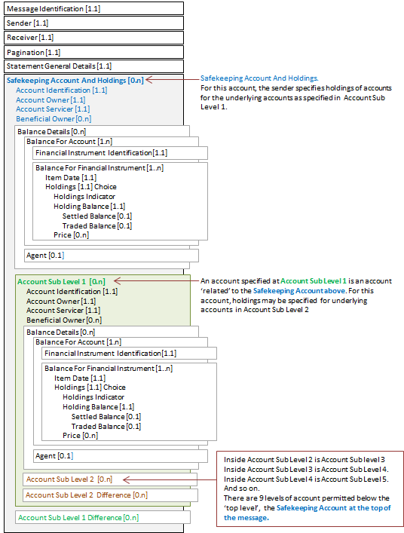

SecuritiesBalanceTransparencyReport semt.041.001.02 - 1

This diagram shows the flow of messages for the scenario illustrated by the business examples:

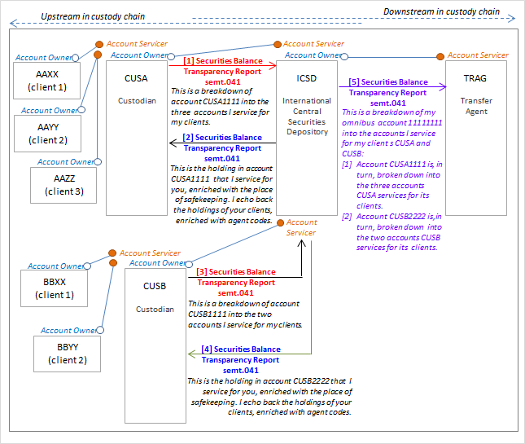

### SecuritiesBalanceTransparencyReport semt.041.001.02 Message 1

Message 1 from the above diagram

Description

CUSA (CUSALULL) sends a SecuritiesBalanceTransparencyReport message to ICSD (ICSDLULL) with a breakdown of the account that ICSD services for CUSA, account CUSA1111. (In the message, this account specified at the safekeeping account level.)

For this account, CUSA specifies the holdings of three accounts of its clients.

CUSA’s three clients account and holdings:

[1.1] Client AAXX (AAXXLULL), account AAXX-c1. For ISIN LU1234567890, the aggregated settled balance is 90 units, the aggregated traded balance is 100 units. (In the message, this is specified at account sub level 1 repetition 1.)

[1.2] Client AAYY (AAYYLLUU), account AAYY-c2. For ISIN LU1234567890, the aggregated settled balance is 110 units, the aggregated traded balance is 120 units. (In the message, this is specified at account sub level 1 repetition 2.)

[1.3] Client AAZZ (AAZZLULL), account AAZZ-c3. For ISIN LU1234567890, the aggregated settled balance is 400 units, the aggregated traded balance is 420 units. (In the message, this is specified at account sub level 1 repetition 3.)

Message Instance

| Message Data | Comment |
| --- | --- |
| <SctiesBalTrnsprncyRpt> |  |
| <MsgId> |  |
| <Id>22AD-7834DC</Id> | Technical message reference. |
| <CreDtTm>2017-02-28T18:00:00</CreDtTm> | Creation date and time of the message. |
| </MsgId> |  |
| <SndrId> |  |
| <Id> |  |
| <AnyBIC>CUSALULL</AnyBIC> | Sender of the statement. |
| </Id> |  |
| </SndrId> |  |
| <RcvrId> |  |
| <Id> |  |
| <AnyBIC>ICSDLULL</AnyBIC> | Receiver of the statement. |
| </Id> |  |
| </RcvrId> |  |
| <Pgntn> |  |
| <PgNb>1</PgNb> | Statement only contains 1 page. |
| <LastPgInd>true</LastPgInd> |  |
| </Pgntn> |  |
| <StmtGnlDtls> |  |
| <SndrBizRole>AOWN</SndrBizRole> | Sender of the message is the owner of the safekeeping account in SafekeepingAccountAndHoldings/ AccountIdentification and is disclosing the breakdown of the underlying owners of the sender’s holdings with the receiver. |
| <StmtNb> |  |
| <Shrt>015</Shrt> | Statement number. |
| </StmtNb> |  |
| <StmtId>OH_1023</StmtId> | Statement identification. |
| <StmtDtTm> |  |
| <Dt>2017-02-28</Dt> | Statement date. |
| </StmtDtTm> |  |
| <StmtPrd> |  |
| <Dt>2017-02-27</Dt> | Statement period. |
| </StmtPrd> |  |
| <Frqcy> |  |
| <Cd>DAIL</Cd> | Statement is daily. |
| </Frqcy> |  |
| <UpdTp> |  |
| <Cd>COMP</Cd> | Statement contains activity. |
| </UpdTp> |  |
| <ActvtyInd>true</ActvtyInd> |  |
| </StmtGnlDtls> |  |
| <SfkpgAcctAndHldgs> |  |
| <AcctId> | Omnibus account of the sender. For this account, the sender specifies holdings of accounts it services for its underlying clients, AAXX, AAYY and AAZZ.  Owner of the account.  Account servicer. |
| <Id>CUSA1111</Id> |
| </AcctId> |
| <AcctOwnr> |
| <Id> |
| <AnyBIC>CUSALULL</AnyBIC> |
| </Id> |
| </AcctOwnr> |
| <AcctSvcr> |
| <Id> |
| <AnyBIC>ICSDLULL</AnyBIC> |
| </Id> |
| </AcctSvcr> |
| <AcctSubLvl1> | Start of Account Sub Level 1, repetition 1. |
| <AcctId> | Account that the sender, CUSA, services for its client AAXX. |
| <Id>AAXX-c1</Id> |
| </AcctId> |
| <AcctOwnr> |
| <Id> |
| <AnyBIC>AAXXLULL</AnyBIC> |
| </Id> |
| </AcctOwnr> |
| <AcctSvcr> |
| <Id> |
| <AnyBIC>CUSALULL</AnyBIC> |
| </Id> |
| </AcctSvcr> |
| <BalDtls> |  |
| <BalForAcct> |  |
| <FinInstrmId> |  |
| <ISIN>LU1234567890</ISIN> | Identification of the holding. |
| </FinInstrmId> |  |
| <BalForFinInstrm> |  |
| <ItmDt>2017-02-27</ItmDt> | Item date. |
| <Hldgs> |  |
| <HldgBal> |  |
| <SttldBal> |  |
| <Unit>90</Unit> | Settled balance. |
| </SttldBal> |  |
| <TraddBal> |  |
| <Unit>100</Unit> | Traded balance. |
| </TraddBal> |  |
| </HldgBal> |  |
| </Hldgs> |  |
| </BalForFinInstrm> |  |
| </BalForAcct> |  |
| </BalDtls> |  |
| </AcctSubLvl1> | End of Account Sub Level 1, repetition 1. |
| <AcctSubLvl1> | Start of Account Sub Level 1, repetition 2. |
| <AcctId> | Account that the sender, CUSA, services for its client AAYY. |
| <Id>AAYY-c2</Id> |
| </AcctId> |
| <AcctOwnr> |
| <Id> |
| <AnyBIC>AAYYLULL</AnyBIC> |
| </Id> |
| </AcctOwnr> |
| <AcctSvcr> |
| <Id> |
| <AnyBIC>CUSALULL</AnyBIC> |
| </Id> |
| </AcctSvcr> |
| <BalDtls> |  |
| <BalForAcct> |  |
| <FinInstrmId> |  |
| <ISIN>LU1234567890</ISIN> | Identification of the holding. |
| </FinInstrmId> |  |
| <BalForFinInstrm> |  |
| <ItmDt>2017-02-27</ItmDt> | Item date. |
| <Hldgs> |  |
| <HldgBal> |  |
| <SttldBal> |  |
| <Unit>110</Unit> | Settled balance. |
| </SttldBal> |  |
| <TraddBal> |  |
| <Unit>120</Unit> | Traded balance. |
| </TraddBal> |  |
| </HldgBal> |  |
| </Hldgs> |  |
| </BalForFinInstrm> |  |
| </BalForAcct> |  |
| </BalDtls> |  |
| </AcctSubLvl1> | End of Account Sub Level 1, repetition 2. |
| <AcctSubLvl1> | Start of Account Sub Level 1, repetition 3. |
| <AcctId> | Account that the sender, CUSA, services for its client AAZZ |
| <Id>AAZZ-c3</Id> |
| </AcctId> |
| <AcctOwnr> |
| <Id> |
| <AnyBIC>AAZZLULL</AnyBIC> |
| </Id> |
| </AcctOwnr> |
| <AcctSvcr> |
| <Id> |
| <AnyBIC>CUSALULL</AnyBIC> |
| </Id> |
| </AcctSvcr> |
| <BalDtls> |  |
| <BalForAcct> |  |
| <FinInstrmId> |  |
| <ISIN>LU1234567890</ISIN> | Identification of the holding. |
| </FinInstrmId> |  |
| <BalForFinInstrm> |  |
| <ItmDt>2017-02-27</ItmDt> | Item date. |
| <Hldgs> |  |
| <HldgBal> |  |
| <SttldBal> |  |
| <Unit>400</Unit> | Settled balance. |
| </SttldBal> |  |
| <TraddBal> |  |
| <Unit>420</Unit> | Traded balance. |
| </TraddBal> |  |
| </HldgBal> |  |
| </Hldgs> |  |
| </BalForFinInstrm> |  |
| </BalForAcct> |  |
| </BalDtls> |  |
| </AcctSubLvl1> | End of Account Sub Level 1, repetition 3. |
| </SfkpgAcctAndHldgs> |  |
| </SctiesBalTrnsprncyRpt> |  |

Diagrammatical Overview

This diagram represents a simplified view of the Safekeeping Account And Holdings sequence of the xml message above.

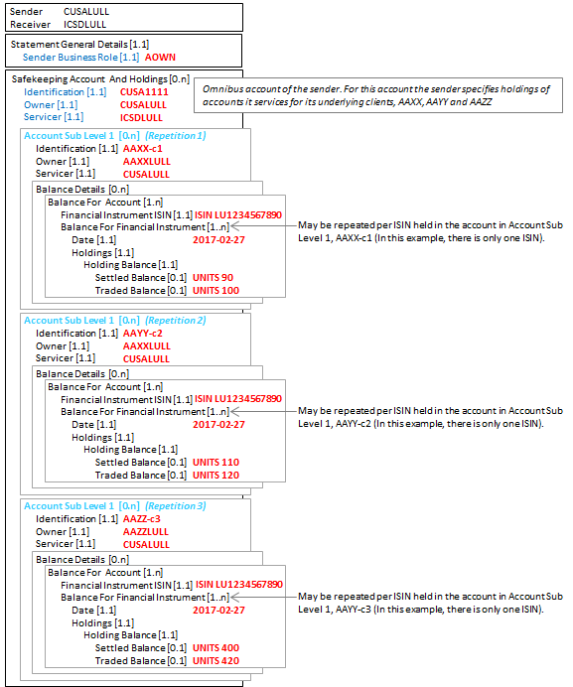

### SecuritiesBalanceTransparencyReport semt.041.001.02 Message 2

Message 2 from the above diagram

Description

ICSD (ICSDLULL), having received a SecuritiesBalanceTransparencyReport message from CUSA (CUSALULL), with the details of CUSA’s three customer accounts, sends a SecuritiesBalanceTransparencyReport message back to CUSA.

[1] The data is enriched with the place where the securities are held. The securities are held at TRAG, account 111111. (In the message, this is specified at safekeeping account level.)

[2] For account CUSA1111, the data is enriched with the holding and balance information. The holding is ISIN LU1234567890, the aggregated settled balance is 600 units and the aggregated traded balance is 640 units. (In the message, this is specified at account sub level 1.)

[3] In addition, the account data provided in the message received (message 1 in the flow) is echoed back and enriched with agent code information for CUSA’s underlying customer accounts:

CUSA’s three clients account and holdings:

[1.1] Client AAXX (AAXXLULL), account AAXX-c1. For ISIN LU1234567890, the aggregated settled balance is 90 units, the aggregated traded balance is 100 units.

The agent code for this client for this holding is 77777, issued by TRAGLULL, the role is distributor.

(In the message, this is specified at account sub level 2 repetition 1.)

[1.2] Client AAYY (AAYYLULL), account AAYY-c2. For ISIN LU1234567890, the aggregated settled balance is 110 units, the aggregated traded balance is 120 units.

The agent code for this client for this holding is AGNTLULL, a distributor.

(In the message, this is specified at account sub level 2 repetition 2.)

[1.3] Client AAZZ (AAZZLULL), account AAZZ-c3. For ISIN LU1234567890, the aggregated settled balance is 400 units, the traded balance is 420 units.

The agent for this client for this holding is DISTLULL, a distributor.

(In the message, this is specified at account sub level 2 repetition 3.)

Message Instance

| Message Data | Comment |
| --- | --- |
| <SctiesBalTrnsprncyRpt> |  |
| <MsgId> |  |
| <Id>803FC-43AC</Id> | Technical message reference. |
| <CreDtTm>2017-03-01T18:00:00</CreDtTm> | Creation date and time of the message. |
| </MsgId> |  |
| <SndrId> |  |
| <Id> |  |
| <AnyBIC>ICSDLULL</AnyBIC> | Sender of the statement. |
| </Id> |  |
| </SndrId> |  |
| <RcvrId> |  |
| <Id> |  |
| <AnyBIC>CUSALULL</AnyBIC> | Receiver of the statement. |
| </Id> |  |
| </RcvrId> |  |
| <Pgntn> |  |
| <PgNb>1</PgNb> | Statement only contains 1 page. |
| <LastPgInd>true</LastPgInd> |  |
| </Pgntn> |  |
| <StmtGnlDtls> |  |
| <SndrBizRole>ASER</SndrBizRole> | Sender of the message is the servicer of the account in ‘Account Sub Level 1 / Account Identification (<AcctSubLvl1><AcctId>) |
| <StmtNb> | Statement number. |
| <Shrt>101</Shrt> |  |
| </StmtNb> | Statement identification. |
| <StmtId>C1-004</StmtId> |  |
| <StmtDtTm> |  |
| <Dt>2017-03-01</Dt> | Statement date. |
| </StmtDtTm> |  |
| <StmtPrd> |  |
| <Dt>2017-02-27</Dt> | Statement period. |
| </StmtPrd> |  |
| <Frqcy> |  |
| <Cd>DAIL</Cd> | Statement is daily. |
| </Frqcy> |  |
| <UpdTp> |  |
| <Cd>COMP</Cd> |  |
| </UpdTp> |  |
| <ActvtyInd>true</ActvtyInd> |  |
| </StmtGnlDtls> |  |
| <SfkpgAcctAndHldgs> |  |
| <AcctId> | Place were the securities are kept (at ICSD’s account at TRAG (enrichment).  For this account, the sender specifies holdings of accounts it services for its underlying client, CUSA. |
| <Id>11111111</Id> |
| </AcctId> |
| <AcctOwnr> |
| <Id> |
| <AnyBIC>ICSDLULL</AnyBIC> |
| </Id> |
| </AcctOwnr> |
| <AcctSvcr> |
| <Id> |
| <AnyBIC>TRAGLULL</AnyBIC> |
| </Id> |
| </AcctSvcr> |
| <AcctSubLvl1> | Start of Account Sub Level 1, repetition 1. |
| <AcctId> | Account that the sender, ICSD, services for its client CUSA. |
| <Id>CUSA1111</Id> |
| </AcctId> |
| <AcctOwnr> |
| <Id> |
| <AnyBIC>CUSALULL</AnyBIC> |
| </Id> |
| </AcctOwnr> |
| <AcctSvcr> |
| <Id> |
| <AnyBIC>ICSDLULL</AnyBIC> |
| </Id> |
| </AcctSvcr> |
| <BalDtls> |  |
| <BalForAcct> |  |
| <FinInstrmId> |  |
| <ISIN>LU1234567890</ISIN> | Identification of the holding. |
| </FinInstrmId> |  |
| <BalForFinInstrm> |  |
| <ItmDt>2017-02-27</ItmDt> | Item date. |
| <Hldgs> |  |
| <HldgBal> |  |
| <SttldBal> | Settled balance of account CUSA1111. This may be sum of the three settlement balance elements for the accounts reported at sub level 2. (If not then, this is reported in the AccountSubLevel2Difference element.) |
| <Unit>600</Unit> |
| </SttldBal> |
| <TraddBal> | Traded balance of account CUSA1111. This may be sum of the three traded balance elements for the accounts reported at sub level 2. (If not then this is reported in the AccountSubLevel2Differenceelement.) |
| <Unit>640</Unit> |
| </TraddBal> |
| </HldgBal> |  |
| </Hldgs> |  |
| </BalForFinInstrm> |  |
| </BalForAcct> |  |
| </BalDtls> |  |
| <AcctSubLvl2> | Start of Account Sub Level 2, repetition 1. |
| <AcctId> | Account that the client of ICSD, CUSA, in turn, services for its client AAXX |
| <Id>AAXX-c1</Id> |
| </AcctId> |
| <AcctOwnr> |
| <Id> |
| <AnyBIC>AAXXLULL</AnyBIC> |
| </Id> |
| </AcctOwnr> |
| <AcctSvcr> |
| <Id> |
| <AnyBIC>CUSALULL</AnyBIC> |
| </Id> |
| </AcctSvcr> |
| <BalDtls> |  |
| <BalForAcct> |  |
| <FinInstrmId> |  |
| <ISIN>LU1234567890</ISIN> | Identification of the holding. |
| </FinInstrmId> |  |
| <BalForFinInstrm> |  |
| <ItmDt>2017-02-27</ItmDt> | Item date. |
| <Hldgs> |  |
| <HldgBal> |  |
| <SttldBal> |  |
| <Unit>90</Unit> | Settled balance. |
| </SttldBal> |  |
| <TraddBal> |  |
| <Unit>100</Unit> | Traded balance. |
| </TraddBal> |  |
| </HldgBal> |  |
| </Hldgs> |  |
| </BalForFinInstrm> |  |
| </BalForAcct> |  |
| <Agt> | Agent code for AAXX that has been assigned by the transfer agent (enrichment by the sender, ICSD). |
| <Id> |
| <Id> |
| <PrtryId> |
| <Id>77777</Id> |
| <Issr>TRAGLULL</Issr> |
| </PrtryId> |
| </Id> |
| </Id> |
| <Role> |
| <Cd>DIST</Cd> |
| </Role> |
| </Agt> |
| </BalDtls> |  |
| </AcctSubLvl2> | End of Account Sub Level 2, repetition 1. |
| <AcctSubLvl2> | Start of Account Sub Level 2, repetition 2. |
| <AcctId> | Account that the client of ICSD, CUSA, in turn, services for its client AAYY. |
| <Id>AAYY-c2</Id> |
| </AcctId> |
| <AcctOwnr> |
| <Id> |
| <AnyBIC>AAYYLULL</AnyBIC> |
| </Id> |
| </AcctOwnr> |
| <AcctSvcr> |
| <Id> |
| <AnyBIC>CUSALULL</AnyBIC> |
| </Id> |
| </AcctSvcr> |
| <BalDtls> |  |
| <BalForAcct> |  |
| <FinInstrmId> |  |
| <ISIN>LU1234567890</ISIN> | Identification of the holding. |
| </FinInstrmId> |  |
| <BalForFinInstrm> |  |
| <ItmDt>2017-02-27</ItmDt> | Item date. |
| <Hldgs> |  |
| <HldgBal> |  |
| <SttldBal> |  |
| <Unit>110</Unit> | Settled balance. |
| </SttldBal> |  |
| <TraddBal> |  |
| <Unit>120</Unit> | Traded balance. |
| </TraddBal> |  |
| </HldgBal> |  |
| </Hldgs> |  |
| </BalForFinInstrm> |  |
| </BalForAcct> |  |
| <Agt> | Agent code for AAYY (enrichment by the sender, ICSD). |
| <Id> |
| <Id> |
| <AnyBIC>AGNTLULL</AnyBIC> |
| </Id> |
| </Id> |
| <Role> |
| <Cd>DIST</Cd> |
| </Role> |
| </Agt> |
| </BalDtls> |  |
| </AcctSubLvl2> | End of Account Sub Level 2, repetition 2. |
| <AcctSubLvl2> | Start of Account Sub Level 2, repetition 3. |
| <AcctId> | Account that the client of ICSD, CUSA, in turn, services for its client AAZZ. |
| <Id>AAZZ-c3</Id> |
| </AcctId> |
| <AcctOwnr> |
| <Id> |
| <AnyBIC>AAZZLULL</AnyBIC> |
| </Id> |
| </AcctOwnr> |
| <AcctSvcr> |
| <Id> |
| <AnyBIC>CUSALULL</AnyBIC> |
| </Id> |
| </AcctSvcr> |
| <BalDtls> |  |
| <BalForAcct> |  |
| <FinInstrmId> |  |
| <ISIN>LU1234567890</ISIN> | Identification of the holding. |
| </FinInstrmId> |  |
| <BalForFinInstrm> |  |
| <ItmDt>2017-02-27</ItmDt> | Item date. |
| <Hldgs> |  |
| <HldgBal> |  |
| <SttldBal> |  |
| <Unit>400</Unit> | Settled balance. |
| </SttldBal> |  |
| <TraddBal> |  |
| <Unit>420</Unit> | Traded balance. |
| </TraddBal> |  |
| </HldgBal> |  |
| </Hldgs> |  |
| </BalForFinInstrm> |  |
| </BalForAcct> |  |
| <Agt> | Agent code for AAYY (enrichment by the sender, ICSD). |
| <Id> |
| <Id> |
| <AnyBIC>DISTLULL</AnyBIC> |
| </Id> |
| </Id> |
| <Role> |
| <Cd>DIST</Cd> |
| </Role> |
| </Agt> |
| </BalDtls> |  |
| </AcctSubLvl2> | End of Account Sub Level 2, repetition 3. |
| </AcctSubLvl1> | End of Account Sub Level 1, repetition 1. |
| </SfkpgAcctAndHldgs> |  |
| </SctiesBalTrnsprncyRpt> |  |

Diagrammatic Overview

This diagram represents a simplified view of the safekeeping account sequence with sub level 1 and sub level 2 account sequences from the xml message above.

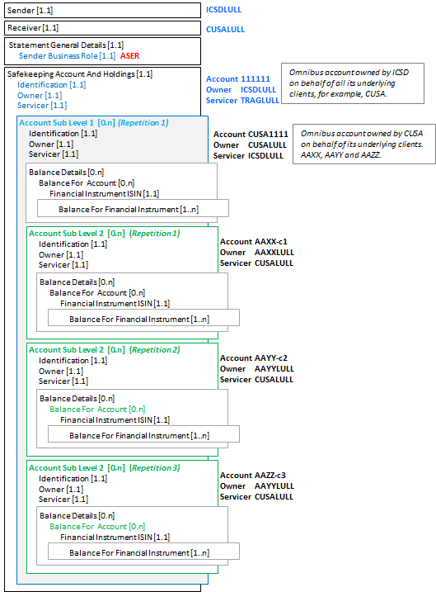

### SecuritiesBalanceTransparencyReport semt.041.001.02 Message 3

Message 3 from the above diagram

Description

ICSD (ICSDLULL) receives a similar SecuritiesBalanceTransparencyReport message from CUSB (CUSBLULL) for its account and the accounts CUSB services for its two clients, BBXX and BBYY.

This XML message, message 3, is not shown.

### SecuritiesBalanceTransparencyReport semt.041.001.02 Message 4

Messages 4 from the above diagram

Description

Having received a SecuritiesBalanceTransparencyReport message from CUSB (CUSBLULL) for its account and the accounts CUSB services for its two clients, BBXX and BBYY, ICSD (ICSDLULL), ICSD may respond with an enriched SecuritiesBalanceTransparencyReport message, enriched with the place of safekeeping and agent code information for CUSB’s two client accounts.

This XML message, message 4, is not shown.

### SecuritiesBalanceTransparencyReport semt.041.001.02 Message 5

Message 5 from the above diagram

ICSD is now in a position to send a SecuritiesBalanceTransparencyReport to TRAG with full information about its clients and the clients of its clients. This provides:

[1] Identification of ICSD’s account at TRAG

[2] Account information for ICSD’s customer, AAAA, account CUSA1111, and its three underlying client accounts

[3] Account information for ICSD’s customer, BBBB, account CUSB1111, and its two underlying client accounts

Description

ICSD (ICSDLULL) sends a SecuritiesBalanceTransparencyReport message to TRAG (TRAGLULL) with a breakdown of holdings in its omnibus, account 11111111 (in the message, this is specified at safekeeping account level), into the customer accounts that ICSD, in turn, services for its two clients.

[1] ICSDs first client, custodian CUSA (CUSALULL), account CUSA1111

For account CUSA1111, the holding is ISIN LU1234567890, the aggregated settled balance is 600 units, the aggregate traded balance is 640 units. (in the message, this data is specified at account sub level 1, 1st repetition)

CUSA’s three clients account and holdings

[1.1] Client AAXX (AAXXLULL), account AAXX-c1. For ISIN LU1234567890, the aggregated settled balance is 90 units, the aggregated traded balance is 100 units.

The agent code for this client for this holding is 77777, issued by TRAGLULL, the role is distributor.

(In the message, this is specified at account sub level 2 repetition 1.)

[1.2] Client AAYY (AAYYLULL), account AAYY-c2. For ISIN LU1234567890, the aggregated settled balance is 110 units, the aggregated traded balance is 120 units.

The agent code for this client for this holding is AGNTLULL, a distributor.

(In the message, this data is specified at account sub level 2 repetition 2.)

[1.3] Client AAZZ (AAZZLULL), account AAZZ-c3. For ISIN LU1234567890, the aggregated settled balance is 400 units, the aggregated traded balance is 420 units.

The agent for this client for this holding is DISTLULL, a distributor.

(In the message, this data is specified at account sub level 2 repetition 3.)

[2] ICSDs second client, custodian CUSB (CUSBLULL), account CUSB2222

For account CUSB2222, the holding is ISIN LU1234567890, the aggregated settled balance is 1000 units, the aggregate traded balance is 1200 units. (in the message, this data specified at account sub level 1, 1st repetition)

CUSB’s two clients account and holdings

[2.1] Client BBXX (BBXXLULL), account BBXX-c1. For ISIN LU1234567890, the aggregated settled balance is 600 units, the aggregated traded balance is 700 units.

The agent code for this client for this holding is, 77777, issued by TRAGLULL, a distributor.

(In the message, this data is specified at account sub level 2 repetition 1.)

[2.2] Client BBYY (BBYYLULL), account BBYY-c2. For ISIN LU1234567890, the aggregated settled balance is 400 units, the aggregated traded balance is 500 units.

The agent code for this client for this holding is AGNTLULL, a distributor.

(In the message, this data is specified at account sub level 2 repetition 2.)

Message Instance - message 5

| Message Data | Comment |
| --- | --- |
| <SctiesBalTrnsprncyRpt> |  |
| <MsgId> |  |
| <Id>803FC-66AC</Id> | Technical message reference. |
| <CreDtTm>2017-03-01T18:00:00</CreDtTm> | Creation date and time of the message. |
| </MsgId> |  |
| <SndrId> |  |
| <Id> |  |
| <AnyBIC>ICSDLULL</AnyBIC> | Sender of the statement. |
| </Id> |  |
| </SndrId> |  |
| <RcvrId> |  |
| <Id> |  |
| <AnyBIC>TRAGLULL</AnyBIC> | Receiver of the statement. |
| </Id> |  |
| </RcvrId> |  |
| <Pgntn> |  |
| <PgNb>1</PgNb> | Statement only contains 1 page. |
| <LastPgInd>true</LastPgInd> |  |
| </Pgntn> |  |
| <StmtGnlDtls> |  |
| <SndrBizRole>AOWN</SndrBizRole> | Sender of the message is the owner of the safekeeping account in SafekeepingAccountAndHoldings/ AccountIdentification and is disclosing the breakdown of the underlying owners of the sender’s holdings with the receiver. |
| <StmtNb> |  |
| <Shrt>120</Shrt> | Statement number. |
| </StmtNb> |  |
| <StmtId>T2-006</StmtId> | Statement identification. |
| <StmtDtTm> |  |
| <Dt>2017-03-01</Dt> | Statement date. |
| </StmtDtTm> |  |
| <StmtPrd> |  |
| <Dt>2017-02-27</Dt> | Statement period. |
| </StmtPrd> |  |
| <Frqcy> |  |
| <Cd>DAIL</Cd> | Statement is daily. |
| </Frqcy> |  |
| <UpdTp> |  |
| <Cd>COMP</Cd> |  |
| </UpdTp> |  |
| <ActvtyInd>true</ActvtyInd> |  |
| </StmtGnlDtls> |  |
| <SfkpgAcctAndHldgs> |  |
| <AcctId> | Omnibus account for which the sender specifies holdings of accounts it services for its underlying clients CUSA and CUSB.  Owner of the account.  Account Servicer |
| <Id>11111111</Id> |
| </AcctId> |
| <AcctOwnr> |
| <Id> |
| <AnyBIC>ICSDLULL</AnyBIC> |
| </Id> |
| </AcctOwnr> |
| <AcctSvcr> |
| <Id> |
| <AnyBIC>TRAGLULL</AnyBIC> |
| </Id> |
| </AcctSvcr> |
| <AcctSubLvl1> | Start of Account Sub Level 1, repetition 1. |
| <AcctId> | Account that the sender, ICSD, services for its client CUSA. |
| <Id>CUSA111</Id> |
| </AcctId> |
| <AcctOwnr> |
| <Id> |
| <AnyBIC>CUSALULL</AnyBIC> |
| </Id> |
| </AcctOwnr> |
| <AcctSvcr> |
| <Id> |
| <AnyBIC>ICSDLULL</AnyBIC> |
| </Id> |
| </AcctSvcr> |
| <BalDtls> |  |
| <BalForAcct> |  |
| <FinInstrmId> |  |
| <ISIN>LU1234567890</ISIN> | Identification of the holding. |
| </FinInstrmId> |  |
| <BalForFinInstrm> |  |
| <ItmDt>2017-02-27</ItmDt> | Item date. |
| <Hldgs> |  |
| <HldgBal> |  |
| <SttldBal> |  |
| <Unit>600</Unit> | Settled balance. |
| </SttldBal> |  |
| <TraddBal> |  |
| <Unit>640</Unit> | Traded balance. |
| </TraddBal> |  |
| </HldgBal> |  |
| </Hldgs> |  |
| </BalForFinInstrm> |  |
| </BalForAcct> |  |
| </BalDtls> |  |
| <AcctSubLvl2> | Start of Account Sub Level 2, repetition 1. |
| <AcctId> | Account serviced by CUSA for its client AAXX. |
| <Id>AAXX-c1</Id> |
| </AcctId> |
| <AcctOwnr> |
| <Id> |
| <AnyBIC>AAXXLULL</AnyBIC> |
| </Id> |
| </AcctOwnr> |
| <AcctSvcr> |
| <Id> |
| <AnyBIC>CUSALULL</AnyBIC> |
| </Id> |
| </AcctSvcr> |
| <BalDtls> |  |
| <BalForAcct> |  |
| <FinInstrmId> |  |
| <ISIN>LU1234567890</ISIN> | Identification of the holding. |
| </FinInstrmId> |  |
| <BalForFinInstrm> |  |
| <ItmDt>2017-02-27</ItmDt> | Item date. |
| <Hldgs> |  |
| <HldgBal> |  |
| <SttldBal> |  |
| <Unit>90</Unit> | Settled balance. |
| </SttldBal> |  |
| <TraddBal> |  |
| <Unit>100</Unit> | Traded balance |
| </TraddBal> |  |
| </HldgBal> |  |
| </Hldgs> |  |
| </BalForFinInstrm> |  |
| </BalForAcct> |  |
| <Agt> | Agent code for AAXX that has been assigned by the transfer agent (enrichment by the sender, ICSD). |
| <Id> |
| <Id> |
| <PrtryId> |
| <Id>77777</Id> |
| <Issr>TRAGLULL</Issr> |
| </PrtryId> |
| </Id> |
| </Id> |
| <Role> |
| <Cd>DIST</Cd> |
| </Role> |
| </Agt> |
| </BalDtls> |  |
| </AcctSubLvl2> | End of Account Sub Level 2, repetition 1. |
| <AcctSubLvl2> | Start of Account Sub Level 2, repetition 2. |
| <AcctId> | Account serviced by CUSA for its client AAYY. |
| <Id>AAYY-c2</Id> |
| </AcctId> |
| <AcctOwnr> |
| <Id> |
| <AnyBIC>AAYYLULL</AnyBIC> |
| </Id> |
| </AcctOwnr> |
| <AcctSvcr> |
| <Id> |
| <AnyBIC>CUSALULL</AnyBIC> |
| </Id> |
| </AcctSvcr> |
| <BalDtls> |  |
| <BalForAcct> |  |
| <FinInstrmId> |  |
| <ISIN>LU1234567890</ISIN> | Identification of the holding. |
| </FinInstrmId> |  |
| <BalForFinInstrm> |  |
| <ItmDt>2017-02-27</ItmDt> | Item date. |
| <Hldgs> |  |
| <HldgBal> |  |
| <SttldBal> |  |
| <Unit>110</Unit> | Settled balance. |
| </SttldBal> |  |
| <TraddBal> |  |
| <Unit>120</Unit> | Traded balance |
| </TraddBal> |  |
| </HldgBal> |  |
| </Hldgs> |  |
| </BalForFinInstrm> |  |
| </BalForAcct> |  |
| <Agt> | Agent code for AAYY that has been assigned by the transfer agent (enrichment by the sender, ICSD). |
| <Id> |
| <Id> |
| <AnyBIC>AGNTLULL</AnyBIC> |
| </Id> |
| </Id> |
| <Role> |
| <Cd>DIST</Cd> |
| </Role> |
| </Agt> |
| </BalDtls> |  |
| </AcctSubLvl2> | End of Account Sub Level 2, repetition 2. |
| <AcctSubLvl2> | Start of Account Sub Level 2, repetition 3. |
| <AcctId> | Account serviced by CUSA for its client AAZZ. |
| <Id>AAZZ-c3</Id> |
| </AcctId> |
| <AcctOwnr> |
| <Id> |
| <AnyBIC>AAZZLULL</AnyBIC> |
| </Id> |
| </AcctOwnr> |
| <AcctSvcr> |
| <Id> |
| <AnyBIC>CUSALULL</AnyBIC> |
| </Id> |
| </AcctSvcr> |
| <BalDtls> |  |
| <BalForAcct> |  |
| <FinInstrmId> |  |
| <ISIN>LU1234567890</ISIN> | Identification of the holding. |
| </FinInstrmId> |  |
| <BalForFinInstrm> |  |
| <ItmDt>2017-02-27</ItmDt> | Item date. |
| <Hldgs> |  |
| <HldgBal> |  |
| <SttldBal> |  |
| <Unit>400</Unit> | Settled balance. |
| </SttldBal> |  |
| <TraddBal> |  |
| <Unit>420</Unit> | Traded balance |
| </TraddBal> |  |
| </HldgBal> |  |
| </Hldgs> |  |
| </BalForFinInstrm> |  |
| </BalForAcct> |  |
| <Agt> | Agent code for AAZZ that has been assigned by the transfer agent (enrichment by the sender, ICSD). |
| <Id> |
| <Id> |
| <AnyBIC>DISTLULL</AnyBIC> |
| </Id> |
| </Id> |
| <Role> |
| <Cd>DIST</Cd> |
| </Role> |
| </Agt> |
| </BalDtls> |  |
| </AcctSubLvl2> | End of Account Sub Level 2, repetition 3 |
| </AcctSubLvl1> | End of Account Sub Level 1, repetition 1. |
| <AcctSubLvl1> | Start of Account Sub Level 1, repetition 2. |
| <AcctId> | Account that the sender, ICSD, services for its client CUSB. |
| <Id>CUSB2222</Id> |
| </AcctId> |
| <AcctOwnr> |
| <Id> |
| <AnyBIC>CUSBLULL</AnyBIC> |
| </Id> |
| </AcctOwnr> |
| <AcctSvcr> |
| <Id> |
| <AnyBIC>ICSDLULL</AnyBIC> |
| </Id> |
| </AcctSvcr> |
| <BalDtls> |  |
| <BalForAcct> |  |
| <FinInstrmId> |  |
| <ISIN>LU1234567890</ISIN> | Identification of the holding. |
| </FinInstrmId> |  |
| <BalForFinInstrm> |  |
| <ItmDt>2017-02-27</ItmDt> | Item date. |
| <Hldgs> |  |
| <HldgBal> |  |
| <SttldBal> |  |
| <Unit>1000</Unit> | Settled balance. |
| </SttldBal> |  |
| <TraddBal> |  |
| <Unit>1200</Unit> | Traded balance. |
| </TraddBal> |  |
| </HldgBal> |  |
| </Hldgs> |  |
| </BalForFinInstrm> |  |
| </BalForAcct> |  |
| </BalDtls> |  |
| <AcctSubLvl2> | Start of Account Sub Level 2, repetition 1. |
| <AcctId> | Account serviced by CUSA for its client BBXX. |
| <Id>BBXX-c1</Id> |
| </AcctId> |
| <AcctOwnr> |
| <Id> |
| <AnyBIC>BBXXLULL</AnyBIC> |
| </Id> |
| </AcctOwnr> |
| <AcctSvcr> |
| <Id> |
| <AnyBIC>CUSBLULL</AnyBIC> |
| </Id> |
| </AcctSvcr> |
| <BalDtls> |  |
| <BalForAcct> |  |
| <FinInstrmId> |  |
| <ISIN>LU1234567890</ISIN> | Identification of the holding. |
| </FinInstrmId> |  |
| <BalForFinInstrm> |  |
| <ItmDt>2017-02-27</ItmDt> | Item date. |
| <Hldgs> |  |
| <HldgBal> |  |
| <SttldBal> |  |
| <Unit>600</Unit> | Settled balance. |
| </SttldBal> |  |
| <TraddBal> |  |
| <Unit>700</Unit> | Traded balance. |
| </TraddBal> |  |
| </HldgBal> |  |
| </Hldgs> |  |
| </BalForFinInstrm> |  |
| </BalForAcct> |  |
| </BalDtls> |  |
| </AcctSubLvl2> | End of Account Sub Level 2, repetition 1. |
| <AcctSubLvl2> | Start of Account Sub Level 2, repetition 2. |
| <AcctId> | Account serviced by CUSA for its client BBYY. |
| <Id>BBYY-c2</Id> |
| </AcctId> |
| <AcctOwnr> |
| <Id> |
| <AnyBIC>BBYYLULL</AnyBIC> |
| </Id> |
| </AcctOwnr> |
| <AcctSvcr> |
| <Id> |
| <AnyBIC>CUSBLULL</AnyBIC> |
| </Id> |
| </AcctSvcr> |
| <BalDtls> |  |
| <BalForAcct> |  |
| <FinInstrmId> |  |
| <ISIN>LU1234567890</ISIN> | Identification of the holding. |
| </FinInstrmId> |  |
| <BalForFinInstrm> |  |
| <ItmDt>2017-02-27</ItmDt> | Item date. |
| <Hldgs> |  |
| <HldgBal> |  |
| <SttldBal> |  |
| <Unit>400</Unit> | Settled balance. |
| </SttldBal> |  |
| <TraddBal> |  |
| <Unit>500</Unit> | Traded balance |
| </TraddBal> |  |
| </HldgBal> |  |
| </Hldgs> |  |
| </BalForFinInstrm> |  |
| </BalForAcct> |  |
| </BalDtls> |  |
| </AcctSubLvl2> | End of Account Sub Level 2, repetition 2. |
| </AcctSubLvl1> | End of Account Sub Level 1, repetition 2 |
| </SfkpgAcctAndHldgs> |  |
| </SctiesBalTrnsprncyRpt> |  |

Diagrammatic Overview

This diagram represents a simplified view of the safekeeping account sequence with sub level 1 and sub level 2 account sequences.

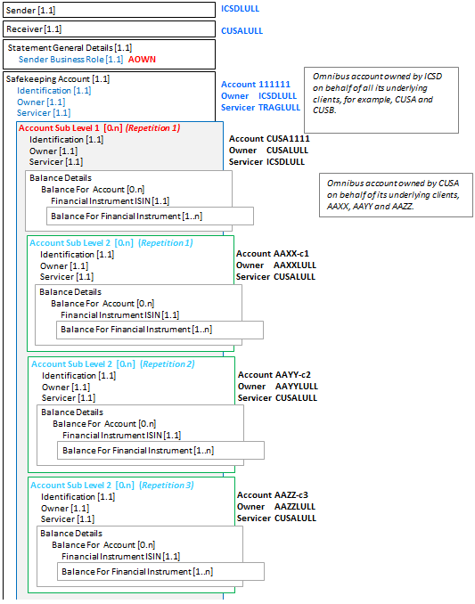

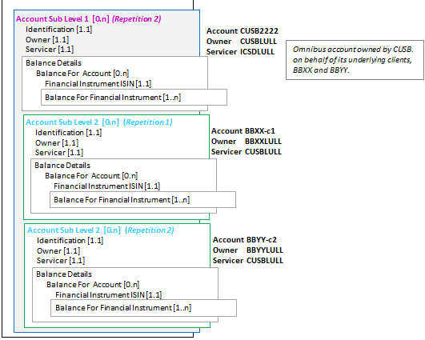

### SecuritiesBalanceTransparencyReport semt.041.001.02 - 2

This diagram shows the flow of messages for the scenario illustrated by the business examples.

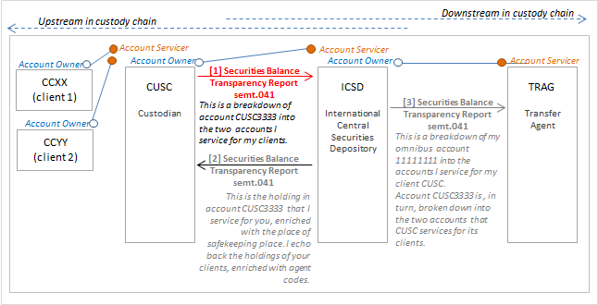

### SecuritiesBalanceTransparencyReport semt.041.001.02 Message 1

Message 1 from the above diagram

Description

CUSC (CUSCLULL) sends a SecuritiesBalanceTransparencyReport message to ICSD (ICSDLULL) with a breakdown of the account that ICSD services for CUSC, account CUSC3333. (In the message, this account specified at the safekeeping account level.)

For this account, CUSC specifies the holdings of two accounts of its clients.

CUSC’s two clients account and holdings

[1.1] Client CCXX (CCXXLULL), account CCXX-c1. For ISIN LU1234567890, the aggregated settled balance is 1500 units, the aggregated traded balance is 1700 units. (In the message, this is specified at account sub level 1 repetition 1.)

The following balance breakdowns are specified:

150 units are traded and pending settlement (PNET).

50 units are traded and pending settlement is overdue (OPNT).

[1.2] Client CCYY (CCYYLULL), account CCYY-c2. For ISIN LU1234567890, the aggregated settled balance is 4700 units, the aggregated traded balance is 5000 units. (In the message, this is specified at account sub level 1 repetition 2.)

The following balance breakdowns are specified:

260 units are traded and pending settlement (PNET).

40 units are traded and pending settlement is overdue (OPNT).

| Message Data | Comment |
| --- | --- |
| <SctiesBalTrnsprncyRpt> |  |
| <MsgId> |  |
| <Id>17AF-567CD</Id> | Technical message reference. |
| <CreDtTm>2017-03-02T18:00:00</CreDtTm> | Creation date and time of the message. |
| </MsgId> |  |
| <SndrId> |  |
| <Id> |  |
| <AnyBIC>CUSCLULL</AnyBIC> | Sender of the statement. |
| </Id> |  |
| </SndrId> |  |
| <RcvrId> |  |
| <Id> |  |
| <AnyBIC>ICSDLULL</AnyBIC> | Receiver of the statement. |
| </Id> |  |
| </RcvrId> |  |
| <Pgntn> |  |
| <PgNb>1</PgNb> | Statement only contains 1 page. |
| <LastPgInd>true</LastPgInd> |  |
| </Pgntn> |  |
| <StmtGnlDtls> |  |
| <SndrBizRole>AOWN</SndrBizRole> | Sender of the message is the owner of the safekeeping account in SafekeepingAccountAndHoldings/ AccountIdentification and is disclosing the breakdown of the underlying owners of the sender’s holdings with the receiver. |
| <StmtNb> |  |
| <Shrt>003</Shrt> | Statement number. |
| </StmtNb> |  |
| <StmtId>STRANS</StmtId> | Statement identification. |
| <StmtDtTm> |  |
| <Dt>2017-03-02</Dt> | Statement date. |
| </StmtDtTm> |  |
| <StmtPrd> |  |
| <Dt>2017-02-27</Dt> | Statement period. |
| </StmtPrd> |  |
| <ActvtyInd>true</ActvtyInd> |  |
| </StmtGnlDtls> |  |
| <SfkpgAcctAndHldgs> |  |
| <AcctId> | Account for which the sender specifies holdings of accounts it services for its underlying clients CCXX and XXYY. |
| <Id>CUSC3333</Id> |
| </AcctId> |
| <AcctOwnr> |
| <Id> |
| <AnyBIC>CUSCLULL</AnyBIC> |
| </Id> |
| </AcctOwnr> |
| <AcctSvcr> |
| <Id> |
| <AnyBIC>ICSDLULL</AnyBIC> |
| </Id> |
| </AcctSvcr> |
| <AcctSubLvl1> | Start of Account Sub Level 1, repetition 1. |
| <AcctId> | Account of the first client. |
| <Id>CCXX-c1</Id> |
| </AcctId> |
| <AcctOwnr> |
| <Id> |
| <AnyBIC>CCXXLULL</AnyBIC> |
| </Id> |
| </AcctOwnr> |
| <AcctSvcr> |
| <Id> |
| <AnyBIC>CUSCLULL</AnyBIC> |
| </Id> |
| </AcctSvcr> |
| <BalDtls> |  |
| <BalForAcct> |  |
| <FinInstrmId> |  |
| <ISIN>LU1234567890</ISIN> | Identification of the holding. |
| </FinInstrmId> |  |
| <BalForFinInstrm> |  |
| <ItmDt>2017-02-27</ItmDt> | Item date. |
| <Hldgs> |  |
| <HldgBal> |  |
| <SttldBal> |  |
| <Unit>1500</Unit> | Settled balance. |
| </SttldBal> |  |
| <TraddBal> |  |
| <Unit>1700</Unit> | Traded balance. |
| </TraddBal> |  |
| <BalBrkdwn> | Balance breakdown repetition 1. |
| <SubBalTp> | Sub balance: number of units traded and pending settlement. |
| <Cd>PNET</Cd> |
| </SubBalTp> |
| <Qty> |
| <Qty> |
| <Unit>150</Unit> |
| </Qty> |
| </Qty> |
| </BalBrkdwn> | End of balance breakdown repetition 1. |
| <BalBrkdwn> | Balance breakdown repetition 2. |
| <SubBalTp> | Sub balance: number of units traded and pending settlement and settlement is overdue |
| <Cd>OPNT</Cd> |
| </SubBalTp> |
| <Qty> |
| <Qty> |
| <Unit>50</Unit> |
| </Qty> |
| </Qty> |
| </BalBrkdwn> | End of balance breakdown repetition 2. |
| </HldgBal> |  |
| </Hldgs> |  |
| </BalForFinInstrm> |  |
| </BalForAcct> |  |
| </BalDtls> |  |
| </AcctSubLvl1> | End of Account Sub Level 1, repetition 1. |
| <AcctSubLvl1> | Start of Account Sub Level 1, repetition 2. |
| <AcctId> | Account of the second client. |
| <Id>CCYY-c2</Id> |
| </AcctId> |
| <AcctOwnr> |
| <Id> |
| <AnyBIC>CCYYLULL</AnyBIC> |
| </Id> |
| </AcctOwnr> |
| <AcctSvcr> |
| <Id> |
| <AnyBIC>CUSCLULL</AnyBIC> |
| </Id> |
| </AcctSvcr> |
| <BalDtls> |  |
| <BalForAcct> |  |
| <FinInstrmId> |  |
| <ISIN>LU1234567890</ISIN> | Identification of the holding. |
| </FinInstrmId> |  |
| <BalForFinInstrm> |  |
| <ItmDt>2017-02-27</ItmDt> | Item date. |
| <Hldgs> |  |
| <HldgBal> |  |
| <SttldBal> |  |
| <Unit>4700</Unit> | Settled balance. |
| </SttldBal> |  |
| <TraddBal> |  |
| <Unit>5000</Unit> | Traded balance. |
| </TraddBal> |  |
| <BalBrkdwn> | Balance breakdown repetition 1. |
| <SubBalTp> | Sub balance: number of units traded and pending settlement. |
| <Cd>PNET</Cd> |
| </SubBalTp> |
| <Qty> |
| <Qty> |
| <Unit>260</Unit> |
| </Qty> |
| </Qty> |
| </BalBrkdwn> | End of balance breakdown repetition 1. |
| <BalBrkdwn> | Balance breakdown repetition 2. |
| <SubBalTp> | Sub balance: number of units traded and pending settlement and settlement is overdue |
| <Cd>OPNT</Cd> |
| </SubBalTp> |
| <Qty> |
| <Qty> |
| <Unit>40</Unit> |
| </Qty> |
| </Qty> |
| </BalBrkdwn> | End of balance breakdown repetition 2. |
| </HldgBal> |  |
| </Hldgs> |  |
| </BalForFinInstrm> |  |
| </BalForAcct> |  |
| </BalDtls> |  |
| </AcctSubLvl1> | End of Account Sub Level 1, repetition 2. |
| </SfkpgAcctAndHldgs> |  |
| </SctiesBalTrnsprncyRpt> |  |

The other messages in this scenario are not illustrated with XML message instances.

### SecuritiesBalanceTransparencyReportStatusAdvice semt.042.001.01

Description

ICSD (ICSDLULL) receives a SecuritiesBalanceTransparencyReport (semt.041) message from CUSA (CUSALULL).

Following processing, ICSD responds with a Securities Balance Transparency Report Status Advice (semt.042).

This status message provides details on the acceptance of a SecuritiesBalanceTransparencyReport message with statement identification OH_1023 which provide details of three holdings.

The status message specifies that the holdings in the original SecuritiesBalanceTransparencyReport message are rejected because the ISIN of the financial instrument is invalid. The general details are still valid, so the status is accepted with exception.

Message Instance

| Message Data | Comment |
| --- | --- |
| <SctiesBalTrnsprncyRptStsAdvc> |  |
| <MsgId> |  |
| <Id>18CA345-DC</Id> | Technical message reference. |
| <CreDtTm>2015-02-28T18:01:00</CreDtTm> | Creation date and time of the message. |
| </MsgId> |  |
| <SndrId> |  |
| <Id> |  |
| <AnyBIC>ICSDLULL</AnyBIC> | Sender of the status advice. |
| </Id> |  |
| </SndrId> |  |
| <RcvrId> |  |
| <Id> |  |
| <AnyBIC>CUSALULL</AnyBIC> | Receiver of the status advice. |
| </Id> |  |
| </RcvrId> |  |
| <RltdStmt> |  |
| <StmtId>OH_1023</StmtId> | Statement identification. |
| <StmtDtTm> |  |
| <Dt>2015-02-28</Dt> | Statement date. |
| </StmtDtTm> |  |
| <Pgntn> |  |
| <PgNb>1</PgNb> | Status advice only contains 1 page. |
| <LastPgInd>true</LastPgInd> |  |
| </Pgntn> |  |
| </RltdStmt> |  |
| <Sts> |  |
| <AccptdWthXcptn> | Status is accepted with exception |
| <Xcptn> |  |
| <Cd>DSEC</Cd> | Invalid security |
| </Xcptn> |  |
| <RptItm> | Start of Holding repetition 1. |
| <AcctId> | Account and financial instrument for the status is provided (1) |
| <Id>AAXX-c1</Id> |
| </AcctId> |
| <AcctLvl>LVL1</AcctLvl> |
| <FinInstrmId> |
| <ISIN>LU1234567890</ISIN> |
| </FinInstrmId> |
| <ItmDt>2015-02-27</ItmDt> |
| </RptItm> | End of Holding repetition 1. |
| <RptItm> | Start of Holding repetition 2. |
| <AcctId> | Account and financial instrument for the status is provided (2) |
| <Id>AAYY-c2</Id> |
| </AcctId> |
| <AcctLvl>LVL1</AcctLvl> |
| <FinInstrmId> |
| <ISIN>LU1234567890</ISIN> |
| </FinInstrmId> |
| <ItmDt>2015-02-27</ItmDt> |
| </RptItm> | End of Holding repetition 2. |
| <RptItm> | Start of Holding repetition 3. |
| <AcctId> | Account and financial instrument for the status is provided (3) |
| <Id>AAZZ-c3</Id> |
| </AcctId> |
| <AcctLvl>LVL1</AcctLvl> |
| <FinInstrmId> |
| <ISIN>LU1234567890</ISIN> |
| </FinInstrmId> |
| <ItmDt>2015-02-27</ItmDt> |
| </RptItm> | End of Holding repetition 3. |
| </AccptdWthXcptn> |  |
| </Sts> |  |
| <NbOfItmsPerSts> |  |
| <Sts>ACPD</Sts> |  |
| <NbOfItms>0</NbOfItms> | Zero items have the status accepted. |
| </NbOfItmsPerSts> |  |
| <NbOfItmsPerSts> |  |
| <Sts>REJT</Sts> |  |
| <NbOfItms>3</NbOfItms> | Three items have the status rejected. |
| </NbOfItmsPerSts> |  |
| </SctiesBalTrnsprncyRptStsAdvc> |  |

# Revision Record

|  |  |  |  |  |
| --- | --- | --- | --- | --- |
| Revision | Date | Author | Description | Section Affected |
| 1 | 9 February 2021 | SWIFT | Updates for maintenance 2020-2021 | All |

Disclaimer

Although the Registration Authority has used all reasonable efforts to ensure accuracy of the contents of the iso20022.org website and the information published thereon, the Registration Authority assumes no liability whatsoever for any inadvertent errors or omissions that may appear thereon. Moreover, the information is provided on an "as is" basis. The Registration Authority disclaims all warranties and conditions, either express or implied, including but not limited to implied warranties of merchantability, title, non-infringement and fitness for a particular purpose.

The Registration Authority shall not be liable for any direct, indirect, special or consequential damages arising out of the use of the information published on the iso20022.org website, even if the Registration Authority has been advised of the possibility of such damages.

Intellectual Property Rights

The ISO 20022 MessageDefinitions described in this document were contributed by SWIFT. The ISO 20022 IPR policy is available at www.ISO20022.org > About ISO 20022 > Intellectual Property Rights.

1. Was previously called ' FundProcessingPassportReport'